|  |
| --- |
| Gregory Brown  Chicago, IL |
| Executive Sales Manager |

(720) 203-8911 ♦ [gab1590@ameritech.net](mailto:gab1590@ameritech.net) ♦

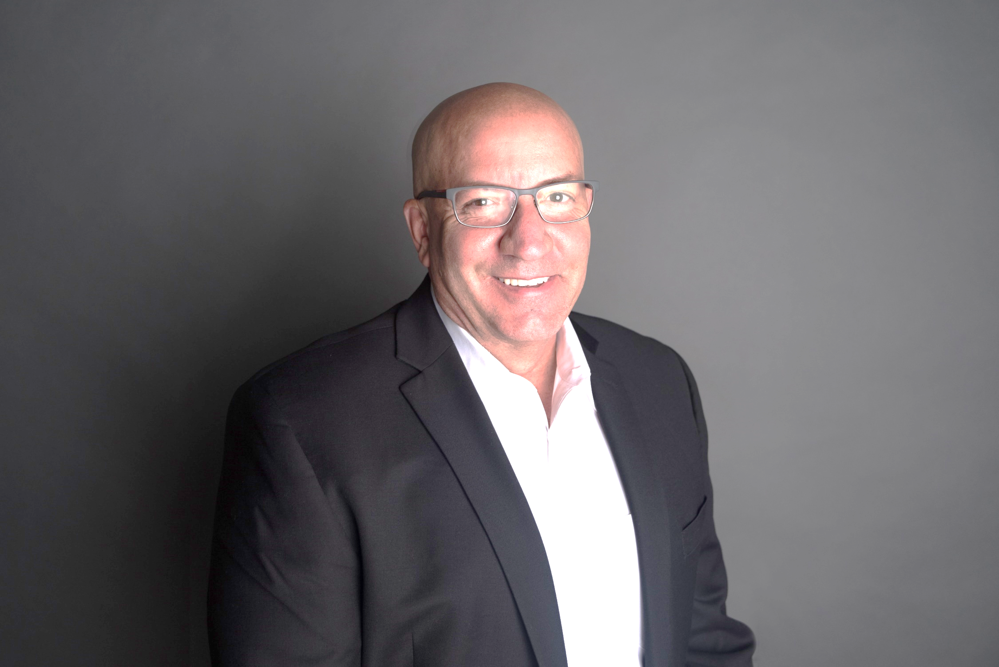

<https://www.linkedin.com/in/greg-brown-chicago>/

Territory & Account Management | Business Development | Sales Plans | Service Delivery & Management | Profit Improvement | Continuous Process Improvement | Key Accounts | Forecasting | Contract Negotiations | Strategic Partnerships | Business Expansions | C-Suite Partnerships | Product Training & Demonstrations |

High-performing and customer-focused sales executive with proven strengths in building alliances and maintaining strategic relationships selling enterprise software and SaaS-based solutions. Respected by peers for ability to share knowledge and mentor team members and recognized as agile and at ease navigating and pivoting through ever-changing and competitive landscapes. Comfortable contributing in the trenches, as well as strategically communicating with leadership and key stakeholders keeping them engaged, informed and earning their trust. Excel at:

* **Developing and executing aggressive and well-organized growth strategies**
* **Researching and creating traction in emerging markets**
* **Sourcing, landing, managing and closing key accounts through consultative selling**
* **Carving out and driving a sharp edge advantage in competitive healthcare market technology**

Hold a Bachelor of Science (BS) degree in Sales and Marketing from DeVry University; and an Associate Degree (AS) in Computer and Information Sciences from Delta College. Currently working on MBA through Keller Graduate School of Management, Chicago.

Career History & Select Accomplishments

Regional Sales Manager, Tea Leaves Health, A Welltok Company, Chicago, IL, Nov 2017-Present. *Leading provider of software solutions to hospitals and large clinics.* Manage 15-state territory. Sell Tea Leaves Health CRM, PRM solutions to help drive revenue into the hospitals. Demo software, RFP's, lead generations, networking, speaking at trade shows. Design territory plans. Manage three direct reports.

**Key Achievements**:

* Sold $1.5m of new business in 2018 (115% quota attainment).
* Ranked #1 Sales Manager. Sold named accounts, large clinics including Ascension Health, Trinity, and University of Chicago.
* Maintained 100% contract renewals driving $2.8m yearly revenue.
* Worked with the IBM and global networking team to design new network that used TCP/IP protocol. Customer was so pleased they signed on all 300 remote offices to use the network. Deal was $300k/month for three years.

Senior Sales Executive, SpectraMedix, Chicago, IL Jan 2015-Nov 2017. *Small company selling software focused on financial incentive, performance improvement, population health and risk management.* Sold healthcare analytic software to hospitals that measured calculations and performance reporting.

**Key Achievements:**

* Ranked #1 out of three sales executives.
* Sold into CFO, CIO, CNO, and CMO. Sold into named accounts in a 20-state territory.
* Partnered with hospital association to develop strategic alliances with C-level leaders. Earned their trust and respect and exceeded yearly $1M quota by 20%.
* Received Top Salesperson Award for consistently negotiating and selling three-year SaaS solution contracts.

MAP App Account Manager, Healthcare Financial Management Associates (HMFA), Chicago, IL, Aug 2010-Jan 2015. *Nonprofit membership organization for healthcare financial management executives.* Responsible for growing sales revenue and launching new benchmarking and analytics tools to hospitals.

**Key Achievements:**

* Launched new benchmarking, analytic tool into hospital market.
* Achieved sales revenue of $2.5m annually on $1m quota.
* Maintained 98% contract renewal. Sold only into named accounts, such as Ascension Health, SSM Health, New York-Presbyterian, Community Health Systems. Maintained deep relationship with HFMA members and local chapters.
* Created aggressive marketing plan for new MAP App that helped hospital pay-off investment in two years vs. five years.

Sales Consultant, The Kramer Group, Chicago, IL, Mar 2009-Aug 2010. *Provider of customizable web-based improvement solutions for hospitals, surgery centers, and large physician practices.* Responsible for development of partnerships, education, and growing new business in uncharted territory.

**Key Achievements:**

* Exceeded $800K quota by 15%.
* **D**eveloped new relationships, redefined and executed marketing plan, and successfully sold product through an ROI model.
* Educated clients on value of product by demonstrating product as a QA tool to help with automation of workflow and ultimately increasing revenue and reducing claims denials.

Account Executive, Quadramed Corporation, Chicago, IL, Apr 2006-Mar 2009. *Provider of enterprise systems to hospitals and integrated delivery networks.* With over 20 different software solutions, hired to grow and protect exiting revenue cycle management and HIM clinical accounts. Managed five state territory.

**Key Achievements:**

* Ranked #3 out of 20 account executives.
* Achieved $2.5m, 105% of sales goal and maintained 99% of customer base after new product rollout.
* Completed territory responsibility and development, including lead generation, consultation, product presentations, and demonstrations.
* Partnered with project manager to engage and educate them on features of new product. Maintained 99% current customer base after new product roll-out.

Regional Sales Manager, American HealthTech, Chicago, IL, Jan 2005-Apr 2006. *Provider of integrated Electronic Medical Records (EMR) systems to long-term care continuum.* Sold EMR solutions to long-term care facilities. Managed and directed technical team devoted to identifying and delivering solutions. Built and maintained C-level relationships.

**Key Achievements:**

* Ranked #2 out of 12 account executives.
* Achieved 120% of sales goal. Attained *Presidents’ Club,* by achieving 120% of $1.5M sales goal**.**

Regional Sales Manager, INFOSYS, Schaumburg, IL, May 2000-Jan 2005. *Delivers intelligence solutions for hospitals, clinics, and long-term care.* Responsible for sales of enterprise software solutions to the healthcare vertical, including physician offices, long-term care, and community hospitals. Handled sale of software on an ASP platform Windows and .NET platforms. Called mainly on CIO, CTO AND VP of companies.

**Key Achievements:** Attained $1.1m quota years 2001-2005.

Technology Toolbox

Salesforce, MS Office OS, PowerPoint, Definitive Healthcare, Internal proprietary software systems, Excel, MS Word, Windows sequel database