|  |
| --- |
| Edward B. Roddick  Seattle, WA |
| Sales Director / Business Development Manager |

(425) 414-0211 ♦ [eddy.roddick@gmail.com](mailto:eddy.roddick@gmail.com) ♦ www.edwardroddick.com

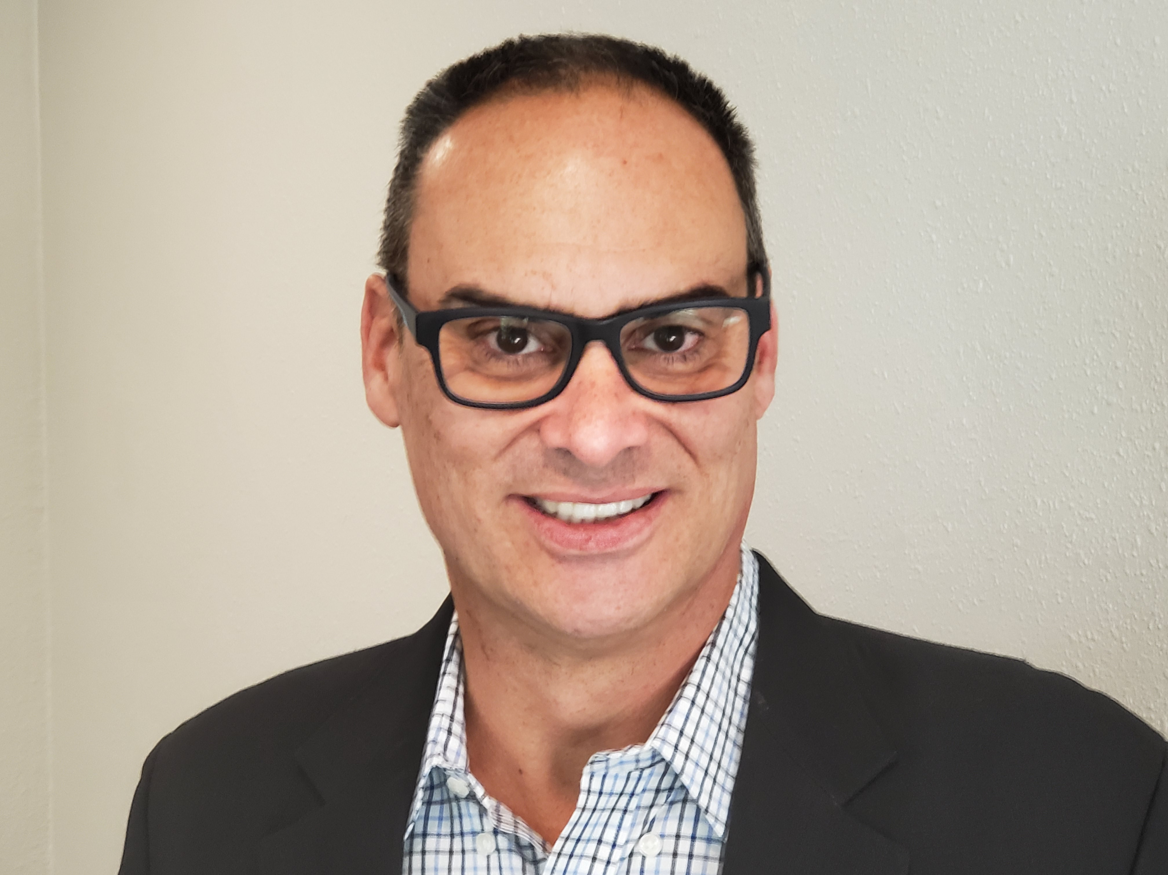

<https://www.linkedin.com/in/eddy-roddick/>

Multi-Channel Distribution / Account Growth / New Product Placement / ROI / Negotiating / Forecasting / Budgeting / Sales Programs / Category-Brand Launch / Sales Analytics / eCommerce / Strategic Sales Program Development

Highly skilled and motivated sales director with extensive experience in big box wholesale environments. Proven business development leader with a wealth of expertise in high volume brokerage sales and mass retailer buying. Repeated success in delivering high return-high impact programs that drive growth and profitability.

Can contribute by offering expertise in product development and in-store presentations, driving sales through highly personalized and strong relationship building, developing and implementing strategic sales plans, and providing cross-functional team management.

|  |
| --- |
| Select Accomplishments |

* When Phillips lost space on Costco’s shelves due to slow sales, I developed a new item, tested and rolled it out to Costco. New item gained shelf space and replaced $18M in lost business.
* Grew Morgan & Sampson’s Amazon business from $250K to $3M in three years.
* **Consistently received bonuses for outstanding achievement in meeting aggressive sales goals.**
* **Developed Cosequin as new product for Costco; resulted in $12M in new business for Nutramax.**

|  |
| --- |
| Work History & Military Service |

# Senior Sales Manager, National Accounts, Costco, Philips USA, Bothell, WA, Mar 2018-Sep 2019. *Leading health technology company*. Provided total business management for Norelco brand at Costco.

Director of Sales Costco Wholesale, Costco International, Morgan & Sampson USA, Issaquah, WA, Jan 2008-Mar 2018. *Multi-faceted products broker.* Total business development and revenue generation for all Costco regions.

Business & Sales Operations Manager, Americas / Global Procurement Manager, Americas, i-mate, Redmond, WA, Jan 2007-Jan 2008. *Telecom Company that sells Windows-powered mobile devices.* Managed front-and back-end logistics, reseller and distributor negotiations, affiliate programs, business development of SMB, enterprise opportunities and extended roles. Executed global purchasing operations.

Assistant Buyer, Costco.Com / Assistant Buyer, International Division / Inventory Control Specialist, Pacific Rim, Costco Wholesale Corporate Office, Issaquah, WA, Jan 1999-Jan 2006. *Operates national chain of membership-only warehouse clubs.* Accountable for purchasing and bottom-line profitability of mp3, audio, GPS, and satellite radio categories. Supported purchasing for Pacific Rim and U.K. locations in media, automotive, office, dry goods, freezer, and deli categories. Calculated inventory levels to support sales patterns.

**U.S Army, Global Installations, Military Intelligence Czech Linguist, TSSI Clearance**

|  |
| --- |
| Education, Professional Continuing Ed & Certifications |

Bachelor of Arts (BA), Sam Houston State University, Huntsville, TX. Pre-Law Criminal Justice major, Philosophy minor, Cum Laude Honors; Federal Law Enforcement Training Center: One of four college seniors selected in nationwide competition to attend internship offering exposure to CIA, FBI, Secret Service and other Federal Divisions.

|  |
| --- |
| Technology Toolbox |

Microsoft Office Suite, Word, Excel, PowerPoint, Outlook and POS Software

**For additional information, please visit:** [**www.edwardroddick.com**](http://www.edwardroddick.com)