
Who I Am…

Marketing Craftsman| Brand Strategist | Creative Problem Solver | Leader Developer
Dynamic marketing executive driven by curiosity, creativity & blue-ocean thinking with 20 years of B2C & B2B brand, Omni channel marketing, and team leadership experience. Rook credits her success of producing results to her drive to collaborate; and her ability dive deep quickly to understand a customer’s behavior and perceptions. Rook earned an MS in Strategic Communications from Northwestern University & is Veteran of the U.S. Air Force.
What I Do …  I’ve produced more than 100+ successful Omni channel B2C/B2B campaigns that contributed to higher sales; greater customer engagement; and created loyalty and product or service advocacy. My philosophy: Deliver measurable results; collaborate with key drivers around the business; and build leaders for the organization. I have proven leadership skills in marketing, customer success, sales, team building and digital marketing.  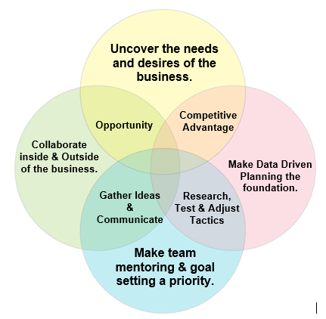  How I Add Value …  I apply my energy to improving company success by:  - Maintaining peak client satisfaction and voice of customer experience advocacy, developing high ROI strategic marketing direction, and cultivating a company-wide “customer first” synergy.  - Establishing and improving full customer lifecycle management, pricing strategies, customer segmentation, consumer/customer insight, and sales & channel effectiveness.  - Providing fluency in building new operations and continually streamlining practices within a matrixed organization.  - Focusing on people by hiring, training, mentoring, coaching, supervising and developing top performers at all levels in sales & support techniques, market knowledge, regulatory compliance and creative troubleshooting. I believe it is my job to create leaders for the Company. | Target Positions  - Omni-Channel Marketing – Senior Manager/Director  - Digital Marketing - Senior Manager/Director  Target Industries  - Durable Goods  - Consumer Package Goods  - Food & Beverage  - Nutrition & Fitness  - Big Data & Analytics  Desired Contacts  - C-Suite Executive  - Chief Marketing Officer  - Vice President of Marketing  Target Companies  - Organizations that place a Customer-Centric focus on company success.  - Forward thinking Companies that take a strategic planning approach with KPIs.  - Companies looking to disrupt the status-quo.

