RYAN P. SHERMAN | 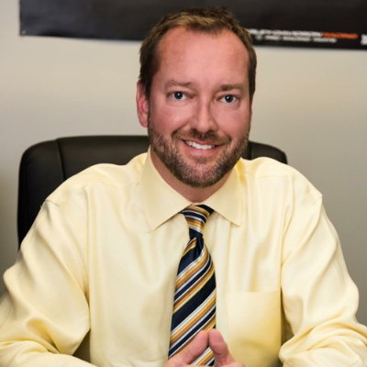
VP Strategy / Business Development
719.684.5715 ▪ shermosu1@gmail.com ▪ https://ryansherman.workfolio.com

Sales Channel Creation & Growth / New Business Development / Product Roadmaps Organic Sales Programs / Growth Strategies / Strategic Marketing / Turnarounds
Alliances & Partnerships / Media Management / Financial Controls
Relationship Building / P&L Management / Team Assemble & Development
Analytical Thinking / Quality Improvement

Exceptional record of driving increased revenues and profits by restructuring, executing successful turnaround strategies, coordinating staff, overseeing day-to-day company operations. Additional strengths in recruiting, identifying new business opportunities, managing budgets, and ensuring the highest levels of customer service. Successful in…

- Identifying and optimizing the return on new business opportunities
- Developing & executing effective business and product line turnarounds
- Crafting and implementing measurable strategic, financial and marketing plans
- Introducing innovative strategies to improve efficiencies and drive sales
- Devising and implementing robust, cost effective business processes
- Building high-level relationships with key B2B and B2C decision makers
Education: BA – Marketing / Psychology - Oklahoma State University.
NADA Dealer Academy Graduate: General Management and Successorship
History and Highlights
General Manager / Dealer Principal
Groove
2016 to Present
Ford sales and service operation located in Denver, Colorado, that provides new and used automotive sales, leasing, service, auto parts and financing.
Most senior leader over all day-to-day operations and decisions that include business development, marketing, advertising, recruiting, customer service, and internal relations with 200 employees. Achieved culture change.
- Increased net profit 18% and sales volume by 20%. Recruited to turn around a high-volume store facing declining financials after several years of steady profit. Took a grass roots approach, outsourcing detailing, restructuring employee compensation and bonus plans, and implementing an employee engagement survey. Employee satisfaction went through the roof, and customer satisfaction went up 12%.
- Increased net profit by $300K per month. After taking control of the business, determined that many expenses were completely out of line and excessive, having risen to as much as $1.4M per month. Renegotiated most contracts with vendors, lenders, and other business relationships. Within six months, cut the expenses to below $1.1M.

EVP / General Manager
Avalanche Harley Davidson
2013 to 2016
Avalanche Harley-Davidson is currently the largest vendor of Harley-Davidson bikes in the state of Colorado, with over 500 new and pre-owned models in stock at any time, providing full range of repair, maintenance, and parts service.
Held full P&L exceeding $50M and led 200+ employees in day to day operations, sales and business development, marketing and advertising programs, growing revenue and margins.
- Grew business into a volume dealership. When hired, morale was low, key organizational components were missing or under-utilized, and there was no online marketing presence. Implemented an internet department and launched an aggressive marketing campaign. Quickly made Avalanche the #2 Harley dealership in the world with net profits soaring from $1.8M to more than $6.2M in less than two years.
General Manager
Century
2008 to 2013
Century Chevrolet is family-owned and is the #1 volume dealer in Colorado, serving the Greater Denver Metro Area.
Managed full range of business operations with $5M net profit and more than 125 employees.
- Orchestrated successful turnaround. The business was losing more than $100K per month, with inventories too low to support sales volume goals. Grew relationship with General Motors and acquired agreements to increase inventory by 300 additional units within a 90-day timeframe. Drove sales to the #1 ranking in the Denver region with more than 600 units in stock, ready for sale.
Director of Finance / General Manager
Mike Shaw Auto Group
2003 to 2008
Colorado Springs GMC & Buick dealer serving customers throughout the Colorado Springs and Denver Metro Areas with full service and repair capability.
Full P&L and directed customer service, sales & service retention programs, HR functions. Negotiated contracts and managed vendor relations.
- Restored growth. Upon arrival, the dealership was selling 40-50 total units per month. Recruited a new management team with training ability and the confidence and talent to drive success. Implemented fresh marketing campaigns, spanning digital, TV, radio, and direct mail. Within a year, increased sales to 200 units and within two years to 300 units per month. Net profit swelled to $4M per year.
Director of Finance
Group 1 Automotive/Bob Howard Auto Group
1997 to 2003
Major auto dealership with both physical and on-line sales and service capability.
Additional Information & Key Skills
Deeply involved in community service – Spearheaded more than $100K in donations to local schools in the Drive for Education program.

Areas of Expertise
Banking Relations / Advertising / Analysis / Best Practices / Budget Analysis / Branding Business Process Development / Budget Management / Budgets / Community Relations
Conflict Resolution / Employee & Vendor Relations / Business Strategy / Change Agent Employee Development / Client Retention / Client Satisfaction / Client Relations / Compliance Contract Negotiations / Cost Control / Marketing / E-Commerce / Leadership / Ethics & Integrity
Forecasting / Inventory Management & Controls / Marketing Campaigns / Mentoring Performance Improvement / Merchandising

