Your Computer Has Problems? We Are The Solution!
“More Than Conquerors – IT Solutions”
Call us at number: (305) 360-9045

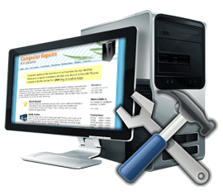





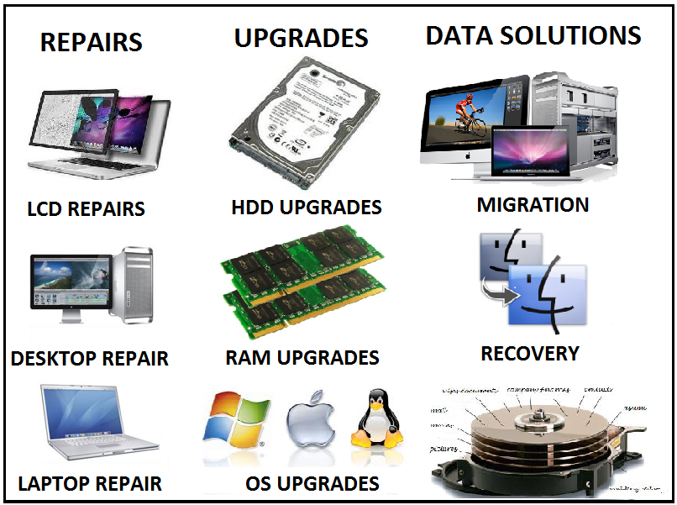



PC REPAIR PACKS:
Windows Install - $50
• Full Hardware/Software Diagnostic
• Personal File Backup / Re-Integration from old OS
• Windows 7 & 2010 Office Suite Install
• Full Security OS Updates
• Install and Test all Hardware Drivers (Printers, webcam etc.)
Hardware/Software Installation - $35/Flat Rate + Parts
• Memory Installation
• HDD Installation
• Replace Cracked Screens
• Replace Key Board
• CPU Processor Installation
• Video/Audio Cards Installation
• Cooling System Installation
• Software Installation
OPTIMIZATION PACKS:
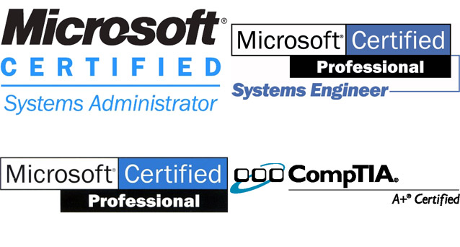
Windows Tune-up - $40
• Full System Diagnostic (Hardware + Software)
• Windows OS Optimization (No Upgrade)
• Registry Clean-up / Virus Scan
• Full Security OS Updates
• Archive Outlook Personal Folders
• Data Recovery - $35 (if not possible, no charge)
• Basic Data Recovery
Virus + Spyware Removal - $35
• Full System Diagnostic (Hardware + Software)
• Virus, Spyware, Spam removal
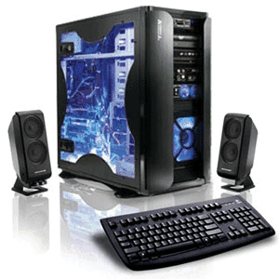
$20 CONSULTATION!
FREE CONSULTATION IF SERVICES ARE RENDERED!
24-48 Hour Pickup/ Drop off Service Guaranteed!
We Service Miami Dade & Broward Counties!
30 Days guaranteed!
5 Free Tech Support Calls (Remote Access) FREE!!!
Military and Senior Citizen Discounts!

Dell, Sony, Acer, HP, Compaq, IBM, Lenovo, Asus, ThinkPad, Toshiba, Fujitsu, Samsung, Mini-Netbook Notebook, Laptop or Desktop Computer and printers.
Contact us at: morethanconquerors.itsolutions@gmail.com or call at telephone number: (305) 360-9045. Certified Technicians, so we are never too busy to help you!
Y Si, Hablamos Español - WE ARE A CHRISTIAN BASED BUSINESS.

