“Planning and Managing Resources” Course Project

Part One: Flexing Schedules and Resources to Your Advantage

As you have seen, for some activities there are options for how you might choose to allocate resources to tasks over time, and there are strategies you can use to choose the best options for you. Now you will reflect on some of your past work experiences in project management in which you’ve used flexibility to achieve your goals.

Answer the following questions, using as much space as you need.

1. Think of a project you have worked on for which you needed to use some flexibility in allocating resources to tasks for some aspect of the work. Describe what happened in that case. What did you do? How did that flexibility help you accomplish your goals?
2. Think of a past situation in which an activity was further decomposed (split into multiple activities) to address person availabilities. What happened in that case? How did you break down the activity to resolve the resource constraints? (If you have not had this experience, imagine how such a case might arise within your organization. How would you try to handle it?)

3. Leverage that past experience now. Bearing in mind the lessons of this module, what do you think you can do differently in the future to get a better result from your scheduling and resource allocation strategies? Share your ideas.

Part Two: Using Critical Project Management Tools

Answer the following questions about the project network below, using as much space as you need.

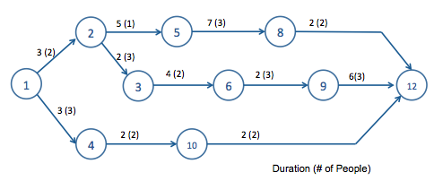

1. Map the earliest start times for each activity to the resource demands over time. What are the earliest start times for each activity?
2. Create a left-justified schedule for the project above.
3. Assuming you have five people available (with similar skills), level the schedule so it is consistent with resource availabilities. What is the new project duration?
4. For this project network, identify the critical sequence. (Frame your answer as Activity Node X to Activity Node Y to Activity Node Z, etc.)

5. Optional Question: Consider the project network shown below. Think about fast-tracking in the absence of resource constraints. Suppose activities 5-8 and 8-12 can be done in parallel. At what level of parallelization is the original critical path no longer the only critical path?

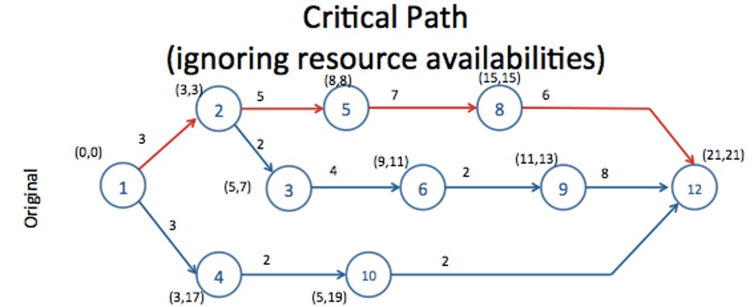

Part Three: Managing Creep, Scope, and the Unknown

Managing scope, the different kinds of creep, and all the things that are known unknowns and unknown unknowns are critical tasks for project managers. Now you will have a chance to plan how you will put the strategies from this module to work for you in some aspect of your current challenges. Outline your plans for improvement. What will you do differently? How do you think it will help you meet your goals?

Answer the following questions, using as much space as you need.

Complete the grid below.
Key Business Problem(s) to be Addressed | What is the key scheduling or project management problem you want to work on?
Strategies | Identify which strategies from the course you plan to use to get better results.
Steps | What are the specific actions you will take to achieve your goals Be as specific as you can in outlining how you will manage some aspect of scope, creep, or the unknown.
Timeline | Identify a timeline for implementation. What will you do (or will you have your team do) in the next month? What will you have completed over the next quarter?
Measurement/Results | How are you going to measure your results or demonstrate that your efforts have had a positive impact? What will success look like in this case?  Outline your measurement strategies here.

