Organizing the Project and Its Components Course Project

Part One A: Identifying the Scope and Complexity

Now you will work with identifying scope and complexity for a real project. You will identify how much you understand about the actual deliverables for two of your projects.

Review the following graph that was presented in this module. The graph showed a scale of relative ambiguity from 1 (vague) to 10 (clear) for project methods, on the X axis, and project outcomes, on the Y axis.

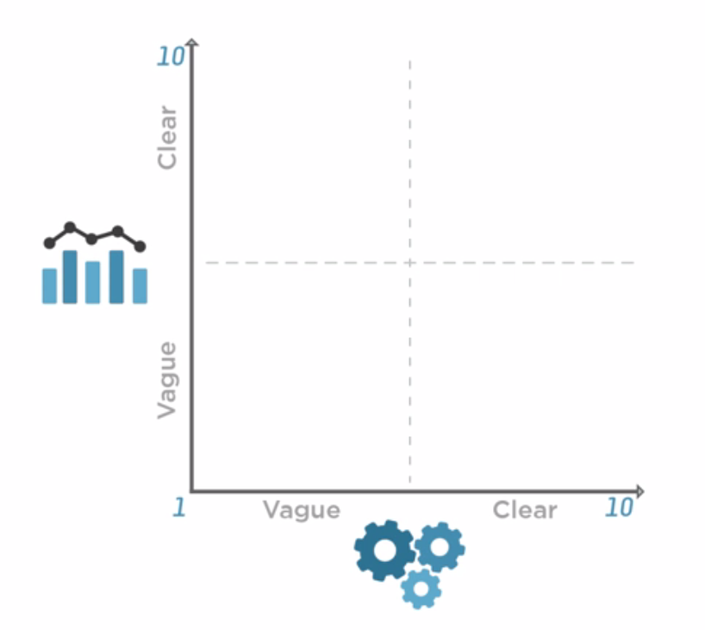

Choose two specific projects to consider in this activity. Ideally, you will choose one project from the past that has already been completed and one that you are working on currently. You will map each of these projects to the ambiguity scale as shown. You want to be able to identify, as early as possible, which quadrant every project is in so that you can work to bring about greater clarity in methods and outcomes as needed.

Project 1: Past Project
Title/description:
Map this project to the graph as shown.
The outcomes (Y axis):

The methods (X axis):
In which quadrant did the project start?

In which quadrant did the project end?
Project 2: Current Project
Title/description:
Map this project to the graph as shown.
The outcomes (Y axis):

The methods (X axis):
In which quadrant did the project start?

In which quadrant is this project currently?

Course Project Part One B: Creating a Work Breakdown Structure (WBS)

When you create a work breakdown structure (WBS), you are identifying the outcome of the project and then breaking it down into workable chunks so that you can show all the steps along the way. This step is critical for effective project management efforts. Now you will practice creating a WBS.

The purpose of this activity is to practice creating a WBS. If you already create these as part of your regular project management work, you can submit one that you have already created; there is no need to create an artificial WBS for the sake of this exercise if you are already experienced at this task. However, it should be your original work, not a WBS created by someone else.

Instructions:
- Choose a project to work with. It can be a simple project.
- Using any format you prefer, create a WBS for your project.
- As discussed in this module, your WBS should show a hierarchical structure. Each level in the hierarchy should contain successively more detail. All the steps that need to be completed should be shown.
- Include logical numbering to indicate in which order the steps should be completed. It is not necessary to explicitly indicate precedence.
- Copy/paste your WBS into this project document and submit it at the end of the course. Alternatively, you can submit it at the end of the course clearly labeled as a separate file using the naming convention “CEPM501_YourName_WBS.”

Hint: How will you know when your WBS is complete? How will you know if it needs more detail? This is subjective. Professor Nozick offers these self-check questions. You should be able to answer “Yes” to these questions:

  - Can you create a meaningful project schedule from your WBS?
  - Does it have enough detail to create a meaningful budget?
  - Can you assign all the work to a team based on this WBS? (In other words, can you assess all the human resource needs this project has?)

If you can’t answer “Yes,” your WBS needs more detail.
Course Project Part Two: Creating the Project Network

It’s important to practice thinking about how to put durations on tasks. In this part of the course project, you will create a project network, which includes mechanisms to identify task durations. You will identify the critical path and also identify whether there are any shortcomings: are there other paths that may become critical? (This is important to do because if you focus only on the critical path, you will miss the things that will make you late.)

Instructions:

- Use the WBS you created in part one of the course project (or another WBS, if you prefer) and translate it into a project network. You can do this in PowerPoint, in Word, or in Visio.
- Identify the activities. You should be able to identify at least 10-12 tasks.
- Identify the durations of the activities. Ask yourself how sure you are about those durations. Indicate whether your certainty is high, medium, or low.
- Identify the precedence between the activities. (In other words, indicate which activities have to be done before something else can be done.)
- Identify the critical path by performing a forward and backward pass.
- Identify the smallest amount of time for the project to be completed, the longest amount of time, and the most likely.
- Copy/paste your project network into this course project and submit it at the end of the course. Alternatively, you can submit it at the end of the course clearly labeled as a separate file using the naming convention “CEPM501_YourName_ProjectNetwork.”

Course Project Part Three: Identifying Sources of Uncertainty

Uncertainty in projects is common; your ability to address that uncertainty will be critical to your success. A Gantt chart is a helpful tool that allows you to view the project schedule with the start and end time associated with each activity. This helps you understand at a glance which of your activities will overlap. In this part of the course project, you will create a Gantt chart for your project so that you can spot those areas of overlap. You will identify sources of uncertainty in task durations and will also use float information to make decisions.

Instructions:

- Construct a Gantt chart for your project.
- Identify some of the sources of uncertainty related to task durations. (As discussed, there are many sources of uncertainty; they may relate to customer requirements, methods, availability of resources, facilities, schedule uncertainty, and so on. For the purposes of this exercise, you are only identifying those related to task durations.)
- Indicate how you can use float information to help you improve your decision making on this project. What does float information tell you?
- Copy/paste your Gantt chart and your answers into this project document and submit it all at the end of the course. Alternatively, you can submit it at the end of the course clearly labeled as a separate file using the naming convention “CEPM501_YourName_Gantt.”

