

The 106th Session
of the
Lancaster District Conference
&
Church School Convention
Official Program

September 19 -20, 2025

Convening at

David Stand A.M.E Zion Church
1989 Riverside Road
Lancaster, SC 29721
Reverend Albert Tucker, Host Pastor

Theme: The A.M.E. Zion Church Serving This Present Age: “Committed to Our Mission, Being Creative in Our Methods, Concentrating on Our Ministries and Connecting through Our Membership.”
Scripture Focus: Ephesians 4:1-4 (Amplified)

Reverend Ruby Miles, First Lady of District
Reverend Dr. Joel D. Miles, Presiding Elder
Mrs. H. Jean McMurray-Leake, Missionary Supervisor
Bishop Eric L. Leake, Presiding Bishop

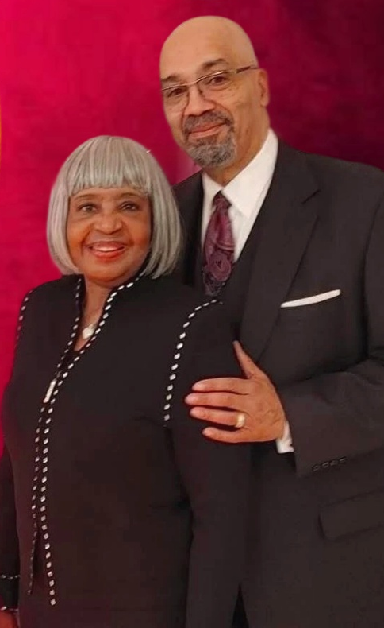
Reverend Dr. Joel D. Miles
&
Reverend Ruby Miles

Friday, September 19, 2025 – 9:00 A.M.
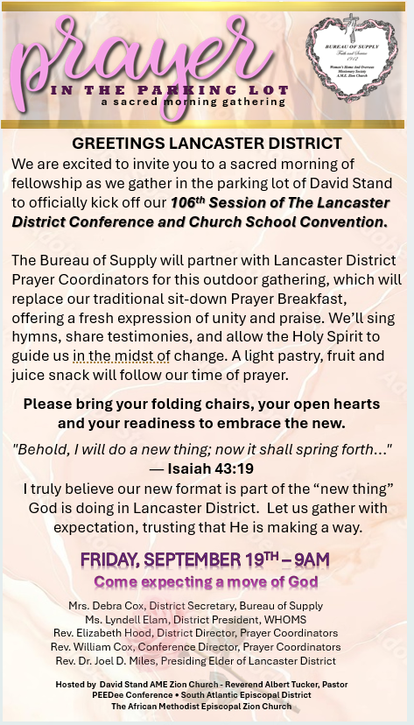
Friday, September 19, 2025 – 10:00 A.M.
Opening of The District Conference

Order of Worship
Reverend Albert Tucker, Worship Leader

The Processional
The Call to Worship……….….…… Reverend Albert Tucker
The Invocation ……….…….……… Reverend Albert Tucker
The Selection ……….….…” What Can Wash Away My Sins”
The Responsive Reading …...... Reverend Rachelle Stevenson
The Affirmation of Faith ….…Reverend Mondray Stevenson
The Scripture Lesson ………... Reverend Claudette K. Felder
The Prayer ……………………. Reverend Barbara Benjamin
The Selection ……………… White Oak A.M.E. Zion Church
The Ministry of Kindness Offering ……. Finance Committee
The Presentation of the Presiding Elder……………
Reverend Jonathan Moore
The Presentation of the Preacher …………….Presiding Elder
Reverend Dr. Joel D. Miles
The Selection ……….….… Camp Creek A.M.E. Zion Church
The Sermon ……………… ….…. Reverend Charles Crockett
The Invitation to Christian Discipleship …………...
Reverend Dr. Paulette Leak
The Offering ……………………………... Finance Committee
The Communion Ritual
The Benediction

(Pastors are to be dressed in clergy attire, black suits)

Health Break 11:45 AM – 12 Noon
Organization of the District Conference
12:00 Noon
Reverend Dr. Joel D. Miles, Presiding

Business Session

The Report of the Rules Committee………………….
Reverend Albert Tucker
The Election of Secretary
The Election of Assistant Secretary
The Roll Call………………………………………. Secretary
The Report of the Credentials Committee…….
Reverend Jonathan Moore
The Seating of the Delegates………. Reverend Dr. Joel Miles
The Treasurer’s Report ………………... Mrs. Tammie White
The Election of Treasurer
The Election of Assistant Treasurer
The Appointing of Committees…… Reverend Dr. Joel Miles
The Pastors & Delegates’ Report (5 minutes each)

Lunch Break
1:30 PM – 2:30 PM
Reports – 2:30 PM
The Pastors & Delegates’ Reports (continued)
The District Departments
The Admissions Committee

The District Studies
The Evangelism Moments ……. Reverend Vanessa McLamb
The Presentation of the Presiding Elder …….
Reverend Dr. Jerret Fite
The Selection ……………….
The Charge to the District…. Reverend Dr. Joel D. Miles
Presiding Elder

The Report of Budget Committee
The Report of the Finance Committee
The Close of the Day

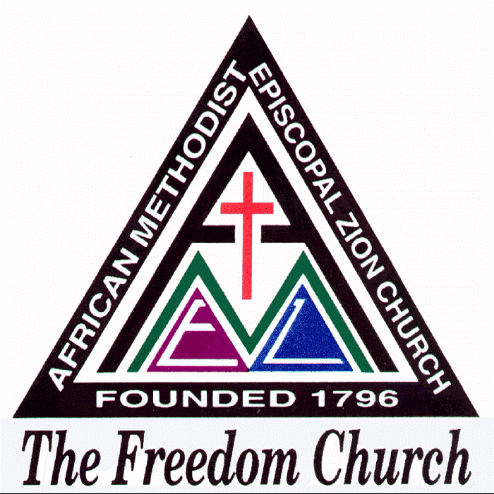

SATURDAY, SEPTEMBER 20, 2025
THE 106TH CHURCH SCHOOL CONVENTION
9:00 A.M.


Convention Theme:
Serving this Present Age: Being Creative in Our Methods

Order of Convention

9:00 – 9:30 – VICYC Café and Attendance Sign-In

9:45 AM
Church Roll Call and Shout
Outs ………………………………………… Tina Johnson

Celebration of our Children’s Ministry –
Penny Brigade 2025 – I’m in the Lord’s Army

Welcome …………………………………. Barbara Boykin
Varick’s Children Director

Introduction of Penny Brigade Contestants

Contestant Presentation

Total Raised ……………………………… Tammie White
Presentation of Winners
CHURCH SCHOOL CONVENTION

Organization of Church School Convention …………
Tina Johnson

11:00 AM – 12:30 PM
Breakouts
Varick’s Children – 3 – 12
VICYC – 13 – 21
YACM – 22 and Up
Adults

12:45 – Reassemble in Sanctuary

Drawing for prizes, attendance awards

Remarks, CED Announcements/Acknowledgements …...
Tina Johnson

Report of Finance Committee ……………………………

The Courtesy Report………… Reverend Barbara Benjamin

Closing Remarks and Closing of Conference ……………
Presiding Elder Reverend Dr. Joel D. Miles


COMMITTEES

STATE OF THE COUNTRY
Reverend Claudette K. Felder (Chairwoman)
Reverends Barbara Benjamin, Sheresa Ingram,
Ms. Jackie Harris

STATE OF THE CHURCH
Reverend William Cox (Chairman)
Reverends Linda Hill, James Scott and Ms. Overta McIlwain,
Ms. Odessa Funderburk

RULES
Reverend Albert Tucker (Chairman)
Reverend Eddie Boykin, Mrs. Nell Davis, Ms. Lyndell Elam
and Mr. Larry Tidwell

DISTRICT ADMISSIOMS
Reverend Dr. Michael Peay (Chairman)
Reverends Charles Crockett, Eric Franks and
Reverend Dr. Jerrett Fite

DISTRICT STUDIES
Reverend Sheresa Ingram (Chairwoman)
Reverend Vera Witherspoon

CREDENTIALS
Reverend Jonathan Moore (Chairman)
Mr. Willie Adams and Ms. Elvira Faulkner McIlwain

BUDGET
Reverend Dr. Michael Peay (Chairman)
Reverend Dr. Justin Barbour, Reverend Charles Crockett,
Ms. Montez Brown and Mrs. Jacqueline Wiley
COMMITTEES CON’T

FINANCE
Reverend Dr. Jerrett Fite (Chairman)
Reverend Dr. Paulette Leak, Reverend Dr. William Cox,
Reverend Jonathan Moore, Mrs. Tammie White,
Ms. Brenda Chisholm and Ms. Kay Strong

COURTESY
Reverend Barbara Benjamin (Chairwoman)
Mrs. Connie McGill

PENNY BRIGADE CONTESTANTS

Name | Church
Nolan “Tre” White | Steele Hill
Jaxson Long | White Oak
Ocir Tadford-Digby | Mt. Tabor
Ja’Kiya Jones | Mt. Carmel
Joshua Howie | El Bethel
Talia Stewart | North Corner
Tynia Haggins | Salem
Martin Gordon | Gold Hill
Ariana Wilson | Mt. Calvary
Ava Green Graham | New Hope
Ly’Nique Crawford | Cedar-Warner
Jamoiah Kirk | Centennial
Valerie Catoe | Greater Frazier
Knowledge Stevenson | Clinton Chapel

DISTRICT CONFERENCE DELEGATES

Church | Delegate | Alternate
Mt. Zion | Ms. Jackie Harrie | Ms. Dianne Pappas
Steele Hill | Mrs. Nadine Morrison | Mr. Reginald Torrence
White Oak | Ms. Zenia Graham | Ms. Lyndell Elam
Mt. Tabor | Ms. Margaret Belk | Mrs. Wanda Crawford
David Stand | Mrs. Gwyn Hudson | Mrs. Lelia Truesdale
Mt. Carmel | Mrs. Tammie White | Miss Shonie Brooks
El Bethel | Mrs. Barbara McAfee | Mr. Eddie Wallace
North Corner | Mr. Jamar Coffey | Ms. Odessa Funderburk
Salem | Mrs. Connie McGill | Mrs. Cynthia Jones
Mt. Moriah | Mrs. Dean Brevard | Mrs. Clara Duncan
Gold Hill | Ms. Kay Strong | Mr. Willie J. Adams
Mt. Calvary | Mrs. Shirley Rainey | Mr. Jabbar Rainey
Camp Creek | Mrs. Wyscle Washington | Mrs. Melzetta Alexander
New Hope | Mr. Robert Stafford | Mr. Harris Benjamin
Cedar-Warners | Mrs. Ida Cunningham | Ms. Montez Brown
Centennial | Ms. Brenda Chisholm | Mrs. Linda Blackwell
New Unity | Ms. Frances Howard | Mr. Frankie Hailey
Greater Frazier | Mrs. Deborah Cox | Mr. Jeff Parker
Pleasant Hill | Mrs. Ada Robertson | Mr. Eugene Robertson
Bingham Chapel | --- | ---
Mt. Nebo | Miss Tiffany Bracey | Miss Joann Massey
Clinton Chapel | Mrs. Vonda Stevenson | ---

CHURCHES LANCASTER DISTRICT & PASTORS – 2025

Mt. Zion | Reverend Dr. Paulette Leak
Steele Hill | Reverend Dr. Jerrett Fite
White Oak | Reverend Dr. Justin Barbour
Mt. Tabor | Reverend Dr. Michael Peay
David Stand | Reverend Albert Tucker
Mt. Carmel | Reverend Eric Franks
El Bethel | Reverend Jonathan Moore
North Corner | Reverend Vera Witherspoon
Salem | Reverend Claudette K. Felder
Mt. Moriah | Reverend Sheresa Ingram
Gold Hill | Reverend Linda Hill
Mt. Calvary | Reverend James Scott, Jr.
Camp Creek | Reverend Charles Crockett
New Hope | Reverend Barbara Benjamin
Cedar-Warner | Reverend Mondray Stevenson
Centennial | Reverend Rachelle Stevenson
New Unity | Reverend Barry Thompson
Greater Frazier | Reverend Eddie Boykin
Pleasant Hill | Reverend Albert Tucker
Bingham Chapel | Reverend Timothy Dupree
Mt. Nebo | Reverend Sheila Bracey
Clinton Chapel | Reverend Mondray Stevenson

PRESIDING ELDER
Reverend Dr. Joel D. Miles
Post Office Box 1329
Lancaster, South Carolina 29721
Cell: 1-773-405-6375

