The Low Down on Tap Water
and Filtration Systems

By Dr. Ritamarie Loscalzo

Most savvy Americans realize that our tap water is not safe to drink. The bottled water industry is making a killing as a result. It’s not clear that bottled water is that much better, since it’s usually stored in plastic bottles containing chemicals that can leach into the water and disrupt your hormones. But that’s a subject for another lesson.

This lesson is intended to give you enough background information to make a decision to avoid tap water and get you pointed in the direction of doing research on what water filtration system is best for you.

Some people choose not to invest in a water filtration system for a variety of reasons. If that’s your decision, be sure to find a reliable source of filtered water and purchase large BPA-free jugs to fill up.

So Why Filter Your Water?

What's wrong with tap water? Don't the powers that be have our best interest at heart?

I wish I could say in good conscience that all you need to do is turn on the faucet and enjoy what comes out, but unfortunately that’s just not true.

Tap water contains a wide variety of disease-causing contaminants including arsenic, asbestos, aluminum, benzene, mercury, toluene, herbicides and pesticides, chlorine, fluoride, parasites and viruses.

These contaminants can contribute to many health challenges including cancer, learning and behavioral problems in children, lower IQ, high blood pressure, problems of the reproductive and nervous systems, Alzheimer's, anemia, liver, kidney, heart damage, respiratory and nervous system damage.

City Water

Approximately 80% of city water systems are not equipped with filters that meet EPA standards.

In addition, most cities add the harmful chemicals of Chlorine and Fluoride to water.

According to Preventative Dental Health Association, fluoridated water is linked to cancer and infertility. According to a 1994 study in the Journal of American Medical Association, drinking fluoridated water doubles the chances of hip fractures in older people.

Pharmaceuticals such as antibiotics, sex hormones, anti-depressants, and seizure pills have been found in the tap water of at least 41 million Americans. Water treatment centers are not currently required to test for pharmaceuticals. Researchers are unsure if the cumulative levels are hazardous.

If you live in an older home, chances are your tap water is contaminated with lead, which can be toxic to your brain and cause non-specific symptoms like low grade depression, fatigue and digestive upset.

Another common contaminant in tap water is automotive fluids, which drip onto the ground and eventually find their way into water supplies.

The Perfect Water Filtration System -- Is There One?

Again, I wish I could, in good conscience and with 100% certainty, claim to know what system is best.

The truth is, no single system takes out all the contaminants of concern. When I first became conscious of the problems with tap water, I did research and purchased a distiller. That was in 1985.

The unit served me until I moved to Austin in 1999 and couldn’t use the unit due to my current kitchen configuration. At that time, I researched again and decided on reverse osmosis with a triple carbon filter system.

These days people are talking about ionized water, aka alkaline water, vortex spun water, and there are counter top pitcher units that do a fairly decent job of removing many contaminants.

If I had to choose all over again, I would pour through all the research available at the time and make a decision.

If you don’t already have a water purification unit and you are looking for one, use the references below as a launch point for your own research project.

There are pros and cons to all solutions.

Water Filtration Comparison Chart

From: http://www.purewaterdynamics.com/water-filtration.asp

Which water filters are able to remove what common water pollutants and contaminants?  (Source US EPA - Water Technology magazine). | Carbon Filter | Distillation | Water Softener | Reverse Osmosis plus Carbon Filter
Aluminum |  | X |  | X
Arsenic |  | X |  | X
Asbestos |  |  |  | X
Cadmium |  | X | X | X
Chlorine & THMs | X | X |  | X
Chromium |  | X | X | X
Copper |  | X |  | X
Endrin | X |  |  | X
Fluoride |  | X |  | X
Giardia/Cryptosporidium |  | X |  | X
Hardness |  | X | X | X
Lead | X* | X |  | X
Mercury |  | X |  | X
Nickel |  | X |  | X
Nitrate |  | X |  | X
Pesticides/Herbicides | X |  |  | X
Radium |  | X | X | X
Radon | X |  |  | X
Toluene | X |  |  | X
Total Dissolved Solids |  | X |  | X

* A carbon filter alone will only remove 50% of this contaminant.

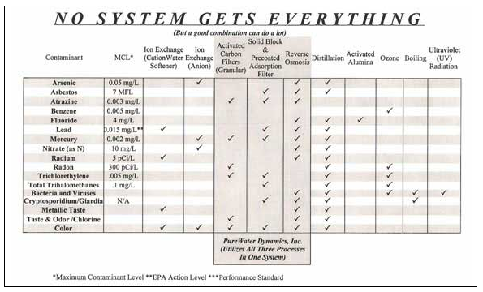
Filtration Systems – Websites to Research:

Ionizers
- Water Filter Comparisons
- Ionizers Compared
- Ionizers Compared: Table
- Water Ionizer (Wikipedia)

Distillers
- Water Distillers and Distilled Water - Myths and Facts
- Distillation for Home Water Treatment

Reverse Osmosis
- How Reverse Osmosis Works
- ESP Water Products: How Do Reverse Osmosis Filter Systems Work & What Do They Do?

Comparison Charts and Information
- WaterUS Comparison
- Water Treatment Alternatives
- Waterise: Water Purification Methods
- Pure Water Dynamics: Water Filtration Systems

Additional Reading About Tap Water And Its Dangers

- Don’t Drink the Water (without Reading This Book). Kahuna Kupua A’o, Lono. 1998. Pagosa Springs, CO: Kali Press.
- Troubled Water. Roddick, Anita. 2004. Boulder, CO: Chelsea Green Publishing Company.
- “Study: Rocket Fuel Chemical Taints Food, Water.” Coren, Michael. CNN. February 25, 2005. Accessed: May 25, 2010.
- “That Tap Water Is Legal, but May Be Unhealthy.” Duhigg, Charles. The New York Times. December 16, 2009. Accessed: May 13, 2010.
- “Probe: Pharmaceuticals in Drinking Water.” CBS News. March 10, 2009. Accessed: May 13, 2010.
- “That Tap Water is Legal, But May Be Unhealthy.” Duhigg, Charles. December 16, 2009. Accessed: May 13, 2010.
- “The Millenium Development Goals and Water.” UNESCO. Accessed: May 13, 2010.
- “Probe: Pharmaceuticals in Drinking Water.” CBS News. March 10, 2009. Accessed: May 13, 2010.
- 20 Little Known Facts about Tap Water
- Tap Water Facts
- 10 Important Facts about Tap Water
- Why Tap Water

