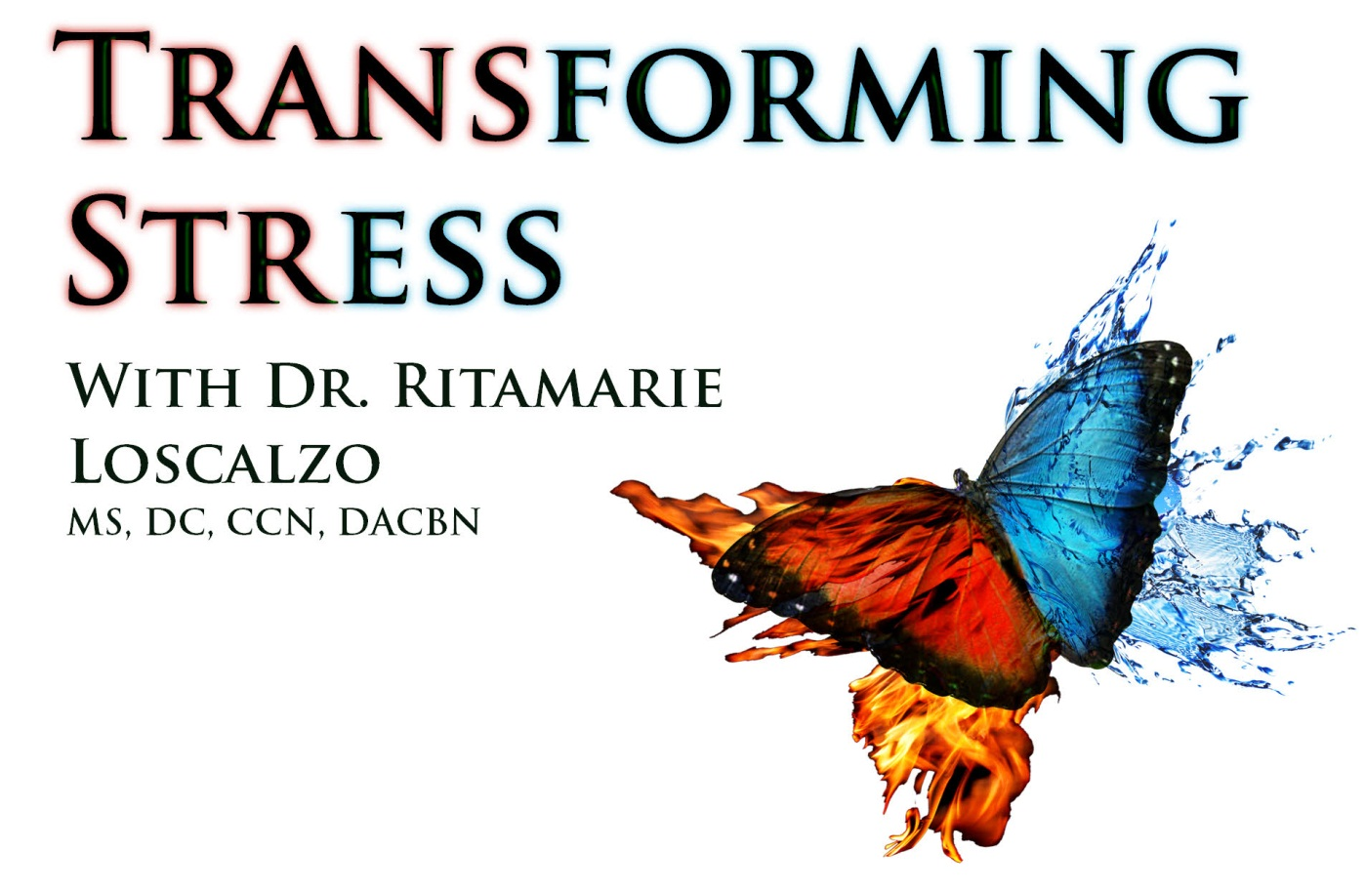



Copyright © Dr. Ritamarie Loscalzo, MS, DC, CCN, DACBN
All rights reserved.
Austin, Texas, USA.

No part of this publication may be reproduced, stored in a retrieval system, or transmitted in any form or by any means, whether electronic, mechanical, photocopying, recording or otherwise, without prior permission of the author. Please do not give away, publish on a website or in a newsletter or sell without permission of the author. You have permission to make as many printed or backup copies as you desire for personal use only. Thank you for respecting the hard work that went into creating this document for your education and enjoyment.

Published in the United States of America by Dr. Ritamarie Loscalzo.
Edition Date: December 5, 2014

DrRitamarie@DrRitamarie.com

Disclaimer
The techniques and advice described in this book represent the opinions of the author based on her training and experience. The author expressly disclaims any responsibility for any liability, loss or risk, personal or otherwise, which is incurred as a result of using any of the techniques, recipes or recommendations suggested herein.

The responsibility for the consequences of your use of any suggestion or procedure described hereafter lies not with the authors, publisher or distributors of this book. This book is not intended as medical or health advice. If in any doubt, or if requiring medical advice, please contact the appropriate health professional. We recommend consulting with a licensed health professional before making major diet and lifestyle changes.

If you enjoy the information in this program, we would like to encourage you to show your support by sharing your testimonial with us, sharing our website with your friends and family, and supporting our continued work by considering our other programs and products.

The Power of Appreciation
“Nothing attracts good fortune and success like a joyous, grateful heart." – Charles Burke
Gratitude is a powerful emotion; it can create really wonderful, lasting changes in your life. Do you sometimes take for granted the abundant blessings in your life? It's a common blunder, but spending a moment for grateful reflection invites you to again savor all that is good in your world. If it does nothing else, being appreciative is just a ‘feel-good’ thing to do and worth the few minutes it requires of your time.

There have actually been studies on the benefits of keeping an appreciation list. The results? Subjects who regularly took just a few minutes a day to reflect upon the things for which they were grateful were happier with a more positive outlook on their future and life in general.

If you have not yet established the daily habit of expressing gratitude, we encourage you to get in touch with the Art of Appreciation. The habit is quick to develop, and it is so easy to do that calling it an exercise seems a bit of an overstatement.

It’s a simple as this: When you awake in the morning, and again when you go to bed at night, think of three things you are grateful for.

These need not be elaborate. Here are some sample statements we’ve made ourselves:

- It makes me so happy awakening to my children’s voices.
- I enjoy being able to stretch out all over this big bed before getting up each morning.
- I’m appreciative of the bird singing outside my bedroom window.

- I am grateful for not having a headache.
- I am grateful for my job and the stability it provides my family.
- I’m so in love with my friends and family and the consistent support they give me!
- I really enjoyed that great lunch today.

It's also worth noting that while the practice of appreciation can be magical in its own right, the timing for this activity is up to you. We suggest practicing appreciation upon awakening and retiring because we like to begin and end the day in the afterglow of gratitude.

You may find a different time or place in your daily routine that seems more organic for you -- perhaps while preparing dinner for your family, while sitting in your porch swing with morning tea, or when relaxing into meditation.

Gratitude connects you to your visions and dreams. Better still, it connects you to your life…

Connecting to Gratitude

The following exercise is helpful for driving appreciation into an even deeper personal experience.

Take 5-10 minutes to randomly list gifts in your life. Just brainstorm here and write down as quickly as possible what first pops into your head. Your list may include the people in your life: from close family members to the paperboy who gets the newspaper onto the front porch each and every morning. What about your environment – your home, books, garden, the computer that allows you to do this exercise?


Be sure to note both internal and external qualities of your life as you aspire towards greater health and happiness. Remember to include those big concepts that give your life meaning – things such as your spiritual beliefs and nature. There are no boundaries on appreciation. Neither are there right/wrong responses to this exercise; you may find some items profound, others inane. They are all good!

This is a powerful exercise for overcoming complacency and self-doubt! See if it might empower you towards the realization of your vision, now and in the future.

Connecting to Gratitude
What I am grateful for…
1.
2.
3.
4.
5.
6.
7.
8.
9.
10.
11.
12.
13.
14.
15.
16.
17.
18.
19.
20.

Keep this exercise as a perpetual, running list of recognized blessings in your life!

But for the sake of this exercise now, pause to read slowly over your list, reflecting on each response in turn and the deep appreciation it elicits in you. Write in any special notations that come to mind.

Appreciation is a skill, and like all skills requires a bit of practice. It may feel awkward or silly doing this exercise at first. Yet, over time, you'll be amazed at how quickly it becomes a natural part of daily living.

If you should find yourself noticing things you are grateful for throughout the day – well done!

On the other hand, if this exercise starts to lose its power, you may be approaching it as just another task. Re-assess how to make the exercise more meaningful for YOU, and commit to doing it consciously (even if only once a week).

Most importantly, have fun and be creative. See if adopting the art of appreciation empowers you towards the realization of your vision, now and in the future.
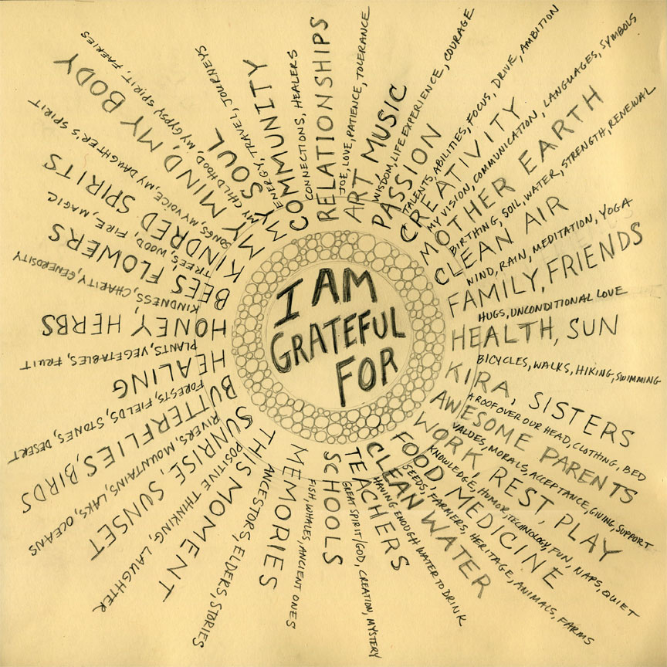

Deepening Your Gratitude

Would you like to try an advanced version of this exercise which focuses on gratitude of self?

If you would like to build upon the self-awareness you have built throughout this program, the following variation of the gratitude list will help crystallize a clear and positive personal image.

- Using the Self Appreciation List below, begin listing all the things you like about yourself.
- These can be random, but you might find it more helpful to start out with one aspect such as “Physical Body” and go systematically from hair to feet, inside and out. As with the previous exercise, this becomes easier as your feeling nature engages in the process.
- Allow yourself to be both serious and silly! You may love that your smile is genuine, but you may also be glad you wear a size 6 shoe so you can try on displays without having to wait for a shoe salesman. There is never a blessing too small…
- Allow yourself to work on this over a matter of days or even weeks. Challenge yourself to expand your vision and add more pages as necessary. An ideal Self-Appreciation List might easily include 100 items or more, once you allow yourself to get into the groove of it.


Self-Appreciation List
Things I love about myself…
1.
2.
3.
4.
5.
6.
7.
8.
9.
10.
11.
12.
13.
14.
15.
16.
17.
18.
19.
20.

Self-Appreciation List
Things I love about myself…
21.
22.
23.
24.
25.
26.
27.
28.
29.
30.
31.
32.
33.
34.
35.
36.
37.
38.
39.
40.

You may choose to hold this list close, keeping it private for sneak peeks when a personal boost is needed. We challenge you, instead, to consider taking the next daring step:

Read your list aloud to a trusted member of your support system! Be bold. Lay claim to these truths, as witnessed by someone who loves you. This can be an exhilarating, emboldening experience, and one you can then offer to your supporter as well!

Gratitude unlocks the fullness of life. It turns what we have into enough, and more.
It turns denial into acceptance, chaos to order, confusion to clarity. It can turn a meal into a feast, a house into a home, a stranger into a friend. Gratitude makes sense of our past, brings peace for today, and creates a vision for tomorrow.
-- Melody Beattie



Transform Your Stress through the Power of Visualization, Connecting to Your Bliss, and Appreciation

As you travel the path you've laid out for yourself, reaching out and drawing in your visions and goals, you are bound to hit some obstacles along the way. Knowing this, we have thus far provided several tips for maneuvering those inevitable challenges.
One of the day-to-day things that gets in the way of attaining your health goals is stress. Usually, we think of stress as a negative feeling rather than a positive feeling. In fact, not all stress is negative, and it's quite possible to transform stress you perceive as negative into a positive.

For example, if you are exercising and start to lift weights that are heavier than your muscles can handle, the extra stress on the muscle causes some breakdown of the muscle tissue. In response, your body makes more muscle tissue in order to be able to handle the extra stress of the weight, and your muscle increases in size and becomes stronger.

That can happen to you on an emotional level as well.

What is Stress?

The Institute of Heartmath™ defines “stress” as “the wear and tear experienced by the body in reaction to everyday tension and pressure.” Webster's dictionary defines stress as “a physical, chemical, or emotional factor that causes bodily or mental tension and may be a factor in disease.” We like to define it as your body and mind’s response to any pressure that disrupts or threatens its normal balance.

The physiologic response to chronic stress can be very damaging to your body. Your adrenal glands, which sit atop your kidneys, have been given the job of helping you in times of stress. Physiological responses to mental stress are usually the same as the responses to physical stress, or imminent danger.

Your heart rate accelerates; your blood pressure rises; your digestive tract shuts down; your “wizard brain” (the higher level thinking powers) slows down and your “lizard” brain (the animal instincts for survival) are enhanced --- all in preparation for you to be able to run away from danger or fight the danger face to face. The adrenal response to stress is often called “fight/flight”.

If you stay in this state too long, or go there too often, your body develops signs of breakdown and disease. Chronic stress will leave you exhausted, overweight, unable to comfortably digest your food, and suffering from a long list of minor and major complaints.

In order to stay on the path to your goals, it's important to build in regular stress management and transformation practices.

The one we're about to teach you is one of our favorites because it can be done quickly and frequently throughout the day. With practice, the techniques in this step can shift you from a stressful to a relaxed state in less than a minute.

Part 1: Preparation

Think of a time when you felt really good inside. This could be a feeling of appreciation or care towards a special person or pet, a place you enjoy or an activity that's fun.

Recall as many details as you need to be able to recreate the good feelings of the joyful or fun time. This is more than visualization; this is experiential as you vividly remember as many particulars as possible – the smells, sounds, tastes, feelings…

Often, drawing upon this memory will cause a smile to curl on your lips, or a tingling to be felt throughout your body. Write it all down in as much detail as you need so that reading it brings back the feeling and experience.

Repeat this process 2 or 3 times and write a brief description of these positive feeling times down below, in order to memorize them. Refer to them when you are in a stressful situation you would like to transform.

Positive Feeling Times:

1)

2)

3)

Transfer the descriptions of your positive feeling times to an index card and carry it with you to use as a positive anchor.

Part 2: Pay Attention to How Your Body Feels in Times of Stress

We all feel stress in certain ways that are uniquely our own. How does your body feel in times of stress?

It may help to recall a trying past event -- bring it back as if it were really happening and notice where you feel tension or discomfort in your body. Is it a tightening of the neck or shoulder muscles? A sensation of butterflies, or a knot, in your stomach? A tight band across your head? A constriction in your chest?

Be fully present with the physical sensations and jot them down below.

My Physical Sensations in Response to Stress:

As you move through each day, remain conscious of your body and its physical sensations. If you notice one of these stress sensations pop up, it's an early warning sign and time to put the stress transformation techniques below into action, before you have a full blown stress attack. As you become more attuned to your body, you'll get better and better at heading off the stress before it gets too bad.

Know that these techniques and the heightened sensitivity they create can help shift you out of a full blown stress response as well as help you to curtail it.

Part 3: Practice Peaceful Transformation

There's nothing like practice to create a new and lasting habit. If you wait for a full blown stress response to use the technique below, you may find it difficult to shift away from your stress reaction as quickly as you'd like.

We recommend learning this process and practicing it many times throughout the day. The more you do it, the easier and quicker it becomes. Before long you will be able to work the technique effectively in less than a minute.

Great practice times are:

- First thing in the morning before you get out of bed
- Before each meal or taking nutritional supplements

- While you're brushing your teeth
- While driving to work
- Right before going into a meeting or confronting someone with whom you've had a rocky relationship
- Before talking to a child about a limit you need to set or a behavior issue they are having
- In bed at night, right before falling to sleep

The 3-Part Transforming Stress
HeartMath™ Process

For additional information on this and other stress transformation processes visit http://www.heartmath.org.

Heart Focus
Shift your attention to the area around your heart. You do this just as you might shift your attention to your toe or elbow. Placing your hand over your heart as you do this might help you focus. If your mind wanders, just keep shifting your attention back to your heart.

Do this for 30 seconds to a minute as you're learning the process. With practice this will naturally occur with a single breath.

Heart Breathing
As you focus on your heart, imagine that your breath is flowing in and out through that area. This helps your mind and energy to stay focused in the heart area and your breathing and heart rhythms to synchronize.

- breathe slowly and gently in through your heart to a count of 1 and 2
- briefly hold your breath to the count of 3 and 4
- then breathe slowly and easily out through your heart to a count of 5 or 6

Do this until your breathing feels smooth and balanced, not forced. You may discover that it's easier to find a slow and easy rhythm by counting “one thousand, two thousand” rather than one, two, etc.

Just continue to breathe with ease until you find a natural inner rhythm that feels good to you.

Heart Feelings
Continue to breathe through the area around your heart. As you do so, recall one of the positive feelings you wrote down during the preparation stage. Be as vivid as you can in your recollection in order to experience the feelings, not just visualize it.
Allow yourself to deeply feel the joy and appreciation that memory gives you. Linger with this good feeling for as long as you can.

Part 4: Ready for Action

After sufficiently practicing these steps, you'll find yourself in a much calmer mood most of the time. Bringing yourself into this relaxed appreciative state many times throughout the day has lots of positive effects on your body.

Some of the benefits of practicing these techniques include:

- sleeping more soundly
- increased energy
- weight normalization and reduction of belly fat
- healthy blood pressure
- mental clarity
- normalization of blood sugar
- decreased pain and inflammation
- joy

Visit http://www.heartmath.org and explore their many wonderful resources for a full list of the benefits they've found through their many years of research.

What follows are some suggestions for nipping a stressful situation in the bud and responding in a positive and wholesome manner.

- Become aware of the physical signs that you're heading into a stress response. Review your list in Part 2.
- As soon as you feel stress mounting, pull out the index card that describes your positive feeling times. Even if you have those time memorized, you might find it helpful to read them over as that alone shifts you from “lizard” to “wizard” brain.
- Do the three-part process: Heart Focus, Heart Breathing, Heart Feeling.
- The more you practice, the easier the process becomes, and the greater, more lasting the benefits. Your health goals will be within your reach in no time.



