Digestion Protocols:
H. pylori

Helicobacter pylori, aka H. pylori, is a type of bacteria which resides in the stomach. To be specific, it is found in the mucus lining of the stomach and duodenum, but can also adhere to the cells lining the stomach. It has a rod-like, helix shape which allows it to burrow deep into the lining. To survive in the acidity of the stomach lining, H. pylori bacteria release an enzyme called urease. This enzyme turns urea into ammonia.

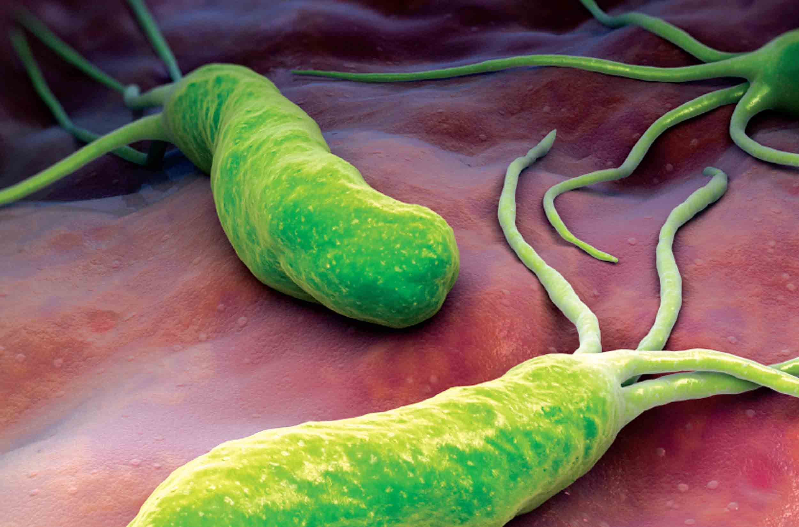
The ammonia neutralizes the gastric juices around the H. pylori bacteria so they can thrive. Normally, your body would send immune cells to attack and kill bacterial invaders. But immune cells can’t burrow into the lining of the stomach, so H. pylori creates havoc in the digestive system. There is also evidence showing that H. pylori bacteria can block immune responses so they can’t have an effect. It is also a common cause of ulcers.

Depending on which report you go by, 1/3 to 2/3 of the world’s population is infected with H. pylori. Researchers aren’t sure exactly how H. pylori bacteria are transmitted, but they guess it is from fecal to mouth contamination. Considering that sanitation has improved so much in developed countries, they also guess that H. pylori can be transmitted from oral-to-oral contact (such as from contaminated food).

Evaluation

- Symptom survey
- Blood antibody test: A blood test checks to see whether your body has made antibodies to H. pylori bacteria
- Urea breath test: A urea breath test checks to see if you have H. pylori bacteria in your stomach
- Stool antigen test: Looking for infections
- Stomach biopsy
  - Ulcer evaluation
  - Upper GI endoscopy
  - Upper GI tests
- CT scan
- Stomach cancer evaluation
  - Blood tests to check for anemia
  - Fecal occult blood test
  - Endoscopy
  - Biopsy
  - CT scans or MRIs

Common Causes

- Fecal-to-mouth contamination
- Contaminated saliva
- Vomit
- Contaminated food, utensils, or water

Symptoms

- 85% won’t have any symptoms
- 10-20%: peptic ulcer
  - Stool that is bloody, dark red, or black
  - Trouble breathing
  - Dizziness or fainting
  - Feeling very tired for no reason
  - Pale skin color
  - Vomit that has blood or looks like coffee grounds
  - Severe, sharp stomach pain
- 1-2%: stomach cancer
- Stomachache
- Belching
- Indigestion
- Burning pains
- Nausea
- Vomiting
- Bloating
- Unintentional weight loss
- Loss of appetite
- Feeling full after eating a small amount
- Abdominal pain that is worse when empty

Lifestyle Habits to Improve H. pylori

- Dry skin brushing
- Oil pulling
- Clay baths
- Epsom salt baths
- Practice stress reduction: HeartMath, meditation
- Mild movement: yoga, tai chi, qi gong, walking
- Eliminate caffeine, alcohol, and tobacco
- Eat smaller meals to buffer stomach acid
- Wash hands often
- Avoid NSAIDs

Dietary Habits to Improve H. pylori

- Avoid processed foods
- Avoid sugar
- Avoid gluten
- Avoid chocolate
- Avoid dairy products
- Avoid red and processed meat
- Avoid pickled products
- Eliminate caffeine and alcohol
- Avoid overeating
- Increase organic vegetable intake
- Increase probiotic foods: sauerkraut, fermented vegetables, and kefir
- Increase vitamin C rich foods: fresh, raw fruit and vegetables - sweet peppers, watercress, kiwi fruit, strawberries, and melon
- Increase iron rich foods: dark leafy greens, legumes, and dried fruit
- Increase carotenoid rich foods: carrots, apricots, parsley, watercress, spinach, cantaloupes, mangoes, and sweet potatoes
- Increase vitamin A rich foods: carrots, apricots, parsley, watercress, spinach, cantaloupes, mangoes, legumes, sweet potatoes, and broccoli
- Increase fiber intake
- Increase fructooligosaccharides (FOS)
- Drink 6-8 glasses of water each day

Herbs and Nutrients to Improve H. pylori

The following have been found to be useful in managing h-pylori infections. Mastic gum and matula tea are the most popular and considered to be the most effective.
- Mastic gum
- Matula tea
- Antioxidants: Vitamins A,C,E, and selenium, N-acetyl cysteine, alpha lipoic acid
- Prebiotics: FOS
- Broccoli and broccoli sprouts
- Probiotics: Streptococcus thermophilus, Lactobacillus acidophilus, Lactobacillus salivarius, Bifidobacterium longum, Lactobacillus plantarum, Bifidobacterium brevis, Lactobacillus paracasei, Bifidobacterium infantis, Lactobacillus delbrueckii bulgaricus subspecies – specific to individual needs
- Black seed (Nigella Sativa)
- Garlic
- Green tea
- Licorice root
- Propolis
- Astaxanthin
- Berberine plants
- Juniper
- Honey
- Usnea
- Ginger
- Alchornea
- Artemisia
- Iceland moss
- Cinnamon
- Capsaicin
- Rhubarb root
- Citrus seed extract
- digestive enzymes
- L-Glutamine – to repair the damage caused by h-pylori
- Be careful with Hydrochloric acid (HCl), as it can create a more hospitable environment

