Nutritionally Oriented Physical Exam
Name: |  |  |  |  |  | Date:
Height: |  |  |  |  | Weight:
Frame size (check one): | Small |  |  | Medium |  |  | Large
Respiration – breaths per minute:
Pulse – beats per minute: |  |  |  | Temperature:
Blood Pressure
Seated, legs uncrossed  Left Arm:  Right Arm: |  |  | If difference between left and right is > 10, top or bottom, there may be a blockage.
Lying Face Up
Standing  Immediately upon arising:  1m:  2m:  3m:  4m:  5m: |  |  | Systolic blood pressure (top number) should increase by 10 when you stand up. If it does not or if it decreases, it’s suggestive of adrenal stress.  The more time it takes to restore the blood pressure to what it should be is suggestive of the degree of adrenal distress. Measure once a minute for up to 5 minutes. Stop when pressure increases by 10 points.
Measurements |  |  |  |  |  |  |  | 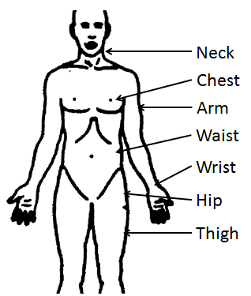
Waist:
Hip (across femur heads):
Waist/Hip Ratio:
Neck:
Chest:
Wrist: | Right: Left:
Arm: | Right: Left:
Thigh: | Right: Left:

Eye Examination
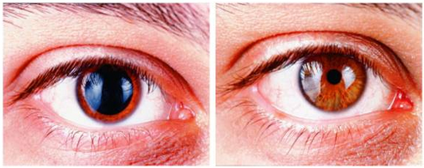
Pupil Constriction: In a darkened room, shine a small penlight in one eye. Pupil should constrict. Continue to shine light and count how many seconds pupil stays constricted. Stop at 20 seconds or upon dilation of pupil.
If a pupil does not contract when a bright light shines on to it, this indicates dulled nerve reflexes, weak adrenal glands, or an overstimulated sympathetic nervous system, often from fear as a hidden, chronic condition. Adrenal weakness is indicated if pupil does not remain constricted for 10 seconds or longer. Adrenal stress is indicated if the pupils begin to expand and contract repeatedly when exposed to bright light for 30 seconds.
Pupil Constriction - seconds held:
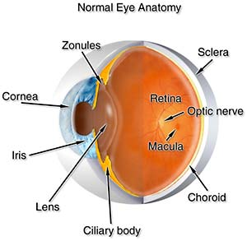  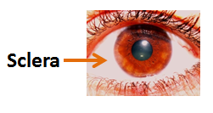  Pupil | Circle all that apply |  | Possible interpretation
 | White ring around the iris |  | Also known as the cholesterol ring. It might indicate an excess of calcium or aluminum, salicylate poisoning or arteriosclerosis. This sign presents as a white halo around the perimeter of the iris. It may indicate a family history of heart disease. Check cholesterol. A heavy white ring near the outer edge of the iris points to salt (sodium) and calcium deposits.
 | Grey ring around the cornea |  | Possible atherosclerosis, Alzheimer’s disease, liver issues
 | Gray pupil |  | Cataracts
 | Green pupil |  | Glaucoma
 | No pupil constriction with light. |  | Weak adrenals
 | Black discoloration below bottom eyelids. |  | Adrenal exhaustion
 | Brown discoloration below bottom eyelids. |  | Adrenal weakness, kidney weakness
 | Puffy bags under eyes |  | Kidney/bladder weakness, edema
 | Yellow discoloration below bottom eyelids. |  | Liver/gallbladder stress
 | Eyes “bug-out” |  | Possible hyper-thyroid
 | Circle all that apply |  | Possible interpretation
 | Deep orange color surrounding pupil |  | Disordered sugar metabolism
 | Yellow patches on eyelids |  | Possible high cholesterol
 | Red upper eyelids |  | gastritis
 | Dry eyes |  | Possible autoimmune disease called Sjogren’s
 | White discharge from corners |  | Digestive problems
 | Grey or milky white ring around cornea |  | Called arcus senilis and is associated with high cholesterol and triglycerides, and increased risk for heart attack and stroke.
 | “eye gunk” at base of eyelashes |  | Seborrhea, dandruff, rosacea, vitamin A deficiency, vitamin B6 deficiency or fatty acid deficiency
 | Sclera Color (white outer wall of the eye)
 | Circle all that apply |  | Possible interpretation
 | Yellow/brown |  | Liver or gallbladder stress
 | Clear with bluish tint |  | Poor circulation/anemia
 | Sclera turns blue |  | Osteogenesis imperfecta, a disease that makes the bones very brittle
 | Red |  | Conjunctivitis, inflammation of the GI tract, liver fire rising
 | Red blotches on sclera |  | Possible hypertension
 | Green |  | Poor bile formation
 | Pasty, off white |  | Lymphatic congestion
 | Gray |  | Constipation, sluggish bowel

Lip and Mouth Evaluation
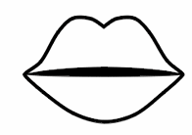  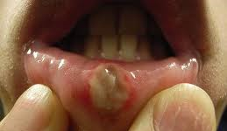  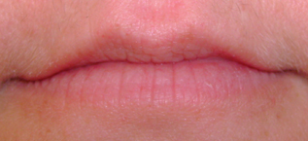 | Circle all that apply | Possible interpretation
 | Pale gums | Iron deficiency
 | Gums, puffy/bleeding | Insufficiency of folic acid, coenzyme Q-10, bioflavonoids, vitamin C, niacin, zinc, or vitamin A
 | Ulcerations or canker sores | Insufficient friendly gut bacteria, low B vitamins (especially folic acid), low lysine, excess arginine, gluten sensitivity, food allergies, stress
 | Lines around mouth | Low estrogen, low essential fatty acids, or vitamins B, A or E
 | Cracks, fissures, and scales, especially at corners | Insufficiency of B vitamins, especially B2, B5, B6, and folic acid, imbalance of essential fatty acids, low magnesium.
 | Dry flaking lips | Essential fatty acids imbalance; Low levels of biotin
 | Metallic taste | Heavy-metal toxicity, excess mineral intake, side effect of medications
 | Loss of tastes, especially sweets | Inadequate zinc, excess copper and/or selenium
 | Bitter taste | Infection or abscess
 | Salty taste | Excess salt intake, bleeding somewhere in body
 | Excessive salivation | Excess mercury
 | Painful dentures | Low stomach acid, low B vitamins, low glutamine
 | Bleeding gums | Deficiency of Vitamin C, bioflavonoids
 | Bad breath | Inadequate digestive enzymes, food allergies, infection, leaky gut, overeating, eating too frequently, stress
 | Acetone-like breath smells | Diabetes or active weight loss process
 | Urine-like breath smells | Protein maldigestion
 | Putrid breath smells | Mouth and/or lung infection
 | Red and inflamed lips | Low B vitamins, poor absorption in small intestine

 | Face Evaluation
 | 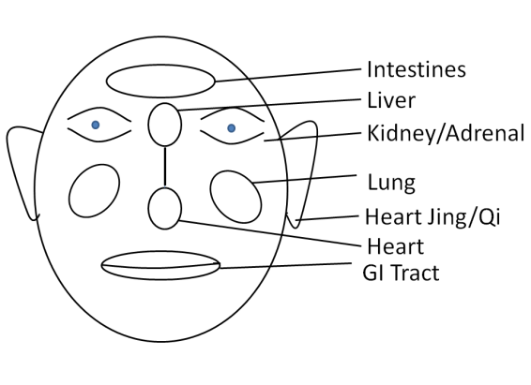 |  | Circle all that apply | Possible interpretation
 |  |  | Facial color: Yellow | Liver, gallbladder issues
 |  |  | Facial color: Ashen gray | Lung problems, shock
 |  |  | Facial color: Red | High blood pressure, alcoholism
 |  |  | Facial color: Bluish | Heart stress
 |  |  | Facial color: Copper | Iron overload
 |  |  | Facial color: Brown | Kidney stress
 |  |  | Red cheeks | Lung heat
 |  |  | Ear lobe creases | Heart stress
 |  |  | Long earlobes | Strong constitution
 |  |  | Creases between eyes | Liver stress
 |  |  | Crack between chin and lips | Ileocecal valve problems
 |  |  | Bulbous nose | Alcohol excess, acne
 |  |  | Acne | Decreased stomach acid, deficiencies of zinc, essential fatty acids, consumption of “bad” oils
 | Tongue Evaluation
Redness/Irritation:
Use a pencil or colored pencil to mark areas of redness or irritation.
 | 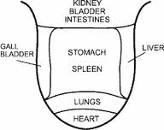
Tongue Shape:
Circle the overall tongue shape that matches closest to yours
 | 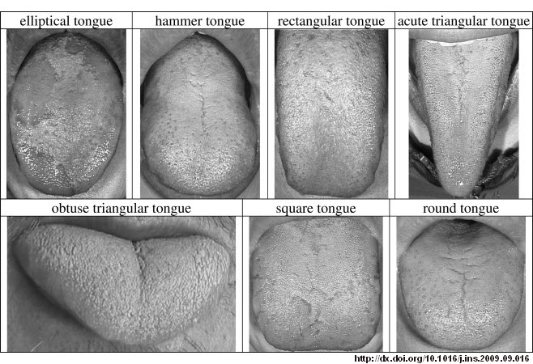
Tongue Shape |  | Possible Interpretation
Elliptical |  | Normal
Hammer |  | Congestion in area of kidneys, bladder or intestines
Rectangular |  | Possible inflammation in lungs or heart
Acute Triangular |  | Thin tongue often indicates deficiency, elongated heart heat
Obtuse Triangular |  | Wide thick tongue often indicates edema or bloating
Rectangular |  | Possible Stagnation and/or possible heart heat and / or deficiency
Round |  | Possible heart heat and / or deficiency

Tongue Evaluation – continued
Distinguishing Marks:
Circle any examples below that show features you see on your tongue.
image source: http://www.sorensonacupuncture.com/wp-content/uploads/2011/06/Tongue-english-31.jpg
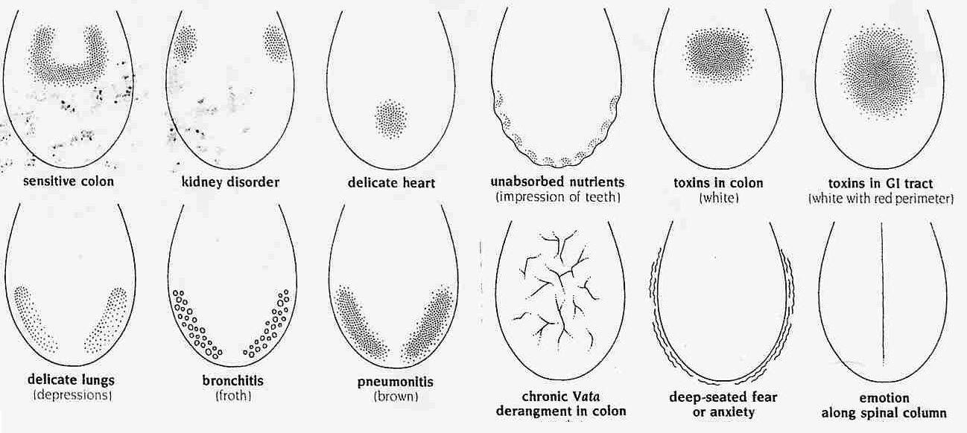
Color |  | Pink/ Multi-Colored (normal) |  | Pale red (mild heat) | Beefy red (heat) |  |  | Purple (circulation) |  |  |  | Pale  (low metabolism, anemia, blood deficient)
Coating |  | None  (Weak digestive fire, dehydration) |  |  | Thin (normal) |  |  |  | Thick  (cold-dampness, phlegm, poor digestion)
Coating Color |  | White  (normal) | Light Yellow/ Dirty White (slight heat, cold or flu) |  |  | Yellow (heat, anxiety, depression, infection, cigarette, coffee, big meal) |  |  |  |  |  |  | Brown/Black  (strong heat or cold, long term smoking, bismuth)
Tongue Evaluation – continued
Circle all that apply |  |  |  |  | Possible interpretation
Tender to touch or sore |  |  |  |  | Deficiency of Vitamin B12, folic acid or iron
Pale red color |  |  |  |  | Normal
Beefy red color |  |  |  |  | Excess heat
Red tip |  |  |  |  | Overeating, maldigestion, excessive fats and/or fried foods or inadequate fiber
Dark gray or reddish back of tongue |  |  |  |  | Adrenal and/or kidney weakness
Chronic coating and/or “furry” tongue |  |  |  |  | Inadequate levels of digestive enzymes, imbalance of friendly to unfriendly intestinal bacteria or toxic bowel, food allergies
Yellowish coating |  |  |  |  | Can be a sign of heat
A “cottage cheese” growth or coating |  |  |  |  | Possible yeast infection
Scalloped edges and teeth marks |  |  |  |  | Allergies, poor digestion, inadequate levels of pancreatic enzymes, inadequate levels of vitamin B6, thyroid problems
Geographic tongue (lines like a map) |  |  |  |  | Low B vitamins (especially B12 and folic acid), low zinc, low D, gluten sensitivity, or wheat allergy
Excessively shiny or smooth tongue |  |  |  |  | Low vitamin B12, low folic acid or iron, allergic reaction; can be a sign of diabetes or early blood-sugar imbalances
Purplish tongue |  |  |  |  | Inadequate levels of vitamin B12
Beefy or enlarged tongue |  |  |  |  | Inadequate levels of pantothenic acid
Black or hairy-looking tongue |  |  |  |  | Possible effect from antibiotics, bismuth-containing products, such as Pepto-Bismol
Head Evaluation
Circle all that apply |  |  |  |  | Possible interpretation
Dry hair |  |  |  |  | Essential fatty acid (EFA) deficiency
Premature graying |  |  |  |  | Pantothenic acid (B5) deficiency
Hair loss |  |  |  |  | Folic acid, vitamin B5, vitamin B6, B-complex, and EFA deficiencies. Vitamin A toxicity, or other environmental toxicity, also causes hair loss
Dandruff |  |  |  |  | Deficiencies in EFA, antioxidants (selenium especially), B6 or B-complex. May also indicate low stomach acid
Excess ear wax |  |  |  |  | Low essential fatty acids (EFA)
 | Head Evaluation – continued
 | Cranial Nerves |  |  |  | Left |  |  |  |  |  | Right
 | Hearing
 | Vision
 | Sensation
 | Smell
 | Movement
 | Taste
Hand and Nail Evaluation
Observe your nails for the following signs and mark the chart for each hand

Nail Analysis: Check all that apply
 |  |  | Moons (lunula) |  | Ridging |  | Spooning |  |  | Clubbing |  |  |  | Beading
Finger |  |  | 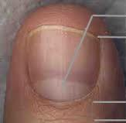 |  | 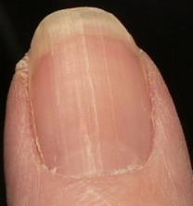 |  | 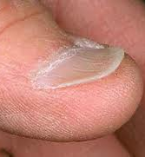 |  |  | 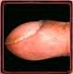 |  |  |  | 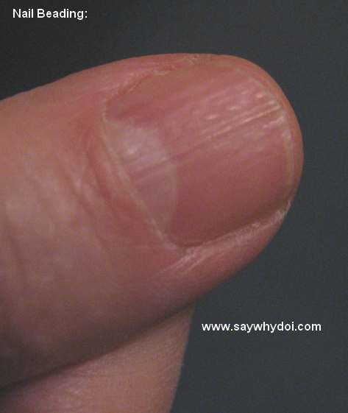
Right Thumb
Right Index
Right Middle
Right Ring Finger
Right Pinky
Left Thumb
Left Index
Left Middle
Left Ring Finger
Left Pinky
Moons Analysis (half-moon at base of nail): Circle all that apply |  |  |  |  |  |  |  | Possible interpretation
Large |  |  |  |  |  |  |  | Good constitutional reserve of energy
Small |  |  |  |  |  |  |  | Low constitutional energy when on many
Large moons on little fingers (plus ear lobe creases and/or reddish tip of tongue) |  |  |  |  |  |  |  | Suggests tendency to heart problems
Hand and Nail Evaluation – continued
Circle all that apply |  |  |  |  |  |  |  | Possible interpretation
Splitting cuticles |  |  |  |  |  |  |  | Essential fatty acid imbalance, over consumption of processed oil, food allergies, low bile or pancreatic enzymes
Rough, red, flaky cuticles |  |  |  |  |  |  |  | B vitamin deficiency, stress
Splitting, breaking nails |  |  |  |  |  |  |  | Low levels of biotin, essential fatty acids, vitamin B6, or magnesium; also low stomach acid
Excessive vertical ridges |  |  |  |  |  |  |  | Inadequate levels of B vitamins, especially B12; poor digestion, gallbladder problems
White spots on nails |  |  |  |  |  |  |  | Inadequate levels of zinc, trauma; protein deficiency
Pitting |  |  |  |  |  |  |  | Tendency to immune problems, low levels of selenium, maldigestion
Pale or bluish nails |  |  |  |  |  |  |  | Iron deficiency
Deep horizontal ridges (Beau’s lines) |  |  |  |  |  |  |  | Bronchitis, maldigestion, local trauma, adrenal stress
Yellowish, bulging, bending, breaking nails |  |  |  |  |  |  |  | Suggests fungal infection like candidiasis
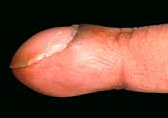  Clubbing (nails grow downward, end of finger noticeably enlarges, nails break in odd ways) |  |  |  |  |  |  |  | Poor oxygenation linked to various serious lung, liver, or kidney diseases
Thumb has ridges |  |  |  |  |  |  |  | Kidney stress
Thumb has appearance of beads on a string |  |  |  |  |  |  |  | Suggestive of arthritis or osteoporosis
Vertical ridges that are split |  |  |  |  |  |  |  | Respiratory problems
Very thin parallel lines |  |  |  |  |  |  |  | Mineral absorption difficulties
Short wide nails or fingertips |  |  |  |  |  |  |  | Poor circulation or heart stress
Vertical ridges on other finger nails besides the thumb |  |  |  |  |  |  |  | Respiratory stress
Yellow nails |  |  |  |  |  |  |  | Digestion issues
Horizontal ridges |  |  |  |  |  |  |  | Poor nutrition or cardiovascular stress
Black spots |  |  |  |  |  |  |  | Digestion difficulties
Spooning |  |  |  |  |  |  |  | Iron deficiency, anemia, lead poisoning
Cracked skin at tips of fingers |  |  |  |  |  |  |  | Low zinc
Cold hands |  |  |  |  |  |  |  | Poor circulation, possible low thyroid

Skin Assessment
Observe your body head to toe. Use a mirror or a trusted companion to see areas you normally would not see. Use the diagrams to note any areas of rash, skin tag, discoloration, bumps, bruises, moles, or other abnormalities of your skin.
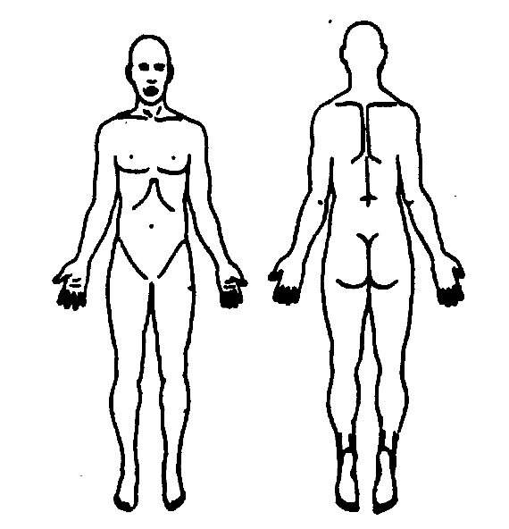
Circle all that apply | Possible interpretation
Skin tags | Blood sugar problems like hypoglycemia, tendency towards diabetes, low chromium, tendency to develop cysts and/or polyps
Dry skin | Deficiencies in EFA, vitamin A or vitamin E
“Goose flesh” at the backs of arms or thighs | Vitamin A deficiency, low thyroid, low essential fatty acids, low zinc, low vitamin E
Bruising – slow to heal or excessive | Deficiencies in vitamin K, C, E, or bioflavonoids
Wounds that take a long time to heal | Deficiencies in vitamin A, vitamin C, zinc or EFA; diabetes may also be the cause
Hemorrhoids | Dehydration, inadequate fiber, low levels of bioflavonoids, vitamin E, vitamin A, or essential fatty acids; inadequate exercise or food allergies
Tenderness at rib margins | Sign of adrenal distress or over-work

