Body Measurements Tracker
The purpose of this self-assessment is to record a snapshot of a set of health parameters at the start of a health program.
After completion of your program, I recommend you repeat the assessment and compare your results. If you follow the program as instructed, you’ll be pleased and surprised at the progress that you’ve made.
Included in the assessments is the measurement of body fat percentage. This is a nice number to have, especially if you’d like to shed a few pounds. Unless you own one of the fancy scales that measure body fat, chances are that this is not something that you can measure on your own. Many health practitioners and gyms have access to the equipment to measure body fat.
There is also a place for measurement of urine and saliva pH. The pH paper used to measure this can be purchased for around $10 at many pharmacies and health food stores.
Blood pressure is a good measurement to take if you have a tendency towards abnormal readings. This can be done with a home blood pressure unit or at most pharmacies and major grocery stores.
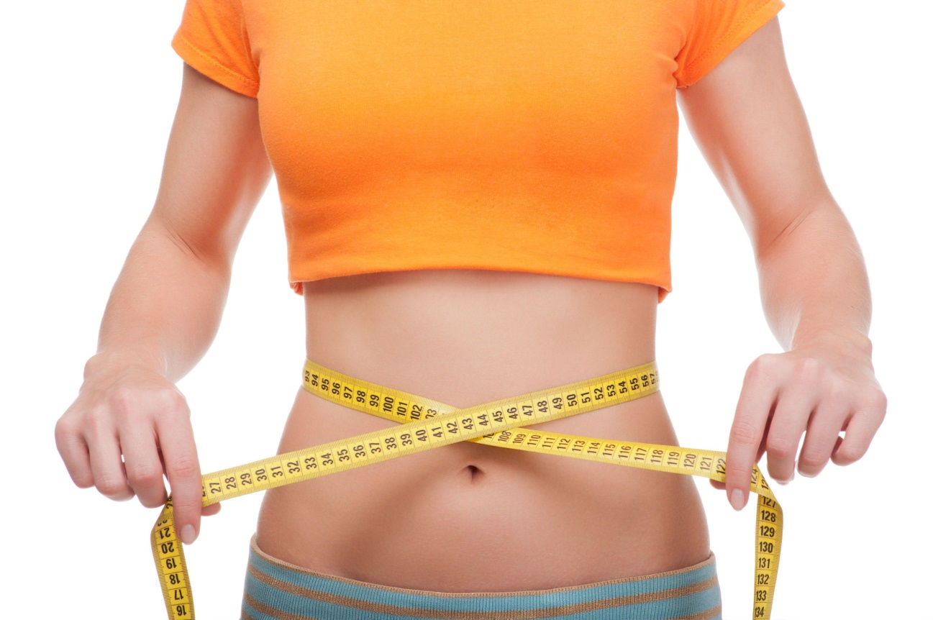

Body Measurements Tracker

Program
Name |  |  |  |  |  |  |  | Age |  |  |  | Date
Height |  |  | Weight |  |  |  |  |  | % Body Fat
Personal Ratings: scale from 1-10 with 1 = very low and 10 = very high
Energy Level |  |  |  |  |  |  | Stress Level
Overall Health and Well-Being |  |  |  |  |  |  | Satisfaction with Life
Measurements
Chest (at nipple line)
Waist (at narrowest part)
Hip (at widest part)
Thigh (at top)
Blood Pressure
Pulse
First AM pH Reading |  | Urine |  |  |  |  |  |  |  | Saliva

