
By Dr. Ritamarie Loscalzo MS, DC, CCN, DACBN
Note: The Portable Anchor System is designed to build upon and put into action your Inspired Health Vision System (IHVS).

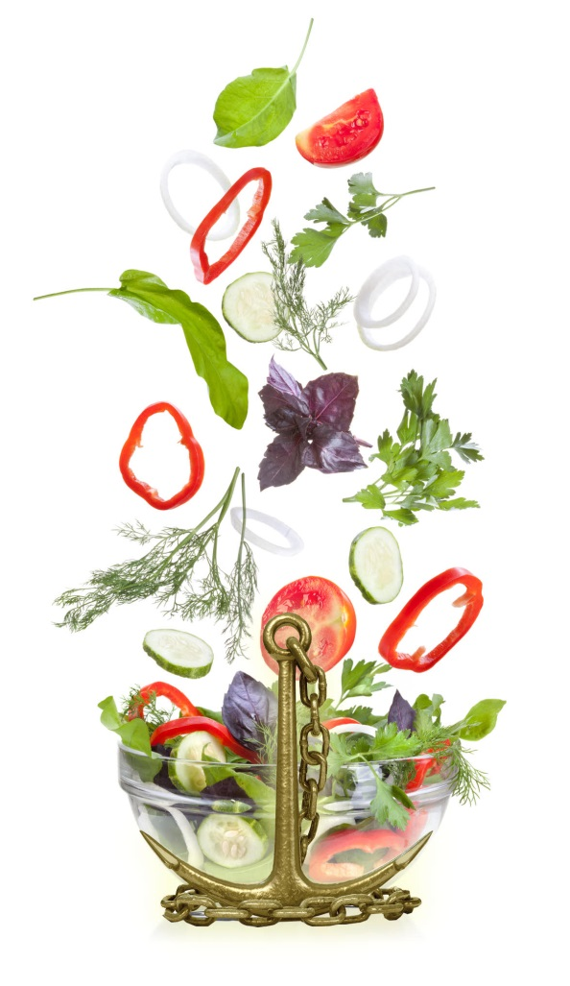
The Portable Anchor System
Once you’ve established your commitment to health, it’s important to remain aware of it so you make those decisions that bring you closer to your goal.
Our experience has taught us the value of an easily portable and accessible reminder. Such reminders when first initiating change are especially helpful in the beginning.
When you surround yourself with reminders, the commitment grows and flourishes; decisions that support your core values and visions become automatic.
Thus we developed the very versatile Portable Anchor System, which uses a simple reminder system involving index cards.
Index cards are a wonderfully convenient way to anchor you to your commitment while working towards your goals. Self-awareness will help you stay conscious of your decision processes when presented with a challenging situation; the index cards can then quickly reiterate your bigger mission and keep you on track.
How to Create Your Portable Anchors

- Get three index cards. On one side of each, list your 90-Day Bold Health Goal and your first 30-Day Goal.
Jot down a few key words or phrases that capture why you're committed to achieving this goal and how it will feel when you do.
- On the flip side of each index card, write your top five core values as identified in Part 1: Clarifying Your Values (IHVS). Write just enough about the value to remind you what’s important about it and how you feel when you’re accessing it.

- Carry one card with you at all times. Tape another to your bathroom mirror and one to your refrigerator. Read the card whenever you are tempted to stray from your health plan. It can be helpful to read over the card whenever faced with a decision that may or may not be in alignment with your core values.

For example, if you are at a meal and trying to decide what to eat, take out your card and read over it. Really connect to your goal and why it’s so important to you. Look at your choices and ask yourself the following questions:
- “Which of these foods will take me closer to my goal?”
- “Which of these foods will take me further from my goal?”
- “What choice do I need to make to stay in alignment with my highest priority core values?”
- “Is there a core value that I will need to violate to succumb to the temptation of the trigger food?”

If you really connect to your motivations and feelings, the decisions about what to eat and drink, and whether or not to exercise, will naturally flow towards your Bold Health Goal and your highest priority values!

Other Anchors You Can Use:
- sticky notes can also be scribed with reminders
- reinforcing self-talk
- pages from your Positive Aspects journal
- goals or values posted in places you frequent.

Be creative with this technique. Use your portable anchor system to remind you of what matters most to you and to keep you focused on your goal.
