Hydration Strategy and Schedule

By Dr. Ritamarie Loscalzo

Dehydration can manifest in a myriad of diseases and symptoms. Most of us are dehydrated and we don't even realize it. There's a fascinating book called You're Not Sick, You're Thirsty by Dr. F. Batmanghelidj, M.D. In it he talks about the mechanisms by which dehydration triggers such things as asthma, allergies, heartburn, fatigue, hypertension and many others illnesses.

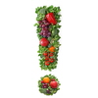
To be properly hydrated you need to drink approximately 1/2 your weight in fluid ounces of water. If you are exercising heavily, you'll need more.

Water Quality and Quantity

Water is vital to your survival. Without sufficient water intake, your entire body slows down and healing and repair become sluggish. Chronic dehydration is an underlying cause of many common diseases. Contrary to popular belief, thirst and dry mouth are not reliable indicators of your need for water.

In this lesson, you'll learn how to take in the proper quantity of water for your body size and activity level. You'll also learn how the quality of water you drink is as important as the quantity. Be sure to drink filtered water or spring water instead of tap water, which may contain many contaminants including remnants of prescription drugs, pesticides, heavy metals, chemicals and viruses.

Hydration Step 1: Evaluate how much water you currently drink.

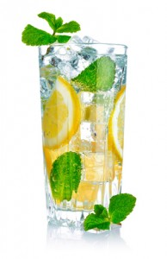
Get a sense of how much water you are currently drinking.

For 2 days, pay attention to:

- how much water you are currently drinking
- notice what triggers you to drink
- whether you drink regularly as a habit or if you drink only when thirsty
- what thirst feels like

Dr. Batmanghelidj says that thirst is not a great indicator of when to drink because by the time you perceive thirst, you are already down about 3 cups of water.

He also explains that often what you perceive as hunger is actually thirst, and suggests you drink at least 8 ounces of water whenever you feel hunger and then wait to see if the feeling goes away.


Keep a journal of your water observations.

Hydration Step 2: Get a sense of how much water you need.

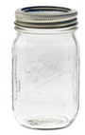
To provide your body all the water you need for optimal functioning, you need to drink at least 1/2 your body weight in fluid ounces of water every day. Add to that 8 ounces for every 15 minutes of vigorous exercise or perspiration. Soft drinks, juice, coffee, tea and other beverages don't count. In fact alcohol and caffeinated beverages actually trigger mechanisms that cause you to lose water, and thus are dehydrating beverages.

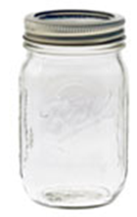
Get yourself some water bottles, pitchers, or glass jars so that you have enough capacity to hold all of the water that you need in a day.

This may seem like a lot. Look at it and fully realize your task at hand. While it's better if you just get started to get this much water in you right away, it may be necessary to gradually increase it.

The sooner you start drinking your full water requirement, the sooner you'll begin to reap the benefits.

Hydration Step 3: Create a schedule.

Following the suggested schedule below will ensure that you get adequate water. Feel free to adjust to your own needs and lifestyle.

When you add up all the water in the schedule below, you get the following quantities (given that you eat 3 meals a day and exercise once a day):

Lower Quantity in range – Total is 72 ounces a day

Higher Quantity in range – Total is 160 ounces a day

This schedule works for weight ranges from 144 to 320 pounds. If you weigh less than 144 lbs, you can drink less each time you drink. If you weigh more than 320 lbs, drink more each time you drink or add an extra water drinking time to the schedule.

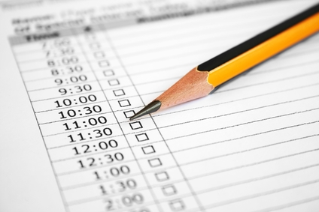
Follow this Hydration Schedule
- Upon awakening: Drink 16 – 32 ounces of water. Keep a water bottle or cup at your bedside and begin to drink before you even get up.
- 30 minutes before each meal: Drink 8 - 16 ounces
- 1 hour after each meal: Drink 8 - 16 ounces
- Before exercise: Drink 8 - 16 ounces

If you're overweight you should also drink 12 - 24 ounces whenever you're hungry.

Wait at least 15 minutes, and if you're still hungry then you may eat.

It's okay to drink a little more than your recommended amount, but not less.

