Fats: Give Your Body an Oil Change
Action Plan

4 Steps to Maximize Your Health by
Eating the Right Kind and Balance of Fats

By Dr. Ritamarie Loscalzo

#1: Choose an Omega-3 Rich Food Source Every Day:

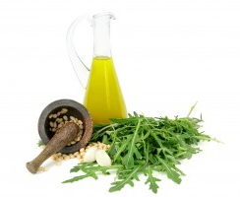
Commit to include your allotment of inflammation fighting omega-3 fat foods in your diet every day. Be sure to choose at least one of the essential fatty acid rich foods daily.
- chia seeds
- flax seeds or flax seed oil
- hemp seeds or hemp seed oil
- walnuts
- sacha inchi oil
- brown varieties of blue green algae
- purslane
- deep ocean fish or fish oils
- borage, evening primrose, black currant seed oil

#2: Eat an Appropriate Portion Size:

Each of the following portions below would be a recommended daily serving. Choose one serving per day (or mix and match in appropriate quantities).
- 1-2 tablespoons of oil per day
- 5-6 tablespoons of seeds per day
- 1-2 tablespoons of blue green algae per day
- 1/2 cup of purslane (edible, wild green)

#3: Track Your Omega-3 versus Omega-6 Balance:

Use the “Omega-3 and Omega-6 Content of Common Foods” chart (provided in ERC) to track your omega-6 to omega-3 ratio on a regular basis. There are several recipes included that are very omega-3 rich for your convenience.

#4: Start Your Day With a Chia Energy Drink or Chia Porridge.

Enjoy chia seeds along with your green smoothie or green juice, or add chia seeds to your greens. Choose from chia-rich recipes provided in your program or make up your own.



