Positive Aspects Journal
“No matter how dark things seem to be or actually are, raise your sights and see the possibilities – always see them, for they're always there.” — Norman Vincent Peale

One of the biggest stresses you may have is the feeling of not being “good enough”. If so, you’re not alone.

The “I’m not good enough” phenomena strikes even the most successful and “together” people you know. Granted, they are unlikely to reveal this feeling about their own inadequacies; nonetheless, it’s there!
Unfortunately, the feeling of being somehow imperfect and inadequate is more common than you think. More unfortunately, the feeling results in addictive behaviors, eating disorders, and OVERWORK!
Feeling “not good enough” may express itself as shyness and discomfort about making your requests. It can also appear as self-expressed criticism or even take on an outwardly bold, but inwardly vulnerable criticism of others.
In general, you are your own worst critic. So, the purpose of this exercise is to make you your own raving fan.
While it may seem humble or modest, did you know that directing negative thoughts towards yourself is truly a wasted and misplaced use of your energy!? When you focus on the negative and overlook the many, many positive aspects of yourself, you create internal stress that damages your health almost as much as Twinkies do!
That’s a bold statement, yet scientific studies, particularly those conducted by the Institute of HeartMath (www.heartmath.org) support the finding that holding negative emotions has a negative effect on your health. Self-criticism and self-reproach create disorder in your nervous system, evoke a stress response, and unfavorably affect your heart rhythms and immune system.

Surprisingly, even those with the most beautiful skin, lovely hair, and fit bodies may nonetheless notice and exaggerate their less-than-perfect physical attributes when they look the in the mirror.

Journal Your Way to Self-Joy
With the Positive Aspects Journal you’ll begin to focus on the things you LIKE about yourself. And the more you LIKE about yourself, the more you move in the direction of both self-acceptance AND belief in your own ability to achieve your dreams.
Getting in touch with what really matters and having something you are working towards helps determine the positive actions you take on a moment-to-moment basis.
This exercise may evoke strong feelings for you, and you may find yourself a little sensitive about what comes up; however, this activity has the potential to transform the stressful feelings that keep you trapped in a body or situation that no longer excites you.
- Get yourself a notebook that you can dedicate to this process.
- On the front cover write the title of the book: Celebrating YOUR NAME

- Be creative on the cover. Decorate with positive anchors. This can be words or images that elicit positive feelings that represent your passions, interests, and hobbies that you find restful and soothing. Choose images and/or words that represent your values or in any other way represent who you are and who you are evolving to become.
- Making your cover should be fun; not something that requires great thought or deliberation. Allow it to take shape from your heart. There’s no need to decorate all at once. When you see a picture, sticker, or image that resonates with you, add it to the cover. It can be a work in process. There is no right or wrong way to do this.

Have fun with it!
Example Positive Aspect Journal

Pages to Include in Your Positive Aspects Journal
The very first page of the journal can be used as a table of contents. As you add pages, list them on the table of contents page. It helps to number pages as you add them, and to note the page number on the table of contents.
I suggest the titles for the pages be personalized. Use one page for each aspect of you – physical, emotional, intellectual, each of your roles, and each your relationships with each person in your life with whom you need to establish better rapport.
Examples of the pages your book might eventually contain:
- Your Name’s Talents
- Your Name’s Body
  - This can be the entirety of your body or if you are self-conscious about certain aspects, you can do a page on that, i.e. your skin, you hair…etc.
- Your Name’s Mind
- Your Name as a Mother
- Your Name as a Friend
- Your Name as a Partner
- Your Name’s Relationships
  - This is an important section if you are having difficulty with a certain person. It may be helpful to list that person’s positive aspects. For example, when my younger son was little, he was a challenge…very rebellious, so I did a “Positive Aspects of Kevin” page and listed all his positive aspects. Then when I needed to set a limit or confront him about something, I had easy access to all the things I loved about him. Our relationship improved dramatically!


Where to Begin in Your Journal
Start with an aspect of you that you feel the best about. This will give you a feel for the process. Then progress to areas that you’re having difficulty with and look for the positive aspects.
Spend 5 minutes a day reading anything you've written before and adding to notes to your entries. As you read what you've written, most likely new insights will spring forth. Jot them down and add to the page as new words come to mind. Start a new page when there seems to be little left to add to existing pages, or when you are called to do so.
Make this a fun part of your day that you look forward to. Keep your journal by your bed or in another place where you will be reminded to complete it each day.
Be creative. This will help shift a lot of your self-criticism and self-doubt to positive feelings and dramatically improve your health.

Examples of What to Write

Below are examples of how you might go about completing each section of the journal.

Body

Using a mirror, take good look at all your physical traits: your face, skin, hair, nails, body structure, muscle tone, etc. If you are really brave, you'll take off all your clothes for a more thorough evaluation. Begin by noting one positive attribute about your body. See if you can find at least two or three aspects you appreciate about your body and write them in your journal.
Body Examples:

- “I like the color of my hair.”
- “My eyes are a pretty color.”
- “My skin is soft and smooth.”
- “My nails are strong and shapely.”

Mind
Write down whatever you appreciate about how your mind and brain work. What do you do well in this realm? Anything you really like, write it down.
Mind Examples:

- “I really know how to problem-solve.”
- “I grasp new information easily.”
- “I understand complex information.”
- “I’m really organized.”

Heart
Reflect upon the positives in your relationships and emotional area. How do you treat others? In what ways do you treat others like you wish to be treated yourself? Explore this part of you, and write down characteristics you treasure about yourself.
Heart Examples:

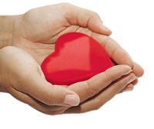
- “I am generous.”
- “I am a loving person.”
- “I do kind deeds for other.”
- “I volunteer regularly.”
- “I help people when they are in need.”
- “I am really good at comforting people.”

Intentions and Character
Sometimes you may not express yourself in your most ideal manner (it happens to everyone…). But your intentions are most likely positive and affirming. Note those great intentions and character traits that make you uniquely YOU and write out your sincere self-observations.
Should you ever fall short of your intentions in the future, avoid berating yourself and, instead, open up your journal to read these positive aspects you have self-identified. Doing so will help bring you back into alignment with your true essence.
Intentions and Character Examples:

- “I intend to live with integrity.”
- “I intend to be honest and open and caring.”
- “I am trustworthy and dependable.”
- “I treat people fairly.”

Healing with Words
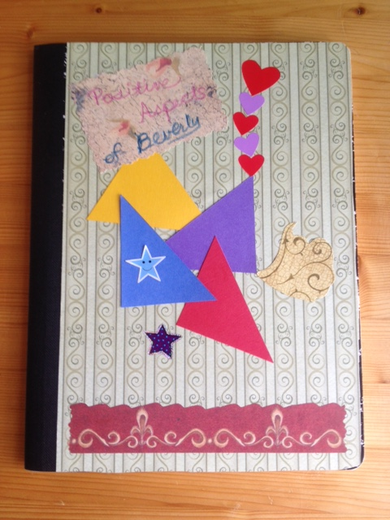
Your positive aspects journal can be used in many creative ways. It can be used to heal wounded relationships with others, to find the positive aspects about less than positive circumstances, and to create the positive attitude that is so critical to health.
Focusing on the positive aspects of difficult circumstances is a sure-fire way to neutralize the negative health effects of stress and worry.
What situations in your life or relationships are you ready to heal? Jot them down in your journal and give them some focused attention.
Brainstorm other ways you can use your positive aspects journal. Experiment and make this technique your own.

Have fun with it, and make it your friend!

