Herbs and Supplements to Assist With Sleep

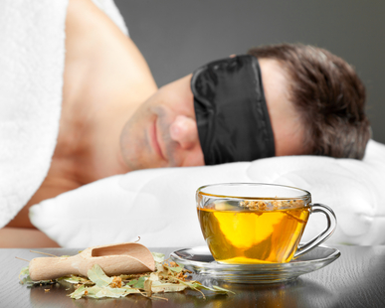
Relaxing Herbs that Help with Sleep:

Read the indications for each herb and pick one or two to experiment with.

Each person has a different response; therefore, what may work for one, may not work for another.

If you have a long-standing problem with insomnia, it may take a bit of trial and error to find the right combination of herbs and activities that flip the switch for you.

- Lemon Balm
- Chamomile
- Milky Oat
- Valerian
- Hops
- Passion Flower
- Magnolia
- Kava Kava

Supplements to Promote Good Sleep:

Nutrient and hormonal imbalances can contribute to poor sleep. Be sure to educate yourself about these so as not to throw things out of balance. Magnesium and Vitamin B6 are fairly safe to experiment with. Excess magnesium can cause loose stools.

- Magnesium
- Vitamin B6
- Melatonin
- Phosphatidyl Serine
- 5-HTP
- GABA
- Theanine

