Fun as an Antidote to Stress

“You will heal to the extent that you clarify what you love

and express it in your actions consistently.”

It’s so easy to become caught up in day-to-day responsibilities and stressors to the point where you forget to take time for yourself and your favorite activities.

One of the absolutely best ways to transform stress is to engage in fun activities. All too often I hear people say, “But I don’t have time to have fun.”

My response is, “You don’t have time NOT to!”


Diverting your attention, even for 5 minutes to something you love to do, can completely transform your physiology and biochemistry. Your muscles soften and relax. Aches and pains can magically disappear once you fully engage in something you love to do.

The positive emotional experience of doing what you love shifts your hormones; your neurotransmitters; and the enzymes in your digestive tract, immune system, and blood vessels.

As a result, you feel more grounded, calm, relaxed, happy, and sexy. Even your immunity boosts so you’re better protected from foreign invaders.

Instead of collapsing in front of the TV, reading the newspaper, or reaching for food when you feel stressed, try engaging in a loved activity – one that brings joy and contentment on a deep level.

Step #1: Figuring Out Your Fun Activities

The exercise in this document will reacquaint you with the things you truly love to do. Perhaps it’s been years, or even decades, since you’ve participated in some of these activities.

The process will leave your mind and heart open to going beyond the present and stepping into your vision of your ideal life.


Interestingly enough, when I give this exercise to my inner circle coaching clients, many express how difficult it is to do. The stress of day-to-day existence has likely taken you too far from your heart’s deepest joys. Well, it is now time to take a journey back!

So sit back, relax, and ask yourself any of these questions to help compose your list of favourite activities:

- What do I truly love to do?
- What are the activities that leave me feeling incredibly alive and elated?
- What would I do with my days if money was not an object, my responsibilities suddenly floated away like a hot air balloon, and I was left with all the time in the world to do whatever I like?

If you haven’t thought like this in a while, or ever, the process may be slow in the beginning.

To stimulate your memory, think about your childhood years, or your last fun vacation before the responsibilities of your job, kids, or relationships kept you so busy. The activities can be as simple as watching a sunset, picking flowers, or doing a word puzzle. Or they may be as elaborate as a hike in the mountains, a ski trip, or exploring a foreign land.

Let the thoughts flow, and as they do write them down in the attached chart. DO NOT filter or judge your ideas in any way. Simply record them in the first column of the form – that is all that is required at this time. There's room for 20 activities in the chart at the end. Grab a separate piece of paper or print a second copy if you have more ideas than the form allows, and just keep going!

Step #2: Planning for Play

Once you’ve listed all the things you love to do, stop to take a few deep breathes and center yourself. Now go back and read the list as if you are reading it for the first time.

Pretend, if you’d like, that it was written by someone you don’t know. What kind of insights about the writer’s personality does the list give you?

Go back over the list for a third time and next to each activity jot down what it is that you enjoy about the activity. Take your time and really get in touch with the pleasure that each activity brings you.

After you’ve written why you enjoy the activity, rate each one in terms of the amount of time it takes to complete.

- A -- small time investment; can be done in 5 - 30 minutes
- B -- medium time commitment; can be done in 30 minutes to 2 hours
- C -- significant time commitment; requires greater than 2 hours
- D -- multiple day commitment; may require travel


Finally, for each activity you've written about, jot down how often you’d ideally like to do it.

If you are ready to incorporate a particular activity into your life on a regular basis, make a commitment about how frequently you will do it in the last column. This can be as infrequently as once a year to as often as multiple times a day.


On a daily basis, choose at least one activity and devote at least 5 minutes to it. It’s that simple.

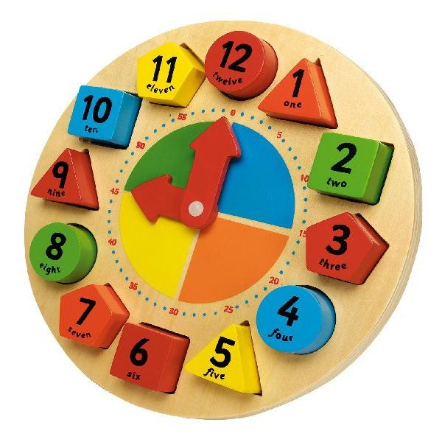
A Few Minutes of Merriment

Add daily fun to your daily “mini vacation” breaks, and you’ll reap massive reward from a time investment of under 10 minutes. Go ahead and start. You might find it addicting and treat yourself to “just 5 more minutes”.

One of my clients did this with playing piano. Her story was, “I don’t have time to sit at the piano for an hour a day.” She also said she missed it and found great comfort and joy when she did play.

I asked her to play for 5 minutes, and pin it to an activity she already did so it would become habit. She decided that right before going to the kitchen to prepare dinner would be a good time.

Next time she spoke with me, she admitted to really looking forward to her 5-minute piano breaks and shared that she often spent more than 5 minutes because it felt so good.

Some of the activities you can link to your 5 minutes of daily fun are:

- preparing dinner
- taking out the trash
- feeding the cat
- walking the dog
- putting your kids to bed
- going out to get the mail
- brushing your teeth
- getting dressed
- washing the dinner dishes

These are just a few of the many activities that you likely do on a regular basis. You wouldn’t think of skipping the teeth brushing…well maybe once in a while, but not on a regular basis.

You’re unlikely to skip feeding a pet or tending to your children, so elevate your status and take 5 minutes a day to take care of YOU!!!

Activities I Like to Do
 | Activity | Reason I Love It | Time it Takes | How Often I'd Like to Do It | How Often I Commit
1
2
3
4
5
6
7
8
9
10
11
12
13
14
15
16
17
18
19
20

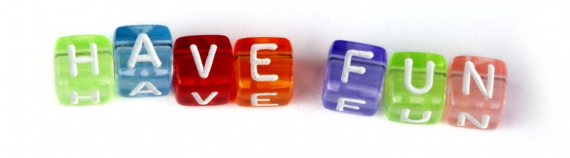

LOL: Laugh Out Loud

Now that you’ve identified the things you love to do, make the commitment to treating yourself. Tell someone your commitment so they can hold you accountable.

Choose activities according to the amount of time you have available, remembering that you are your own top priority.

Have FUN!

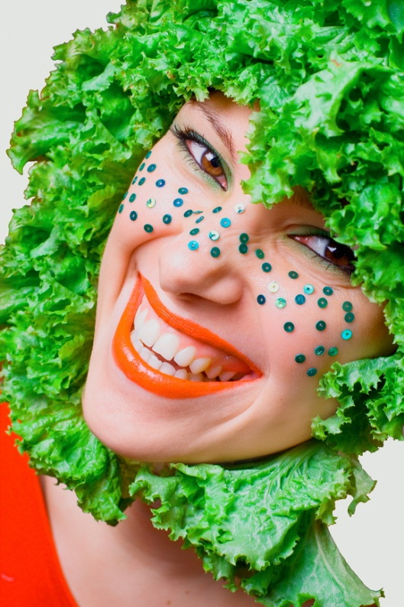
It’s part of your health plan.

