

By Dr. Ritamarie Loscalzo
MS, DC, CCN, DACBN

Do you ever find that you eat for reasons other than hunger? It's very common, you know. Most people do, sometimes more frequently than they care to admit.
Many people have a goal of changing what they eat, so they can enjoy better health.
Think of your goal as the destination, your values as a vehicle, and your action plan as the road ahead.
Using this image it is easy, then, to see emotional eating as a huge boulder in the middle of the road. Hard as you try to ignore it or go around it, it stays between you and your goal of a strong lean body, boundless energy, comfort, and joy.
How Do You Know if You’re an Emotional Eater?

Emotional eating is the uncontrollable urge to eat even when not hungry, and this habit leads to unconsciously eating foods that soothe an emotional wound without regard to actual nourishment.
For example:

You find yourself distraught, frustrated, upset, angry, or hurt, and the feeling is so uncomfortable you want it to stop. So you reach for a candy bar, ice cream, chocolate chip cookies, or whatever food you find comforting.

Unfortunately, the original driving emotion tends to resurface soon afterward, and it is often accompanied by guilt and self-remorse for having succumbed to the distraction.
Just like the chemicals in air, food and water can be toxic to your body, certain emotions are toxic as well. These emotions are considered toxic not because you shouldn't feel them, but because when you do, you generate chemistry in your body that can be harmful.
Toxic emotions include:

- Sadness
- Hate
- Shame
- Jealousy
- Hopelessness
- Self-righteousness
- Worry
- Greed
- Anger
- Guilt

How Toxic Emotions Affect Your Brain
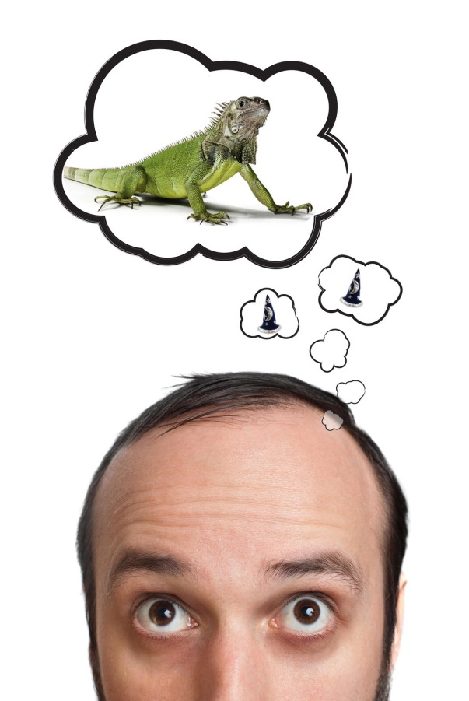
Any of these toxic emotions have the ability to put you into a flight/fight response and inhibit the cerebral cortex, that part of the brain responsible for high-level thinking function. At the same time, being in fight/flight mode enhances access in your brain to the limbic system, the part of the brain responsible for survival, so it becomes predominant. (We have coined the cerebral cortex as your ‘wizard brain’ and your limbic system as your ‘lizard brain’, respectively.)

When stressed it’s hard for the wizard brain to speak up with, “This is not in alignment with my high level values!” In these situations, the lizard brain is in control; not the wizard brain. Unfortunately, it’s easy to lose touch with your vision, and even your core values, when trapped in the lizard brain. At this point, a common reaction is to reach for food as a way to stuff or numb the feelings.
I know this is all an unconscious process for you when you emotionally eat. You don't suddenly say, “I’m just going to eat this food even though I’m not hungry because I have an emotional wound and I want to heal it.”
Usually, with emotional eating you experience an uncontrollable urge to eat when you’re not even really hungry.

Reaching for Comfort
When you find yourself distraught, frustrated, upset, angry, or hurt, the feeling is so uncomfortable, you just want it to stop. So you reach for a candy bar, ice cream, chocolate chip cookies, or whatever food you find comforting.

When that urge rears its ugly head and doesn't settle down, emotional eating can create a path of devastation in its wake. Emotional eating is defined as eating for comfort rather than nourishment. It is usually associated with out of control eating behavior, but not
always. Sometimes it's the uncontrollable urge to eat something that you know won't nourish you, but will entertain you.
Comfort eating most likely started when you were very little. Some well-meaning adult offered you a lollypop to soothe the hurt when you scraped your knee. You felt better and a neural pathway was created. The event was repeated and the pathway got reinforced.
Now, every time you feel a certain way, you reach for food to soothe it.
Reprograming the Pattern
Breaking free of emotional eating is not easy, but it is very possible. It takes time and multiple iterations of replacing the old response with a new one until you've reprogrammed your brain to the new response.
Here are some guidelines for
- identifying triggers for emotional eating
- establishing strategies for overcoming it
- creating new neural pathways in your brain

Identifying the Triggers
First, make a list of the foods that soothe your emotional pain.
- What foods do you reach for when you're tired, really frustrated, angry, or feeling that life just isn’t going the way you want it to?
- What foods do you find addictive...once you start eating them you can't stop until either the package is empty or you're in so much pain that you have to stop?

Next, explore the circumstances and emotions that trigger emotional eating.
- Is it visiting your mother, going to restaurants with friends, or fights with your partner?
- What emotions are most likely to trigger you to soothe yourself with food?


A way to identify the emotional trigger is to think back to the last time you were tempted into an emotional eating pattern. What was that emotion?

- Was it fear?
- Was it anger?
- Was it frustration?
- Was it overwhelm?
- Was it feeling like you’re just not good enough?
- Insecurity?
- Was it when somebody said something that made you feel like a small child who couldn’t do anything right?

There may be one or two emotions that are key for you.
Establishing Patterns for Overcoming Emotional Eating
Emotional eating is very common. It affects a very large percentage of the population, and it’s a way for many of us to avoid addressing our underlying feelings.
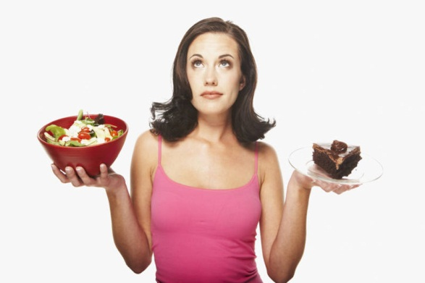
Reflect back on the last time you gave in to emotional eating. When asked if eating helped soothe your feelings, your initial response might be, “Sure. It did, at least for a little while because I was distracted from feeling the loneliness. I was distracted from having to solve an issue or a problem with my relationship.”
Food can distract you for a little while, but as soon as you finish eating, the original hurt tends to resurface, and it’s often accompanied by a feeling of guilt or self-remorse. You might add to your original upset because you caved in and you did what you told yourself you weren’t going to do anymore.

Sometimes, when you’re in the middle of one of these emotional eating patterns, no matter how much logic you try to apply to it, the feeling and the habit are so strong that you just “go for it” in spite of your best judgment.
Wired to Want Relief
What I would like you to do is first get in touch with the strength of your emotional eating urge, and then understand that the reason the urge to emotionally eat is so strong is that it’s a pattern that has been habituated and repeated over and over. It has actually burned a neural pathway in your brain. This is important to understand.

The first time you started eating emotionally may have been when you were only 5 or 10 years old. The first time you did it, it created a new neural pathway in your brain. The next time that situation happened, you may not have thought about going to food right away. You may have done some other things and then remembered that the last time this happened, food provided relief.
As you repeat a behavior over and over, a shortcut pathway is burned in your brain.
So, instead of having to go through five or six different neurons to get from stimulus to response, you jump right from stimulus to response. It this case, you jump from emotional pain to eating. So as soon as you feel angry, afraid, upset, or hurt, you reach, without even consciously thinking, for food.
That’s the habit you need to break.
There are a lot of techniques you can use to break this pattern (see below for a list). Changing your mindset happens slowly, so you can really grasp each shift and get involved with the process. The reason we spend so much time on creating a new, positive mindset is because spending time on this thinking process creates a foundation from which we can change our behaviors around food and our unconscious emotional responses.
Having your values and goals written down on index cards, even if it’s just one goal, is an essential link to something positive. (If you need support in this area, my Portable Anchor System, a component of the Inspired Health Vision System, is available as a separate program: http://www.drritamarie.com/go/HealthPrograms)


In the Inspired Health Vision System, we teach how to create goals and visions then anchor back to them whenever stressful decision points occur.
You get into a relaxed state to write your goals then transfer them to index cards that you can carry with you. When you originally write your goals in a relaxed state (which is strong, emotional, and real to you), reading those words again on the index card can shift you out of your emotional lizard brain and into your core-aligned wizard brain.
What the index cards do is help you to shift back into the relaxed mode. Then, you can make logical comparisons and informed choices. Lizards can’t compare and contrast, but high level thinking humans can.
Creating New Neural Pathways in Your Brain
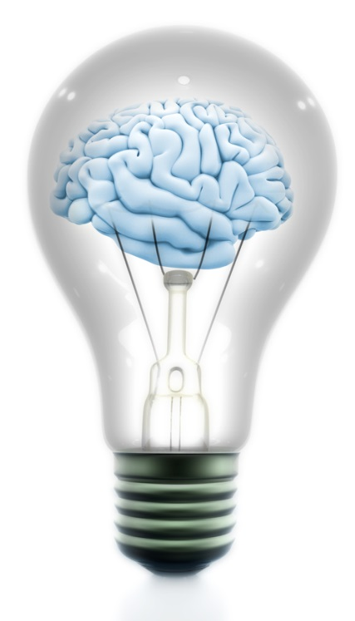
The goal is to do something just a little differently each time you feel ready to eat emotionally.
See if you can pause just long enough to start a question and answer dialogue with yourself. You must ask yourself honest questions the moment you see yourself in danger of emotional eating.

For example:

“Is reaching for this doughnut going to solve the problem of my boss being not appreciating me at work?”
The answer to that is, “Well, of course not. It’s not going to solve that problem at all.”
“So, is it productive to eat the donut?”
“No.”
If you ask, “Will it allow me to be temporarily distracted from that problem?”
The answer is, “Yes.”
So, the next question you can ask is, “What action can I take right now that can soothe me and keep me in alignment with my highest purpose?”

Comforting Actions to Replace Comforting Food
- Run a hot bath, put some lavender oil in, and luxuriate in the bath. It’s an aromatic, soothing way to comfort and distract you.
- Another idea might be to put on some meditative music or to listen to someone who’s very inspirational and distract yourself that way.
- Call a friend, or write and journal to express and release your feelings.
- Engage and lose yourself in one of your favorite hobbies: artwork, playing music, knitting, bird-watching, gardening, dancing, swimming, yoga, theater, sports, etc.
- Focus on your breathing and feelings of appreciation as you visualize a time and place that brought you pleasure. Transport yourself in space and time back to that place.

This last option is one of the most effective choices.
It doesn’t matter whether you’re actually experiencing something or you’re remembering experiencing something; your nervous system responds the same. You can quickly shift yourself from being in fight/flight mode into the calm part of your nervous system. In that “wizard” mode, you can access your high-level thinking.
Once you come out of the visualization ask yourself if you still feel compelled to use food for comfort and what your best course of action might be.

Choosing “2” Look Ahead
The next part of the process is to see beyond the current time to how your choice will affect you into the future. One of my coaching participants asks herself the following questions:
“If I choose to eat emotionally, what would the results be in...”
2 minutes? I'd feel love, connection, satisfaction, bliss.
2 hours? I'd still feel overfull. I'd probably feel tired from eating all the sweet stuff. I would be sluggish and not very present for the rest of my day.
2 days? I might not be able to zip up the jeans that I just *barely* fit into right now.
2 weeks? Since I passed on this opportunity to interrupt the emotional eating pattern, I might continue emotional eating... which means that in 2 weeks that I'd be right where I am today, without making strides forward in my healing.
“If I choose not to eat emotionally, and instead just love myself without needing food to prove it, what would the results be in...”
2 minutes? I'd feel sad, tired, left out, a little lost, and confused.
2 hours? I'll have "true hunger" by this time and will get to eat a meal, plus a healthy treat.
2 days? Those jeans might be a little less tight. :-)
2 weeks? From just this one choice, I'll have made great strides forward in healing my emotional eating. I can see how this choice will support other healthy choices along the way. I can feel how this is actually a more loving choice overall.

What you can say to yourself over and over is:
"I still love myself even if I don't eat this."

Emotional Eating Worksheet
Spend some time in quiet contemplation and fill in all the blanks.
- Identify the feelings, circumstances, or problems that trigger you to eat emotionally.

- Name the foods that you generally eat as a result.

- How do you feel physically after eating these foods?

- How do you feel emotionally after eating these foods?

- What does eating these foods keep you from achieving in the long term? (e.g. vibrant health, strength, stamina, clean arteries, etc.)

- Does eating these foods solve the problem that triggered your emotional eating?

- What you can do instead to soothe the negative emotions?

- As a result of doing the alternate activity, how do you feel?

Personal Emotional Eating Strategy Statement
Use the answers to the above questions to fill in the blanks and create your personal Emotional Eating Strategy Statement. Make several copies and keep them handy. Post one on your mirror, another on your refrigerator, and one near your computer. Read this statement daily. It would be most effective to read it several times daily until you have it memorized and are consistently taking the alternative action.

When I feel (emotions) ____________________________________________________,

It drives me to eat (foods) __________________________________________________.
I usually end up feeling (emotions) ___________________________________________
and I have the symptoms of (physical symptoms) _________________________________
which keeps me from achieving (goals) _______________________________________.
Instead of reaching for the (foods listed above) ___________________________________,
I can (enjoyable activities) ____________________________________________________,
and as a result I will feel (emotions and physical) ______________________________________

______________________________________________________________________.

