

Copyright © 2007 – 2015 Ritamarie Loscalzo, MS, DC, CCN, DACBN

All rights reserved.

Austin, Texas, USA.

No part of this publication may be reproduced, stored in a retrieval system, or transmitted in any form or by any means, whether electronic, mechanical, photocopying, recording or otherwise, without prior permission of the author. Please do not give away, publish on a website or in a newsletter or sell without permission of the author. You have permission to make as many printed or backup copies as you desire for personal use only. Thank you for respecting the hard work that went into creating this document for your education and enjoyment.

This edition was published in the United States of America by Dr. Ritamarie Loscalzo.

Edition Date: June 11, 2024

DrRitamarie@DrRitamarie.com

Disclaimers

The techniques and advice described in this book represent the opinions of the author based on her training and experience. The author expressly disclaims any responsibility for any liability, loss or risk, personal or otherwise, which is incurred as a result of using any of the techniques, recipes or recommendations suggested herein.

The responsibility for the consequences of your use of any suggestion or procedure described hereafter lies not with the authors, publisher or distributors of this book. This book is not intended as medical or health advice. If in any doubt, or if requiring medical advice, please contact the appropriate health professional. We recommend consulting with a licensed health professional before making major diet and lifestyle changes.

If you enjoy the information in this program, we would like to encourage you to show your support by sharing your testimonial with us, sharing our website with your friends and family, and supporting our continued work by considering our other programs and products.

The information in this document has not been evaluated by the FDA and is not intended to diagnose, cure, prevent, or treat any disease. The information presented is for educational purposes only with the intent of teaching you how to properly nourish and balance your body and trigger your innate self-healing mechanisms.

This information is not intended as a substitute for the advice or medical care of a qualified health care professional. You should seek the advice of your health care professional before undertaking any dietary or lifestyle changes, especially if you have any serious medical conditions or health concerns.
Assess Your Own Body Chemistry:
Home Testing Handbook

Assess Your Own Body Chemistry: Home Testing Handbook 3

Digestion Home Assessments 5

HCl Challenge Test for Optimizing Stomach Acid 6

HCL Challenge Test Tracking Chart 8

Bowel Transit Time 11

Bowel Transit Time Tracking Chart 12

Pulse Testing for Food Allergies 13

Pulse Test Tracking Chart – Individual Foods 15

Diet/Pulse Record 16

Elimination-Provocation Tracking Chart 17

Urinary Indican Test for Intestinal Malabsorption 18

Malabsorption Urine Test Chart 18

Cardiovascular Home Assessments 20

Nitric Oxide Testing 21

Nitric Oxide Tracking Chart 22

Acid-Alkaline Balance Home Assessments 23

About pH Balance 24

Breath Hold Test 25

Respiration Rate Test 25

Salivary pH Test 26

Urine pH Test 26

pH Tracking Chart 27

Morning Saliva and Urine pH Tracking 28

Morning Saliva and Urine pH Tracking Chart 28

Salivary pH Challenge 29

Salivary pH Challenge Tracking Chart 30

Hormone Home Assessments 31

Measuring Your Blood Glucose 32

Blood Sugar Tracking Chart 34

Glucose Tolerance Test Guidelines 35

Home Glucose Tolerance Test Tracking Chart 36

Glucose Testing Individual Foods 37

Glycemic Monitoring of Individual Foods Chart 37

Basal Body Temperature Test 38

Temperature Tracking Chart 39

Konisburg Adrenal Fatigue Test 40

Vitamins, Minerals, and Anti-Oxidant Home Assessments 41

Vitamin C Flush 42

Vitamin C Amount Calculation Chart 44

Zinc Taste Test and Zinc Challenge 51

Zinc Taste Test 52

Zinc Taste Test Chart 52

Zinc Taste Test Interpretation 52

Zinc Challenge 53

Zinc Challenge Tracking Chart 53

Zinc Challenge Interpretation 54

Iodine Patch Test 55

Iodine Patch Test Tracking Chart 56

Iodine Patch Test Result Interpretation 56

Body Bio Mineral Testing Process 57

Mineral Testing Tracking Chart 58

Body Bio Mineral Testing Brochure 59

OXIDATA™ Anti-Oxidant Test 69

Oxidata Test Results Tracking Chart 70

About Dr. Ritamarie Loscalzo, MS, DC, CCN, DACBN 71

Health Restoring Books and Programs 72

A Sampling of Other Online Video Classes 74

Digestion Home Assessments
- HCl Challenge Test for Optimizing Stomach Acid
- Bowel Transit Time
- Pulse Testing for Food Allergies
- Urinary Indican Test for Intestinal Malabsorption
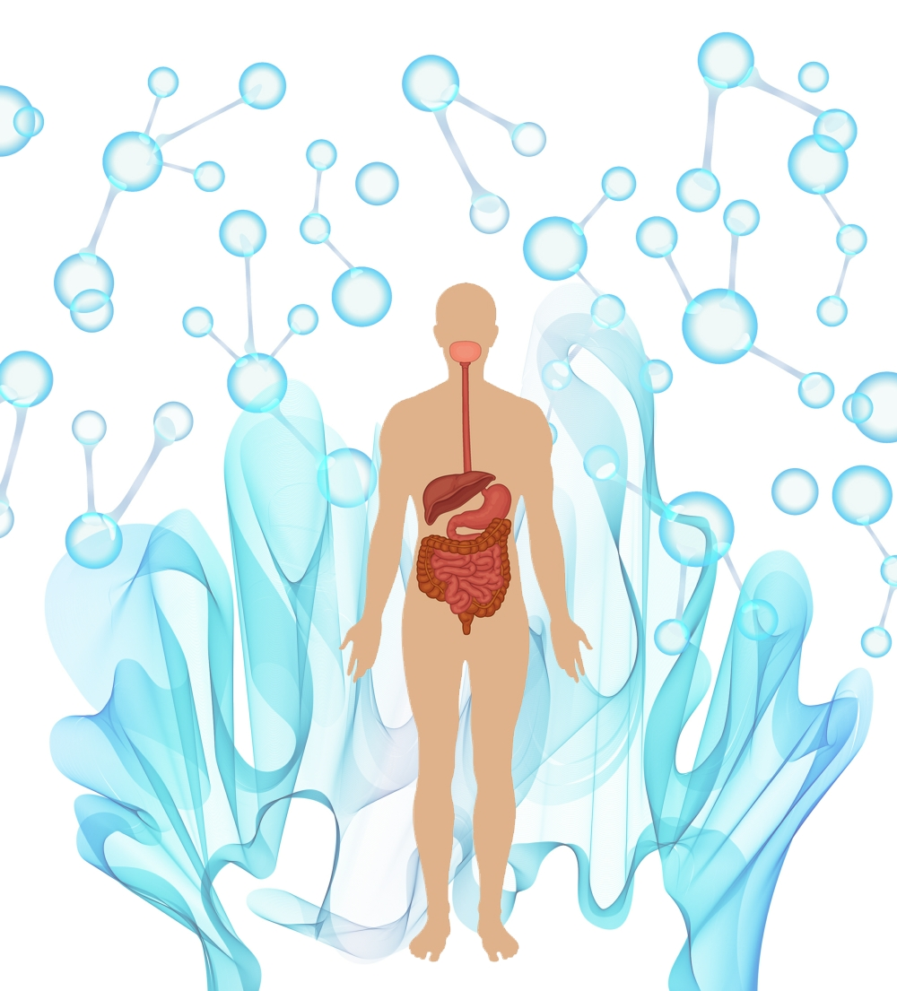
HCl Challenge Test for Optimizing Stomach Acid

Caution: Do not do this test without first consulting a qualified medical professional familiar with your personal health history if you have or have had stomach related health conditions such as GERD, ulcers or gastritis. Taking HCl, even if you need it, can aggravate these conditions and result in increased pain and burning.

Purpose

This test is used to determine the integrity of your stomach lining and its ability to produce HCl (Hydrogen Chloride). HCl is the acid produced by your stomach to initiate protein digestion and mineral absorption. Without adequate HCl, you will not efficiently extract nutrients from your food, no matter how excellent your diet may be.

This test helps you to identify whether you are producing enough HCl to efficiently digest protein and minerals. It helps to determine the amount of supplemental HCl required or to assess the effectiveness of food and herbal approaches to improving digestion in your stomach.

Procedure

Day 1: Take ONE 500-650 mg capsule (not tablet) containing both hydrochloric acid (HCL) and approximately 150 mg of pepsin after you’ve eaten a few bites of food at the beginning of a substantially complex meal, i.e. your largest meal of the day. Do not test yet on simple meals, like fruit, a light, low fat salad without added concentrated protein or a simple fruit or green smoothie.

Do not take on an empty stomach or after meals and do not open capsules and take as a powder.

Observe how you feel throughout the meal and during the hour following. If you have discomfort (burning or warm sensation), STOP and proceed to How to Handle Stomach Discomfort then read the Interpretation paragraph below.

Continue with the same dose of HCl for each substantial meal that day, observing carefully for symptoms. During testing, only take HCl at your larger meals that contain concentrated foods (i.e. nuts, seeds, grains, legumes, fish, meat, eggs or dairy). During the initial phase of testing, do not take if your meal is just fruit, a smoothie or salad.

Day 2: Take 2 capsules at the beginning of your first complex meal. Make it a meal that’s similar in complexity to test meals from previous days. If you have discomfort (burning or warm sensation), STOP and proceed to How to Handle Stomach Discomfort then read the Interpretation paragraph below.

Day 3: Take 3 capsules at the beginning of your first complex meal. Make it a meal that’s similar in complexity to test meals from previous days. If you have discomfort (burning or warm sensation), STOP and proceed to How to Handle Stomach Discomfort then read the Interpretation paragraph below.

Day 4: Take 4 capsules at the beginning of your first complex meal. Make it a meal that’s similar in complexity to test meals from previous days. If you have discomfort (burning or warm sensation), STOP and proceed to How to Handle Stomach Discomfort then read the Interpretation paragraph below.
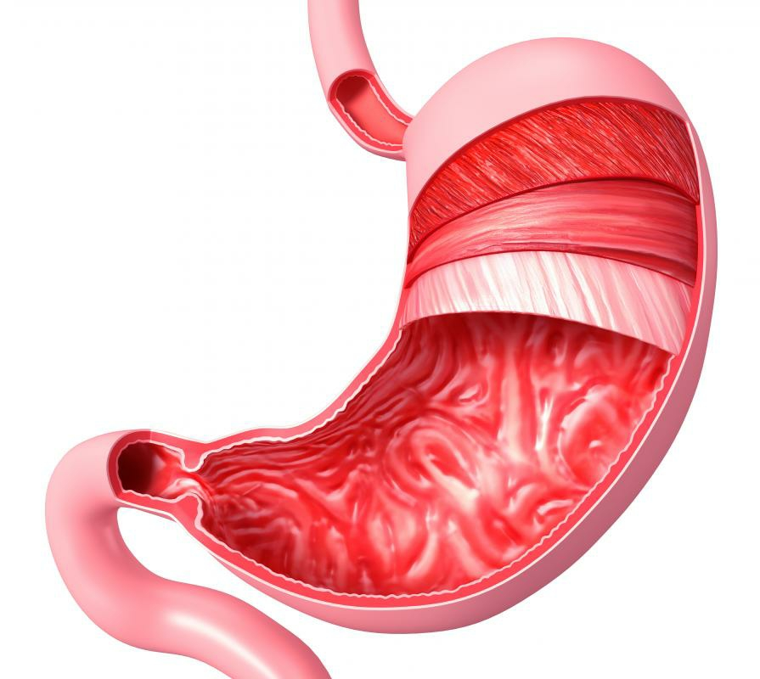

HCL Challenge Test Tracking Chart
Name
Date |  | # HCl Capsules | Meal | Reaction

How to Handle Stomach Discomfort

If at any point you experience warmth, discomfort, or burning, drink 16 ounces of purified water to quench the reaction and stop taking HCl until the discomfort subsides.

If that’s not sufficient, there are several options for pain relief. Preferred are a) and b).
- Drink 1 teaspoon slippery elm dissolved in 8 ounces warm water. Continue every 15 minutes until pain subsides, usually within an hour.
- Drink 1/4 cup aloe vera juice.
- Drink 1/4 teaspoon baking soda in 4 ounces water.
- Take an antacid like Alka Seltzer Gold.

Interpretation

If you had pain with the first dose it's likely that either you don't need HCl or you have disruption of your stomach's protective mucous lining, as in an ulcer or gastritis. If you have symptoms of low stomach acid as indicated on your symptom questionnaire and discomfort with taking HCl, You might try a month or two of DGL Licorice and slippery elm to soothe and heal your stomach lining combined with bitters as described in step 2 below.

If you made it to day 4 without discomfort, you likely have a severe deficit in HCL and have been experiencing significant digestive inefficiency as a result.

Corrective Action

Choose one of the following actions:

- Supplement with HCL
  - With each of your heavier or more complex meals, take the number of HCl capsules you took the day BEFORE you experienced warmth or discomfort. Take the first HCl capsule at the beginning of the meal, after a few bites of food. After each HCL capsule, take a few bites of food before taking the next. If you take digestive enzymes, take those at the end of the meal for best results.
  - With your lighter meals, retest starting from Day 1 and determine the optimal dose.
  - Take at MOST 4 capsules.

- Stimulate your own HCl production with bitter herbs, juices and foods.
  - Dandelion, arugula and other bitter greens, either as juice or whole leaves chewed to juice and swished in mouth about 15 minutes before each meal.
  - Bitters formula as a tincture, taken 15 minutes before each meal and swished.

- ** Preferred** Take HCl AND bitters so that as you replenish your HCl and get the benefit of improved protein and mineral digestion, you will also restore your body’s ability to make it.

***** Regardless of which option you choose, it’s advisable to also supplemental with Zinc, as it’s important for the production of HCl and is not well absorbed in low HCL states. Start with about 30 mg per day of zinc picolinate or zinc citrate or 1 teaspoon liquid zinc.

If you have indications of long standing mineral or protein deficiencies, you might also consider an amino acid or protein drink supplement while you are getting things balanced as well as a liquid multi-mineral formula, taken on an empty stomach.

You should not go above the maximal dose, which is approximately
four 650 mg capsules unless under supervision.

Brief Summary of Major Signs of Low Stomach Acid
- Digestive woes immediately after eating like burping, gas, bloating.
- Bouts of nausea and/or unexplained diarrhea
- Soft brittle or peeling nails
- Parallel ridges on fingernails indicate malabsorption
- Dry skin on lower leg may indicate malabsorption
- Diffuse hair loss in women
- Chronically coated tongue
- Chronic bad breath
- Food allergies
- Non responsive to supplements and dietary efforts
- Muscle cramps
- Heavy, full sensation after eating (called delayed gastric emptying)

Blood Lab Scores That Are Suggestive (Not Diagnostic) Of Insufficient Stomach Acid
- Low total protein, globulin, ferritin, Calcium, magnesium Mg, BUN
- B12 below 350 pg/ml
- Complete Blood Count (CBC): MCV over 93
- Stool testing: Imbalance of normal gut flora and overgrowth of unfriendly critters, known as dysbiosis, and lots of yeast
- Hair analysis: 5-6 low minerals (not including sodium and potassium)

Caution: Do not do this test without first consulting a qualified medical professional familiar with your personal health history if you have or have had stomach related health conditions such as GERD, ulcers or gastritis. Taking HCl, even if you need it, can aggravate these conditions and result in increased pain and burning.
Bowel Transit Time

Purpose

This test is used to determine how long it takes food to travel through your digestive tract from mouth to anus. Ideally, it should take between 18 and 24 hours for food to completely be moved through your digestive tract and undigested fiber to be eliminated.

This test uses charcoal, an inert substance that doesn’t get absorbed, to measure the transit time. Charcoal will stain your stool black or gray, so it’s easy to detect its presence in your stool.

Materials
- Charcoal capsules, available at your local health food store.

Procedure
- Swallow 4 charcoal capsules at your evening meal. Record the date and time in the chart below.
- After each bowel movement, observe your stool for the first sign of black or grey. Observe in a brightly lit room.
- Calculate the number of hours between Time Charcoal Taken to Time/Date Color First Appears. Record in the Transit Time column.
- Continue to observe every stool and note the time and date when the color has completely disappeared.
- Wait 5 days to make sure all sign of charcoal has completely disappeared and try again.
- You can repeat this test with a variety of test meals to see if there is a difference between meals of different components (i.e. Do higher fat meals take longer to pass through you?). Repeated testing can help determine where your digestive imbalance lies.

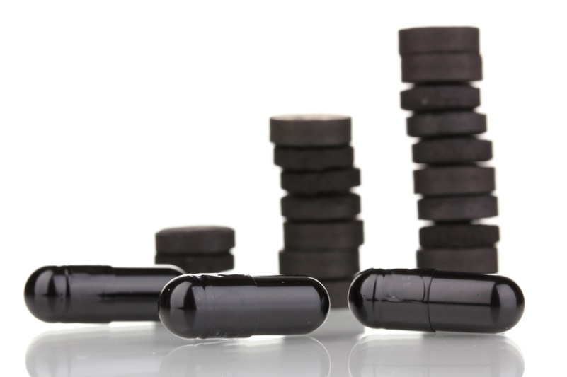

Bowel Transit Time Tracking Chart

Name
Date |  | Time Charcoal Taken | Time/Date Color First Appears | Transit Time  (# hours to first charcoal in stool) | Date/Time Charcoal Completely Cleared | Time Charcoal in System | # Bowel Movements

Pulse Testing for Food Allergies

The pulse test is a simple two-minute self-test to determine if a particular food or supplement causes a stressful reaction. Some people say this is a food allergy reaction. We can’t say for sure without testing for immune system reaction via antibodies and immunoglobulins. However, it’s safe to assume that a food that causes a stressful reaction via an increase in pulse rate is one to which you’re sensitive and it should be avoided for enough time to allow your body to calm down. After at least three weeks of avoidance, you may retest to determine if the intolerance remains.

Test Individual Foods for Tolerance
- Sit down, take a deep breath, and relax.
- Establish your baseline pulse by counting your heart beat for a full minute and record your pulse in the Before space on the Pulse Test Tracking Chart – Individual Food.
- Put a sample of a food or supplement to evaluate in your mouth (on your tongue).
- You may chew, but refrain from swallowing. You need to taste your test food or supplement for approximately 30 seconds, so tablets must be chewed and capsules opened and contents poured out for the test results to be valid.
- With the food or supplement still in your mouth, retake your pulse. Write down your result in the After space pulse on the Pulse Test Tracking Chart – Individual Food.
- Discard the tested ingredient (do not swallow) and repeat the procedure to test other foods or supplements. Repeat the procedure as frequently as you like, as long as you always return to your normal pulse before testing the next food.
- Test all foods you suspect create a problem for you, all foods you crave, and all foods you eat on a daily basis.
- Write all foods that increased your pulse in the Suspicious Foods column. I generally recommend testing a food three times before putting it into either the Foods that Work Well for Me list or the Stressful Foods list on the Elimination-Provocation Tracking Chart.


Test Your Normal Diet
- Take your pulse upon awakening and record at the top of the Diet/Pulse Record form.
- Take your pulse for one full minute, first lying down and then sitting up.
- Before each meal, sit down, take a deep breath, and relax.
- Take your pulse for a full minute and record the number on the form.
- Eat your meal as usual, recording each food in the menu column.
- Record your pulse on the form provided at the following time intervals: Before, 30 Minutes After, 60 Minutes After, and 90 Minutes After.
- In the Activities/Feelings column, record any symptoms or feelings you experience from the time of the meal, up until the time of your next meal. Note the time. Pay attention to your digestion, mood, aches and pains, skin, sinuses and any specific symptoms that you tend to experience.
- Observe for magnification or reduction of current complaints as well as any new ones.
- For any meals that result in an increase in your pulse rate or an increase in symptoms, ALL foods in that meal are suspicious. Write them down in the Suspicious Foods list on the Elimination-Provocation Tracking Chart and be sure to test them again. I generally go with the “three strikes you’re out” rule, but if you’ve had an adverse reaction on two occasions, feel free to move the food to the Stressful Foods column.


Pulse Test Tracking Chart – Individual Foods

Name
Date/Food |  | Pulse  Before/After | Difference | Date/Food | Pulse  Before/After | Difference
 |  | I |  |  | I
 |  | I |  |  | I
 |  | I |  |  | I
 |  | I |  |  | I
 |  | I |  |  | I
 |  | I |  |  | I
 |  | I |  |  | I
 |  | I |  |  | I
 |  | I |  |  | I
 |  | I |  |  | I
 |  | I |  |  | I
 |  | I |  |  | I
 |  | I |  |  | I
 |  | I |  |  | I
 |  | I |  |  | I
 |  | I |  |  | I

Diet/Pulse Record
Name |  |  | Date
I. WAKING PULSE ______/______ (1 full minute; first lying down and then seated)
All Pulse counts below are to be taken while sitting and for 1 full minute
II. BREAKFAST  Before:  After 30 min:  60 min:  90 min: |  | Menu: |  |  | *Feelings/Activities:
Ill. LUNCH  Before:  After 30 min:  60 min:  90 min: |  | Menu: |  |  | *Feelings/Activities:
IV. DINNER  Before:  After 30 min:  60 min:  90 min: |  | Menu: |  |  | *Feelings/Activities:
V. BEDTIME
(Take pulse sitting up.)
*NOTE: List the following in the Feeling/Activity area: Cravings (examples: salt, sweet, chocolate, etc.), digestion, bowel movements, urinary frequency or urgency, mood, headaches, body aches or pains, sinus congestion, the need to clear your throat, or any other symptoms or bodily signs you notice.

Elimination-Provocation Tracking Chart
Name
Foods That Work Well for Me |  | Suspicious Foods | Stressful Foods

Urinary Indican Test for Intestinal Malabsorption

Intestinal malabsorption is a common health challenge. It can be caused by the overgrowth of unfriendly organisms in your gut, low stomach acid, decreased production of enzymes, poor liver and gallbladder function, and any number of dietary overload situations.

Indican originates from bacterial growth, often in the small intestine. Indican is an indole produced by bacterial action on the amino acid tryptophan in your intestine. Most of the indole produced is excreted in your feces. The remainder is absorbed and metabolized and excreted as indican in your urine.

In normal urine, the amount of indican excreted is small. It increases with high protein diets or inefficient protein digestion. If not digested properly, or if the wrong type of proteins are ingested, bowel putrefaction can occur.

Normally, only a small amount of indican is found in the urine. The amount of urine indican increases with high protein diets or inefficient protein digestion. If protein is not digested adequately, bacteria act on the protein causing putrefaction in the colon and the production of indoles, which are absorbed and converted in the liver to indican. The inability to digest protein can have adverse effects on glycemic control, hormone balance, and water balance.

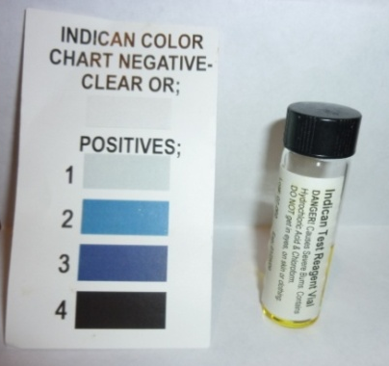
Materials Required
- Freshly voided urine - minimum of 5.0 mL
- Indican test vial
- Dropper
- Test card

Malabsorption Urine Test Chart
Name
Color of Vial After Test Complete |  | Score | Interpretation
Clear |  | 0 | Normal
Light Blue |  | +1 | Mild Dysbiosis
Blue |  | +2 | Moderate Dysbiosis
Dark Blue |  | +3 | Heavy Dysbiosis
Indigo/Black |  | +4 | Extreme Dysbiosis

Interpretation

A positive test may indicate one of the conditions listed below. All positive scores need to be investigated to find and correct the underlying cause. Many people return to normal indican scores after supplementation with enzymes and probiotics and cleaning up their diet. If elevated indican persists more than a few months in spite of diet and supplement changes, a GI stool function test may be warranted.

Conditions with Elevated Levels of Urinary Indican

- Inflammatory bowel disease
- Celiac disease
- Hypochlorhydria
- Achlorhydria
- Gastric ulcer
- Biliary and intestinal obstruction
- Jejunal diverticulosis
- Scleroderma
- Postgastrectomy
- Hartnup's disease
- Pancreatic insufficiency
- Diminished peristalsis
- Blue diaper syndrome
- Hypermotility of the small intestine

Conditions that Lead to Excess Urine Indican Include:
- Maldigestion and/or malabsorption of protein
- Hypochlorhydria (insufficient stomach acid), Achlorhydria (lack of stomach acid), or use of antacids or H2 blockers to decrease stomach acid
- Gastric ulcers
- Stomach cancer
- Insufficient digestive enzymes, in particular proteases such as trypsin, pepsin, and chymotrypsin
- Malabsorption syndromes such as celiac, gluten intolerance, Hartnup disease, a rare disorder in which amino acids are poorly absorbed from the intestine and other disorders that produce malabsorption
- Bacterial overgrowth in the small and/or large intestine
- Intestinal obstruction
- Concurrent intestinal parasitic infections
- Concurrent intestinal fungal infection
- Liver dysfunction
- Gallbladder or intestinal obstruction
Cardiovascular Home Assessments
- Nitric Oxide Testing



Nitric Oxide Testing

Nitric oxide, or NO, is a gas molecule that sends signals to your muscles and blood vessels. It expands the diameter of blood vessels, which allows a higher concentration of oxygen-rich blood cells to enter tissues. Because of this action, it helps athletes maintain stamina and treats a range of heart and circulatory problems, including angina and hypertension (high blood pressure). Exercise causes your body to produce more nitric oxide.

In addition to helping you maintain a normal blood pressure, your cardiovascular system uses nitric oxide to keep your blood platelet cells from sticking together to prevent strokes and heart attacks, plus it’s also used to heal and repair damage to the lining of your blood vessels (called the endothelium).

Nitric oxide is also used by your body as a neurotransmitter to transmit impulses between nerve cells. Your immune system uses nitric oxide to destroy infectious agents like bacteria, viruses, and tumors. In fact, just about every cell, tissue, or organ in your body is directly or indirectly impacted by nitric oxide.

Importance of Nitric Oxide

- Improves memory and behavior by transmitting information between nerves
- Improves sleep quality which increases energy
- Increases endurance and strength
- Assists in gastric motility and intestinal health
- Assists immune system at fighting off bacteria and defending against tumors
- Regulates blood pressure by dilating arteries
- Reduces inflammation

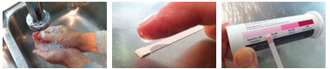
Materials
- Nitric oxide test strips available here: http://www.neogenis.com

Procedure

- Wash hands.
- Place saliva on test strip.
- Compare test strip to color indicator.
- The deeper the red on the test strip, the more Nitric Oxide you have in your body

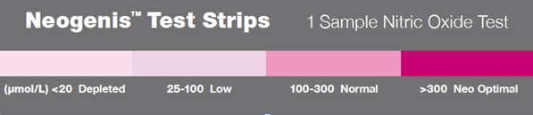

Nitric Oxide Tracking Chart

The deeper the red on the test strip, the more Nitric Oxide you have in your body.

Name
Date | Color Result & Interpretation
 | Depleted | Low | Normal | Optimal
 | Depleted | Low | Normal | Optimal
 | Depleted | Low | Normal | Optimal
 | Depleted | Low | Normal | Optimal
 | Depleted | Low | Normal | Optimal
 | Depleted | Low | Normal | Optimal
 | Depleted | Low | Normal | Optimal

Acid-Alkaline Balance Home Assessments
- About pH Balance
- Breath Hold Test
- Respiration Rate Test
- Salivary pH Test
- Urine pH Test
- Morning Saliva and Urine pH Tracking
- Salivary pH Challenge

About pH Balance

The measurement of acidity and alkalinity in your body is called your pH (potential hydrogen) balance.

It’s important to maintain a properly balanced pH system. Your blood pH must be maintained within a very narrow range or serious illness and death can result. Optimal pH of the blood is needed for oxygen delivery to your cells and for the correct action of insulin to control blood sugar levels.

Your blood pH must remain in the range of 7.35 to 7.45. This means that your internal environment is slightly alkaline. Your enzymatic, immunologic, and repair mechanisms all function their best in an alkaline environment. Your metabolic processes – the processes of living, tissue repair and the metabolism of food – produce a great deal of acid. In order to maintain your internal alkaline state, you need oxygen, water, and acid-buffering minerals available as you are eliminating waste products.

Certain areas of your body require an acid environment to work optimally, for example your stomach, while most others require an alkaline environment. Your body uses a number of complex systems to keep the pH within a normal and optimal range, and the following series of tests are designed to see if those regulatory mechanisms are working properly.

The two main systems of pH regulation are your respiratory system and your kidneys, which coordinate to finely regulate the level of acid and alkaline in your body. Thus, by measuring how long you can hold your breath, how many breaths you take in a minute, and your urine and salivary pH you can determine what areas of your body are in need of further support to bring your pH system into balance.
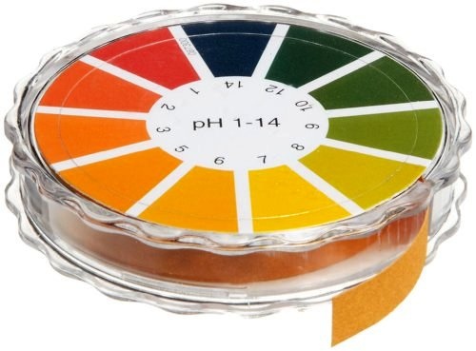
Breath Hold Test

This test is an actual measurement of how long you can hold a deep breath.

Materials
- You will need a stopwatch, a watch with a second hand, or a timer to time the breath holding.

It is hard to time your own breath-hold time, so it is best to have a family member or friend do the timing.

Procedure
- In a seated position, take a deep breath and hold it for as long as you can. Stop when it begins to feel uncomfortable or you feel as if you need to take another breath. This is not meant to be a test of endurance!
- When you can no longer hold your breath, let it out, and record the number of seconds the breath was held on the pH Tracking Chart.

Respiration Rate Test

This test is an actual measurement of how many breaths you take in a minute. This is your respiration rate.

Materials
- You’ll need a stopwatch, a watch with a second hand, or a timer to time your respiration rate.

It is hard to time your own respiration rate because you will most likely alter your respiration rate if you’re doing the timing. It’s best to have a family member or friend do the timing.

Procedure
- It’s best to be lying down when this test is performed and the trick is to breathe as normally and unconsciously as possible.
- The person measuring your respiration rate can either watch the rise and fall of your chest, or place a hand on your abdomen and count the number of breaths in a full minute.
- Remember to tell them to count one full cycle of inhalation and exhalation as one breath.
- Record the number of breaths taken in a minute on the pH Tracking Chart.

Salivary pH Test

Materials
- This test uses pH test paper that ranges from 5.5 to 8.0.

Procedure
- Testing must be done at least 30 minutes away from any food or beverage intake and is best done in the middle of the day.
- Tear off a 2-inch strip of the pH paper from the roll.
- Place the pH testing strip in your mouth on top of the tongue. You should get it nice and moist, but not saturated. Please keep your lips closed, as clinical readings of salivary pH must not allow exposure of the sample to air, which can result in inaccurate readings.
- Immediately after removing the pH strip from your mouth, compare the strip with the color code on the box. Try your best to make your reading within 3 seconds.
- Record the result on the pH Tracking Chart.

Urine pH Test

Materials
- This test uses pH test paper that ranges from 5.5 to 8.0.

Procedure
- There are several methods for timing the measurement of pH depending on the purpose. For this test, simply measure your urine pH sometime during the day rather than the first urine of the day. There’s another worksheet for tracking first morning urine.
- Tear off a 3-inch strip of the pH paper from the roll.
- Hold the paper in the stream of urine.
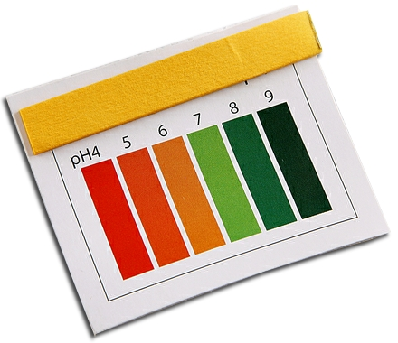
- Immediately after removing the pH strip from the urine stream, compare the strip with the color code on the box. Try your best to make your reading within 3 seconds.
- Record the result on the pH Tracking Chart.

pH Tracking Chart

Name
 |  | Breath Hold Test | Respiration Rate Test | Salivary pH Test | Urine pH Test
Date
Time
Result
Date
Time
Result
Date
Time
Result
Date
Time
Result
Date
Time
Result

Morning Saliva and Urine pH Tracking

The pH of the saliva and the urine, taken in the morning upon first voiding of the day, can reveal much about the metabolic activity of the body. This information is essential to determine the proper therapeutic protocol that is unique to your body chemistry. The following are optimal values for both the a.m. saliva and the a.m. urine:
Saliva: 6.8 to 7.2
Urine: 6.4 to 6.8

Procedure
- Use pH paper to record the first morning’s saliva pH and urine pH in the chart below. Also, record the color, clarity, and odor of the urine.
- Wait at least one hour and record a second urine pH reading. Eating during this time is allowed.

Morning Saliva and Urine pH Tracking Chart
Name
Date | 1st Morning Saliva pH | 1st Morning  Urine pH | Urine  Color | Urine Clarity | Urine Odor | 2nd Morning Urine pH
Salivary pH Challenge

The Salivary pH Challenge test is a dynamic measurement of your body's alkaline mineral reserves. These reserves are one of the systems your body uses to correct acid and alkaline imbalances.

During this test you will challenge your body with acid in the form of lemon juice to determine whether your body has the reserves to appropriately respond to an acid challenge. In an ideal situation, the initial acidity of the lemon juice will cause your saliva to become more alkaline in order to buffer the acidity of the lemon juice over the course of a few minutes. Your body does this by mobilizing the necessary alkaline minerals.

This test also allows us to see how stress and sympathetic dominance impact mineral reserves in your body. Increasing levels of stress can cause the loss of your primary mineral reserves.

Materials
- Fresh lemon juice, pH paper

Procedure
- Cut seven 2-inch strips of pH paper and lay them out on paper towel.
- Prepare your lemon juice drink: 1 tablespoon of fresh lemon juice and 1 tablespoon of water.
- To take a saliva pH reading, make a pool of saliva in your mouth and dip half of the pH strip into this pool of saliva, remove, and compare the color of the dipped pH strip to the test indicator chart that comes with the pH paper. Do not put the whole strip in your mouth or hold it in for too long.
- Record this first reading as a baseline on the Saliva pH Challenge Tracking Chart.
- Drink the lemon drink, check your saliva pH again, and start timing.
- Test and record your saliva pH every minute for 5 minutes.

Record all your results on the Saliva pH Challenge Tracking Chart.

Normal Result for Salivary pH Challenge
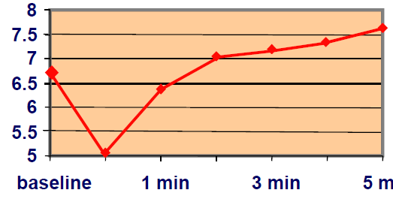


Salivary pH Challenge Tracking Chart
Name
Date | Baseline | After 1 Minute | After 2 Minutes | After 3 Minutes | After 4 Minutes | After 5 Minutes

Hormone Home Assessments
- Measuring Your Blood Glucose
- Glucose Tolerance Test Guidelines
- Glucose Testing Individual Foods
- Basal Body Temperature Test
- Konisburg Adrenal Fatigue Test



Measuring Your Blood Glucose

Knowing how your body responds to a particular food, meal, activity, or even thought can be one of the most valuable skills you’ll ever learn. Measuring your blood glucose will give you this feedback, and it’s really easy to learn and do.

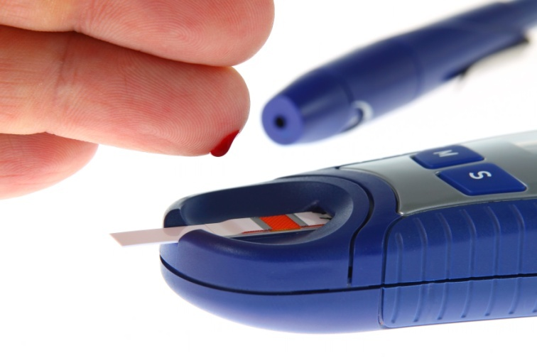
Materials
- inexpensive home monitoring glucometer (glucose meter), available at most local pharmacies and pharmacy chains for approximately $10 - $20.
  - The replacement strips can be pricey, so before you decide which meter to buy, check out the price of the strips.
- sterile lancet for sticking your finger
- glucose meter test strips
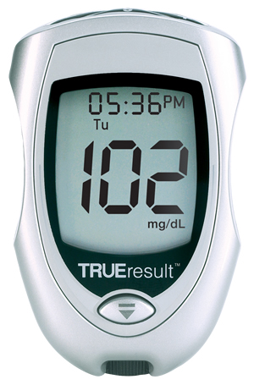
  - The meters I personally use for myself require the TrueTest brand strips. If you purchase them locally, the cost is about $48 for 50 strips. Online you can find them for $23 for 100 strips.
Here’s info on the ones we use (current at the time of publication):
TrueResults – my desktop model
http://www.drritamarie.com/go/TrueResultStarterKit
True2Go – portable
http://www.drritamarie.com/go/True2GoPortableKit
TrueTest Test Strips – use for both Glucose Meters
http://www.drritamarie.com/go/TRUEtestTestStrips50 or
http://www.drritamarie.com/go/TRUEtestTestStrips100
- cotton balls or tissue for blotting blood

Procedure

Estimated time, start to finish: about 2 minutes.

- Wash your hands. Invisible debris on your fingers can result in erroneous readings.
- Avoid the use of alcohol, especially if you’re checking regularly. It can dry your fingers and cause calluses.
- Rinse your fingers under warm water to increase blood flow to the area.
- Prepare your materials. Load your glucose meter with a sterile lancet and have your test strips and a tissue ready.
- Choose a location to get a blood sample. Rotate areas to prevent calluses.
  - Back of your hand
  - Fingers near your nails
  - Between the first and second joints of any finger
  - Fleshy pads of your fingertips
- Collect a blood sample.
  - Cock the spring loaded device and prick any finger. Follow the specific instructions provided by the glucose meter manufacturer.
  - Squeeze your finger using a pumping action.
  - Touch the blood to the test strip.
- Obtain the glucose reading.
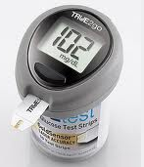
  - The glucometer will count down once the blood has been absorbed by the test strip.
  - After the countdown has begun, inspect to make sure the strip is properly covered by the drop of blood. If not, discard and start again.
  - Record the number from the glucometer on your Blood Sugar Tracking Chart.
- Clean up.
  - Discard used lancet.
  - Discard any blood soaked tissues or cotton balls by flushing down the toilet to prevent contaminating any others with your blood.

Blood Sugar Tracking Chart

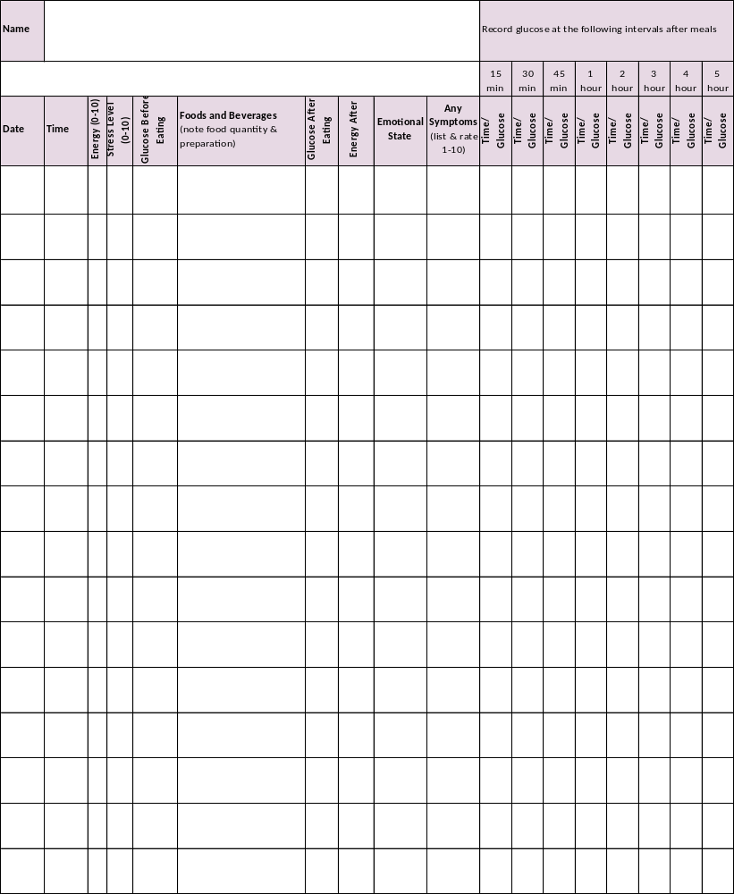
Glucose Tolerance Test Guidelines

Purpose

The usual purpose of the glucose tolerance test is to see how your body responds to a glycemic load. It’s usually done in a doctor’s office and is very costly to do. After taking a fasting glucose reading, you would be asked to drink a sugar syrup concoction and your blood sugars would be tested for several hours afterwards. It’s a great way to assess how your body handles a huge sugar load, but it doesn’t measure how well your body handles your typical daily diet.

You can perform a glucose tolerance test of sorts at home when you purchase an inexpensive home monitoring unit, available at most local pharmacies and pharmacy chains (see Materials under Measuring Your Blood Glucose).

Instead of glucose syrup, you’ll test with a real meal…representative of the worst meal you’d typically eat in a week.

Procedure
- Measure your fasting blood sugar. Your fasting blood sugar is usually measured in the morning after about 12 hours of no food (water is permitted).
- Eat a test meal. Write down the exact ingredients, including amounts of each food or beverage.
- Measure your blood sugar immediately after the test meal.
- Measure your blood sugar every 15 minutes for the first hour after the test meal.
- Measure your blood sugar at 2, 3, 4, 5 and 6 hours after the test meal.
- Write your findings on your Home Glucose Tolerance Test Tracking Chart.

Start with the worst meal you typically eat, including the most carbohydrate-rich foods you’re likely to eat at a meal. Follow the process above with several representative test meals to see how your body handles different types of foods. This will help you design the diet that’s just right for you.

In addition to measuring blood sugar, monitor how you feel and write down your observations in the right-most columns. Record your symptoms, including light headedness, headache, dizziness, hunger, cravings, nausea, etc. Be sure to record the time the symptoms occurred.

Home Glucose Tolerance Test Tracking Chart
Name
Test Meal 1:  List exact ingredients, including amounts of each food or beverage. |  | Date and Time of Test Meal: | Glucose: | Symptoms:
 |  | Pre-meal (right before)
 |  | Immediately after
 |  | 30 minutes after
 |  | 60 minutes after
 |  | 2 hours after
 |  | 3 hours after
 |  | 4 hours after
 |  | 5 hours after
 |  | 6 hours after
Test Meal 2:  List exact ingredients, including amounts of each food or beverage. |  | Date and Time of Test Meal: | Glucose: | Symptoms:
 |  | Pre-meal (right before)
 |  | Immediately after
 |  | 30 minutes after
 |  | 60 minutes after
 |  | 2 hours after
 |  | 3 hours after
 |  | 4 hours after
 |  | 5 hours after
 |  | 6 hours after
Test Meal 3:  List exact ingredients, including amounts of each food or beverage. |  | Date and Time of Test Meal: | Glucose: | Symptoms:
 |  | Pre-meal (right before)
 |  | Immediately after
 |  | 30 minutes after
 |  | 60 minutes after
 |  | 2 hours after
 |  | 3 hours after
 |  | 4 hours after
 |  | 5 hours after
 |  | 6 hours after
Notes:

Glucose Testing Individual Foods

It’s helpful to know how your body responds to certain foods that you regularly eat or would like to eat. You can do a mini-test on each food.

Procedure
- Measure your blood sugar before eating the food.
- Eat the food.
- Measure your blood sugar at 30 minutes, 1 hour, and 2 hours.

Your blood sugar should stay at 120 or below and return to, or close to, baseline by two hours.

Daily pre- and post-meal glucose monitoring for a week is also a way to determine the foods that create glucose spikes.

Glycemic Monitoring of Individual Foods Chart
Name

Day/Time | Food | Glucose
Day/Time | Food | Before Food | After Food
Day/Time | Food | Before Food | 30 minutes | 1 hour | 2 hours

Basal Body Temperature Test

Your body temperature reflects your metabolism, which is largely determined by the hormones secreted by your thyroid and to a lesser degree your adrenal glands.

There is considerable evidence that the currently available tests for the diagnosis of hypothyroidism (low thyroid function) are less accurate than desired accuracy. The function of your thyroid gland can be observed by measuring your body temperature. All that is needed are a thermometer and the diligence to record temperatures at regular intervals for 7 days.

Procedure
- Ideally, use a glass, mercury-filled thermometer that has been shaken down below 96.0°F the night before and put beside the bed. A good-quality digital thermometer will suffice if the old fashioned kind isn’t available. Ear and tape thermometers are too inconsistent and inaccurate for this purpose. A special basal body thermometer is best. They are sold in drug stores in kits for fertility assessment.
- Upon awakening, place the bulb part of the thermometer into the deepest part of your armpit (for 10 minutes) and record a temperature each morning for two days. Do this before you have gotten out of bed, had any physical activity, or had anything to eat or drink. Record the temperature to 1/10 of a degree as the Arising Temperature in the Under Arm Reading row of the Temperature Tracking Chart.
- Next, shake the thermometer down and immediately take an oral temperature for 3 minutes. Record this temperature as the Arising Temperature in the Mouth Reading row. Repeat either the oral or armpit temperature first thing in the morning for 7 days.
- Repeat the oral temperature at three-hour intervals for 7 days.
- Record the time when meals are consumed and what foods are eaten.
- Note any activity or exercise time as movement or exertion can have an effect on your core temperature.

Note for menstruating women: Take temperatures starting with day 3 of your cycle to avoid confusion with normal monthly temperature cycling.

Temperature Tracking Chart
Name |  |  |  |  | Age
Date |  |  | *Date of LMP
 | Arising Temp. | 3 Hours Temp. |  | 6 Hours Temp. |  |  | 9 Hours Temp.

Under Arm Reading

Mouth Reading
 | Meal 1 | Meal 2 |  | Meal 3 |  |  | Snacks (if any)

Meal Time

Foods

Exercise / Activity Time(s)
Date |  |  | *Date of LMP
 | Arising Temp. | 3 Hours Temp. |  | 6 Hours Temp. |  |  | 9 Hours Temp.

Under Arm Reading

Mouth Reading
 | Meal 1 | Meal 2 |  | Meal 3 |  |  | Snacks (if any)

Meal Time

Foods

Exercise / Activity Time(s)

*** (LMP = Last Menstrual Period. Record the starting date.)

Konisburg Adrenal Fatigue Test

Adrenal stress is a very common cause of health challenges. It’s important to identify and correct the underlying cause of adrenal stress. Testing at regular intervals is advised.

This simple urine test, called the Konisburg test, is widely used by functional medicine practitioners as an indirect measure of adrenal function. It measures the amount of chloride displaced in your urine. Minerals such as sodium, potassium, and magnesium are bound to chloride and are displaced due to either high or low adrenal activity.

This test can determine fairly precisely whether you are in sympathetic dominant mode or if your adrenals are tired. It’s a qualitative test, not a quantitative measure, meaning that it’s either positive or negative, and the actual result is not used to determine the degree of fatigue or overcompensation.

The test also gives you information about how burdened your kidneys are and can infer deficiency of magnesium, potassium, and calcium.

Materials

- A fresh urine sample
- A dropper
- A disposable plastic test tube
- *Konisburg indicator – potassium chromate
- *Titrating agent – silver nitrate
- *Ordering available through:
Apex Energetics
www.apexenergetics.com
or call 1-800-736-4381

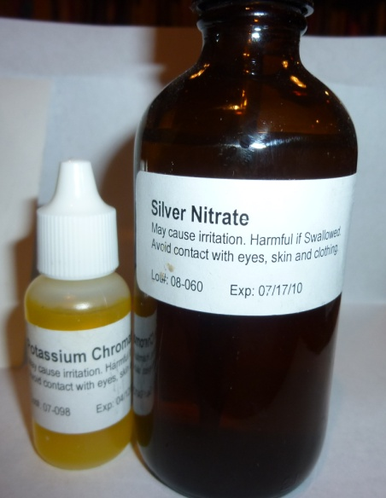
Procedure
- In a clean test tube, add one drop Konisburg indicator.
- Add 10 drops urine.
- Mix well by inverting the tube a few times.
- While counting the drops, add the titrating agent one drop at a time, inverting the test tube after each drop.
- Continue until an orange or red color rapidly occurs.
- Record results.

Interpretation of Results

17 to 25 drops: normal adrenal activity

1 to 16 drops: adrenal stress

26+ drops: adrenal fatigue
Vitamins, Minerals, and Anti-Oxidant
Home Assessments
- Vitamin C Flush
- Minerals
  - Zinc Taste Test and Zinc Challenge
  - Zinc Taste Test
  - Zinc Challenge
  - Iodine Patch Test
  - Body Bio Mineral Testing Process
- OXIDATA™ Anti-Oxidant Test


Vitamin C Flush
How to do a Vitamin C (Ascorbate) Calibration Protocol (“Vitamin C Flush”) to Determine Individual, Functional Need for Vitamin C

This material is provided from a mentor of mine, Dr. Russ Jaffe, MD:

http://www.drrusselljaffe.com/

Which Vitamin C Is Best to Use

It is preferable to use a 100% I-ascorbate, fully reduced, buffered mineral ascorbate form of Vitamin C that contains a proper balance of the major essential buffering minerals: 1) potassium, 2) magnesium, 3) calcium, and 4) zinc. No dl-ascorbate or d-ascorbate should be used as the d-ascorbate form is not absorbed by humans: people take up only the l-ascorbate. Per gram of ascorbate, we find best outcomes, patient compliance, and satisfaction from a balanced mineral content of potassium (66 mg.), calcium (27 mg.), magnesium (11 mg.), and zinc (400 mcg.).
- This means that if you were taking a half-teaspoon of buffered ascorbate that has no masking or “inert” agents in it, you would have 1.5 grams of Vitamin C and potassium, 99 mg.; calcium, 40 mg.; magnesium, 16 mg.; and zinc, 600 mcg. If there is less than 1.5 grams of Vitamin C per half-teaspoon, there is likely to be a hidden or masking agent that may cause digestive or immune problems. Perque brand is highly recommended.

How to do an Ascorbate Calibration “Vitamin C Flush”

When possible, it is best to start on an empty stomach, first thing in the morning. Allow yourself that day to finish the “flush”. Most people saturate their Vitamin C need within a few hours. Occasionally, the need is much greater, and it may take a number of hours to complete the initial calibration “flush”.

Dissolve each half-teaspoon (1.5 grams) of fully reduced, buffered mineral l-ascorbate powder (Vitamin C powder, Perque brand is highly recommended) in 2 or more ounces of water. Plan to count and record each dosage. After dissolving the powder and allowing any effervescence to dissipate (typically dissolves within two minutes), drink the beverage. The amount of Vitamin C needed depends on how quickly your body uses it up.

Below are suggestions for how to best determine your needs based on how healthy you are:
- A healthy person begins with a level half-teaspoon dissolved in 1-2 ounces of water every 15 minutes.
- A moderately healthy person begins with 1 teaspoon every 15 minutes.
- A person in ill health begins with 2 teaspoons every 15 minutes.
- If after four doses there is no gurgling or rumbling in the gut, you should double the initial dosage and continue every 15 minutes.

Continue with these instructions at the proper time intervals until you reach a watery stool or an enema-like evacuation of liquid from the rectum. This is as if a quart or so of liquid is expressed from the rectum. Caution: Do not stop at loose stool. You want to energize the body to “flush out” toxins and reduce the risk that they may recirculate and induce problems. At this time stop consuming the buffered Vitamin C for the day. However, if your calibration dosage is more than 50 grams of Vitamin C, you should consume a dosage of Vitamin C of at least 10% of the total needed to induce the “flush” later in the afternoon or evening.

Many people find that preparing a “batch” of Vitamin C allows for easier, timelier consumption of the beverage rather than making up a new batch at each interval.

Example: 30 grams (10 teaspoons) may be dissolved in 10-20 ounces of liquid. If this method is chosen, we recommend using a capped, dark bottle to avoid air or light (photo-) oxidation of the Vitamin C. Dissolved Vitamin C is stable for a day if kept cool or cold and tightly sealed.

Changing Vitamin C Need

As you become healthier, Vitamin C is used more efficiently and is better conserved in your body and less will be needed to achieve the desired effect. As your need decreases, you may notice loosening of your stool indicating that your body is consuming Vitamin C more efficiently and your need has decreased. That is the time to taper your intake.

Daily Consumption of Vitamin C After the Flush

Between calibrations, consume 75% of the total Vitamin C you need to induce the flush. You may use a liquid, powder, or a capsule and take two to four or more doses per day. The usual need for a person in a state of good health is 2-10 grams/day.

Hints for Calculating Daily Therapeutic Vitamin C Requirement
- Total the number of teaspoons consumed during the flush.
- Total the number of 1/2 level teaspoons = 1.5 grams or 1 level teaspoon = 3 grams.
- Multiply number of teaspoons times 3 (each teaspoon contains 3 grams of Vitamin C)
- Then calculate 75% of the total. This is your current daily recommended dose of Vitamin C.

Vitamin C Amount Calculation Chart
Number of level ½ tsps. = 1.5 gms. per ½ teaspoon | Number of level tsps. = 3 gms. Per teaspoon | Total grams of  Vitamin C consumed for calibration | Daily recommended dose in grams (75% of calibration total)
6 | 3 | 9 | 4.5
10 | 5 | 15 | 7.5
25 | 12.5 | 37.5 | 19
90 | 45 | 135 | 67.5

Outcome of Vitamin C Flush

Many people report a subjective sense of improved well-being after the completion of a Vitamin C calibration. This may be of short duration, initially, but is a promising sign for long-term improvement. As toxins are eliminated from the body and as it is energized through the action of the Vitamin C, you should feel progressively better for longer periods of time.

Repeat of Vitamin C Calibration

For most rapid progress, once per week is recommended. You select the frequency that meets your needs. As you repair, you may find that your need for Vitamin C increases until a consistent dose of Vitamin C is maintained.

Potential Reservations Regarding Vitamin C Calibration Process

Be sure to consume adequate water with each Vitamin C dose. A concern about fluid or electrolyte loss from the stool is thus minimized. Some people report gas or fullness while doing the Vitamin C calibration “flush”, but that is almost always due to dissolving the Vitamin C in too little water or rushing the procedure. Room temperature liquid is best for absorption. Cramps may occur, though rarely, and it is usually because too little fluid is used to dissolve the Vitamin C.

Helpful Hints and Insights
- Most people find that the flush is easy to do. Since the amount of time can vary quite a bit, it is best to do your first Vitamin C calibration on a day when you can stay home for most of the day. Once you have done a Vitamin C calibration/flush, you will have a better idea of how much time is needed.
- For most people, it takes somewhere between 3-8 teaspoons of Vitamin C to flush. It could differ for others: 15, 20, or more than 50 grams depending on your health status and how quickly your body uses up Vitamin C.
- Sometimes people remain bloated for the rest of the day of calibration. Occasionally, people have loose stools for a day or so after doing the Vitamin C flush.
- Some people have reported hot stools that seem to burn the anus after several evacuations. If so, you can use a natural salve, such as calendula ointment, to soothe the area. This tends to cease after the first few times you do the calibration.
- People with hemorrhoids, irritable bowel disease, or inflammatory bowel disease may find that the Vitamin C activates their tissues in the healing process. They may need to increase Vitamin C and bioflavonoids slowly over time before doing a Vitamin C calibration.
- Usually, people find that they feel better than they have in a very long time after the first Vitamin C flush. Some report a greater sense of well-being after the second or third. The overall consensus is that as time goes on doing these calibrations helps people feel increasingly better.

Supporting Supplementation

When introducing higher dosages of Vitamin C, your cellular machinery works harder and more efficiently. The following supplements may be helpful to allow your repair to go most smoothly.

When energy disturbances, cramps, and magnesium deficits are likely:

- Magnesium: 200 mg magnesium citrate or magnesium glycinate, twice a day

When digestive problems and inflammation are significant:
- Probiotics: 50 – 100 billion organisms in divided doses throughout the day or probiotic foods with each meal
- Anti-inflammatory nutrients and herbs: including queritin, digestive enzymes, turmeric and ginger
- Mucilaginous seeds and herbs: such as slippery elm, marshmallow, DGL licorice, plantain, chia seeds, or flax seeds

Scientifically shown homeostatic benefits Vitamin C promotes or enhances:

- Scurvy resistance: improved blood vessel and cardiovascular integrity
- Enhances hormone healthy and reduces hormone unhealthy actions
- Enhances neurotransmitter functions healthy and reduces unhealthy actions
- Promotes immune system healthy and reduces unhealthy actions 
- Enhances nitrous oxide (NO) functions 
- Enhances and repairs detoxification functions 
- Enhances ATP energy compound production 
- Enhances healthy bone formation
- Enhances and rebuilds glutathione functions 
- Promotes iron balance [uptake and release] 
- Reduces bioaccumulation of toxins 
- Improves transit time 
- Protects DNA from oxidative damage 
- Reduces toxic minerals in body 
- Enhances natural anti-cancer surveillance 
- Direct tumor cytolytic effects 

Scientifically disproven effects that Vitamin C promotes or enhances:
- immortality
- Fenton reactions in vivo
- B-12 remains active in vivo
- DNA replication error theory not confirmed in vivo

Vitamin C: Its scientific significance for human health

Vitamin C (ascorbic acid or l-ascorbate) is nature’s most potent, safer antioxidant cofactor. Vitamin C has gotten a fair amount of attention from the media in the last few years, including whether it is helpful, neutral, or harmful in limiting the number of colds, their symptoms, and their duration.
- Vitamin C aids in the maintenance of cellular membranes, cellular respiration, the peroxidase cleansing system, the restoration of vitamin E / selenomethionine complexes, and sulfhydryl enzymes such as glutathione synthetase, thereby helping to detoxify various drugs and chemicals.
- Vitamin C is also involved in hormone biosynthesis and maintaining the integrity of connective tissue, cartilage, capillaries, bones, and teeth. Vitamin C is, therefore, important in wound repair and tissue healing.
- Vitamin C has been shown to increase cellular resistance to many common viral infections (most probably due to its interferon-like activity) and enhance specific parameters of immune function.

All of these actions of Vitamin C are related to its antioxidant or reducing or electron donating abilities. The use of Vitamin C in health and disease is complex and sometimes misunderstood, although much less so when one considers the following facts and supportive background information.

While almost all animals and plants synthesize their own Vitamin C, exceptions are guinea pigs, monkeys, and humans. The first two of those eat mostly fresh Vitamin C-rich foods: fruits and vegetation. Non-human animals, when adjusted for size and weight, make the equivalent of 5 to 15 grams of Vitamin C a day, mostly in their livers and when stress free. Production can more than double when the animal is distressed.

Our genetic ancestors once had the ability to synthesize Vitamin C but appear to have lost it years ago. One enzyme is missing in a 6-enzyme process converting glucose to Vitamin C. Scientists estimate that without this mutation, when healthy we would be making 10-30 grams of Vitamin C a day throughout our lives and more when we are unwell or distressed.

Vitamin C Need

Many of us eat only small amounts of Vitamin C-rich foods. Also, our food supply contains less and less Vitamin C because of premature food harvesting, artificial ripening, and food processing.

Studies of the effects of Vitamin C seem to be confusing.
- Generally, when small doses are used (1 gram or less), little to no significant effects were reported. When larger doses are given (20-200 grams/day), significant positive changes are typically reported.
- Almost all conditions, acute or chronic, can have shortened courses and patients respond favorable. Vitamin C (in the pure, buffered, l-ascorbate) has virtually no side effects. Vitamin C has been given up to 300 grams per day, taken intravenously, without reported side effects.

This approach to determining your need for Vitamin C is of the next generation and builds upon the experience gained with “bowel tolerance” determination of Vitamin C need. Your liver would be making Vitamin C steadily, with increases commensurate with distress, if we had not lost that key enzyme. Thus, for best health, it is important to take Vitamin C regularly and steadily. Often gas, cramps, and diarrhea occur at rather low doses of Vitamin C (below 10 grams). There are many possibilities for this that are addressed above in the additional supplements recommended as helpful in selected cases.

If you wish to or must stop Vitamin C for any reason, it is quite important to taper gradually. If you stop too quickly, it doesn’t give your body time to accommodate to the change, and your body will continue to metabolize and excrete large amounts. You must reduce your Vitamin C level by several grams/day over a sufficient period (depending on how much you were taking) to prevent this from occurring.

Using the C Flush is important. Many helpful things happen at the Vitamin C saturation level that will not happen otherwise. Doses for 50 grams to 200 grams or more a day are usual for immune dysfunction states like cancer, chronic viral and bacterial infections, and other serious inflammatory or autoimmune diseases. We recommend appropriate doses throughout life and see l-ascorbate used effectively to charge up the cellular electron pool, promoting cellular healing and metabolism, purging the body of foreign invaders, and providing a base on which to build health.

Over a period of Vitamin C use, the amount of Vitamin C necessary to achieve bowel tolerance changes and fluctuates. During stress or illness, many time more can be taken (and is appropriate to take) than at other times. As healing occurs and health becomes more balanced, the amounts of Vitamin C should also change accordingly. Vitamin C can be useful to you. Use it wisely and you will be well rewarded.

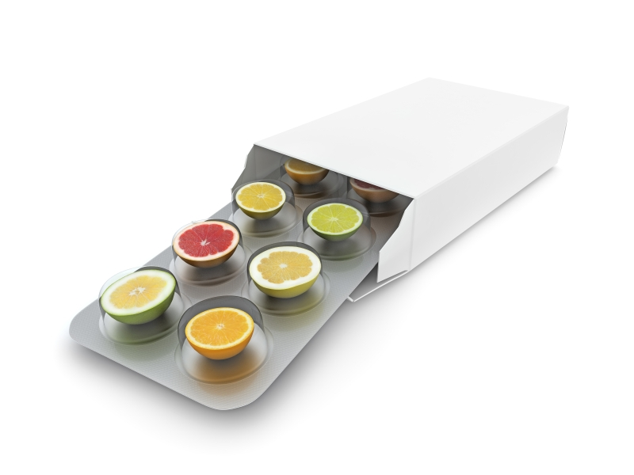

References
- Anderson R. Ascorbic acid and immune functions. In Vitamin C: Ascorbic Acid, ed. J.N. Counsel, D.H.Homed, London: Applied Science 1984:249-72.
- Anderson R. The immuno-stimulatory, anti-inflammatory and anti-allergic properties of ascorbic acid. Annals Rev Nutr 1984; 6:19-45.
- Delafuente JC and Panush RS. Modulation of certain immunologic responses by Vitamin C. Int J Vitam Nutr Res 1980; 50: 44-51.
- Seib PA, Delbert BM, eds. Ascorbic Acid: Chemistry, Metabolism and Uses, Advanced Chem User, Washington DC: Am Chem Soc 1982; 604.
- Thomas WR and Holt PG. Vitamin C and immunity: An assessment of the evidence. Clin Exp Immunol 1978; 32:370-79.
- Banhegyi G, Braun L, Csala M, Puskas F and Mandl J. Ascorbate metabolism and its regulation in animals. Free Radical Biology & Medicine 1997; 23 (5):793-803.
- Meister A. Glutathione-ascorbic acid antioxidant system in animals. J Biol Chem 1994; 269: 9397-9400.
- Winkler BS, Orselli SM, Rex TS. The redox couple between dilatation and ascorbic acid: a chemical and physiological perspective. Free Radic Biol Med 1994; 17: 333-349.
- Smimoff N and Pallanca JE. Ascorbate metabolism in relation to oxidative stress. Biochem Soc Trans 1994; 24: 472-478.
- Bode AM, Yavarow CR, Fry DA, Vargas, T. Enzymatic basis for altered ascorbic acid and dehydroascorbic acid levels in diabetes. Biochem Biophys Res Commun 1993; 191:1347-1353.
- Frei B, England L, and Ames BN. Ascorbate is an outstanding-antioxidant in human blood plasma. Proc National Academy Science. USA. 1989; 86: 6377-6381.
- Chattedee IB. Ascorbic acid metabolism. World RevNutr Diet 1978; 30:69-87.
- Johnson FC. The antioxidant vitamins. CRC Crit Rev Food Sci Nutr 1979; 11:217-309.
- Levine M and Morita K. Ascorbic acid in endocrine systems. Vitam Horm 1985; 42:1-64.
- Lewin S. Vitamin C: Its Molecular Biology and Medical Potential. New York/London: Academic 1976.
- May JM, Qu ZC, Whitesell RR. Ascorbic acid recycling enhances the antioxidant reserve of human erythrocytes. Biochemistry 1995; 34:12721-12728.
- Jaffe R and Deykin D. Evidence for the Structural Requirement for the Aggregation of Platelets by Collagen. J Clin Invest 1974; 53:875-883.
- Jaffe R, Kasten B, MacLowry K, Young D. False Negative Occult Blood Tests Caused by Ascorbic Acid. Ann Int Med 1975; 83:824-826.
- Jaffe R. Platelet Interaction with Connective Tissue. In Physiological Reaction of Blood Platelets (Gordon, Ed.) Elsevier 1976, 261-292.
- Jaffe R. The Science of Wellness Medicine. Proceedings 2nd International Symposium on Human Functioning. Biosynergetics Institute. Wichita, Kansas, 1978.
- Jaffe R and Zierdt W. An Occult Blood Test Procedure not Subject to Inhibition by Reducing Substances. J Lab Clin Med 1975; 93: 879-886.
- Pitas R, Nelson C, Jaffe R, Mahley R. 15,18-Tetracosadienoic Acid Content of Sphingolipids from Platelets and Erythrocytes of Animals Fed Diets High in Saturated or Polyunsaturated Fats. Lipids l978; 13: 551-556.
- Jaffe R, Lawrence L, Schmid A, MacLowry K. Inhibition by Ascorbic Acid (Vitamin C) of Chemical Detection in Urine. Am J Clin Path 1979; 42: 468-470.
- Jaffe R. Delayed Hypersensitivity in Chronic Illness and Health. Health Studies Collegium, Vienna, VA, 1985; 44.
- Jaffe R. Delayed Allergy and Inflammation: Link to Autoimmunity. Health Studies Collegium, Vienna, VA, 1985; 33.
- Jaffe R. Immune Defense and Repair Systems: Clinical Approaches to Immune Function Testing and Enhancement.
- Townsend Letter for Doctors Part 1: #79/80, 88-92; Part 2: #81/82, 38-44; Part 3: #83/84, 59-64, 1989.
- Deuster PA and Jaffe R. A Novel Treatment for Fibromyalgia Improves Clinical Outcomes in a Community-Based Study. J Musculo Pain 1998; 6:133-149.
- Jaffe R. Autoimmunity: Clinical Relevance of Biological Response Modifiers in Diagnosis, Treatment, and Testing, Part I. Intl J Integrative Med 2000; 2 (2):16-22.
- Jaffe R. Autoimmunity: Clinical Relevance of Biological Response Modifiers in Diagnosis, Treatment, and Cofactor Replacement, Part II. Intl J Integrative Med 2000; 2 (4): 58-65.
- Jaffe R and Brown S. Acid-Alkaline Balance and Its Effect on Bone Health. Intl J Integrative Med 2000; 2 (6): 7-18.

For additional information, questions, and clinical comments on this Vitamin C Calibration

protocol, please contact PERQUE LLC

Client Services Department

44621 Guilford Drive, Suite150, Ashburn, VA 20147

Tel: 800.525.7372 • Fax: 703.450.2995

E-mail: clientservices2@PERQUE.com Web: www.PERQUE.com
Zinc Taste Test and Zinc Challenge

Zinc is one of the most important trace minerals and is frequently found deficient. It is essential for tissue growth, skin integrity, immunity, adrenal function, blood sugar control, and essential fatty acid regulation.

Zinc deficiency can lead to a number of problems including infertility, lowered immunity, poor wound healing, thyroid imbalance, adrenal imbalance and inefficient digestion. The zinc taste test is an excellent test for assessing zinc deficiency. The zinc challenge will help determine how zinc deficient you are and what type of supplementation you may need. The zinc taste test is an easy method of assessing your zinc levels that can be performed at home to establish a baseline then repeated to assess the effectiveness of supplementation.

Zinc Taste Test

Materials
- Liquid zinc solution
- Stopwatch or timer

Procedure
- Make sure your mouth is free of strong tastes such as mint. Have a stopwatch, timer, or watch with a second hand on it, because you will be timing how soon you taste the zinc taste test solution.
- Measure out 1 tablespoon of liquid zinc, put it into your mouth, hold and swish around your mouth, but do not swallow.
- Start timing as soon as the solution is in your mouth and note when you first taste the solution. Swallow after 30 seconds.
- On the form below, note the time it took to first taste the solution and describe the strength of taste or presence of an after taste in the column marked Initial test.

Zinc Taste Test Chart
Name
 | Time to Taste Solution | Describe Strength of Taste or After-Taste  Circle the best description
Initial  Test |  | Immediate taste, strongly metallic | Moderate taste, delayed metallic | No taste initially  Sweet or bitter | Tasteless or tastes like water
Initial  Test |  | Level 1 | Level 2 | Level 3 | Level 4
 |  | No Need for Further Testing |  | Do Zinc Challenge

Zinc Taste Test Interpretation
Level | Interpretation | Description
1 | Optimal Zinc Levels | An immediate, unpleasant, strongly metallic taste occurs within a few seconds.
2 | Mild Zinc Deficiency | A definite, but not strongly unpleasant taste, is noted within 4-6 seconds and tends to intensify over time. Metallic taste is delayed.
3 | Moderate Zinc Deficiency | No taste initially, but develops in 7-13 seconds. Possibly sweet or bitter.
4 | Extreme Zinc Deficiency | Tasteless – tastes like water.
Zinc Challenge

The Zinc Challenge is used to assess how zinc deficient you may be.

Procedure
- Follow the same directions for doing the Zinc Taste Test.
- Repeat the test successively, resting 30 seconds between tests.
- Note on the Zinc Challenge Tracking Chart the time it took to taste the solution and the strength of taste.
- Repeat this process until you have a strong immediate taste, or you perform 6 successive tests with no taste noted. At this point discontinue the testing.

Zinc Challenge Tracking Chart
Name
 | Time to  Taste Zinc |  | Describe Strength of Taste or After-Taste  Circle the best description
Challenge  #1 |  |  | Immediate taste, strongly metallic. | Moderate taste, delayed metallic. | No taste initially.  Sweet or bitter. | Tasteless or tastes like water.
Challenge  #2 |  |  | Immediate taste, strongly metallic. | Moderate taste, delayed metallic. | No taste initially.  Sweet or bitter. | Tasteless or tastes like water.
Challenge  #3 |  |  | Immediate taste, strongly metallic. | Moderate taste, delayed metallic. | No taste initially.  Sweet or bitter. | Tasteless or tastes like water.
Challenge  #4 |  |  | Immediate taste, strongly metallic. | Moderate taste, delayed metallic. | No taste initially.  Sweet or bitter. | Tasteless or tastes like water.
Challenge  #5 |  |  | Immediate taste, strongly metallic. | Moderate taste, delayed metallic. | No taste initially.  Sweet or bitter. | Tasteless or tastes like water.
Challenge  #6 |  |  | Immediate taste, strongly metallic. | Moderate taste, delayed metallic. | No taste initially.  Sweet or bitter. | Tasteless or tastes like water.

Zinc Challenge Interpretation
Level from Zinc Taste Test | Interpretation | Description
1 | Optimal Zinc Levels | - No need for zinc supplementation. Repeat zinc taste test once a month or anytime you’re in a particularly stressful situation, exposed to people who are ill, or experiencing signs of zinc deficiency.
2 | Mild Zinc Deficiency | - Supplement with liquid zinc: 1 teaspoon twice a day on an empty stomach.  - Retest in 1 month.

If your score was Level 3 or 4, use the table below to determine your next action steps.

# Challenges to Metallic Taste | Interpretation | Action Plan
1 | Moderate Zinc Deficiency | - Supplement with liquid zinc: 1 teaspoon twice a day on an empty stomach.  - Retest after 1 bottle.
2 | Significant Zinc Deficiency | - Supplement with liquid zinc: 1 teaspoon twice a day on an empty stomach.  - Retest after 2 bottles.
3 | Moderately Severe Zinc Deficiency | - Supplement with liquid zinc: 1 teaspoon twice a day on an empty stomach.  - Retest after 3 bottles.
4 | Severe Zinc Deficiency | - Supplement with liquid zinc: 1 teaspoon twice a day on an empty stomach.  - Retest after 4 bottles.
5 | Very Severe Zinc Deficiency | - Supplement with liquid zinc: 1 teaspoon twice a day on an empty stomach.  - Retest after 5 bottles.
6 | Extremely Depleted of Zinc | - Supplement with liquid zinc: 1 teaspoon twice a day on an empty stomach.  - Retest after 6 bottles.
Did not achieve metallic taste | (Probably other nutrient deficiencies confounding the test.) | - Supplement with liquid zinc: 1 teaspoon twice a day on an empty stomach.  - Test homocysteine and look for high iron/low hemoglobin, low liver enzyme levels, and other signs of Vitamin B6 deficiency; supplement if indicated.  - Test white blood cell zinc and magnesium and supplement as indicated.

** If zinc levels are still low after the recommended supplementation, switch to 45 mg twice a day of zinc picolinate or zinc citrate and take for 60 days. Redo the Zinc Taste Test.

Iodine Patch Test

Iodine is a very common deficiency because our soils are depleted and the only reliable

source of iodine is the sea. Since most people don’t eat sea vegetables on a regular basis,

it’s difficult to consume enough iodine unless you use iodized salt. Another factor that increases your need for iodine is the presence of radioactive iodine in the environment via the widespread consumption of the iodine antagonists:
- fluoride and chlorine (added to public water supplies)
- bromine (used as a dough conditioner in most commercially available bread)

These chemicals will quickly deplete iodine from the body and interfere with iodine metabolism leading to a number of problems including hypothyroidism, lowered vitality, cognitive dysfunction, lowered immunity, and obesity. Iodine is essential for the proper synthesis of thyroid hormone, so it is very important to maintain healthy iodine levels.

The Iodine Patch Test is a test that’s used by many functional medicine doctors to assess for iodine deficiency. It’s an easy test that can be performed at home. Although it’s somewhat controversial as a valid indicator for iodine deficiency, there appear to be as many opponents as proponents. I’ve used it for close to two decades and it appears to be a fairly good indicator.

The theory behind the test is that the iodine will take about 24 hours to fully penetrate your skin if your body is sufficient in iodine. If you’re deficient, you’ll absorb it more quickly. I’ve observed people who had their “iodine patch” disappear within 8-12 hours, then supplement with topical iodine such that as soon as it disappeared, they would reapply. With repeated application, the patch began to last longer until after a couple of weeks, the iodine patch lasted over 24 hours. By this time, the patient was feeling more energetic and had fewer low thyroid indicators.

Materials
- a bottle of liquid iodine: I generally use Ioply by Apex Energetics: 800-736-4381 or online

Procedure
- Paint the skin of the inside of your forearm or abdomen with a 2-inch square patch of 2% iodine solution, being careful not to get the solution on your clothes as it will stain.
- Note the time you put the iodine onto the skin on the Iodine Patch Test Tracking Chart.
- Let the iodine path air dry before putting on clothes.
- You will need to monitor how quickly the patch fades.
- Avoid soaking in hot tubs or baths for 24 hours as the chlorine or bromine in the water will cause the iodine to patch to come off.
- Note the time it takes for the patch to disappear on the chart.

Iodine Patch Test Tracking Chart
Name
Date | Time Iodine Applied | Time Color Disappears | # Hours to Completely Disappear

Iodine Patch Test Result Interpretation

Overall, the faster the body draws in the iodine, the greater the iodine need is likely to be.

- Patch Disappears | - Iodine Deficiency | - Action
- < 12 hours | - Severe | - Supplement with topical iodine. Reapply as soon as it disappears. Alternatively, take Ioderal (available on Amazon) or other oral iodine supplement: 12.5 mg three times a day. Repeat test in 2 weeks and adjust dose.
- 12 - 18 hours | - Moderate | - As per above except oral dose 12.5 mg twice a day.
18 - 24 hours | - Mild | - As per above except oral dose 12.5 mg once a day.
- > 24 hours | - None | - Nothing. Continue to eat and supplement as you have been to support Iodine sufficiency.

Body Bio Mineral Testing Process

Mineral deficiencies are almost epidemic in today’s world. Soil is depleted, food processing removes vital minerals, and stress depletes your reserves.

The test kit form Body Bio, uses a taste testing process to determine if you have a deficiency or excess of any of the 8 minerals listed below. Details about the process follow in a copy of the product brochure.

- Potassium
- Zinc
- Magnesium
- Copper
- Chromium
- Manganese
- Molybdenum
- Selenium

Materials
- Body Bio MTK plus - Liquid Minerals Test Kit

Procedure
- Pour a small amount of the mineral solution from the test bottle in a glass or cup and sip.
- Record the number that best fits how that mineral tastes on the Mineral Testing Tracking Chart.

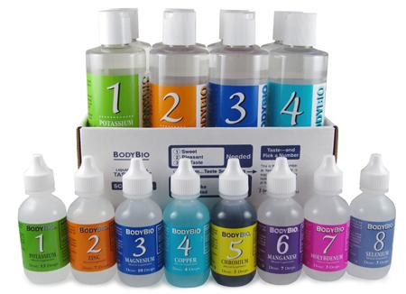

Mineral Testing Tracking Chart

Name
Date | Rating  (1 – 7) | Potassium  Bottle 1 | Zinc  Bottle 2 | Magnesium  Bottle 3 | Copper  Bottle 4 | Chromium  Bottle 5 | Manganese  Bottle 6 | Molybdenum  Bottle 7 | Selenium  Bottle 8

Ratings

- Sweet
- Pleasant
- No Taste
- Hmm… Taste Something
- So-So
- Don’t Like
- Pretty Bad

*** The goal is to achieve Rating #4 – Your body is telling you that you are getting adequate amounts of this mineral.

Body Bio Mineral Testing Brochure

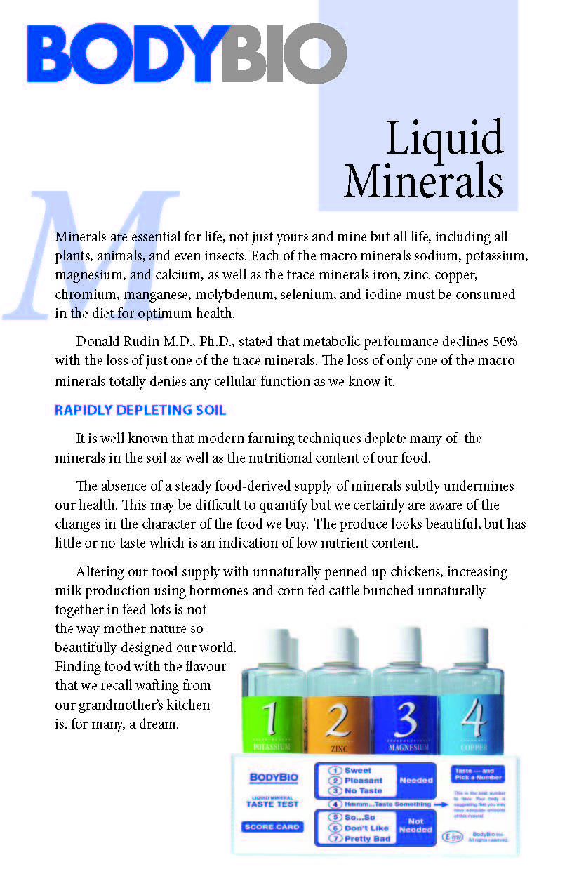





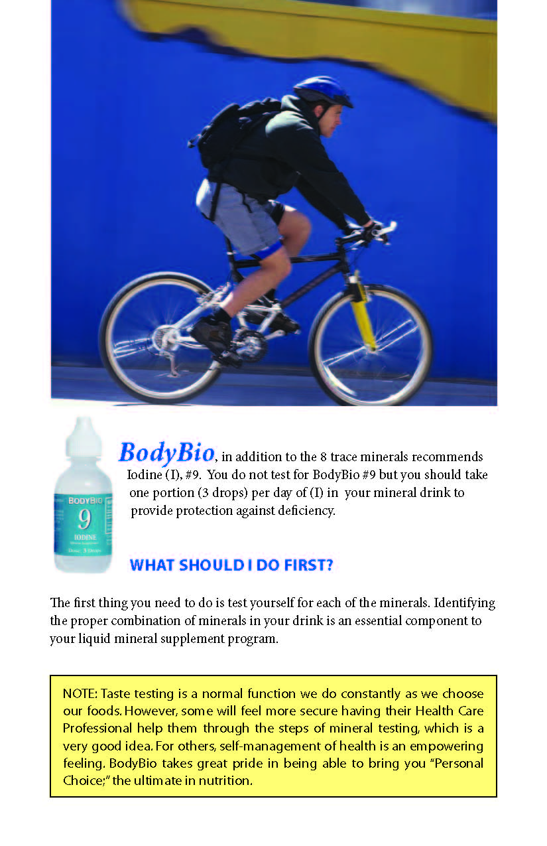



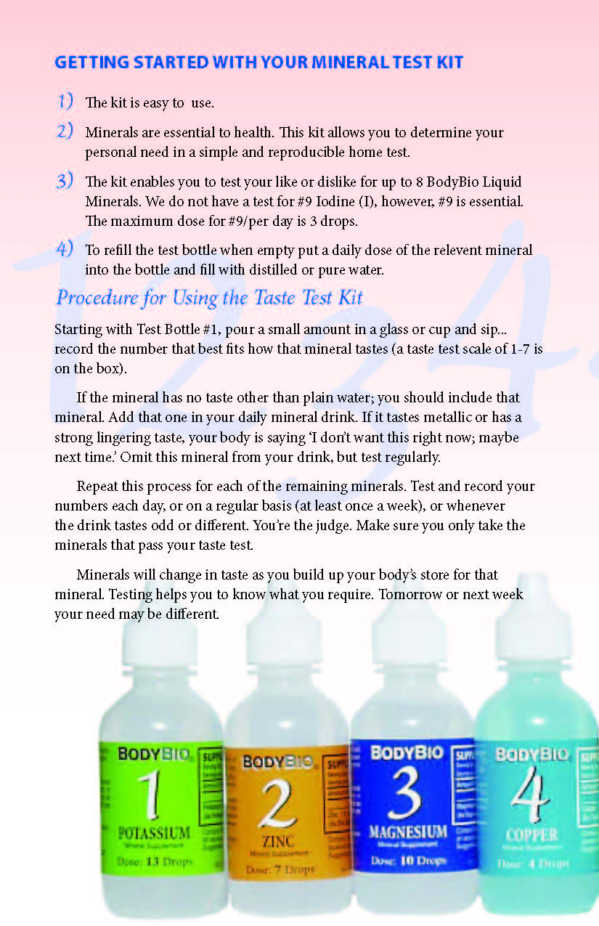

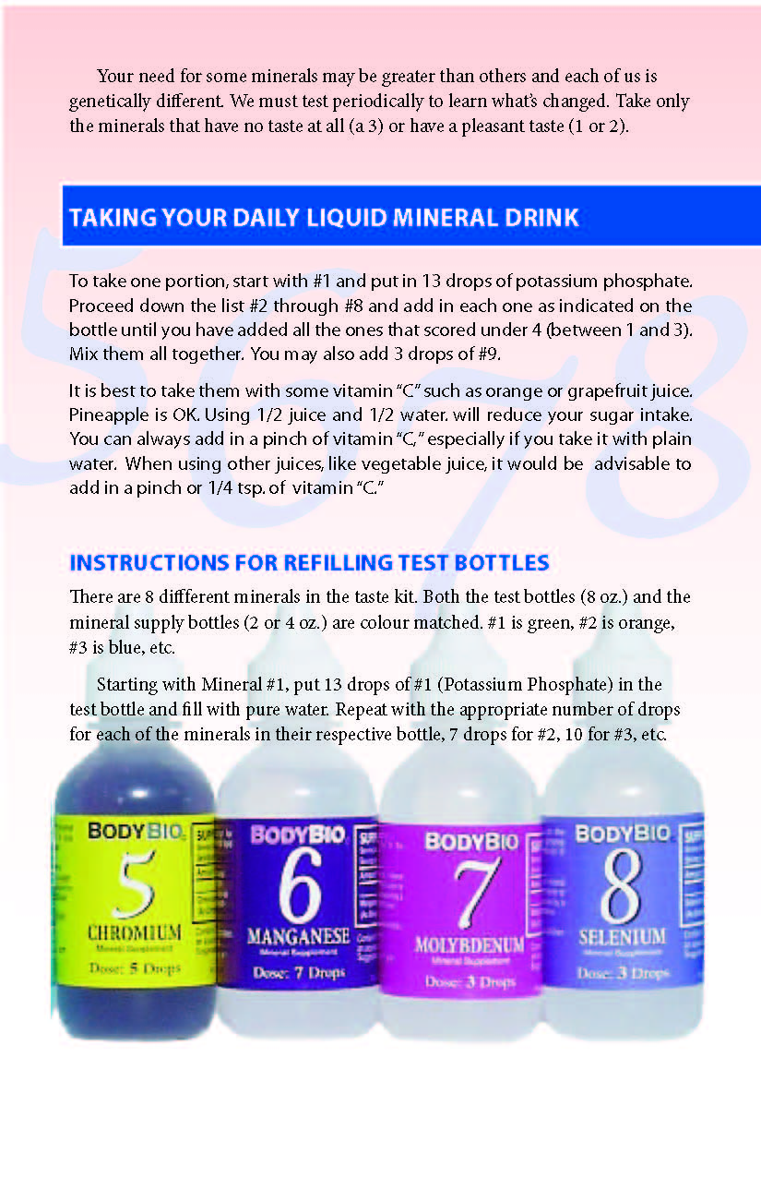



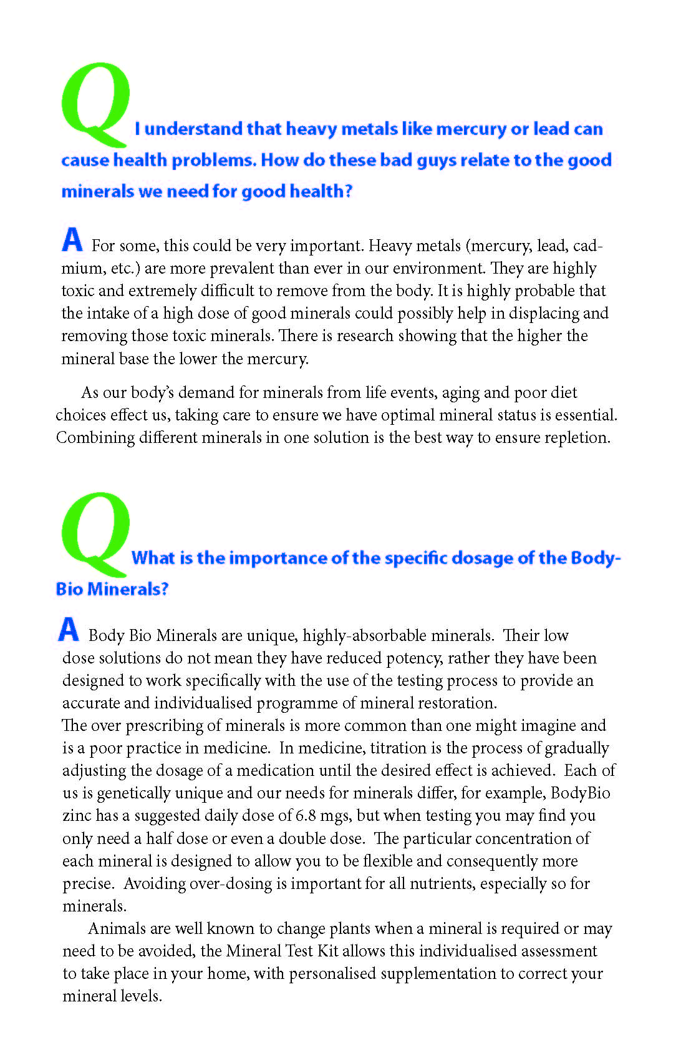

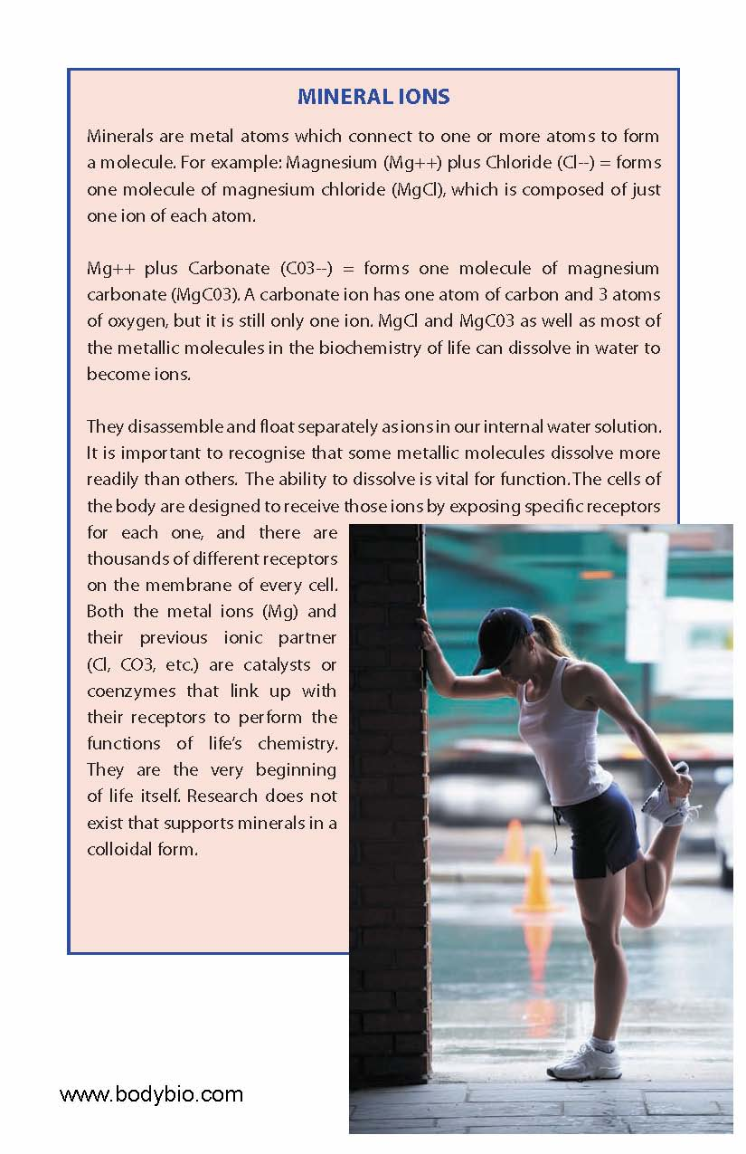

OXIDATA™ Anti-Oxidant Test

Free radical damage to your body tissues have been linked to all the major health challenges – heart disease, diabetes, cancer, autoimmune disease, infections…the list goes on. Too many free radicals over a period of time lead to chronic diseases, cell damage, and faster aging.

Causes of free radical damage:
- Heavy metals and petrochemicals in the environment and in our foods
- Over-the-counter and prescription drugs
- Cooked oils and fats
- Radiation
- Viruses, yeast and bacteria in the system
- Low dietary anti-oxidants
- Mental/emotional stress

Free radicals are like wild fire. When you have inadequate anti-oxidant activity, free radicals attack normal, healthy tissue which is the trigger for disease and rapid aging. Anti-oxidant supplementation is a popular approach to improving health. But how do you know if your supplementation is working?

The Oxidata test enables you to determine the degree of stress on your body caused by free radical activity. The test measures a free radical called malondialdehyde (MDA) in your urine. It’s a measure of the overall antioxidant capacity of the body. This urine test is 40 to 50 times more reliable than a MDA blood test, one of the standards used in clinical laboratory testing. It’s also much easier and less expensive than a blood test. Test accuracy is within the range of 90%.

Materials
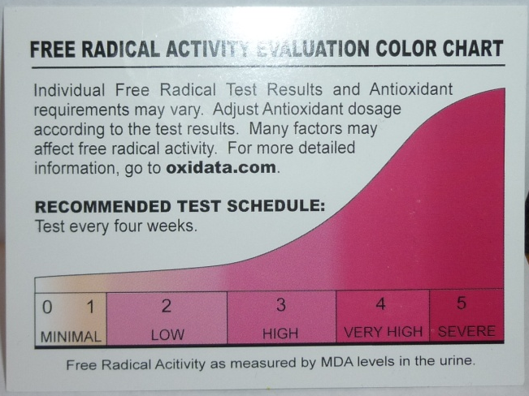
- Oxidata test kit: includes a tiny ampoule containing the reagent, a urine collection cup, and a dropper
- You can order the test kit at http://www.drritamarie.com/go/Oxidata

Procedure
- Collect a fresh urine sample.
- Draw up the urine into the dropper and add the specified number of drops to the vial.
- Let it sit for 5 minutes to develop.
- Compare the color to the card and interpret the results.

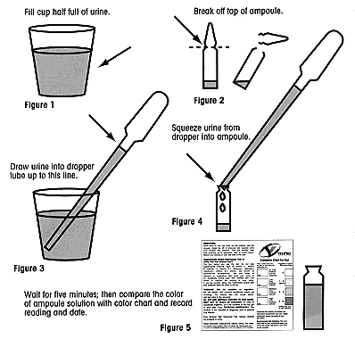
There are some diet and supplement restrictions to pay attention to the day before you take the test.

Avoid taking vitamin C, vitamin B complex, or any individual B vitamins such as vitamin B-1 (thiamine), vitamin B-2 (riboflavin), or vitamin B-3 (niacin).

Use the test at least once a week if the initial test shows high oxidative stress, then reduce to once or twice a month after antioxidant supplementation has
reduced it to a normal level.

Oxidata Test Results Tracking Chart
Name
Date |  | Oxidata Value | Follow-up Actions

About Dr. Ritamarie Loscalzo, MS, DC, CCN, DACBN


Dr. Ritamarie Loscalzo is fiercely committed to transforming our current broken disease-care system into a true health care system where each and every practitioner is skilled at finding the root cause of health challenges and using ancient healing wisdom married with modern scientific research to restore balance.

As the founder of the Institute of Nutritional Endocrinology, Dr. Ritamarie specializes in using the wisdom of nature to restore balance to hormones with a special emphasis on thyroid, adrenal, and insulin imbalances. Her practitioner training programs empower health and nutrition practitioners to get to the root cause of health concerns by using functional assessments and natural therapeutics to balance the endocrine system, the master controller.

Dr. Ritamarie is a licensed Doctor of Chiropractic with Certification in Acupuncture and is a Diplomat of the American Clinical Nutrition Board. She is a Certified Clinical Nutritionist with a Master of Science in Human Nutrition and Computer Science, and she has completed a 2-year, 500-hour Herbal Medicine Program.

Dr. Ritamarie is also a certified living foods chef, instructor, and coach, and she has trained and certified hundreds of others in the art of using palate-pleasing, whole fresh food as medicine. As a certified HeartMath® provider, Dr. Ritamarie is passionate about using HeartMath® techniques to guide clients and reduce the negative impact of stress on their health.

A best-selling author, speaker, and internationally recognized nutrition and women’s health authority with over 23 years of clinical experience, Dr. Ritamarie offers online courses, long-distance coaching and counseling, and deeply empowering and informative live events.

Her articles have appeared in the Journal of Nutritional Perspectives, Natural Awakenings, Purely Delicious, and many other national magazines as well as countless online publications. She is in great demand as a speaker at conferences nationwide and is the author of several books.
To learn more and get started on 7 Simple Strategies to Jumpstart Your Energy Practically Overnight, visit www.JumpstartYourEnergy.com.
Call 877-727-5992 or visit www.DrRitamarie.com to add value to your events and programs by inviting Dr. Ritamarie as an expert energy recharge coach and/or to find out how you can benefit from her extensive collection of vibrant living health resources.
Health Restoring Books and Programs


B4 Be Gone Program: Balance your blood sugar and banish belly fat, brain fog, and burnout so you can regain the energy, focus, and self-confidence to live your life with passion and purpose. Complete with instructional modules, 30 days of menu plans, a 220-page recipe collection, exercise regimes, stress transformation techniques, sleep guidelines, timing cycles, videos, audios, and a community support forum, you'll have an effective and balanced lifestyle approach to reclaiming your health. http://www.B4BeGone.com


CAFE (Correcting Adrenal Fatigue and Exhaustion): If you need a wake-up call that will heal instead of steal your energy, it’s time for Dr. Ritamarie’s CAFE program. This 5-part program provides insight and strategies to repair and refuel your tired adrenal glands, the body part responsible for protecting you in the face of stress and danger. http://www.CAFEProgram.com


FAST (Food Allergy Spy Training): You’ll be guided step-by-step through my clear, proven system to uncover your food allergy culprits, repair the damage, and remove the underlying causes of your food intolerances. The FAST program is built around the Gold Standard for identification of food allergens - the Food Elimination Provocation Process (FEPP) - and allows you to move through the healing process at your own pace. http://www.FoodAllergySpy.com


GREEN Cleanse: A 7-day cleanse built around the healing mineral and nutrition-rich benefits of eating leafy is just what you need to transform exhaustion into energy, eliminate excess belly fat, and feel younger and stronger than you did in your teens! http://www.GREENCleanseProgram.com


VITAL Community: Dr. Ritamarie's VITAL Community offers Vibrant Ideas and
Tools for Awesome Living! VITAL is a member community offering monthly features for those who want the networking support of like-minded people, are looking for chef-approved ways to "liven" up meals, appreciate cutting-edge science on natural health topics, and who enjoy the fulfilling benefits of Awesome Living! http://www.VITALHealthCommunity.com



Dessert: Making It Rich Without Oil: The only dessert book comprised of 100% gluten-free, dairy-free, sugar-free, soy-free, and oil-free whole raw ingredients. Each recipe includes a mouth-watering, full-sized photograph. The recipes are easy to make, fun to eat, and will make the transition to a healthier diet a very pleasant experience.
http://www.DrRitamarie.com/makeitrich

Dried and Gone to Heaven DVD Home Study Kit: This kit includes full instruction on the care and use of your dehydrator, health gems, and complete recipe demonstrations. Now you can make all your favorite comfort foods in ways that support your health, rather than drain it. Complete with DVDs, recipe guide and instruction manual, laminated reference cards, and a whole new perspective on life.
http://www.DriedAndGoneToHeaven.com
Power Breakfasts Ideas: Quick, healthy, and energizing recipes and tips for starting your morning with recipes that give you plenty of energy to fuel you throughout the day!

http://RawPowerBreakfastablespooncom
Quick Healthy Meals on the Run: Lunch and Dinner Ideas: A valuable resource of more than just recipes! A complete guide to creating quick and delicious meals from ingredients you have on hand.
http://drritamarie.com/classes/lunchdinner.htm

Seasonal Specials: Halloween, Thanksgiving, Christmas and Hanukah recipe books and videos. http://www.drritamarie.com/shop/seasonal
A Sampling of Other Online Video Classes

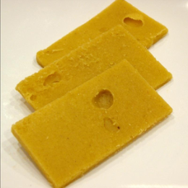
www.RawFoodUniversity.com
These include access to a private web page, a PDF format recipe e-book with photos of each recipe, and a separate video for each recipe.

Cheese: No Dairy, No Guilt Online Video: Learn to make delicious, nutritious raw cheeses that satisfy your cravings and nourish your body.
http://www.drritamarie.com/go/cheese

Thai Food Goes Raw Online Video: Gluten-free, dairy-free and brimming with exotic spices, these recipes are easy to make and will delight any palate.
http://www.drritamarie.com/go/Thai

Gluten Free Pizza and Pasta Online Video: Experience the traditional tastes of Italy with a gluten-free and dairy-free twist as we prepare pizza (crust, sauce and cheese); Living Lasagna, Rawvioli, Manicotti, Spaghetti and other pasta dishes; "Parmesan Cheese", and more.
http://www.drritamarie.com/go/RawPizzaPasta
Healthy Holiday Feasts Online Video: It’s easy to prepare a delicious, nutritious, gluten- free, dairy-free holiday meal that everyone can enjoy!
http://www.drritamarie.com/go/holidayfeast
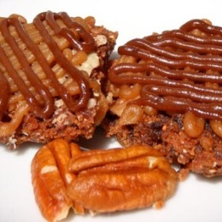
Sweets for the Holidays Online Video: Create amazing gluten-free, dairy-free, raw vegan versions of traditional holiday treats such as gingerbread men, cookies in festive seasonal shapes, candy, turtle brownies, and more.
http://www.drritamarie.com/go/sweets

Find all the Resources You Need for Natural Healing
Based on Leading-Edge Science

http://www.DrRitamarie.com



