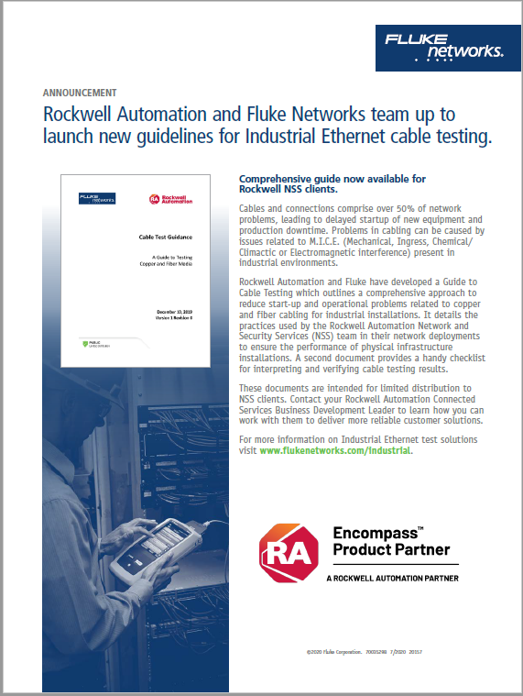
In addition to the test guidance below, Rockwell Automation’s Network and Security Services (NSS) group offers additional guidance for their network deployments to ensure the performance of physical infrastructure installations.

See the announcement and work with your Rockwell Automation dealer and Rockwell Automation Connected Services for more information.

------------------
The intent of this test guidance document is to provide users, consultants and engineers with a guide to executing cable tests for new Industrial Ethernet network deployments or major retrofits to existing Industrial Ethernet networks that suffer from intermittent problems. This document can aid consultants or engineers in developing contractual specifications covering the certification of copper communication cables (Category 5e, etc.) used for Industrial Ethernet.

The goal is for the cable media to be fully tested to ensure that the Industrial Ethernet cable has been installed in a manner that 1) reduces the time to commission new infrastructure and 2) minimizes startup-up problems. The cable test results create a baseline that can be referred to if network problems down the road impact plant operations.

There are hundreds of combinations of test methods and test limits possible in Industrial Ethernet Cabling. This document describes the minimum test requirements for the most commonly specified cabling used in Industrial Ethernet network designs.

Content contained within this document was developed by Fluke Networks and Rockwell Automation. It is offered as a general guide. Suitability for any intended use is the responsibility of the user. This document may be copied and edited without Fluke Networks’ permission solely for the purpose of developing such specification. No other licenses or permissions are granted. (March 2020)

Copper Cable Test Guidance
  - Copper Cable
The copper cabling to be used must comply to the cable specifications defined within the network design. The cabling specified may vary based on the areas in which the cable will be used and routed.
Proper testing of the cable will require that the cable tester be setup to test to the correct environmental classification. The three environmental classifications (M.I.C.E. 1,2 and 3) are determined using four categories: Mechanical, Ingress, Climatic/Chemical, and Electromagnetic Compatibility (EMC) referred to as MICE in TIA-1005A and ISO 11801:3 standards. Note: Electromagnetic Compatibility (EMC) may also be referenced as Electromagnetic Interference or EMI.

The MICE factors are graded on a severity scale from 1 to 3, where 1 is negligible, 2 is moderate and 3 is severe (refer to Figure 1.1).

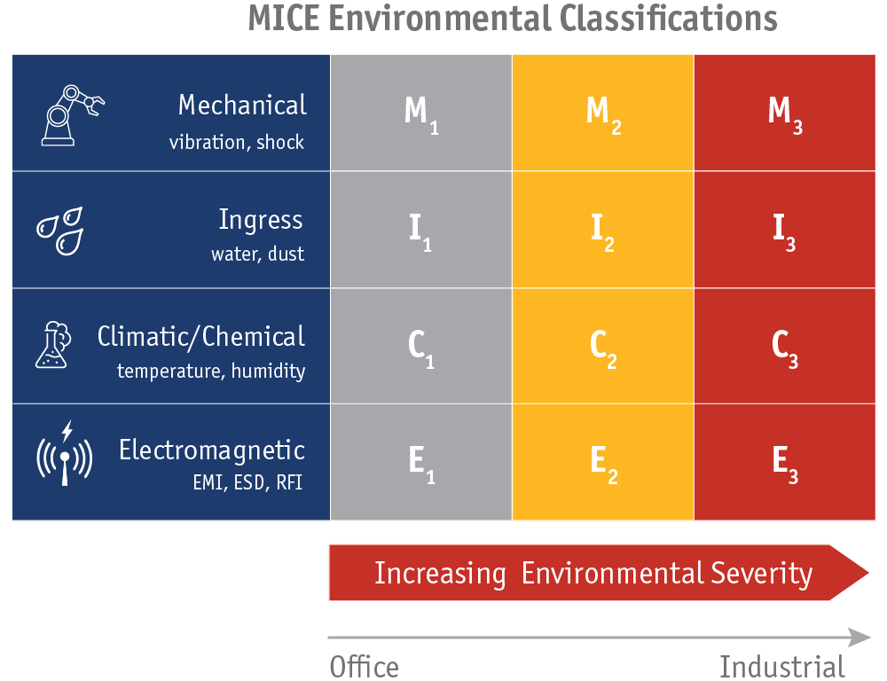
Figure 1.1 - TIA-1005A MICE Criteria
Figure 1.2 illustrates an example of different MICE classified areas within a facility. As one can see from this simplified illustration, it is possible for cabling to be in multiple areas that may be classified or rated differently. The ODVA document provides further details on how MICE classifications can be reduced or mitigated using different techniques including separation and isolation. Once the MICE ratings have been determined, networking components can be selected that meet the MICE classification.

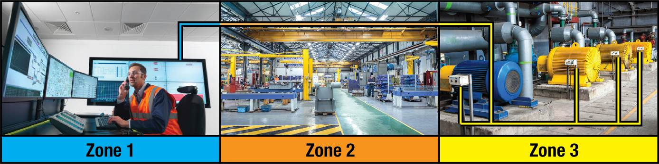
Figure 1.2 - Example MICE Classification Areas

EtherNet/IP Media Planning and Installation Manual: Publication PUB00148RO

This publication by the ODVA describes the required media components and how to plan for, verify, troubleshoot and certify EtherNet/IP networks.

  - General Requirements
- All tests are to be performed to the latest revision of ANSI/TIA-568 including the TIA-1005A standard for industrial premises.
- Test equipment is to be within the calibration period and have current firmware when the test is performed.
- All cables to be tested using proper test limits for the cable specified and installed.
- All cables must PASS the test run using the proper test limits.
- Marginal test results shown with an asterisk (*PASS) are considered a failure and are not acceptable.
- Test results for every cable are to be documented and delivered in native LinkWareTM (.flw) format.
- Personnel performing the cable testing have been trained on the test equipment being used.

  - Cable Category and Testing Limits
and Table 1. summarize the key data points that are necessary to properly test the most common cable types used in Industrial Ethernet installations. The first table should be used for testing the complete channel down to the end device connection. The second table should be used for testing the backbone or permanent link portion of the installation. The tables identify the copper cable Category, the Fluke Networks cable tester to be used, and the test limits to be specified for the EMC factor of the MICE environmental classification (i.e., the “E” in the MICE categories).

 | TIA 1005A and ISO 11801:3 identify the MICE criteria and ratings as referenced in Figure 1.1. All MICE factors are important to the overall installation but the ability to test to all the MICE factors is not feasible. Cable testers can only test to the EMC factor and therefore the cable tester limits are defined by the EMC factor.  An area classified with a MICE EMC factor of E3 and tested using the E3 test limits will have more stringent performance requirements for Electromagnetic Interference or EMI than an area classified as an E1 or E2.

Table 1.3 - Common Copper Cable Categories and Test Limits for End Device Connections
End Device Connections |  | Set-up and Test Limits for MICE EMC Factor
 |  | EMC Rating E1 | EMC Rating E2 | EMC Rating E3
Copper Cable Type  Category | Fluke Networks Test Equipment  Channel Test | Office  General Purpose Office Areas and Data Rooms | Light Industrial Plant Floor, Cabling Run Separated from High Noise (EMI) Sources | Heavy Industrial Cabling Run Near High Noise (EMI) Sources (VFDs, Motors, Welding, etc.)
Cat5e | DSX5000 CableAnalyzerTM with RJ45 Channel Adapters, and M12  (D or X) adapters.  Model DSX2-5-IE-KIT | TIA 1005A  CAT 5e Channel  E1 (+ALL) | TIA 1005A  CAT 5e Channel  E2 (+ALL) | TIA 1005A  CAT 5e Channel  E3 (+ALL)
Cat6 |  | TIA 1005A  CAT 6 Channel  E1 (+ALL) | TIA 1005A  CAT 6 Channel  E2 (+ALL) | TIA 1005A  CAT 6 Channel  E3 (+ALL)
Cat6A |  | TIA 1005A  CAT 6A Channel  E1 (+ALL) | TIA 1005A  CAT 6A Channel  E2 (+ALL) | TIA 1005A  CAT 6A Channel  E3 (+ALL)

It is best to test the complete channel end to end, however in some circumstances this may not be possible (e.g., MDF to IDF locations cabled patch panel to patch panel and patch panels to wall outlets, etc., but no end devices are installed or patched). When these situations arise, the cable should be tested following the permanent link test guidelines outlined in Table 1..

Permanent link tests use the test limits of the MICE EMC factor E1 rating. Standards organizations have not provided specific values for E1, 2, and 3 environments for the Permanent Link limits

Table 1.4 - Common Copper Cable Categories and Test Limits for Permanent Link Cabling
Backbone (Permanent Link) |  | Set-up and Test Limits for MICE EMC Factor
 |  | EMC Rating E1 | EMC Rating E2 | EMC Rating E3
Copper Cable Type  Category | Fluke Networks Test Equipment  Permanent Link Test | Office  General Purpose Office Areas and Data Rooms | Light Industrial Plant Floor, Cabling Run Separated from High Noise (EMI) Sources | Heavy Industrial Cabling Run Near High Noise (EMI) Sources (VFDs, Motors, Welding, etc.)
Cat6 | DX-5000 CableAnalyzerTM with DSX-PLA004S Permanent Link Adapter Set | TIA  CAT6 Perm. Link  (+ALL) | n/a | n/a
Cat6A |  | TIA  CAT6A Perm. Link (+ALL) | n/a | n/a

  - Preparing for Test Execution
In order to expedite the testing process, the proper equipment and information about the cable to be tested must be known.
    - Test Equipment
The recommended test equipment is the DSX Cable Analyzer, DSX2-5-IE-KIT, shown in Figure 1.. The kit includes measurement modules and M12D, M12X and RJ45 adapters. Optional Permanent Link Adapters (not shown) may be needed for Cat 6 or 6A backbone cable testing.
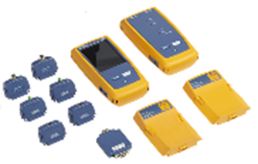
Figure 1.5 – Fluke Networks DSX Cable Analyzer used for Copper Testing
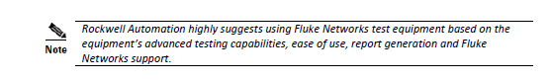
The test equipment must be checked to confirm acceptability of the test results.
- Confirm the tester has the latest firmware.
- Confirm the Copper Modules to be used for the test are within the 1-year calibration period.
- Confirm ALL testing will be completed within the calibration period (i.e., don’t start testing with a meter that will be out of calibration by the time testing is completed).

    - Cable Data Required
In order to properly set-up the tester to perform the test, data for each cable to be tested is required. This includes the following data:
- Cable ID
  - From Location (device and port) of end 1
  - To Location (device and port) of end 2
- Cable Type (e.g., Cat5E, Cat6, Cat6a, etc.)
- Cable Construction (e.g., U/UTP, S/FTP, etc.)
  - Review Cable Manufacturer’s Specifications
- Cable Nominal Velocity of Propagation (NVP) expressed as a percentage
  - Review Cable Manufacturer’s Specifications
- MICE Rating as defined by ODVA and TIA-1005A (i.e., the environment classification of the installed cable)
- Cable Usage - Structured or End Device
  - Structured/Permanent Link or Backbone Cable (e.g., cable typically used between major network locations, MDF to IDF, IDF to Zone, etc.)
  - End Device Cable (e.g., cable typically used an access switch and a controller, PC, IO, or node to node in a device level ring application)
- Cable Length - Approximate length of cable de-rated for temperature if over 85M

    - Basic Steps to Set-up a DSX-5000 for Copper Cable Testing
- Select an Existing Project or Create a New Project
- Select or Enter Operator Name
- Select an Existing Test or Create a New Test Setup
- Choose Cable Type Category – refer to Network Design Package and installed cable Category
- Choose Cable Construction - refer to Network Design Package and installed cable
- Choose Test Limit – refer to and select the limit based on MICE Rating classification
- Choose Outlet Type – options will be based on the selected test limit (e.g., TIA568A/B, M12-D two pair, and M12 X-Code)
- Save Test Setup for re-use
- Execute Test
- Save Test and enter the Cable ID – refer to cable schedule and use the From/To fields for the cable identification. Note: the cable IDs can be entered on the tester or imported into LinkWare from an Excel file.

    - Cable Test Set-up Screens
Figure 1.6, Figure 1., and Figure 1. show example cable test screens for different cable types and MICE EMC ratings. These also show the type of test to be run, channel or permanent link and the referenced TIA Standard.
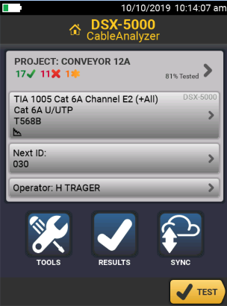  Figure 1.6 - Cat 6A EMC Rating E2 | 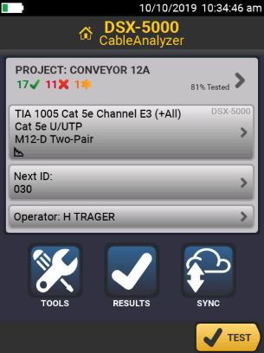  Figure 1.7 - Cat 5e EMC Rating E3 | 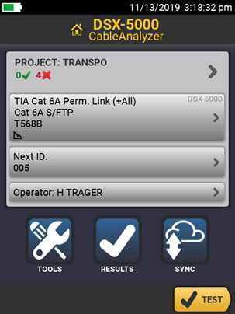  Figure 1.8 - Cat 6A Structured Cabling
Channel Test on Unshielded Cat 6A cable in a MICE EMC Factor E2 environment (industrial area distant from electrically noisy wires and equipment) using RJ45 connectors. | Channel Test on Unshielded Cat 5e cable in a MICE EMC Factor E3 environment (close to electrically noisy; motors, VFDs, welding, etc., washdown, vibration, flex, or temperature extremes) using M12-D code connectors set-up for 2 pair cable. | Permanent Link Test on Shielded Cat 6A backbone cable using RJ45 connectors.

    - Cable Length Derating Based on Expected Temperature
The total length of a copper channel includes all the cabling between the two devices (i.e., permanent link cable plus equipment cords and patch cords). The standards used for testing assume a temperature of 20°C or less allowing for a total length of 100 meters. If the expected temperature is over 20°C, the total length of the cable is to be reduced by the amount shown in Table 1.9. The table assumes that the channel includes 10 meters of patch and equipment cords at 20°C.

The cable tester length limits cannot be changed for higher temperature operating conditions and there is no option to enter the expected temperature. Therefore, it is up to the tester to flag test results that pass but may be impacted by temperature.

Table 1.9 - Copper Cable Length Derating
Temperature |  | Length Derating (m)
Deg. C | Deg. F | Unshielded | Shielded
20 | 68 | 0.0 | 0.0
25 | 77 | 1.0 | 0.5
30 | 86 | 3.0 | 1.5
35 | 95 | 4.5 | 2.3
40 | 104 | 6.0 | 3.0
45 | 113 | 8.3 | 3.5
50 | 122 | 10.5 | 4.5
55 | 131 | 12.8 | 5.3
60 | 140 | 15.0 | 6.0

Example:
If a cable is installed in an environment where the temperature averages 40°C over the length of the cable, then the maximum horizontal cable distance should be reduced from 90 meters to 84 meters.

    - Testing the Shield
Industrial control systems are known for generating EMI, also called noise. Many devices generate noise with the most common being variable speed motor drives and motors used for moving machinery or materials around the factory floor. When shielded cables are used it is possible for a loop to be formed by the currents using the shield as a path between the two earth ground offsets. These currents can increase the error rates and chances of machine outages.

Unshielded (UTP) cables selected for the appropriate EMC rating (E2 or E3) are sometimes specified in place of shielded cables to prevent EMI and ground offsets from disrupting network traffic. EMI immunity is measured with Transverse Conversion Loss (TCL) and Equal Level Transverse Conversion Transfer Loss (ELTCTL) tests. TCL and ELTCTL is measured with the +ALL test limit shown in the Cable Test Set-Up Screens section. The tester will always run a continuity test for the shield. It will fail a unshielded cable if the he shield test is set to “on”, so shield test should be set to “off” for unshielded cables.

Shielded cables may be specified for the application to prevent radiated noise. Special attention must be paid to how the shield is used within the application as sometimes the shield is intentionally disconnected at one end to eliminate ground current between devices. The tester will perform a continuity test on the shield, but it will only fail a cable for an open shield if shielded cable is selected and the shield test is set to “on”.

If a shielded cable fails the TCL test (part of the +ALL measurements), the cable manufacturer should be contacted, and the specific application and installation discussed. Be prepared to advise them of the EMC rating (E2 or E3) in your situation and whether the shield is connected at one end only or both ends. It is possible that the cable manufacturer will have a recommendation for the proper testing to execute in this situation to validate the test results.

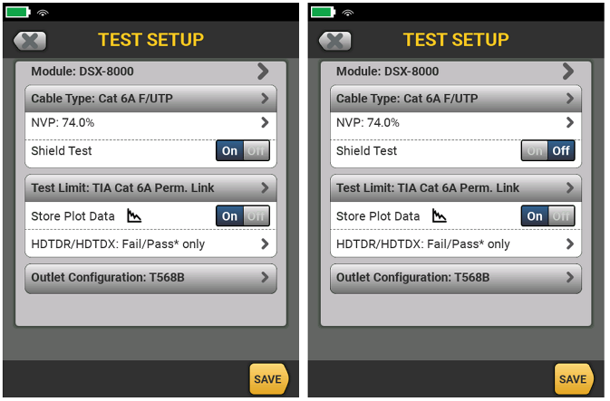
Figure 1.9 – Shield test on (left) and off (right)

Fluke Networks – What are TCL and ELTCTL?

This blog explains the terms, what they indicate and the cable tester’s capability to execute this test. TCL and ELTCTL are excellent indicators of noise immunity and whether a cable link will provide adequate performance in noisy.

Rockwell Automation Knowledgebase - Grounding the Ethernet Cable Shield in an EtherNet/IP System

This article explains the history of screened cable usage and best practices when selecting and installing Ethernet cabling in noisy environments.

Cable Testing – Evaluating the Results

Copper Test Results – Example from LinkWare Software
The Network Design Package should include the Cable Test Guidance Document which states the test results be provided in LinkWare (.FLW) format. This format is the raw data collected by the cable tester at the time of the test. Using LinkWare software allows the test results to be analyzed more quickly. It also provides more details on the measured link especially failures. The data can be sorted and analyzed much easier than attempting to read the data in the PDF report and unlike the .FLW file, PDF reports can be edited.
The snapshots provide some examples extracted from the LinkWare software to illustrate the key areas to review when analyzing the test results. The checklist will reference these figures and areas so they should be used in parallel.

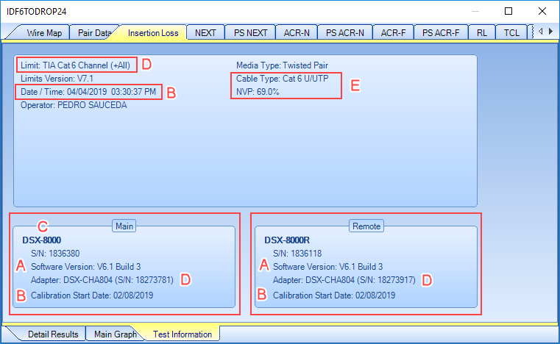  Figure 2.3 - General Test Information | 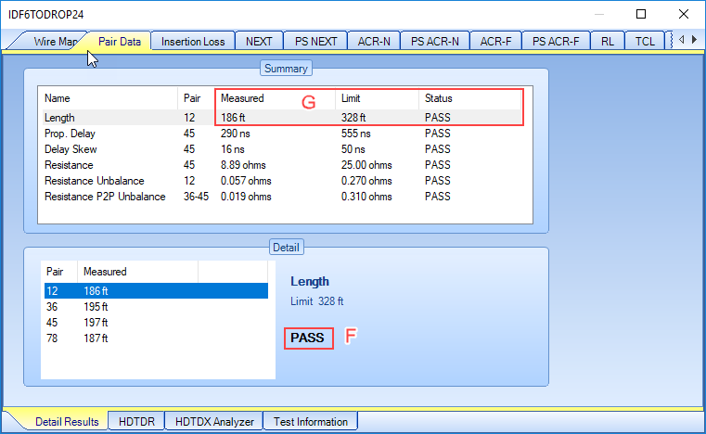  Figure 2.4 - Copper Pair Data Test Results

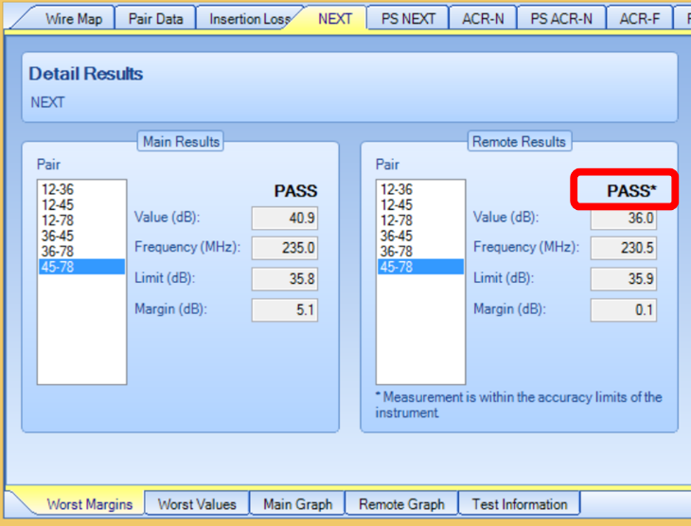  Figure 2.5 - Marginal Pass (PASS*) Test Results - Not Acceptable | 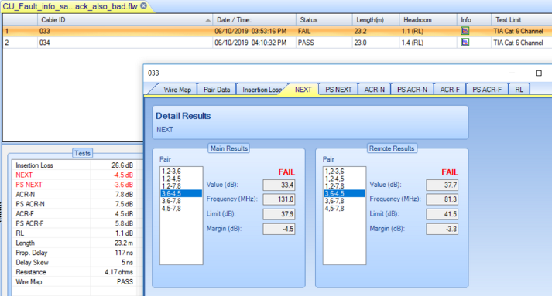  Figure 2.6 - Copper Failure Example

Copper Test Results – Example PDF Report
In cases where the test results have only been provided as a PDF Report, analyzing the results will take more time.
The snapshots provide some examples taken from PDF Reports to illustrate the key areas to review when analyzing the test results. The checklist will reference these figures and areas so they should be used in parallel.

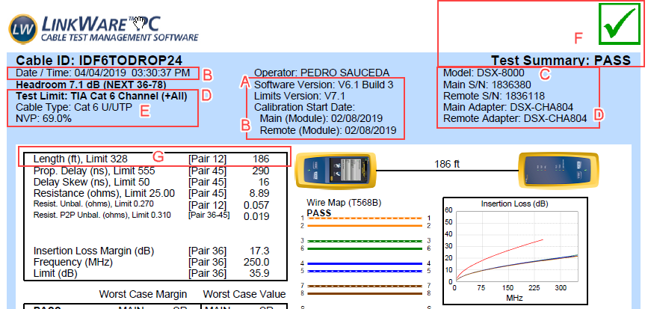
Figure 2.7 – General Test Information
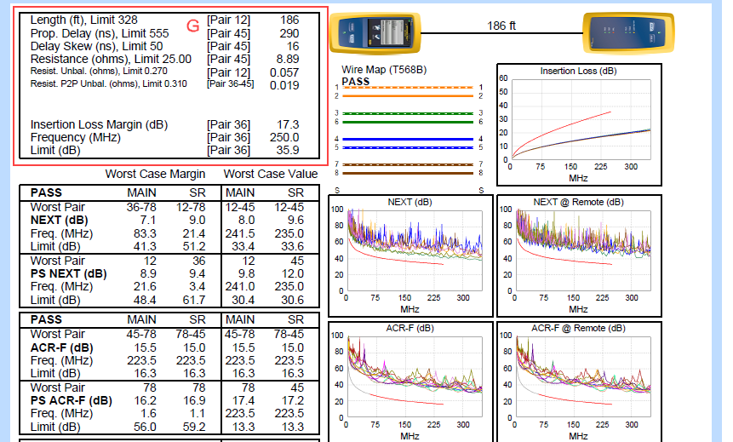

Figure 2.8 - Pair Data Test Results

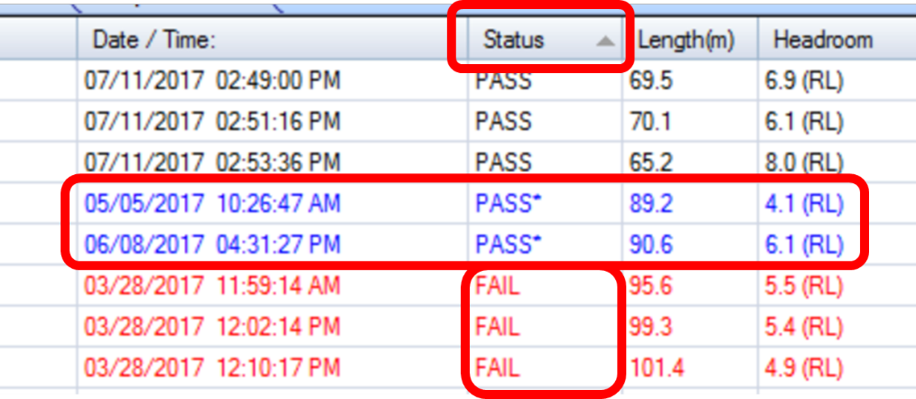
Figure 2.9 - Marginal Pass (PASS*) and Failed Test Results – Not Acceptable

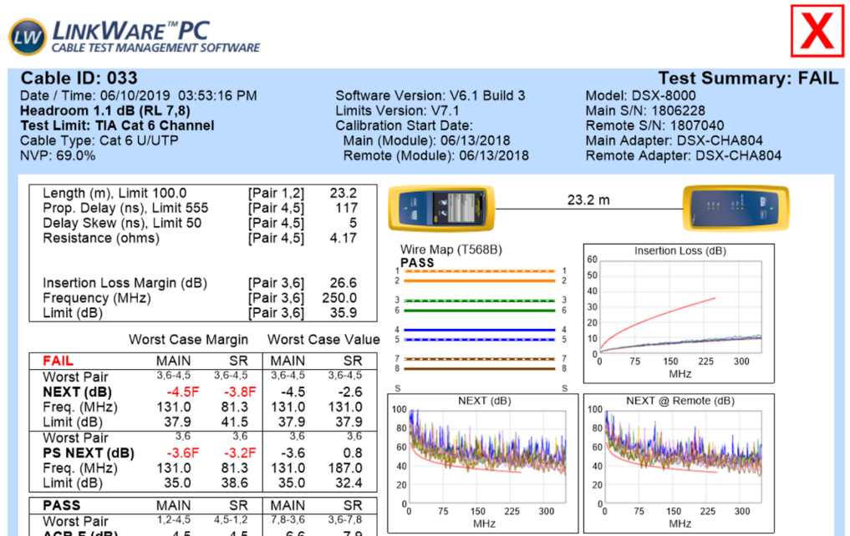
Figure 2.10 – Copper Test Failure

Copper Test Checklist
The checklist should be used to confirm acceptance of the test results provided. If any of the checks do not meet expectations, then the issue should be remediated, and tests rerun if required.

Item | Task |  | Expected Results/Remediation |  | Reference Examples
C.1 | Review the testing requirements that were specified within the Network Design Package and what the Installer received as part of the RFP.  Confirm the test results provided match what was specified in the Bid Documents.  Refer to the Cable Test Guidance document included in the Network Design Package. | The test results provided match what was specified in the Bid Documents.  Request the tests be completed per the specification documents if they do not conform. |  | The specification calls out the test results to be provided in LinkWare (.flw) format but only the PDF was received.  The tester is out of calibration.
C.2 | Confirm the tester has the latest firmware.  Compare the Software Version to the latest available from the Fluke Networks website. | The cable tester Software Version matches the latest available from the Fluke Networks website.  Software Version = Latest Version  Perform a firmware update if the tester is not using the latest version and retest. |  | Refer to ‘A’ in the test result examples.  Software Version V6.1 Build 3  (As of 4/10/2020, the latest Software Version available for download is V6.5)
C.3 | Confirm the tester and copper modules used for the test are within the 1-year calibration period.  Compare the Test Date to the Calibration Dates shown. | The test was run within 12 months of the Calibration date.  Test Run Date – Calibration Date < 12 months  Get the meter calibrated and retest if the results are not within the 12-month calibration period.  To make sure that the modules operate within the published specifications for accuracy, have them calibrated at a Fluke Networks authorized service center every 12 months. |  | Refer to ‘B’ in the test result examples.  Calibration Date was 02/08/2019  Test Run Date was 04/04/2019
C.4 | Confirm the cable tester used is an approved model for the cable test to be performed. | The cable tester used for the test meets or exceeds the capabilities of the specified cable tester.  Cable Tester Used >= Cable Tester Specified |  | Refer to ‘C’ in the test result examples.  The DSX-8000 cable tester was used. The cable tester provides additional capabilities above the specified DSX-5000.
C.5 | Using the Cable Data collected (i.e., Cable ID, Cable Type, Cable Construction, Cable NVP, MICE Rating, Cable Usage, and approximate Cable Length) and the Cable Test Guidance table of Common Copper Cable Categories and Test Limits…  Confirm the Test Limit used for the test is correct for the Cable Type, Cable Usage, and MICE Rating for where the cable is installed. | The cable tester was setup using the correct Test Limit. (e.g., Test Limit = TIA 1005A Cat6A Channel E3 (+All) for a Cat6A cable installed in a heavy EMI environment connecting to a controller).  The module adapters used are correct for the test limit executed (e.g., channel adapters used when the test limit is a channel).  The test must be executed again If the wrong test limit was specified for the module adapter used. |  | Refer to ‘D’ in the test result examples.  The cable tester was setup for TIA Cat6 Channel (+All) and the RJ45 Channel Adapters were used.
C.6 | Confirm the correct Test Module Adapters were used.  Check the module adapter to verify the correct adapters were used based on the cable to be tested.  CHA = Channel Adapter  PLA = Permanent Link Adapter | The cable tester used the correct channel or permanent link modules for the test (i.e., Test Limit) performed.  Example Modules (not all possibilities are shown)  RJ45 Channel Test should use DSX-CHA004  RJ45 Perm. Link Test should use DSX-PLA004  M12D Channel Test should use DSX-CHA021S  M12X Channel Test should use DSX-CHA-M12-X-S  The test must be executed again if the wrong modules were used. |  | Refer to ‘D’ in the test result examples.  The cable tester used the RJ45 Channel Test Modules for a Cat6 Channel Test.
C.7 | Using the Cable Data collected (i.e., Cable ID, Cable Type, Cable Construction, Cable NVP, MICE Rating, Cable Usage, and approximate Cable Length).  Confirm the Cable Type and Cable Construction tested matches the installed cable. | The installed cable type matches the cable specified in the network design and the tester was configured to test that cable type.  Example  Network Design = Cat6 U/UTP  Installed Cable = Cat6 U/UTP  Cable Type Configured = Cat6 U/UTP  The test must be executed again if the wrong cable type and construction was used. |  | Refer to ‘E’ in the test result examples.  The Cable Type Configured = Cat6 U/UTP.  The Network Design specified Cat6 U/UTP and the cable installed is Cat6 U/UTP.  The cable tester was set-up for Cat 6 U/UTP and this aligns with the design and installed cable.
C.8 | Compare the measured Cable Length to the approximate Cable Length collected as part of the Cable Data details.  Using the Cable Data collected, confirm the Cable NVP value shown in the test result matches the cable manufacturer’s specifications.  NVP characterizes how fast a signal is traveling down the cable relative to the speed of light in a vacuum, and it is what allows the tester to calculate the length of the cable.  Expressed as a percentage, NVP is best set by using the NVP specification provided by the cable manufacturer. Since the speed of light in a vacuum is the highest speed that can possibly be achieved, the value is always below 100% with most twisted-pair cabling in the 60 to 80% range. | The cable length should be in the ballpark of the approximated length and should not exceed the maximum length as defined by the standards.  Maximum Length = 90m for Permanent Link  Maximum Length = 100m for Channel Link  Note the standard allows 10% extra length.  The installed cable’s NVP is properly entered into the cable tester. If this value doesn’t match, it can affect the cable length results. |  | Refer to ‘E’ and ‘G’ in the test result examples.  The installed cable specification listed the NVP as 69% which is the value shown in the test results.  The measured cable length of 186ft is less than the standard limit of 328ft (100m).
C.9 | Confirm the cable tested past the test. Review the results for each cable looking for PASS, PASS*, and FAIL results. | Each cable tested must result in a PASS.  PASS* are marginal results and are not acceptable.  All PASS* and FAIL test results require rework and retest. |  | Refer to ‘F’ in the test result examples.  Additional details on failed tests are shown in snapshots included in the test result examples.  Using LinkWare, you can sort the results by the Status column and quickly uncover Marginal PASS and FAIL test results.

