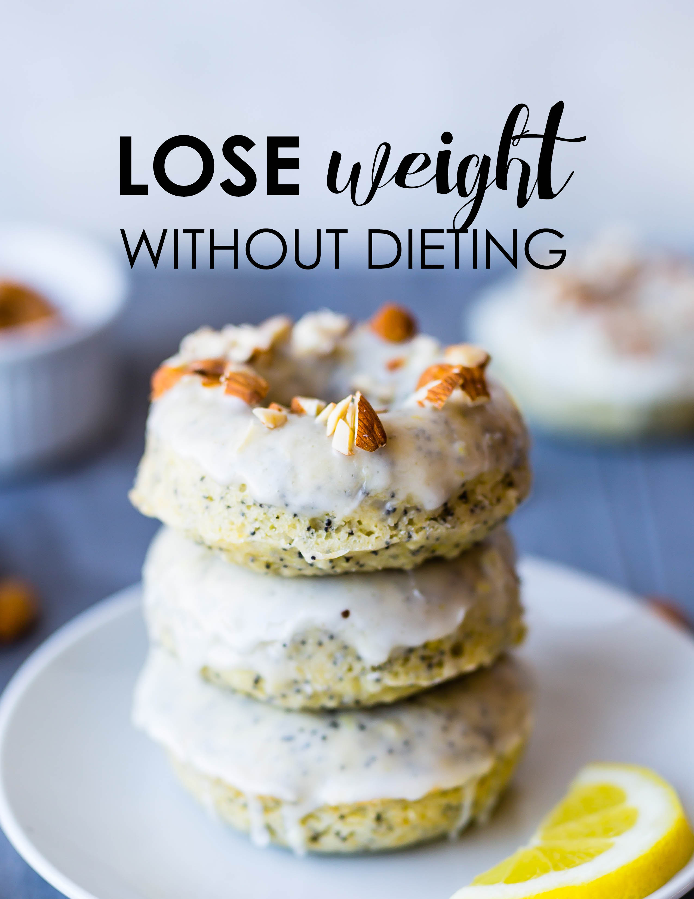

WHY WHAT YOU EAT IS IMPORTANT TO LOSING WEIGHT

Let’s start by looking at what you eat. What foods are you addicted to, what are your favorite foods? What foods can you not live without? We all have foods we say we can live without, wouldn’t bother us if, say, Brussel sprouts fell off the face of the earth, never to be seen again. But there are other foods that, whether they provide real sustenance or not, we feel like we could not live without.

What foods would be hard for you to let go of? What foods do you crave? Now that you have those in mind, write them down on a piece of paper. Then write down WHEN you usually eat them. If there are healthier foods on your list, give yourself permission to eat them. Try to substitute a healthy food at a time when you crave a junk food. But also give yourself permission to eat those unhealthy foods every once in awhile. If you don’t allow them every now and then, and try completely denying yourself them, you will more than likely eat just about anything to try to satisfy the craving or end up overindulging on that food anyway.

The more you deny yourself of what you want, the more you are going to crave it, and the more likely you are to abuse the craving in the end. You crave a cookie, have A cookie, or two, but don’t have six or seven or ten or the whole bag! Be good to you and you will be a happier person in the end. You can still lose weight, believe it or not! I am not a doctor or dietitian. I don’t have a degree, nor am I a weight loss counselor. I am just like you—I have tried and failed many times and have found out a few things over the years that opened my eyes to healthier living. The key to long-term weight loss isn’t just about losing weight; it’s about gaining a healthier lifestyle.

WHY THE DIETS YOU TRY

DON'T WORK

When it comes to weight loss, you can’t just diet and lose a few pounds and think, “That’s it! I’m all done and good to go.” Losing weight is a lifestyle choice and a total change in how you eat and what you do. Sure, you can go on a diet and restrict yourself; there are thousands out there! I am sure you have heard of the grapefruit diet and cabbage soup diet, but think about what that means. It means truly restricting yourself from all the foods you really like, and eating only what you are told to eat. You lose a bunch of weight and feel great (or maybe not so great, because you haven’t been able to eat your favorite foods) and you quit the diet. You’ve lost the weight you wanted to, so why continue?

So here you are, 10, 15, 20 pounds lighter and looking better and feeling better. Your clothes are fitting much better, and maybe you even go buy new clothes! You are so excited for the new you and can’t imagine a better feeling. The diet worked and you start telling all your friends about it and they decide to try it and everyone is excited. But when you stop the diet, the weight starts creeping back on, and you wonder where you failed.

It failed because it didn’t teach you the one most important thing when it comes to real, sustained weight loss: HOW to eat what you usually eat and keep the weight off! Those pre-made packaged food diets do the same thing; they don’t teach you how to portion your own meals correctly, so once you get off them you start putting the weight back on. So now what? Where do you go from here? If no diet will truly work, what hope is there for losing weight?

You can and will lose weight as soon as you find your groove and stick to it! Yes, you can still eat your favorite foods and lose weight. Yes, you can go to parties and enjoy and lose weight. And yes, you can go on vacations and lose weight. Isn’t it great to be able to say YES to yourself? You need to be able to say “no” also though. No, you don’t need that extra helping. No, you don’t need an extra piece of cake and no, you can’t sit idle and expect to lose any weight. You need to know the limits and stick to them without having to deny yourself anything. If you can remember this one thing, I can ALMOST guarantee you that you will still lose some weight, even if you do nothing else.

It takes 20 minutes for your stomach to register as full; in other words, it takes about that long for the food to get into your stomach and the signal that there is food in there to reach your brain. If you can wait 20 minutes before you go and get seconds, you will most likely realize you are not hungry and don’t need that second helping. Surprised? Try it and see!

GETTING IN YOUR GROOVE

AND STICKING WITH IT

When it comes to losing weight, it’s important for you to get into your groove. You need to lose weight for you and only you; your parents, friends, and significant others who are getting onto you about your weight are not reason enough to lose it and, in most cases, the pressure will cause the opposite effect. When you set out to lose the weight, do it because it is what you want, not what others want you to do so you are not setting yourself up for failure.

Find at least 1 activity you really enjoy doing and do it with all you have! If you like bike riding then get a good bike and go out and ride. Even if you are only going around the block at first don't give up, after a while, you will be able to do that block a few times without effort and pretty soon you will find yourself going a mile or two or more! The point is to get you up and moving, doing something you don't do on a daily basis because that is something you aren't used to doing and you will start losing weight because you are adding an element to your lifestyle that wasn't there before.

Find something you enjoy and take advantage of it—you will have fun and lose weight at the same time. Anything you do, any change you make in your normal routine when it comes to fitness will have some impact on not only your health but your weight. Let’s say you walk around the house quite a bit, a little up and down stairs cleaning or picking up after yourself or the kids and with your daily routine you have been stuck at the same weight for months or even years. When you ADD something else to your routine you are getting more of a workout, you’re changing things up and burning more calories than you had been.

Keep It Off

You could lose weight by making one small change in your everyday routine. It doesn’t have to be difficult, and you don’t have to starve yourself or go on some odd diet. Real, long-term weight loss happens when you change both what you EAT and what you DO. Those crazy diet plans? They only address one part of the problem, and it’s only a temporary fix. You CAN lose weight, and you DON’T have to diet.

Losing the weight and keeping it off does not happen overnight; it is the result of consistent effort. Start small. Change the way you eat one particular food for one meal of the day—say, more vegetables at dinner and fewer sweets before bed. Change or add one activity in your day; if you usually take the elevator at work, or drive the two blocks to pick up your child from school, try the stairs or take the sidewalk. Do that for a week. The next week, keep those changes but add one more. You will gradually start to see a change in your lifestyle and your waistline that you can be happy with.

Work with Me

