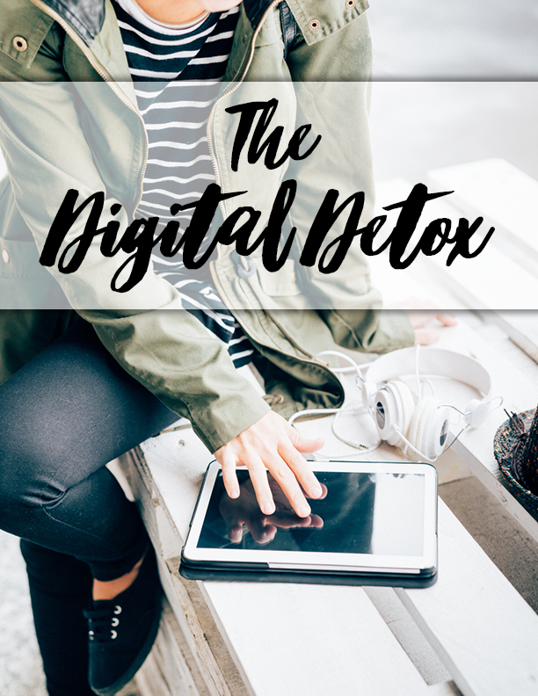
[Insert picture of yourself]
Hi there!

My name is [insert your name], and I’m a Certified Health Coach through [insert name of the school you attended].

[insert short paragraph about yourself]

[INSERT YOUR MISSION STATEMENT & NICHE – aka “I help busy moms lose weight without the hassle of constant dieting.”]

It’s my passion to teach [insert your why and the reason you’re sharing this guide with your clients]

Ready to dive in? I am!
Love,
[insert your name]

We are living in an age of ever-increasing technology which has brought digital devices to our hands and made them accessible throughout the day and even during the night. These technological advancements are causing more harm than good to our health and relationships and detaching from them is becoming a challenge.
However difficult your think it may be, it is not impossible to digitally detoxify yourself, if you stay committed.
The following step-by-step guide will help you to attain the goal of setting a limit on the technology and not letting it take over your life.

Plan Your Digital Detox
If it seems like your life cannot run without technology these days, to digitally detoxify yourself, you will need a well-thought-out plan.
You can follow these steps to plan your digital detox in a better way:
- Motivate: It is a huge decision to make, so motivate yourself by considering pros and cons and making a list of the things that you will need to do.
- Date you start: Plan out the date that you will start the process of digitally detoxing and work out the things that you need to take care of before that date.
- Think through: You might not realize how many ways you are dependent on the technology, so think thoroughly. Decide to what limits you can restrict yourself to in order to get maximum benefits from the process without causing any stress.
- Duration: Decide how long you want to continue your digital detox in order to get used to it and maximize the benefit.
- Notify in advance: Notify your friends and colleagues about your plan so that they don’t get worried or have an alternate way to reach you in case of emergencies.
Planning it through will help you to consider all the points and prepare yourself mentally when starting the digital detox.

Overcome Your Digital Addiction
Almost everyone is stuck in a digital rut these days. We have become slaves to our smart devices and the technology. In order to overcome this digital addiction, the following steps can help you.
- Miss the morning roll call: The first thing you do in the morning after getting up is probably checking your phone an all your social media accounts. Skip this routine, indulge in some morning exercise or walk and then hop into the shower. Read the newspaper and have your breakfast. Do all these things without touching your smartphone. Repeat daily.
- Fend off Internet Intrusion: While you’re working on a very important presentation at your office and suddenly your smartphone dings and you run to check the notification you get totally distracted from your workect. To avoid this distraction, just turn off the internet on your phone for a while and focus on your work.
- Don’t be available 24/7: Taking a break from all the technology for a while and just being on your own can be liberating in this fast world. Try to indulge in some mindful meditation instead of being available on social media 24/7. Just develop a habit of doing so daily for a period of time. This will teach you to break free from the internet and the need to be attached while giving you peace of mind.
- Stop researching the internet for every little thing: Do not depend on the internet to find out about every little thing. For instance, you want to know about food of a particular area, do not get on the internet to collect the information for a change. Just talk to a foodie friend and get all the information as everything has an alternative and as a bonus, you actually connect to people.
These steps will help you with your digital detox.

Entertain Yourself without a Digital Screen
The next step in digitally detoxifying yourself is to find ways to entertain yourself without using any digital screens. This can be done by using the following entertaining tips.
- Read a book: Find a book that matches your interests and spend your free time reading it to avoid the distractions that may lead you to using your digital screen.
- Cook yourself: If you have some extra time, make yourself some healthy food that you love and treat yourself.
- Exercise: Exercise is another better time pass for you to avoid digital screens and get yourself moving as well. You can either join a gym or transform the attic into your own little gym by bringing in some equipment. Either way, you will develop a new healthy habit that helps you avoid your craving for the digital screen.
- Get a pet: You can get a pet to spend some quality time with. Look after them and take them for a walk.
- Play board games: You can convince a partner or friend to play board games like monopoly, chess or even cards. Spend some fun time with your loved ones and be entertained without a digital screen.
- Play outside: You can select your favorite outdoor game and join a team in your community. Spend some athletic time avoiding the digital screen. You may play basketball, football, baseball or whatever game you enjoy the most.
Choosing these healthy activities over the digital screen will help you to get over your addiction of it.

Turn Off the Lights Early
We are so addicted to the digital screen these days that it occupies us as soon as we get up until we turn off the light to get to bed. Even then it sometimes keep us awake and hinders proper sleep as well.
Due to this, digital addiction is actually harmful to our health. Excessive use of the digital screen can slow down brain functions and deteriorates our vision. It also has other health issues like obesity.
In order to restrict yourself from over-use you must set some boundaries. Limit the amount of the time you spend in front of any sort of digital screen for your own well-being.
The most important step towards this goal is to turn the lights off early and get enough sleep. You can achieve this goal by having your dinner earlier so you can go to bed. Research has also shown that using a digital screen right before the bedtime disturbs the sleeping pattern and causes insomnia by stimulating the brain. So avoid it a couple hours before sleeping and be safe.

Go Old School
Another very smart way to defeat your addiction to digital screens is to go old school. By going old school, we mean try out the things that used to occupy us in the 90s.
You can try the following:
- Start writing: If you consider yourself good at writing, give it another try. Write a poem, story or even a song or you might keep a journal to record the important events of your life. Once you get started you can even continue to writing a novel if you have the desire and talent.
- Draw or paint: If you banish the boredom with a digital screen, you can do the same by drawing or painting. hatever you love. This can help to avoid the tech-addiction and exercise the artist inside you who has been suppressed.
- Write a letter: Instead of writing an e-mail to your friend abroad, or personal messaging your relative, you can go old school and write a letter to them. It would be such a great surprise for them and would show that you truly care about them.
- Try arts and crafts: You can apply your time to look around yourself and take little things from daily life and transform them into masterpieces. For instance, you can decorate your house by makingyour photo-frames, pictures, and home decorating items more interesting.
Adopting these old school habits will leave you peaceful and kee your away from technology.

Avoid Social Media
In the last decade social media has been brought to our hands through our mobile devices. This makes it more difficult to not get addicted to it. With just a swipe of your finger you’re connected to the whole wide world which is quite addictive in itself. This addiction is affecting modern world relationships negatively. You can avoid it with the help of the following step.
- Turn off Notifications: This step will help you avoid the distraction caused by the single beep then spending hours on the social media once you get into its trap.
- Set Boundaries: Set a boundary for yourself to spend a limited time on social media websites and get off it as soon as the limit is reached. If you exceed your limit, punish yourself in some way to help yourself avoid it next time.
- Spend more time with your loved ones: We usually ignore our family and kids while using social media when it should be the other way round. Try to spend more time with your loved ones to leave you feeling happy and satisfied.
- Select a new hobby: Select a new hobby for yourself which you find interesting. For instance, learn to play a guitar or violin instead of running mindlessly through your newsfeed all day long.
These steps will help you to fend off your social media addiction and get you connected to people in your life.

Take a Break from Your Email
It is of prime importance to take a break from the continuous incoming mail pings that contribute to health issuess. Email has removed all the barriers that are important to stay healthy, but your client living in another time zone pings you and you say goodbye to sleep.
To ensure you get a break from your mail while at home or on vacation take follow the following steps.
- Sign out: Don’t just sign out of your office also sign out of your email to get actual rest once office hours are up.
- Turn off the notifications: Turn off the pinging sound so you get a whiff of the fresh air and relax.
- Set boundaries: Set up some boundaries for yourself and limit the time you spend on your email to help with your digital detox.
- Email Preference: Set an email preference to receive the mails hourly or whatever suits you instead of getting them when sent.
- Set timer: Set a timer to check your mail instead of checking it continuously.
These steps will help you to digitally detoxify yourself from email and move one step forward in setting yourself free.

Leave Your Phone Alone
Being addicted to your smartphone is a very common phenomenon these days which contributes to us being unproductive and unhealthy. When you feel a constant need to check your phone every 5 minutes and can’t seem to get over it, you need to get help to take a step back.
Step away from your smartphone with the following steps.
- Unfriend: Unfriend anyone that you do not know in the real life. That contributes to wasted time in your life.
- Turn off the notifications: Turn the notifications off to stay away from your phone and getting distracted by the beeps as much as possible.
- Resist: Resist the urg to look at your smartphone as soon as you wake-up because believe it or not your day will start just fine without it.
- Go out and leave it at home: When you plan to go out with your loved ones, just leave it behind. It is a major distraction and causes you to be disrespectful by steeling time from you. Do yourself a favor and let it stay at home for once and actually spend some quality time with your family.
- Turn it off for a day: Try to turn it off for a whole day and see what happens. You will notice that you spent your time better that day and you actually slept well that night since you spent the day in utter peace.
These steps will help to break the spell of your smartphone and set you free.

Pay Attention to Your Loved Ones
Living in an age, where you are constantly being bombarded in one form of technology or another, you hardly pay any attention to your loved ones. This causes you to drift apart from them. Try to connect with your family and friends by disconnecting from technology and actually spending time with them.
Some of the steps and benefits are as follows.
- Feel loved: When you spend quality time with your loved ones, both parties feel loved which promotes healthy relationships. Make them feel loved by turning the technology off when you are with them.
- Be respectful: When you are with your family but continuously keep checking your devices, it shows lack of respect. Just stay off every possible device or even leaving them behind to get rid of the distraction. You actually pay attention to every little detail of your meeting and stay mindful in this way so you can enjoy every moment.
- Maintain eye-contact: When you leave your devices behind, you can make eye-contact with your partner instead of constantly looking at your smartphone.
Leaving the tech behind and spending quality time with your loved ones can help to digitally detoxify your life.

Get Enough Sleep
Sleeping well is as important as eating healthy food. If you don’t get a good night’s sleep, it’s written all over your face and in your body language. The quality and quantity of our sleep has greatly been negatively affected since the invention of digital screens. Take your relationship with your digital screens a step back and give a priority to more important things such as your health.
To get enough sleep, the following steps can help you.
- Fall asleep easily: Study shows that using smartphones extensively leaves you feeling stressed and restless which results in a lack of sleep. Avoid using your smartphone at least 2 hours before bed to promote a good sleeping pattern.
- Blue light: Blue light emitted by the digital screens make us stay awake by suppressing your sleep hormone which leads to insomnia. Avoid their use in bed so you can sleep well.
- Physically Comfortable: When you restrict yourself from using the smartphone or any other form of digital screens in bed, you’ll feel more comfortable physically. This habit helps to keep your eyes and body from having to over-work.
- Turn off your devices: Make sure to turn off your devices before you get into bed, to avoid them from disturbing your sleep.
- Let your brain rest: By turning off your devices, you actually allow your brain to have some rest and promote healthy sleep so you’re refreshed for the next day.
Getting enough sleep promotes better health and helps you concentrate on your work better the following day.
Following through this step-by-step process to complete your digital detoxification will help you improve your health and good relationships.

Take Your Digital Detox to the Next Level

Think about how amazing you could feel with even more healthy habits.

If you’re ready to love the skin you’re in and feel better than you have in years, it’s time to try my proven system. It’s worked for me and countless clients, and I know it will work for you, too.

Are you ready to dive deeper into a clean eating program to take your health, life, and energy to the next level?

Join me for my [insert name of your program] at [insert link]. You’ll receive an in-depth guide, over [insert number] mouthwatering, allergy-friendly, easy-to-make recipes, and a step-by-step plan of action with suggested whole foods meals that will help you cleanse your body naturally.
Most importantly, you’ll get access to me to address any questions, concerns or struggles coming up for you.

Here’s What Others Are Saying About Working with Me

[Add testimonials here or remove this section]

CONNECT WITH ME
www.facebook.com/YOURPAGENAME
www.twitter.com/YOURTWITTERHANDLE
www.YOURWEBSITE.com

