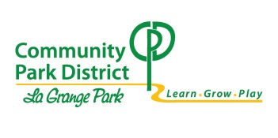AGENDA

REGULAR PARK DISTRICT BOARD MEETING

COMMUNITY PARK DISTRICT of La GRANGE PARK

1501 BARNSDALE ROAD, La GRANGE PARK, ILLINOIS

September 12, 2022 - 6:30 PM

1. Call to Order & Roll Call
2. Pledge of Allegiance
3. Park District Mission: The Community Park District of La Grange Park supports a healthy and inclusive community by positively impacting physical, social, emotional, and environmental well-being.
4. Open Forum
5. Approval of the September 12, 2022 Agenda
6. Approval of Board Meeting Minutes
   1. August 8, 2022 Regular Meeting Minutes
7. Communications/Proclamations/Presentations
8. Staff Recognition
   1. Jackie Newton, Recreation Manager
9. Staff Reports
   1. Executive Report
   2. Marketing and Operations Report
   3. Recreation Report
   4. Parks Report
   5. Financial Consultant
10. Approve Monthly Disbursements
11. Committee Reports
    1. Sustainability
       1. Arbor Advocates Update
    2. Long Range Planning
       1. Comprehensive Master Plan Update
12. Unfinished Business
    1. Part Time Benefits
    2. SEASPAR Fund Intrafund Transfer
13. New Business
    1. Signage Policies
    2. Library IGA for Snow Plowing
    3. OSLAD Grant Authorization Resolution
14. Adjourn to Executive Session  
    In Accordance with the Open Meetings Act under Section 2(c)(16) for the consideration of self-evaluation, practices and procedures or professional ethics when meeting with a representative of a statewide association of which the public body is a member.
15. Reconvene Open Session -
16. Potential Action on Items Discussed in Executive Session
17. Next Regular Meeting: Monday, October 10, 2022, 6:30pm
18. Adjournment

In accordance with the provisions of the Americans with Disabilities Act, any individual who is in need of a reasonable accommodation in order to participate in or benefit from attendance at a public meeting of the Community Park District Board of Commissioners should contact Jessica Cannaday, Executive Director at 708-354-4580.