

Press contacts:
Dennis Crowley dennis.m.crowley@disney.com
Danielle Ruff danielle.e.ruff@disney.com

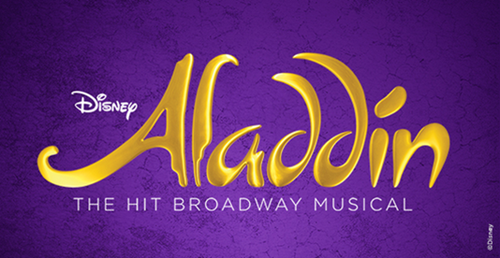

DISNEY’S HIT BROADWAY MUSICAL ALADDIN
SOARS INTO ITS SIXTH YEAR

Aladdin, the hit Broadway musical, continues to reach a whole new world as it continues into its sixth “genie-us” (USA Today) year on Broadway at the New Amsterdam Theatre (previews began February 26, 2014). Aladdin is the fourth Disney Theatrical Productions show (following Beauty and the Beast, The Lion King, and Mary Poppins) to play five or more years on Broadway. With six productions on four continents, Aladdin is a worldwide phenomenon that has grossed over $1 billion and welcomed over 10 million guests.

For more information, visit AladdinTheMusical.com.

ABOUT ALADDIN

Disney's Aladdin, the hit musical based on the Academy Award®-winning animated film, is now in its sixth smash year on Broadway at the New Amsterdam Theatre (214 West 42nd Street).

Aladdin opened to critical acclaim on March 20th, 2014 and quickly established itself as one of the biggest new blockbusters of recent years, breaking 14 New Amsterdam Theatre house records. Worldwide it has expanded to include productions in Tokyo, Hamburg, London and a tour across North America.
Produced by Disney Theatrical Productions, under the direction of Thomas Schumacher, the show features music by Tony Award® and eight-time Oscar® winner Alan Menken (Beauty and the Beast, Newsies, Little Shop of Horrors), lyrics by two-time Oscar winner Howard Ashman (Beauty and the Beast, The Little Mermaid), three-time Tony Award and three-time Oscar winner Tim Rice (Evita, Aida) and six-time Tony Award nominee Chad Beguelin (The Wedding Singer), with a book by Beguelin, and is directed and choreographed by Tony Award winner Casey Nicholaw (The Book of Mormon).

Aladdin, adapted from the Disney film and centuries-old folktales including “One Thousand and One Nights,” is brought to fresh theatrical life in this bold new musical. Aladdin’s journey sweeps audiences into an exotic world of daring adventure, classic comedy, and timeless romance. This new production features a full score, including the five cherished songs from the Academy Award-winning soundtrack and more written especially for the stage.

The film won the Oscar for Best Original Score and introduced the hit song “A Whole New World,” which won the second of the film’s two Academy Awards as Best Original Song. The Peabo Bryson/Regina Belle recording of the tune soared to #1 on the Billboard Hot 100 chart.

Aladdin is designed by seven-time Tony-winning scenic designer Bob Crowley, six-time Tony-winning lighting designer Natasha Katz, two-time Tony-winning costume designer Gregg Barnes, and sound designer Ken Travis.

The production team also includes illusion designer Jim Steinmeyer, hair designer Josh Marquette, and makeup designer Milagros Medina-Cerdeira. The music team is headed by music supervisor and music director Michael Kosarin, who also created the vocal and incidental music arrangements, joined by orchestrator Danny Troob, and dance music arranger Glen Kelly.

For more information, visit AladdinTheMusical.com.

# # #

