**Clean Keto Coconut Oil Fat Bombs [Recipe]**

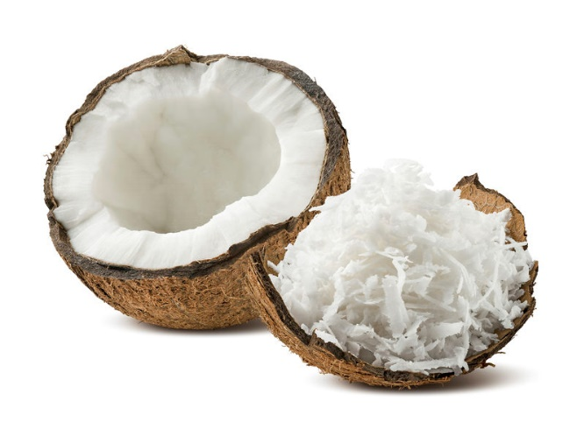If you haven’t tried fat bombs, you’ve got to give this recipe a try.

Don’t go for one of the all-butter recipes you can find online. Grass-fed butter is a fine, relatively healthy fat especially as you are transitioning to an alkaline diet. However, it is still a dairy product, which does have some acidifying effects.

Coconut oil is right up there with avocados as my favorite sources of healthy fat, and is a great snack for anyone trying to get off their sugar, and move to a healthier lifestyle, where you are burning FAT for fuel! (Stay tuned on Thursday when I’ll share 7 ways to get MORE fat into your diet.)

These bite-size bombs are the perfect treat to get a quick hit of the medium-chain triglycerides (MCT) your body needs for optimal performance. Plus, they give you long-lasting energy and taste like the tropics.

Enjoy these as a snack when cravings for sugar arise or as a simple dessert. There’s no guilt in this pleasure!

Give it a try and let me know what you think over [on Facebook](https://www.facebook.com/GetOffYourAcid?ref=hl).

**CLEAN KETO COCONUT OIL FAT BOMBS**

**Ingredients [12 Servings]**

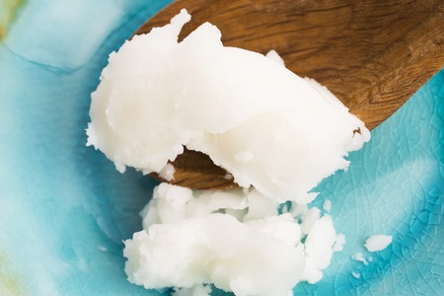1½ cups unsweetened coconut flakes   
½ cup cold-pressed coconut oil (or ¼ cup Kerrygold grass-fed butter as a substitute for half of the coconut oil)   
¼ teaspoon cinnamon   
¼ teaspoon vanilla bean powder (or 2 drops Medicine Flower Vanilla)   
Pinch of salt (Celtic Grey, Himalayan, or Redmond Real Salt)   
20 drops organic liquid stevia extract (or any other low-carb sweetener such as Lo Han or coconut drops from Medicine Flower) (optional)

**Directions**

Preheat the oven to 350 degrees. Spread the shredded coconut flakes onto a baking sheet. Place in the oven and toast for 5 to 8 minutes until light golden. Mix once or twice during heating to prevent burning. Remove from the oven and carefully transfer the coconut flakes into a blender. Pulse until a smooth and runny consistency is reached.

Next, add the grass-fed butter if using (softened at room temperature, chopped into pieces) and coconut oil (in its softened, liquid form, which occurs above 76 degrees. In addition, add cinnamon, vanilla, stevia, and sea salt, and blend again.

Once a smooth consistency is obtained, pour 1½ tablespoons of the liquid mixture into each mini muffin paper or an ice cube tray. Place in the fridge for at least 30 minutes to cool and solidify.

Enjoy!

[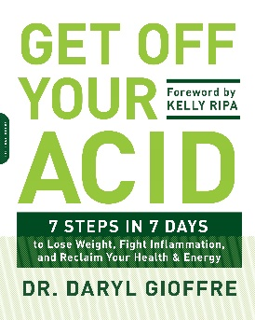](https://www.amazon.com/gp/product/0738219924?tag=hacboogrosit-20)Want more CLEAN, healthy recipes like this one?

My best-selling book, [***Get Off Your Acid***](https://www.amazon.com/gp/product/0738219924?tag=hacboogrosit-20): *7 Steps in 7 Days to Lose Weight, Fight Inflammation, and Reclaim Your Health and Energy*, is full of recipes, tips, and ideas to take you from sugar cravings, pain, and inflammation, towards a healthy, energetic, alkaline, and clean keto lifestyle!

**Kelly Ripa, who wrote the Foreword, had this to say:**

“What I like most about Dr. Daryl’s method is that it’s not a ‘diet’ but more of a lifestyle change. There’s no counting calories or limiting portion sizes, only a new awareness of ‘alkaline eating.’ Once you learn the difference between alkaline and acidic ingredients, you will know what to eat and will be able to benefit from keeping this balance in your bodies.

“Whether your goal is to lose weight, sleep deeper, feel more rested, think more clearly, or boost your energy, this plan will get you there…”