**Top 7 Ways to Get MORE Fat in Your Diet**

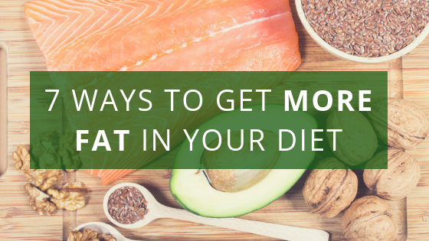

Yes, you read that right. Today’s post is about getting MORE fat into your diet.

You don’t have to be on the Keto diet to notice that more and more health experts are actually encouraging people to eat more fat. FINALLY!

And yet, even today, so many people are afraid to eat fat. The decades of scare-tactics from the sugar industry was successful at giving fat a bad name. Just look at grocery stores today – there are still low-fat and fat-free foods all over the place!

But the truth is, there’s no reason to fear the fat, especially if you are looking to lose weight. Fat has a unique ability to satiate us, keeping us fuller longer so we are less likely to overeat.

We need fat in our diet and in fact, it’s nutritious for us – if we’re getting the right fats.

**There are fats that HEAL… And fats that KILL.**

And that’s what we’re going to talk about today: what the good fats are and how to get eat MORE of them, while avoiding the bad fats that do so much damage to our health, both in the short and long term.

Let’s start by breaking down the different terms you hear about fat so we’re all on the same page about the good, the bad, and the ugly sides of fats.

There are 4 main types of fats that we eat: saturated fats, monounsaturated fats, polyunsaturated fats, and trans fats. With the exception of trans fats – which are always terrible for you and should be avoided at all costs – you’ll find both good and bad fats within the other 3 types.

Let’s break down the different types:

**Saturated Fats**

These get a very bad wrap, but the truth is, there are different types of saturated fats. Some deserve a bad wrap, whereas others are actually really good for you and a vital part of your diet.

* 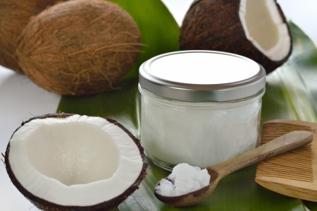**Animal-based –**These are the saturated fats that give all of them a bad name. This category contains dairy products, meat, junk food, eggs, and many dessert foods. This is the artery-clogging fat you want to cut down on or even avoid completely.
* **Plant-based –**Healthy saturated fats are medium-chain triglycerides (aka. MCTs), which are found in coconut oil and MCT oil. They are **anti-inflammatory, antioxidant buffers of acid** that help reset your body’s metabolism to burn fat and move away from burning sugar as the primary source of fuel.

They are easily digested, are a quick source of sustainable energy, and have numerous health benefits. Our bodies send these types of fats straight to the liver where they can be easily converted into energy or ketone bodies, which are actually great fuel for the brain, and they’ve been proven to have a therapeutic impact on brain disorders such as Alzheimer’s.

**Monounsaturated Fats**

These fats, also known as Omega-9 fatty acids, are excellent sources of fat. They reduce the risk of heart disease, protect against diabetes, and may reduce the risk of cancer. They also improve your mood and make it easier to lose weight. In general, the Western diet gets plenty of Omega-9 fats.

You’ll find monounsaturated fats in:

* Avocados
* Olives
* Extra virgin olive oil
* Sesame oil
* Macadamia nuts
* Almonds

**Polyunsaturated Fats**

Even more important than the distinction between healthy and unhealthy saturated fats is the distinction between the 2 different kinds of polyunsaturated fats, omega-3 and omega-6.

Omega-6 fats are pro-inflammatory, and omega-3 fats have an anti-inflammatory effect. The omega-6 fats are *linoleic acid* (LA) and *arachidonic acid* (AA), which are found in animal products. You’ll find unhealthy omega-6 fats, which you want to minimize, in:

* Vegetable oils, including canola, safflower, sunflower, soy, and grapeseed oils
* Mayonnaise and store bought salad dressings
* Edamame
* Corn and canola oil
* Peanuts, peanut butter, and peanut oil
* Margarine
* Meat
* Eggs
* Poultry
* Dairy
* Farmed fish, including salmon
* Cookies, crackers, candy, frozen pizza, granola/granola bars, pastries, popcorn, and other processed foods

Most Americans consume a heavily acidic diet high in **Omega-6 fats**, which leads to chronic and excessive inflammation, and the result is chronic disease. Because your brain is primarily fat, a diet that heavily favors Omega-6 fats causes inflammation in your brain.

In addition, a diet that favors Omega-6 fats will trigger greater fat storage. Many studies show animals fed a diet high in Omega-6 fats will become fatter than animals on a non-Omega-6 diet with identical calories.

If you have been trying to lose weight and have been unsuccessful, bringing your [Omega-6:Omega-3 ratio into balance](https://www.getoffyouracid.com/products/omega-3-inflammation-test-kit) may be the answer.

**Omega-3 fats** are *alpha-linolenic acid* (**ALA), which is plant-based**, and ***docosahexaenoic acid* (DHA) and *eicosapentaenoic acid* (EPA), which are animal based**. Omega-3 fats are ESSENTIAL, which means your body does not make them, so therefore, you need to get them from your diet. Most Americans do not get enough Omega-3 fatty acids from the foods we eat, which is why supplementation is so necessary.

Now that we’re on the same page about what’s healthy and what’s not when it comes to fat, let’s dive into my 7 tips to eat MORE fat.

1. **Don’t Hold Back on (the Right) Cooking Oils**

This first tip is simple. When you go to put cooking oil in the pan, use a generous amount. If you would typically add 1 tablespoon before you sauté, add 2 or 3. If you would typically roast veggies in 2 tablespoons, try 4. You’ll find that the flavors of your finished dish are richer, and you’ll stay satiated for longer.

BUT you have to make sure you’re using healthy oils when you cook. **Avoid these inflammatory ones:**

* Hydrogenated vegetable oils
* Safflower oil
* Sunflower oil
* Grapeseed oil
* Soybean oil
* Canola oil
* Peanut oil

Instead, opt for coconut oil or avocado oil when you’re cooking on the stove because it can withstand high temperatures, and extra virgin olive oil when you roast in the oven. Be careful that you’re getting your olive oil from a good source, because some brands that claim to produce extra virgin olive oil actually mix it with vegetable oils.

1. **Top Dishes with Healthy Fat Foods**

Whether you’re making lettuce wraps, salads, or quinoa bowls, you can add healthy fat ingredients to make them even better. Some of my favorite healthy fat foods to add are:

* Avocado – where most people add cheese, I add avocado! And there’s a reason why this health fat has been nicknamed “God’s Butter”.
* Chia, Hemp, and Flax seeds
* Green olives
* Almonds, walnuts, macadamia, or other nuts
* Sunflower seeds (use in moderation due to high Omega-6 fat content)
* Hummus

1. **Eat Low-Mercury, High-Omega-3 Fish Regularly**

If you’re a vegetarian, this one doesn’t apply to you. And yet, it’s even more important that you take a good quality fish oil. My wife, Chelsea, is a vegetarian, but she takes [**Daily Omega-3**](https://www.getoffyouracid.com/collections/daily-omega-3) because she understands that there’s no substitute for the omega-3 fatty acids found in fish and she knows we made the most sustainable, most humane fish oil supplement on the market.

Vegetarians, while I SO appreciate their philosophy, tend to have the HIGHEST levels of inflammation, even worse than meat eaters in many cases. Why is that? Two major reasons…

1. There are no vegan/vegetarian sources of EPA, the one component you find in fish oil that fights inflammation. You can find trace amounts in algae, but its neglible, has POOR ratios, and comes along with toxix residues that can cause plaquing in the brain similar to Alzheimer’s.
2. ALA, the plant-based version of Omega-3s, converts LESS THAN 1%. Therefore, plant-based sources of Omega-3 like chia, flax, and hemp won’t give you the necessary levels of EPA, or DHA for that matter.

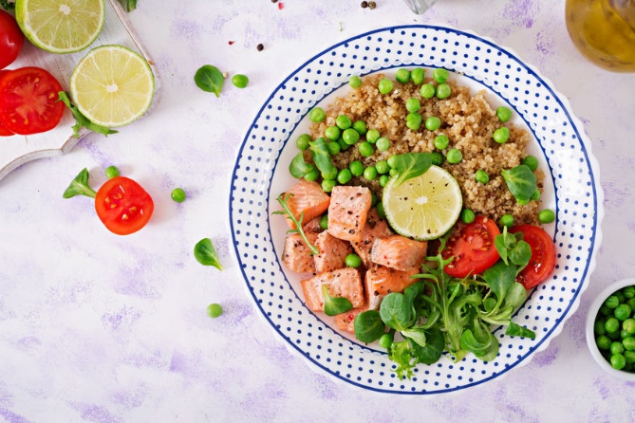

Pescatarians and omnivores, I encourage you to not only eat wild-caught salmon once or twice a week (die to ocean toxicity), but also branch out and try some of the other low-mercury, high-omega-3 fish that you might not eat as often like [anchovies, sardines, and mackerel](https://www.getoffyouracid.com/blogs/news/the-3-fish-you-should-eat-that-you-probably-aren-t). The smaller the fish, the better, as there is LESS toxicity. It’s still important that you take a fish oil supplement, but this is another great way to get healthy fats in your diet on a regular basis.

1. **Go Nuts at Snack Time**

Nuts are a great addition to any snack to get some extra healthy fat in, which will keep you full until your next meal. My favorites are Brazil nuts, hazelnuts, pine nuts, and pecans. Walnuts and almonds are good choices too, but you have to be careful because they do contain inflammatory Omega-6 fatty acids. Cashews and pistachios are okay as well, but in moderation due to their potential for mold.

TIP: If your snack is going to involve any fruit at all, make sure you load up on the nuts or nut butter along with it because the fat will help metabolize the sugar in the fruit over a longer period of time.

1. **Drizzle Entrées with Finishing Oil**

Don’t you wish you could serve restaurant quality food in your own kitchen? Well, I’ll let you in on 2 of their secrets that I learned as a certified raw food chef. First, they sprinkle everything with an extra dash of salt before serving, which you can easily do with one my favorite salts – Celtic grey, Himalayan, or Redmond Real Salt. I tend to use more Himalayan these days, because sea salts tend to have plastics which we need to stay cleat from.

And second, lots of dishes, including soups, salads, and pasta dishes are finished with a drizzle of extra virgin olive oil or another finishing oil. You can do the same thing with the alkaline soups, salads, and zoodle dishes you make at home. Macadamia nut oil, sesame oil, avocado oil, and extra virgin olive oil are my favorites to finish entrées with.

1. **Add Healthy Fat to Every Smoothie**

You know I’m a big fan of starting off your day with a smoothie because it delivers a big dose of leafy greens, supplying you with chlorophyll and alkaline minerals.

But another reason to love green smoothies is the healthy fat they can deliver. My favorite healthy fats to add to smoothies are:

* 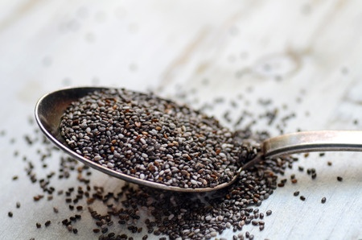Hemp seeds
* Chia seeds
* Avocado
* Raw almond butter
* Flax seeds (use in moderation due to Omega-6 fat content)
* Coconut oil
* Coconut flakes
* MCT oil

1. **Enjoy Fat Bombs!**

When you need a little fat to keep you fuller longer, this dessert from my book is the best…

**Clean Keto Coconut Oil Fat Bombs Recipe** [LINK TO POST ABOVE ONCE LIVE]

They’re full of the medium-chain triglycerides that give you long-lasting energy and fight inflammation.

**BONUS TIP:** **Take a good Omega-3 supplement** every day. It’s very difficult to eat a diet rich enough in Omega-3, and unless you eat salmon 3 meals a day (which you don’t want to do), you are deficient without a supplement.

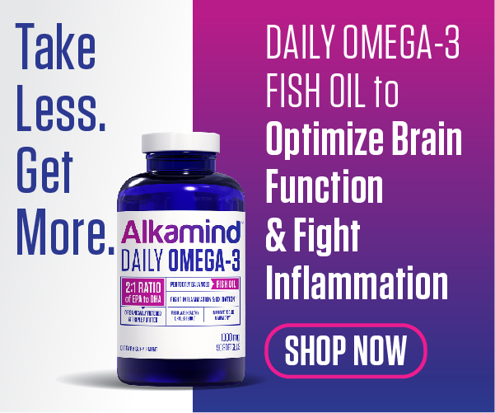And Omega-3 is not just good for you – it’s necessary for everyone in your family, from your kids right on up. That’s why research shows fish oil supplements help children with ADHD, and brain development. If you have aging adults in your life, make sure they are taking Omega-3 supplements to keep their brains sharp as well. And of course, by taking them yourself, you’re staving off aging and possibly adding quality years to your life.

Our [**Alkamind Daily Omega-3**](https://omega3.getoffyouracid.com/sales-page17877958) is the best quality supplement on the planet. Out of ALL the fish oil supplements out there, it’s the ONLY one with the ideal 2:1 ratio of EPA to DHA in a highly concentrated, molecular distilled form. So you can TAKE LESS and GET MORE benefit from it. Plus it’s heavy metal free and guaranteed for potency and freshness, so no fishy taste.

Based on the research, the average adult needs to take 3,000mg daily, which is 3 softgels of Daily Omega-3…and they CAN be taken in one sitting (with food)!

[**Subscribe & Save 15%**](https://ilovelongbeach3.myshopify.com/collections/daily-omega-3/products/daily-omega-3) today!

*EAT FAT…LOSE FAT…and GET OFF YOUR ACID*!

Dr. Daryl