• Interrelationship of building and surroundings:
This property includes two parcels totaling 11.4 acres, located in the northwestern part of Newtown. Blackman Road is a former section of Mount Pleasant Road (US Route 6 and CT Route 25) which was realigned, leaving Blackman as a local access road. The property is near the high point of a hill, which slopes south and east to Taunton Pond. To the east, Mount Pleasant Road connects with Main Street and leads to the historic town center. Interstate 84 runs east-west on the north side of the hill. In addition to the 11.4 acres, the Blackman Farmstead formerly included additional land to the south across the road and east of Tunnel Road. Much of the surrounding area has been developed with small cul-de-sac streets and single-family residential developments, although some belts of woodland remain.
The farmstead includes the farmhouse and ten outbuildings ranging from barns to small sheds and an outhouse. The farmhouse is a 1 ½-story Colonial-style building thought to date to c. 1760. The south block, 37 feet x 46 feet, oriented with its ridge-line east-west parallel to the road, appears to be the earliest construction. It has a roughly symmetrical façade with two doors, a pair of twelve-over-twelve double-hung windows between the doors, and outboard of the doors, two windows on the right (east) and three on the left (west). The leftmost pair are wider and closely-spaced, with a projecting bracketed cornice above. This treatment extends around the west gable-end, creating a well-lit interior at the southwest corner. The upper floor has four windows in the right side and three in the left, with the second from the left apparently filled in. According to the owners, the second floor windows had been replaced by six-over-six sash, but the originals were found in the barn and restored. A hip-roofed 1-story porch extends across the center part of the façade, over both doors. The porch is supported by square posts with Italianate-style detailing. Two chimneys match the locations of fireplaces in each side. The house is two rooms deep and has a modern rear extension toward the north (rear) consisting of a double-height living room with a cathedral ceiling and a window wall facing north. Between this space and the front block, a vestibule area leads from a 1-story porch on the east side of the building and serves as the functional entry. Siding is wood clapboards and the roof which was covered in metal shingles as recently as 2008, has been restored to wood shingles.
South of the farmhouse a wood fence lines the roadside, with an opening for the front walk. To the east of the fence is a driveway entrance leading north into the site, and further east a stone wall lines the property line and extends north around the corner along Tunnel Road. Open hay fields extend north and west up a slope beyond the barns.
The barns and other outbuildings are located to the north and east of the farmhouse. The site slopes up toward the north, with the barns located upslope of the house. The main Barn I, now a painting studio, northeast of the house, is connected to a wagon shed, Barn II, also converted to studio use. To the west is a barn known as the Blacksmith shop (Barn III). East of the house is a Carriage barn (IV) and to its north an Icehouse (V) and Smokehouse (VI). Slightly removed from the main group and located to the northeast, is the Borning shed (VII). Two chicken coops (VIII and IX) are sited northwest of the main group. An outhouse formerly located north of the farmhouse has been relocated to the west (X). All the buildings are painted a putty-gray color.
• Other notable features of building or site (Interior and/or Exterior):
Architectural description:
Inventory of structures (C – contributing, NC – non-contributing):
House c. 1760 C Icehouse V 19th-20th c. C
Barn I 19th c. C Smokehouse VI 19th -20th c. C
Wagon shed II 19th c. C Borning shed VII 19th -20th c. C
Barn (Blacksmith) III 19th c. C Chicken coops (VIII, IX) 20-th c. C
Carriage barn IV Late 19th c. C Outhouse X (relocated) 19th -20th c. C
Barn I:
This is a 1 ½-story three-bay gable-roofed English bank barn, approximately 24’ x 34’ with its ridge-line oriented east-west and its principal entry doors in the south eave-side. The natural grade has been augmented along the south side with a fieldstone retaining wall extending southward from the southeast corner to support a ramped entry. The east gable-end has its basement level fully exposed at the lower grade level. Wagon shed II is attached at the west gable-end. The barn has been re-used as the owner’s painting studio, with a series of modifications which are generally not visible to the public view.
Exterior:
The south eave-side has a pair of full-height hinged barn doors in the center bay. The doors have iron strap hinges and there is a shallow hood or cornice above the doorway. A pass-through door is located at the left (west) corner; it also has iron strap hinges and a simple trimmed lintel and casing. Grade is ramped up to the sill level along the entire south side, with the ramp terminated by a mortared fieldstone retaining wall aligned with the east gable-end wall. Siding is vertical boards.
The east gable-end has a full basement exposed on the lower slope of the hill. This is sided with grooved plywood siding up to an elevation approximately five feet above the main floor level. The basement has three six-pane stable windows, a pass-through door to the right (north), and a small projecting shed addition at the northeast corner. The upper part of the wall has wood shingle siding; a siding divide is indicated by a step out in the wall plane. A four-pane attic window has a pointed head, paralleling the roof pitch. The window trim includes ornamental sawn casings in a Victorian style and a simple molded cornice at the head.
On the north eave-side the center bay has a large three-part panel of windows for studio day-lighting, all with square trim. A central fixed-glass light is flanked by shorter lights with awning sash in the lower parts. Below the windows is a pass-through door with iron strap hinges; the door is fixed shut. The right bay has a three-pane barn sash below the level of the studio glazing. Two metal flues are attached to the exterior and run up through the roof overhang. As grade declines toward the left (east) the fieldstone foundation wall is partially exposed. Siding on this elevation is painted vertical boards.
The west gable-end is partially covered by the attached Wagon shed II which abuts the north third of the end wall. At approximately the center is a modern pass-through door with a glazed panel in its upper half. Further to the right (south) is a twelve-pane sash, possibly formerly installed in the farmhouse, with square trim and a simple head cornice trim. At the attic peak is a four-pane pointed sash matching the east gable-end. Siding is pained vertical boards.
The roof has overhangs at the eaves and rakes, with sloped soffits and simple molded trim fascias. Roofing is asphalt shingles.
Interior:
The interior has been finished with insulated walls, leaving many of the barn timbers exposed. Posts and girts have visible circular saw marks, while some of the angle braces exhibit the straight saw marks of a sash or band saw. Connections are wood-pegged.
At the main level the three-bay layout has the traditional center posts connecting to the tie-girts, which are dropped below the plates. A pair of longitudinal purlins run at the center of the rafter spans, and are supported by queen posts sitting on the tie-girts. Rafters are concealed behind the finished cathedral ceiling. Some horizontal girts in the lower part of the space that would typically partition the hay mow from the threshing floor, have been removed, leaving the mortises. A loft in the western bay provides storage space for art materials, and below it are an enclosed bathroom and stair to the basement level. At the northwest corner a door leads to the interior of Wagon shed II.
The basement level is accessible by a stair from the main level or from the east gable-end door. There are full-height mortared fieldstone walls on three sides. Joists supporting the upper level are hand-hewn and mortised into the central girder. The girder appears to have been supported originally on a series of posts, but the basement was converted to a dairy layout with two rows of stanchions, and a transfer system was devised to support the central girder on a short beam with two posts located in the lines of the stanchions. This allowed a clear center aisle for feeding. A concrete floor was installed with manure gutters along the outer walls, and the ceiling and walls painted white as is typical of dairy barns in the early 20th century. Natural light in this situation is not optimal, coming from only small basement windows along the south wall and from the east end wall. The present plywood-surfaced east wall is likely a modern arrangement, as there is not sufficient doorway width for cattle at present.
Wagon shed II:
This is a 21’ x 34’ 1 ½-story gable-roofed structure, lower than the adjacent Barn I, with its ridge-line oriented east-west. It abuts Barn I at the east gable-end but is set back toward the north so that its north wall extends beyond Barn I. The long south wall has a 1-story eave-side façade consisting of four sliding doors, each with a twelve-pane window. The doors are fixed in place. The south eave has a deep overhand sheltering the doors. A single gable dormer is located off-center toward the left (west) in the roof. This is boarded over with siding.
The west gable-end has a pass-through door in the right (south) corner. Barn III is set very close to the Wagon shed, approximately two feet. The north eave-side has a row of eight floor-to-ceiling single-pane windows. Siding is painted board-and-batten and roofing is asphalt shingles.
The interior has been converted to an extension of the painting studio, with exposed collar ties and finished interior walls and cathedral ceiling.
Barn III:
This is a 12’ x 24’ 1 ½-story two-bay gable-roofed structure with its ridge-line oriented east-west, located approximately two feet west of Wagon shed II and set slightly northward. The south eave-side has a pair of hinged doors off-center toward the right (east). The west gable-end has a six-pane window vertically oriented at the ground level and a four-pane attic window. The north eave-side has two un-matching windows – an eight-pane sash just left (east) of center and a twelve-pane sash toward the right. These may be sash from the farmhouse that were re-used during a past renovation of the house. The east gable-end has an attic window. Siding is vertical tongue–and-groove boards. A few courses of fieldstone foundation are visible at the northeast corner where the grade slopes. Roofing is asphalt shingles.
The interior is a hand-hewn timber frame with mortise and tenon joints and dropped tie-girts. Numerous repairs have been made with modern materials including sawn joists, plywood roof decking and plywood shear gussets.
This building is said to have been a blacksmith shop for the farm.
Carriage barn IV:
This is a 2-story gable and shed-roofed structure with its ridge-line oriented north-south. The gable-roofed portion is 20’ x 24’ and has its original door openings in the west eave-side, including two sliding doors with a shallow hood projecting over the track hardware, and a single pass-through door, of planks with iron strap hinges, at the left (north) corner. Above in the upper level is a hinged hay door, off-center toward the right.
The south gable-end has a pair of modern overhead garage doors at the ground level for use as an automobile garage. Above in the attic is an ornamental nine-pane window with trim in a simple Victorian style. Siding on this side is board-and-batten with molded battens. A shed addition on the east side extends fourteen feet, and may have been the stable space. It has board-and-batten siding at the attic level and flush-board siding below. The east eave-side elevation of the shed addition has two eight-pane stable windows. The north gable-end has a pass-through door at the left (east) corner, with iron strap hinges, which now opens above grade without a porch or steps. In the attic gable is a six-pane window with square trim. Below there appears to be a hinged hay door, although the location of Icehouse V very close to the wall makes access impossible. Grade slopes down toward the east, and the mortared fieldstone foundation wall is exposed. The east and north sides are sheathed with flush-board siding, and the roof is asphalt shingles.
The interior of the garage/carriage barn is finished in plastered walls and ceiling and has a concrete floor. The shed addition is constructed of sawn dimension lumber, unfinished. It has a partial concrete floor.
Icehouse V:
This is a 1-story wood-framed gable-roofed structure 16’ x 16’ with its ridge-line oriented east-west. It has a door in the west gable-end and a hay-door in the attic above. The north side has a row of three horizontal windows high in the wall, which were added by the owner in the late 1970s so he could use this space as a painting studio when he first moved here. Siding is vertical boards and roofing is asphalt shingles.
Smokehouse VI:
This is an 8’ x 8’ gable-roofed structure with its ridge-line oriented east-west and a door in the west gable-end. Siding is vertical boards and roofing is wood shingles. South of the Smokehouse is a concrete trough.
Borning shed VII:
This is a shed-roofed structure located some distance east of Barn I and north of Smokehouse VI. It has a concrete foundation, two six-pane windows in its south side, and vertical siding. This is said by the owner to have been used for birthing livestock.
Chicken coops VII and IX:
These are two 1-story structures with low-pitched gable roofs oriented east-west. They are located at a higher point on the hillside some distance to the northwest of the rest of the building group, both facing south. Coop VIII is 18’ x 30’ and has six twelve-pane windows in its south eave-side. Coop IX is 18’ x 22’ and has four twelve-pane windows in its south eave-side. Both are constructed of sawn dimension lumber and have been repaired with new material. Siding is vertical boards and roofing is asphalt shingles.
• Historical or Architectural importance:
Applicable Connecticut State Register Criterion:
2. Embodying the distinctive characteristics of a type, period, or method of construction.
This site is significant as an exceptionally intact complex of farm buildings in its rural landscape setting, located at a highly visible location. The buildings include an unusual 18th-century double farmhouse and a complex of outbuildings with a square rule-framed English bank barn, cow shed, and chicken coops. The farmstead gains additional significance from its history of ownership by a single family from the mid-18th century until the 1970s. The bank barn has been re-used as an artist’s studio, with all changes to its appearance confined to the rear, leaving the street side view unchanged.
Historical background:
The farm is said by the owners to have belonged to members of the Blackman family from 1759 until Caroline C. Blackman bequeathed the house and barns with 1.8 acres to the Newtown Historical Society around 1970. The Society sold the property and it was soon resold in 1977 to Jane and Robert Cottingham. The Cottinghams purchased an additional 9.6 acres from the last Blackman sister in 1978, assembling the present site. They have provided the probable farmhouse construction date of c. 1760 and alterations to the kitchen as c. 1890. The outhouse was moved to the west side of the house by the Cottinghams in 1995. Jane Cottingham is an antique dealer, while Robert Cottingham is a noted Photo Realist painter whose work is represented in museums and galleries across the country. He continues to use the barns as his workplace.
Members of the Blackman family have figured in Newtown history from the time of the purchase of land from the Pootatucks in the early 18th century. John Blackman (1685-1764) was among the group of 52 first settlers or Proprietors of the township. A number of branches of the Blackman family appear in federal census records of the late 19th century, living in various parts of Newtown from Hawleyville to Sandy Hook.
Maps published in 1854 and 1856 show the name “J. Blackman” at the corner site now identified as 12 Blackman Road. “B. Blackman” is shown next to the west, while “Miss S. Blackman” is to the east on the north side of the road and “R. Blackman” is to the east just past Taunton (then called Fountain) Lake. Census records identify James and Joseph Blackman and several other Blackmans as farmers in 1860 and 1870 while others were engaged in carpentry (Clarke Blackman), hatting (Reuben Blackman), tanning, silversmithing, and factory work. Three women – Letty, Sybil, and Harriet Blackman – formed a household together. By the 1910 census, Joseph Albert Blackman was identified as a dairy farmer. In 1920 and 1930, Stanley J. and Sarah Blackman were also dairy farmers. Several household lists include boarders, servants, and farm laborers, including Joseph Blackman in the 1860 census with wife Mary, children Zulla, Ann, Albert, and Mary F. plus five boarders. James Blackman was listed with Hannah, his wife, and children Cornelia (a hat trimmer), Caroline, Leroy, Frances, and two couples who boarded with them. By 1890, Albert was grown and had a son, Frank (b. 1880) enrolled in the North Center District School, where Blackman Road is located. Joseph A. Blackman shows on the Grand List of 1890 in the North Center District, and also as a registered voter in that year, as does John H. Blackman.
Without a detailed title search, it is unclear which families lived and farmed at 12-16 Blackman Road, but it seems possibly to have been Joseph A. and his family, with the double house providing accommodations for more than one family or a number of boarders.
A few notable Blackmans left Newtown for New Haven or Danbury for careers as lawyers, judges, or politicians. In the 20th century, Samuel A. Blackman in 1907 and Stanley Blackman in the mid-1900s, served as first selectman in Newtown. By the 1960s the owners were the two Blackman sisters, who made the bequest of the buildings to the Newtown Historical Society, leading to the sale to new owners after over 200 years.
Architectural significance:
The Blackman Farmstead is significant as an outstanding and substantially intact example of a subsistence farming complex representing the agricultural way of life in a 19th-century township of the Western Uplands. With a farmhouse and ten outbuildings, most in their original positions, and the land maintained in open fields by ongoing haying, the property stands as a significant representative of the historical landscape and buildings.
The farmhouse is an example of an uncommon type, the double house, in which the original one-chimney structure was doubled by mirroring a second house, either early in its history or at a later time. The primary barn (Barn I) is a square-rule-framed English bank barn. Circular saw marks on the posts indicate a construction date in the second half of the 19th century, which is consistent with the Victorian style of the attic windows and some of the modifications to the farmhouse. The building exteriors have been carefully preserved, with modern interventions limited to the north side areas away from public view.
The complex also represents the ongoing evolution of the farmstead. The basement dairy barn layout is an example of typical efforts made in the early 20th century to conform to new farming requirements by adding the concrete floor and painting or whitewashing the walls and ceiling. In more recent times the barns have been re-used for the owner’s painting studio, showcasing an appropriate adaptive re-use for a historic barn.
• Sources (continuation):
Photographs and field notes by Charlotte Hitchcock 3/06/2012.
Interview with owners Jane and Robert Cottingham, 3/06/2012, at the site.
Map resources:
Newtown Assessor's Records http://maps.newtown-ct.gov/ags_map/
Parcel ID: Map 6-12-1 (12 Blackman Road, 1.82 acres), 6-12-2 (16 Blackman Road, 9.6 acres)
Newtown GIS Viewer http://maps.newtown-ct.gov/ags_map/ accessed 11/17/2011.
Aerial views from:
http://maps.google.com/ and http://www.bing.com/maps/ accessed 3/14/2012.
Beers, Ellis, and Soule, Atlas of New York and Vicinity, 1867.
Bicentennial Map of the Town of Newtown, 1905.
Chace, J., Clark’s Map of Fairfield County, Connecticut, Richard Clark, Philadelphia, 1856.
Fagan, L., Map of the Town of Newtown, Richard Clark, Philadelphia, 1854.
United States Geological Survey Maps, Danbury and Derby, 1892.
Historical aerial photography and maps accessed at UConn MAGIC:
http://magic.lib.uconn.edu/mash_up/1934.html
http://magic.lib.uconn.edu/historical_maps_connecticut_towns.html .
USGS Historical Maps accessed 6/22/2012 at http://historical.mytopo.com/ .
UTM coordinates: http://itouchmap.com/latlong.html
Print and internet resources:
Ballard, Rose-Marie, Historic Resources Inventory for Newtown CT, 1996.
Connecticut Trust for Historic Preservation, Historic Barns of Connecticut Resource Inventory, 2010,
http://www.connecticutbarns.org/6765 .
Crevier, Nancy K., “A Look At The People Behind The Names Of Newtown’s Roads,” Newtown Bee, 3/6/2008.
Eliasoph, Philip, “An American Master’s Road Trip Express,” VENU Magazine, No. 2 CT_Edition, 2010, venumagazine.com.
Housatonic Valley Council of Elected Officials, History of Land Use in Newtown CT, http://www.hvceo.org/luchange_newtown.php , accessed 3/14/2012.
Mitchell, Mary, Goodrich, Albert, Touring Newtown’s Past, Newtown Historical Society, 1996, p. 113.
Newtown Historical Society, Newtown Old Building Inventory Questionnaire, 1995
Note: information was provided by Jane Cottingham, as told to her by Blackman sisters in 1978.
Newtown Cyrenius Booth Library Genealogy Collection: Grand List, school enrolment, voter registration records transcribed.
Newtown Bee Archives available online.
U.S. Federal Census, accessed at http://persi.heritagequestonline.com/hqoweb/library/do/census/search/basic .
Sexton, James, PhD; Survey Narrative of the Connecticut Barn, Connecticut Trust for Historic Preservation, Hamden, CT, 2005, http://www.connecticutbarns.org/history.
Visser, Thomas D., Field Guide to New England Barns and Farm Buildings, University Press of New England, 1997, 213 pages.

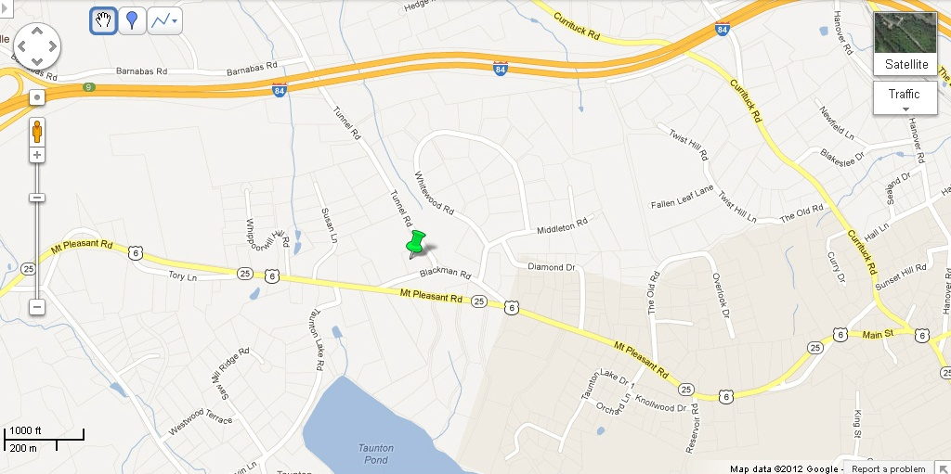

1. Location map of 12-16 Blackman Road, Newtown CT – from http://maps.google.com/ accessed 3/19/2012.

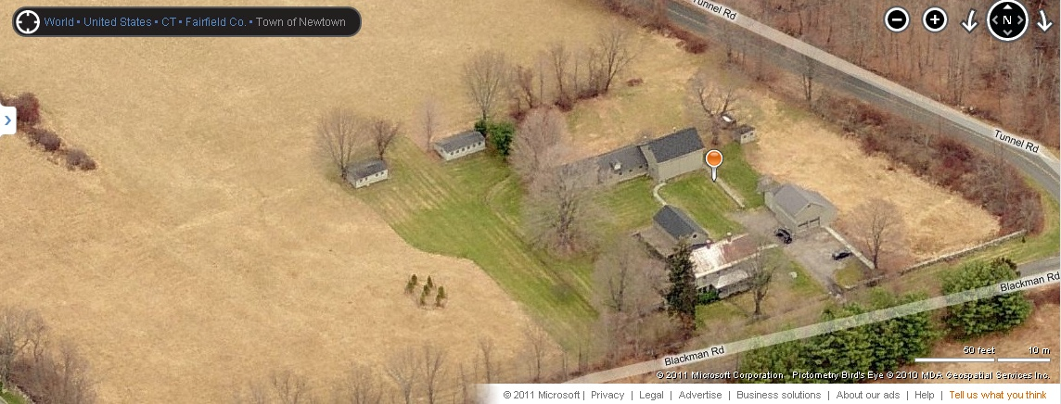

2. South view – aerial “bird’s-eye” map 12-16 Blackman Road, Newtown CT – http://www.bing.com/maps accessed 11/7/2011.

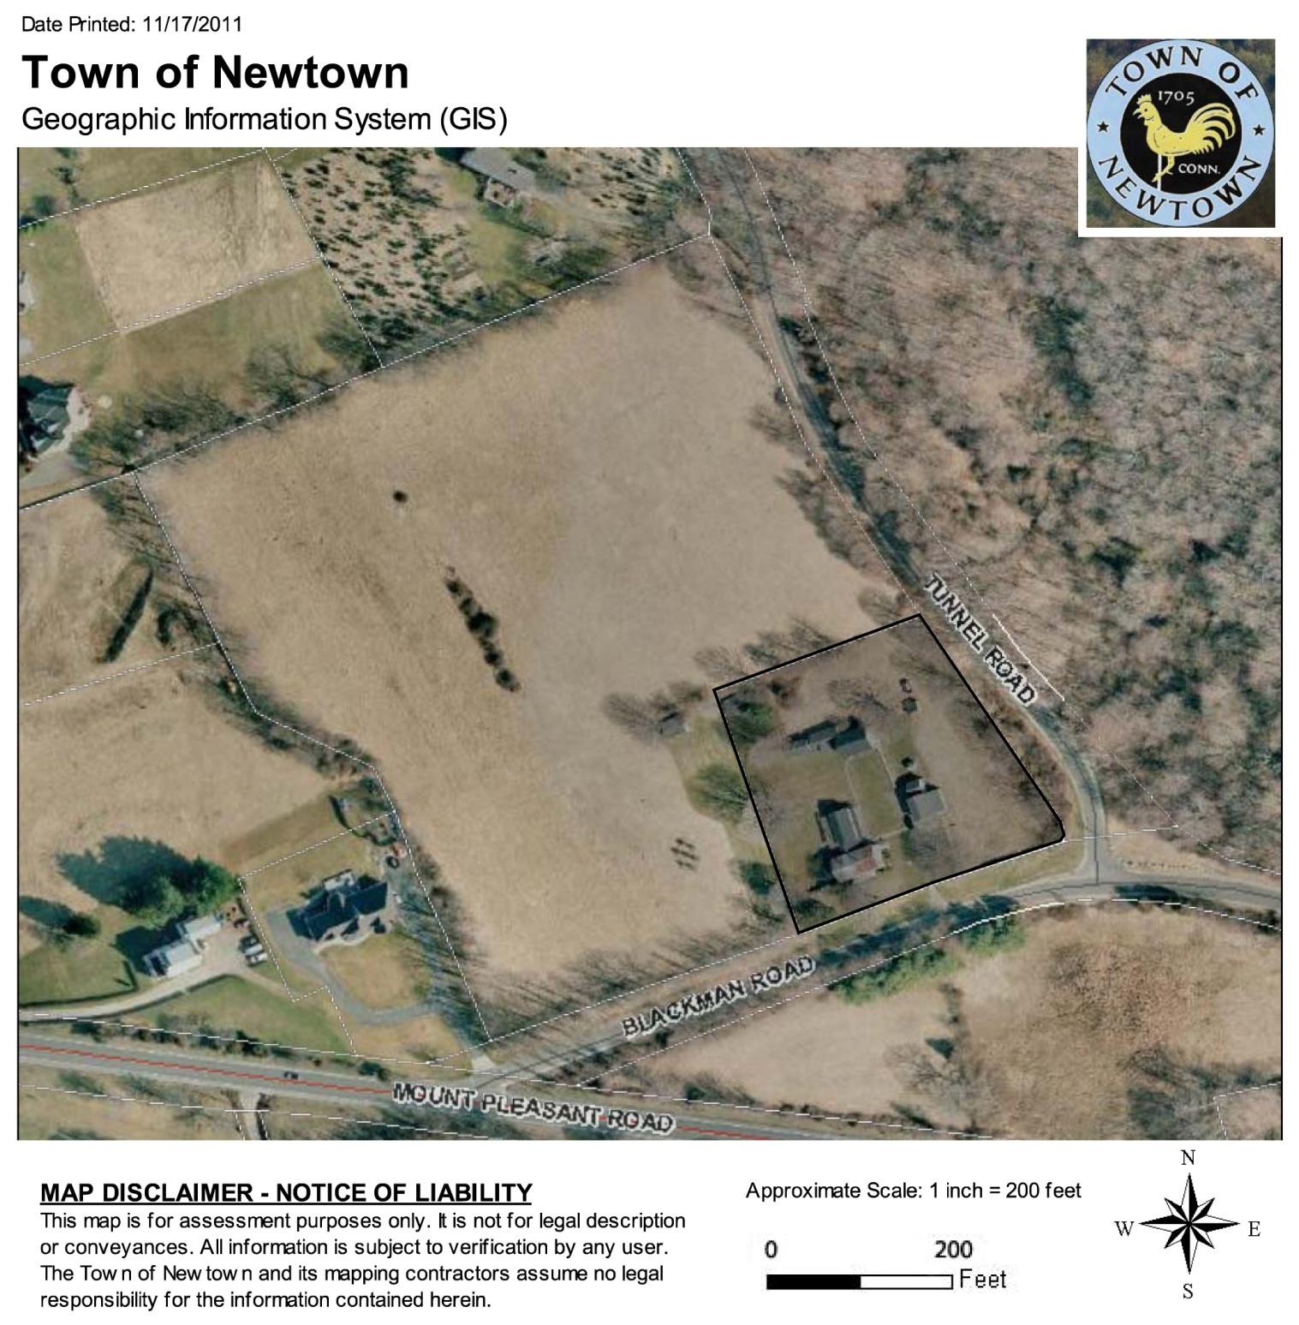

3. Parcel map – from Newtown GIS Viewer http://maps.newtown-ct.gov/ags_map/ accessed 11/17/2011.

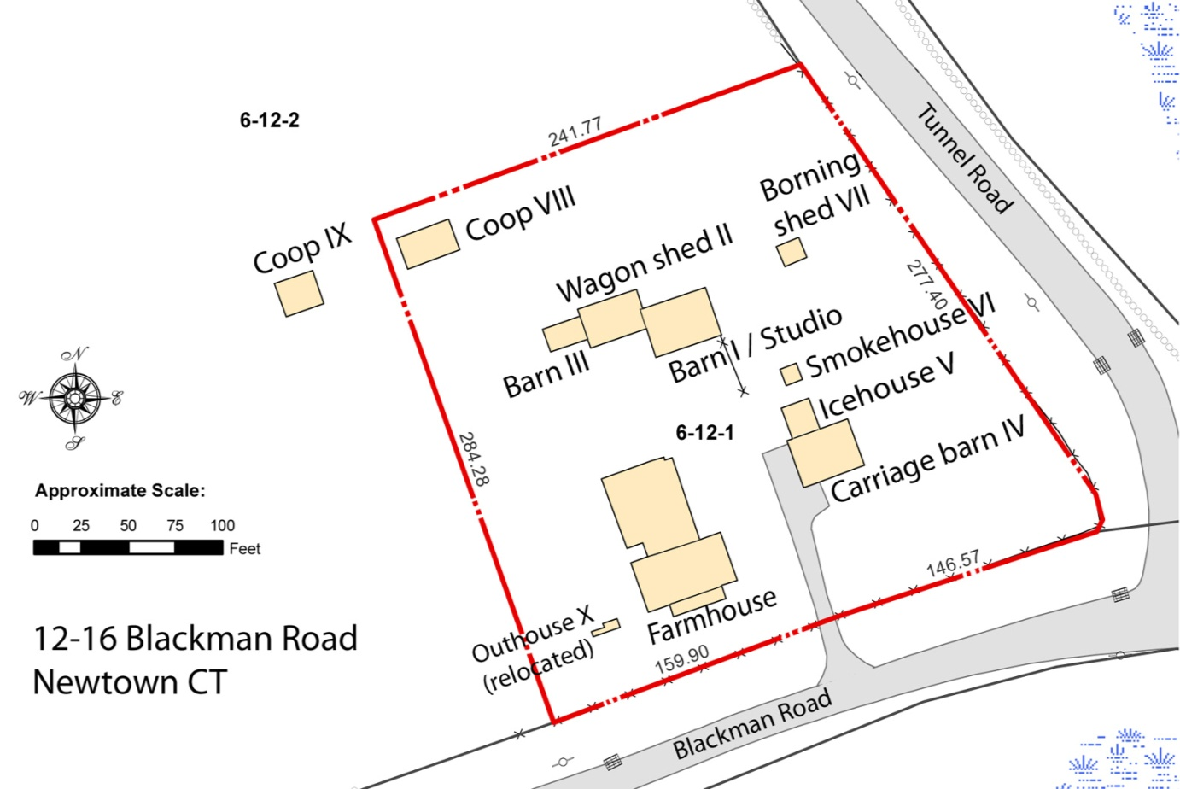

4. Site Plan Sketch showing contributing resources numbered as buildings I through X. Plan based on data from Newtown GIS viewer http://maps.newtown-ct.gov/ags_map/.

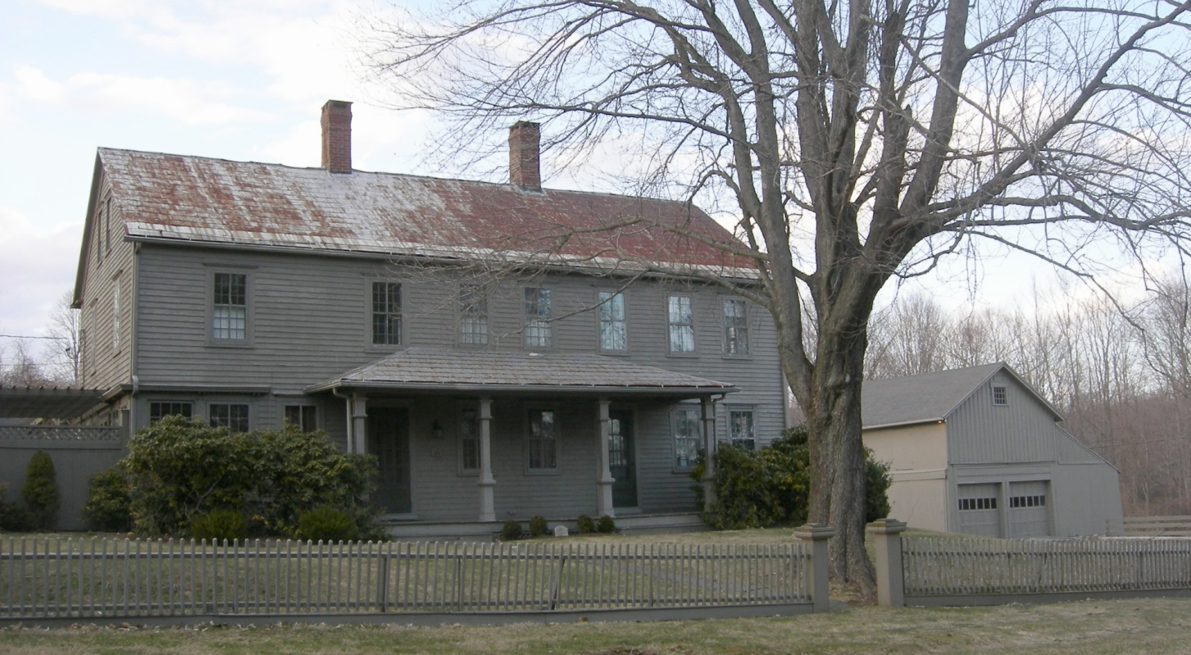

5. South view of 12 Blackman Road farmhouse, camera facing north; Carriage barn IV at right rear.
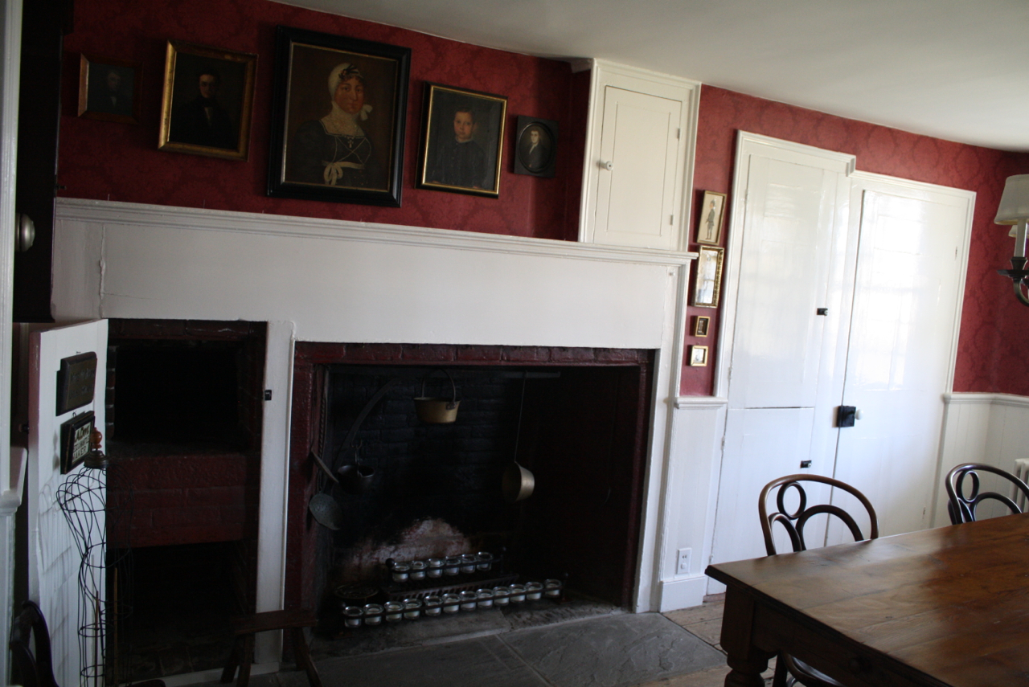

6. Interior view of west dining room fireplace wall, camera facing east.

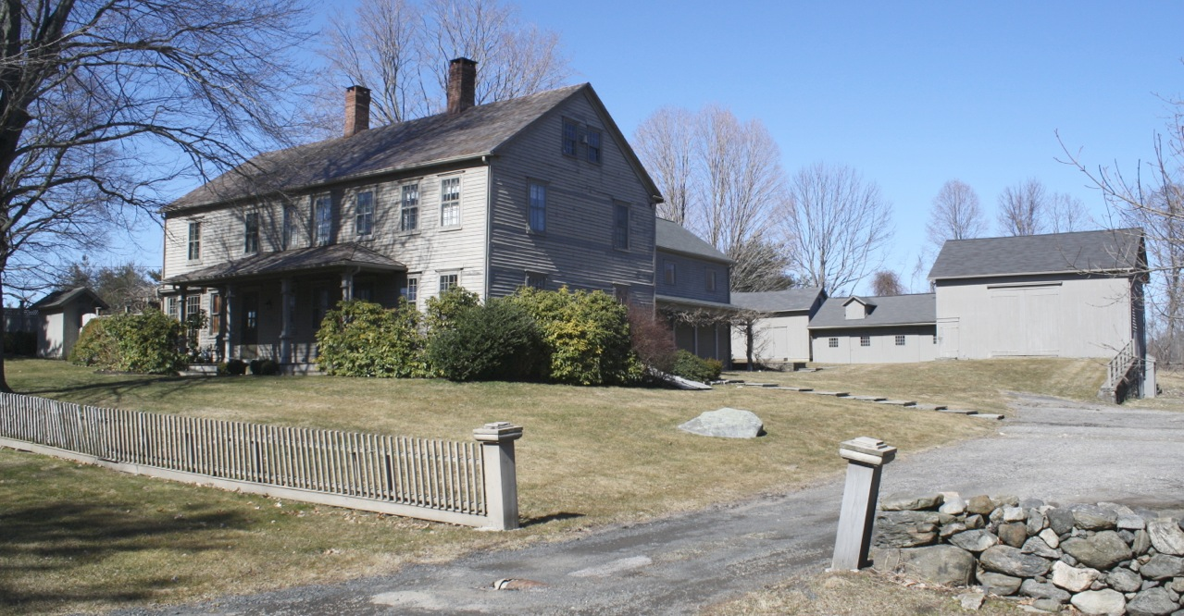

7. Southeast view of Farmhouse, camera facing northwest, with Barn I at right rear, Wagon shed II and Barn III at center rear. Outhouse X is at the far left.

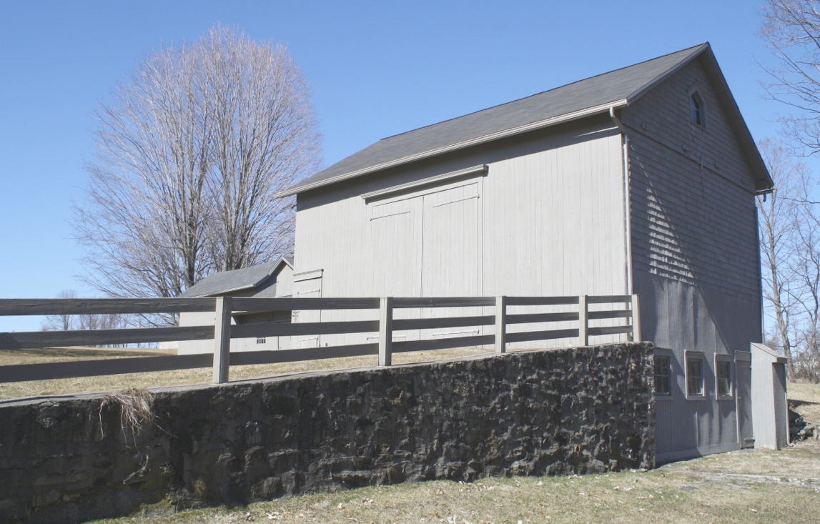

8. Southeast view of Barn I, camera facing northwest.

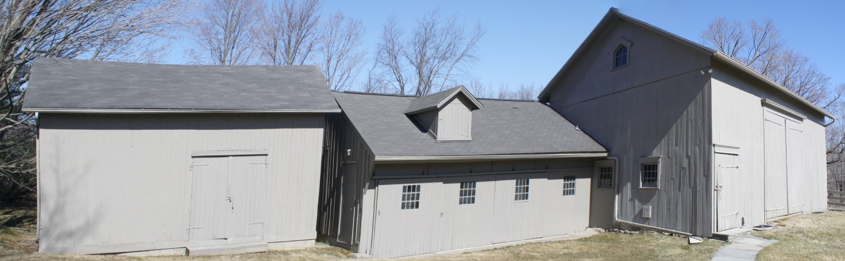

9. South view of Barn I-III, camera facing north. Barn III is seen at left, Wagon shed II at center, Barn I at right.

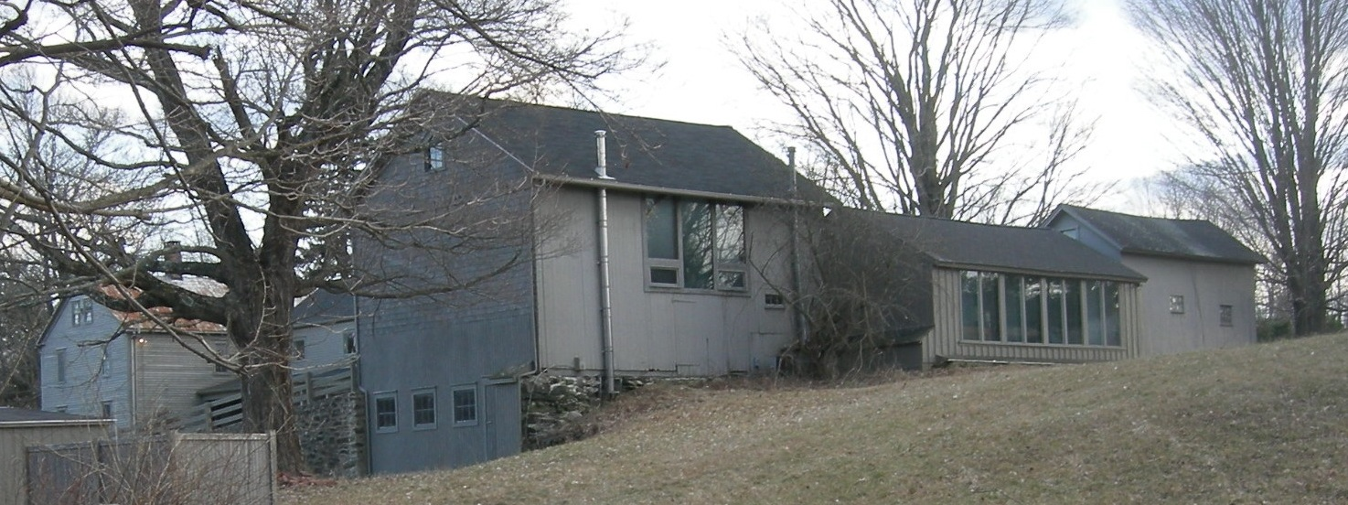

10. Northeast view of Barn I, Wagon shed II, Barn III, camera facing southwest.

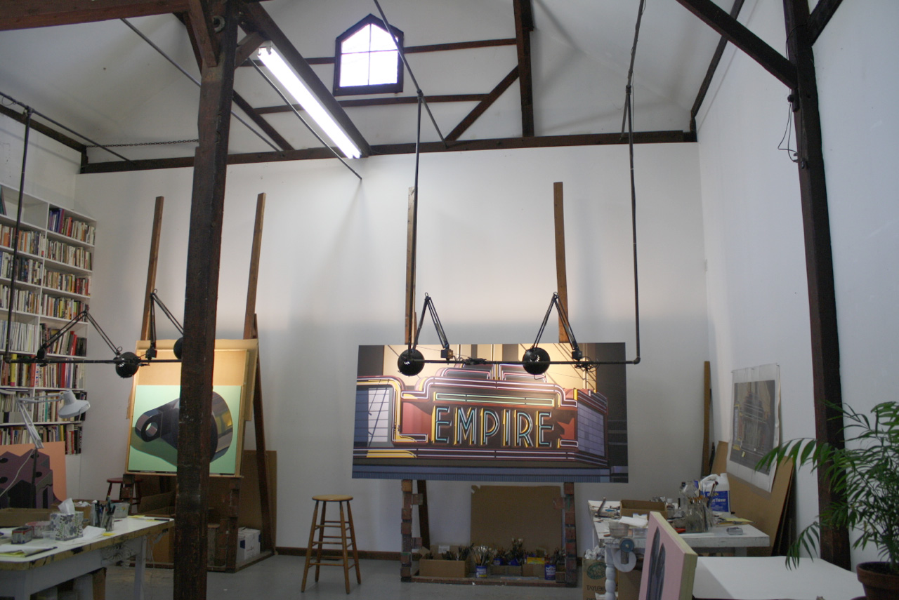

11. Interior view of Barn I, camera facing east.

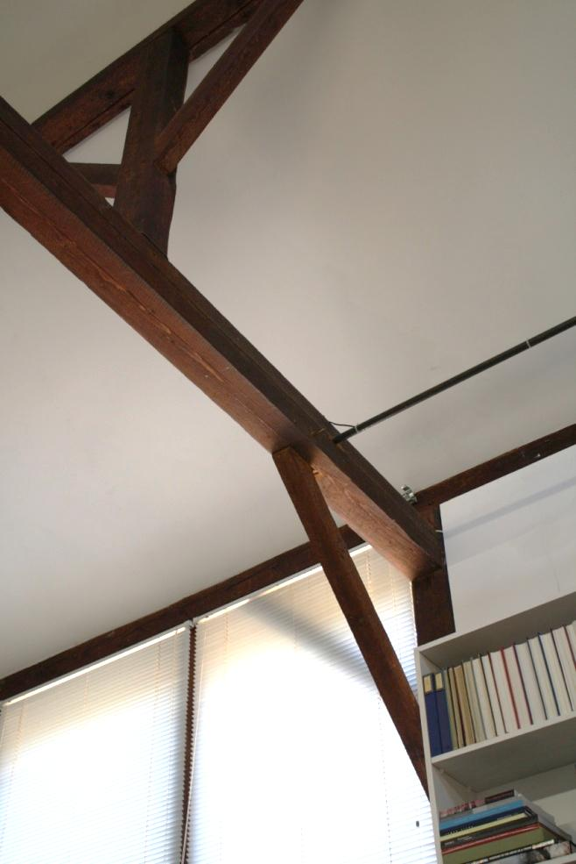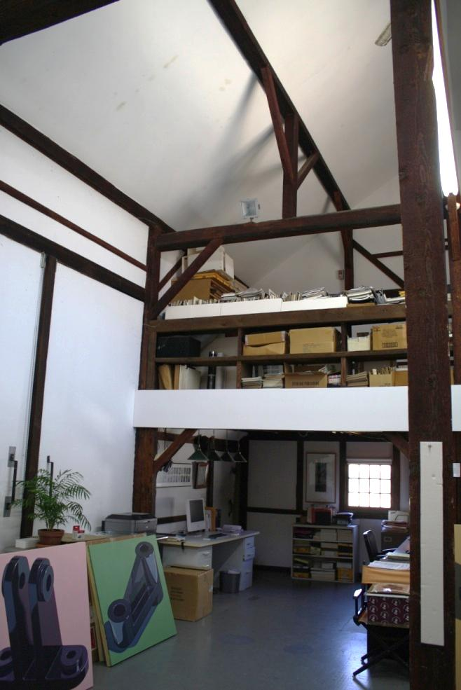

12. Interior of Barn I, camera facing north, showing 13. Interior of Barn I, camera facing southwest,
central north window, timber bent east of the center, showing barn doors at left, loft and roof
with longitudinal purlin above. purlin system.

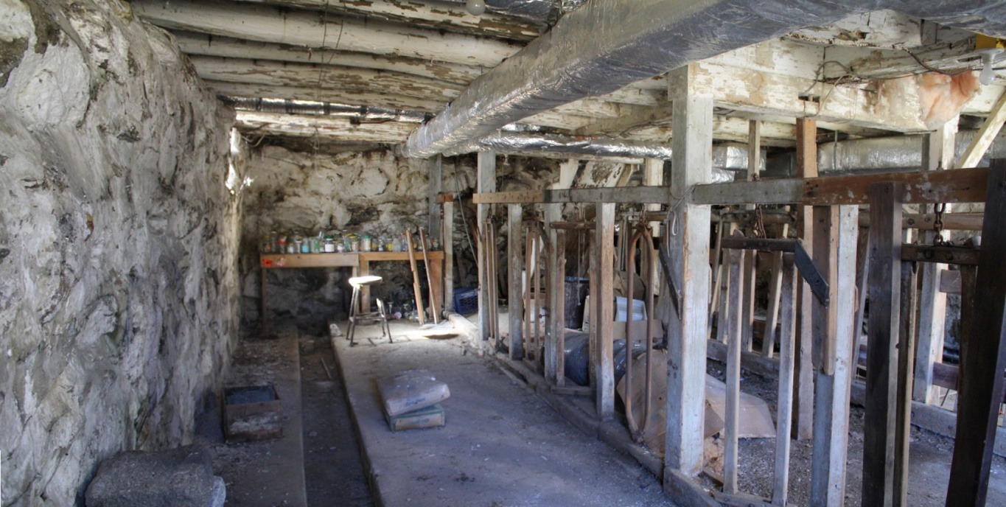

14. Interior of Barn I basement, camera facing west, showing concrete floor with manure gutters, stanchions, and structural modification to eliminate center posts, transferring load to two spaced posts in the stanchion racks.

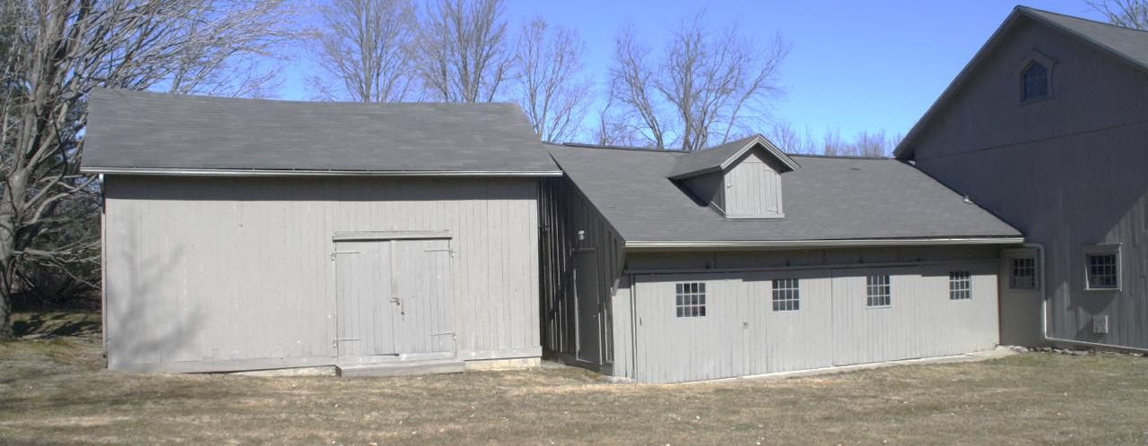

15. South view of Barn III (left) and Wagon shed II (right), camera facing north. Barn I is to the right.

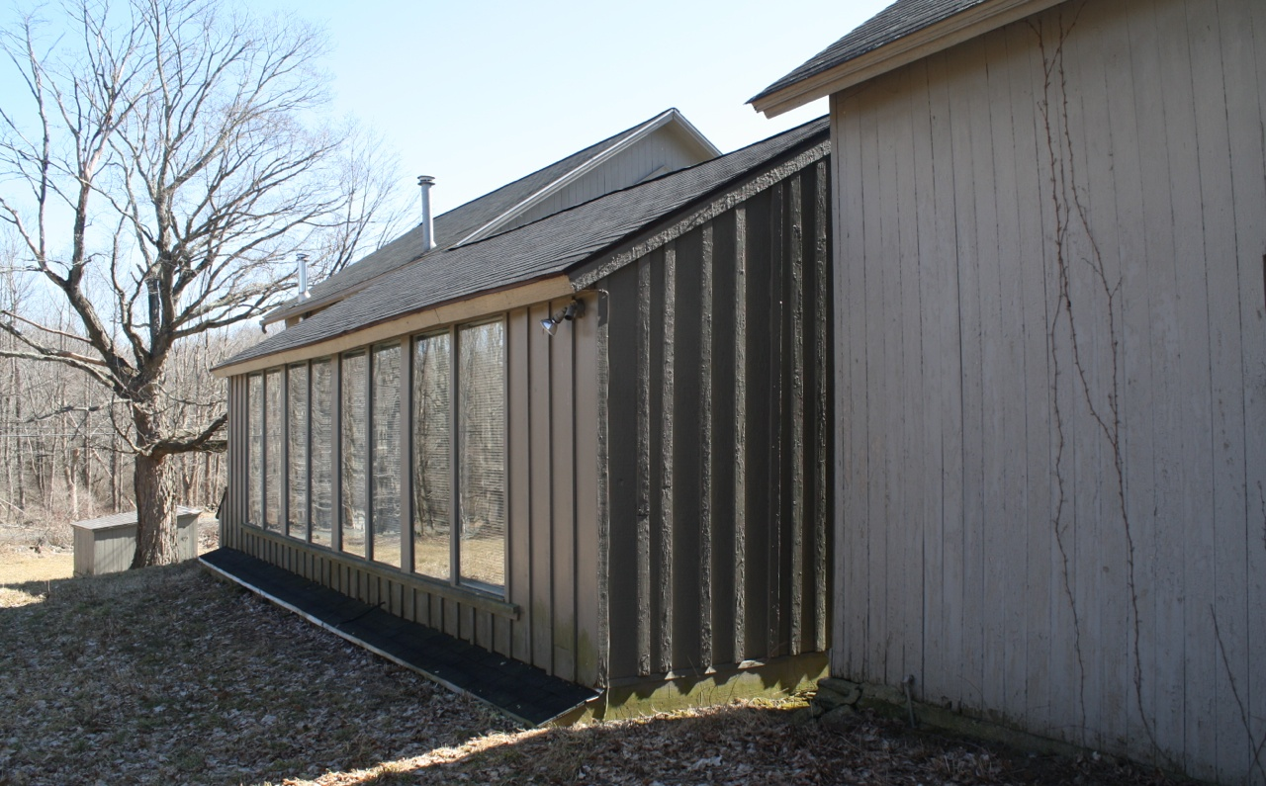

16. Northwest view of Wagon shed II, camera facing southeast, showing north-facing studio windows. Barn III is at right.

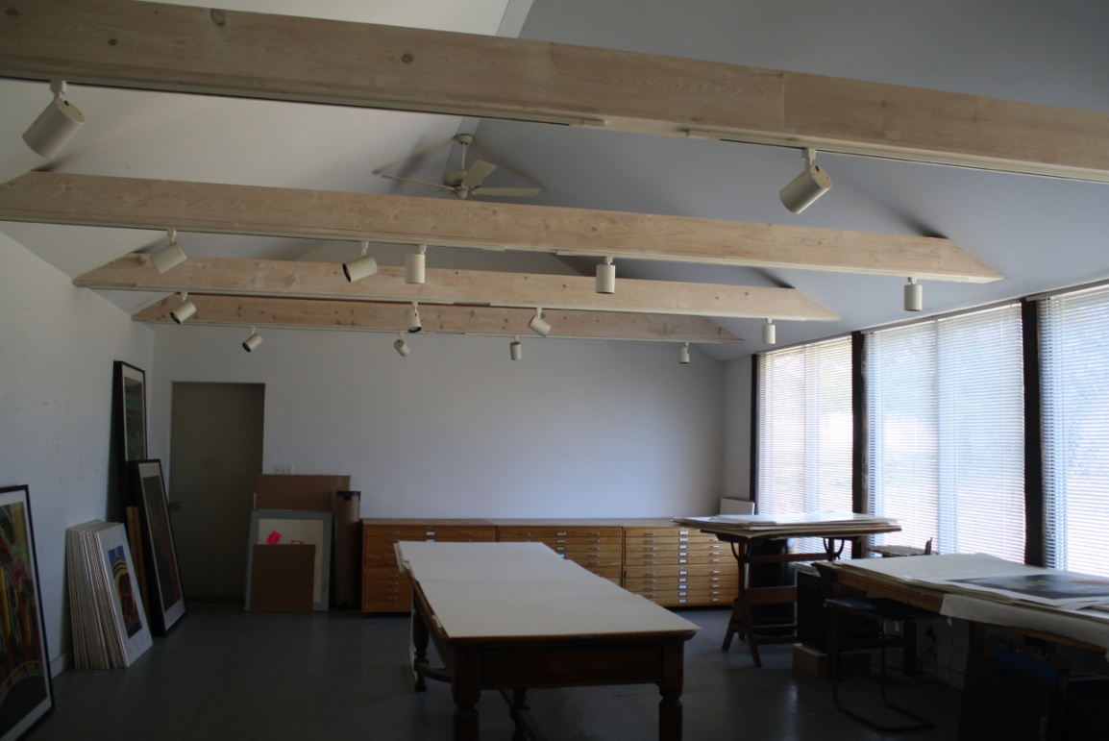

17. Interior view of Wagon shed II, camera facing west.

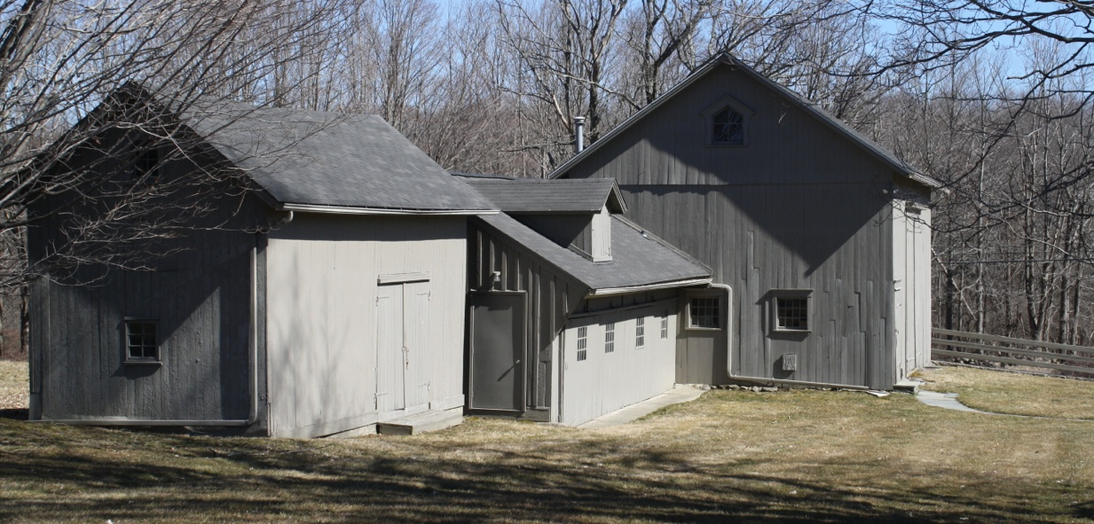

18. Southwest view of Barn III (left), Wagon shed II, Barn I.

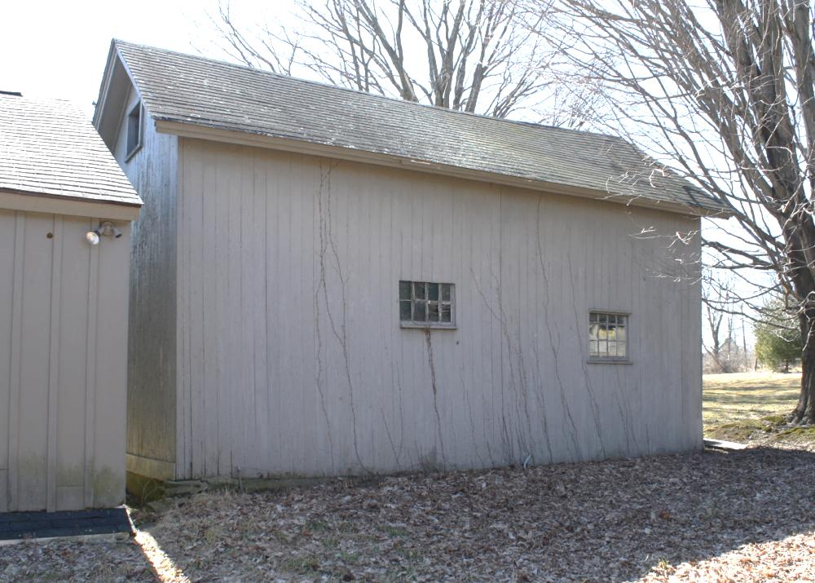

19. North view of Barn III, camera facing southwest.

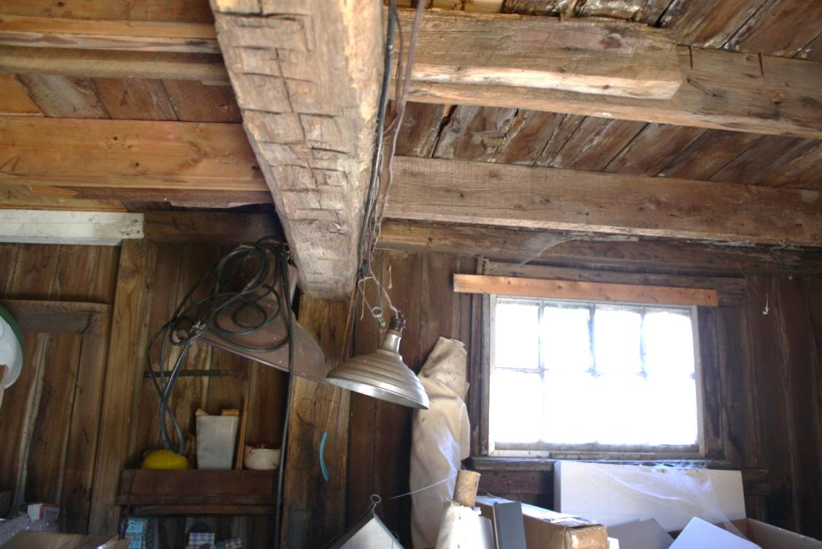

20. Interior view of Barn III, ground level wall and ceiling, camera facing north.

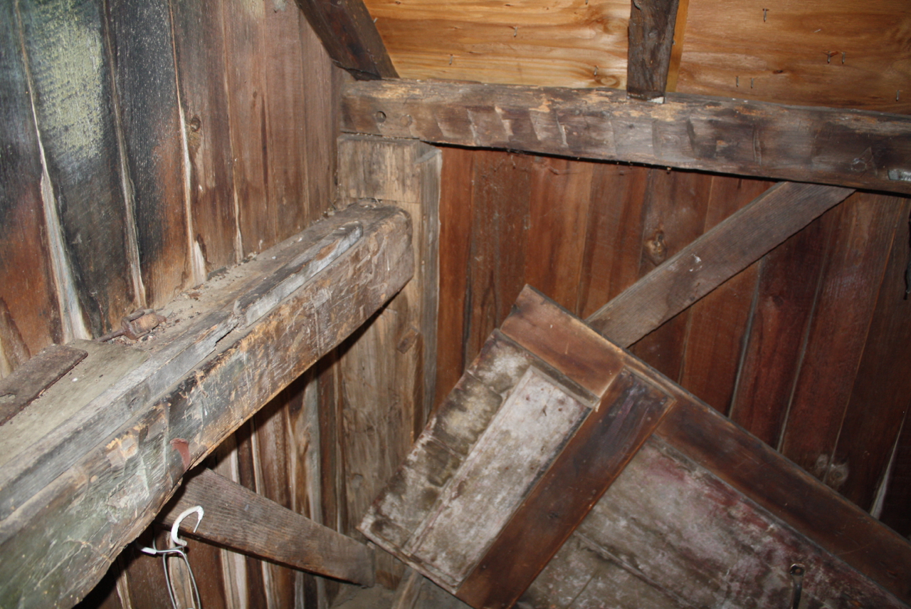

21. Interior view of Barn III, loft level, camera facing south, showing dropped girt, hewn plate.

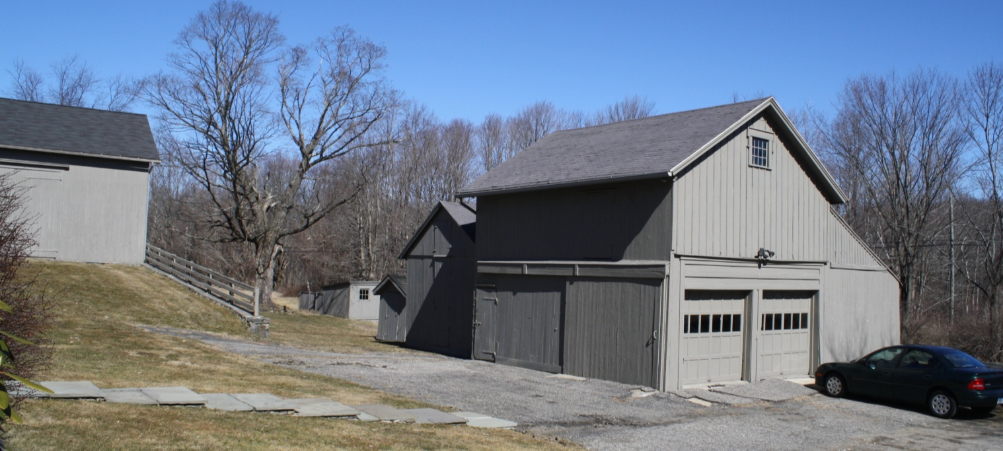

22. Southwest view of Carriage barn IV, camera facing northeast. To the left is Icehouse V and Smokehouse VI. Borning shed VII is at the left rear. Barn I is at far left.

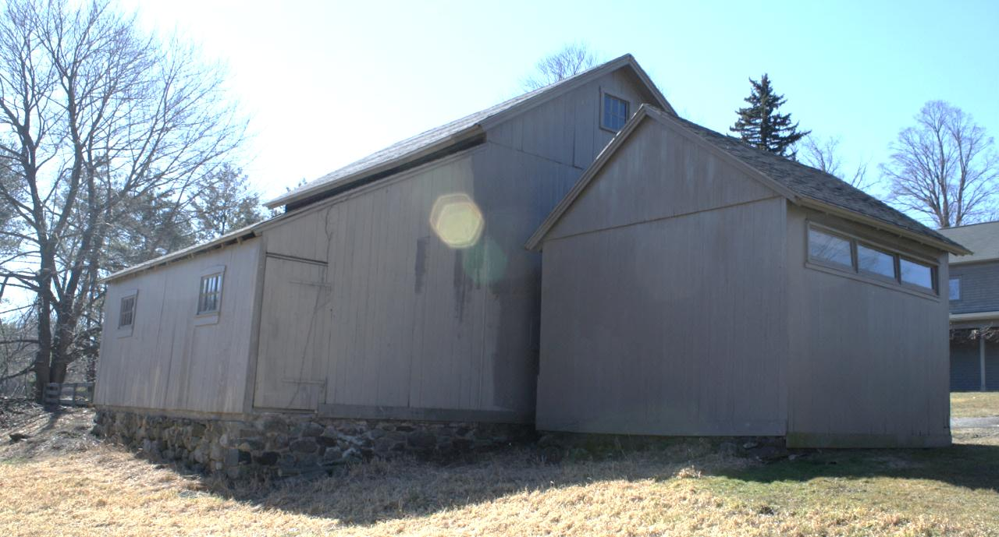

23. Northeast view of Carriage barn IV, and Icehouse V, camera facing southwest.

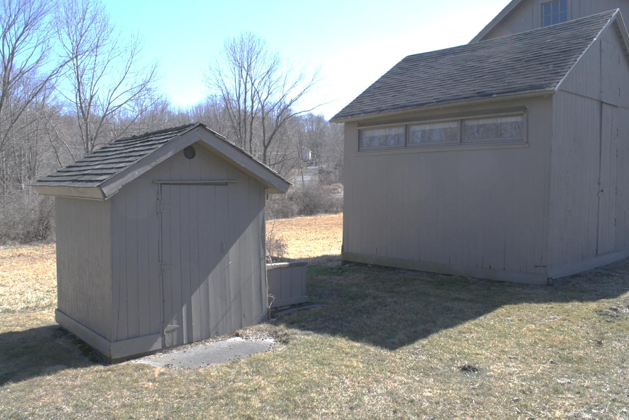

24. Northwest view of Smokehouse VI (left) and Icehouse V (right), camera facing southeast.

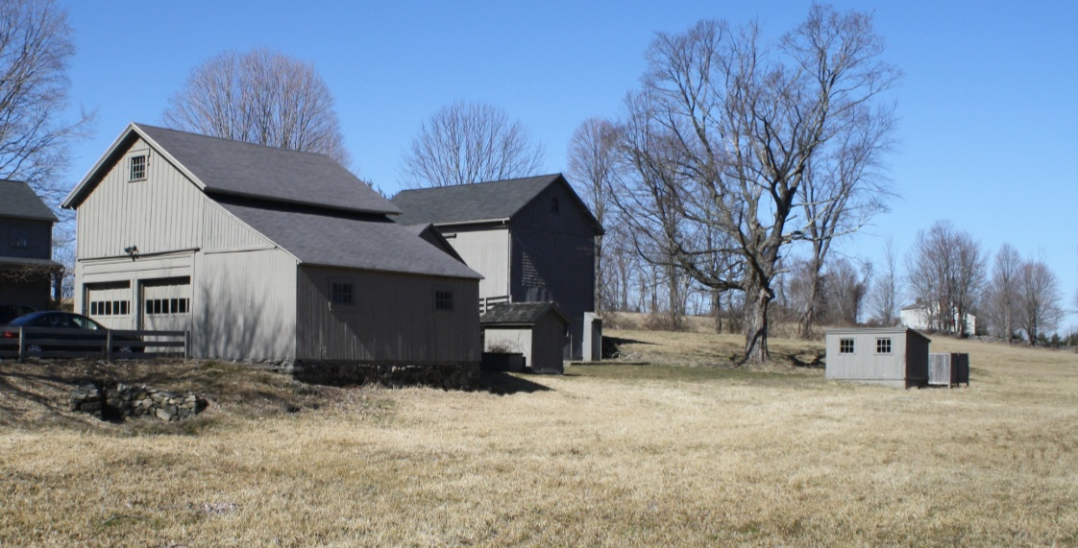

25. Southeast view of (left to right) Carriage house IV, Smokehouse VI, Barn I beyond, Borning shed VII; camera facing northwest.

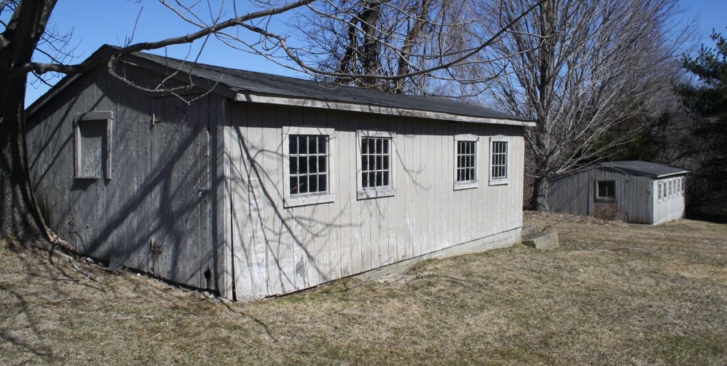

26. Chicken coops IX (left) and VIII (right), camera facing northeast.

