Transforming HomeChef Digitally with a Refined Ordering Experience
A cross-platform solution to make meal planning flexible

Overview

HomeChef is a platform that offers a unique experience by connecting people with Homechefs. It aims to provide a taste of home to individuals who are busy and don’t have the time to cook. HomeChef allows users to order meals directly from home cooks, offering a convenient and healthier alternative to traditional restaurant food.

Requirement:
- HomeChef already had a native app, but it lacked proper structure and features.
- The backend data was further disjointed, leading to inefficient data management.
- The user interface was lacking in refinement, and the overall user experience wasn’t up to standards. HomeChef sought a solution that could address these issues and provide a seamless and user-friendly platform for its customers.

The Solution:
- Reactree’s solution to HomeChef came in the form of building a cross-platform app from scratch using Flutter.
- The app allows people to choose the location, time, as well as cuisine/chef they want to order from. While also providing discounts and offers on ordering for multiple people and creating meal plans.
- The app has 3 different payment options available:
  - Cash on Delivery
  - Wallet top-ups from past payments
  - Alpha payment gateway integrated in-house by Reactree
- Reactree also developed and organized the backend to be more optimized, refined, and accessible for admins.

App Features

Custom Ordering

People can choose their preferred chefs/cuisines and timings.

Payment Methods

Multiple payment gateways to make ordering and paying easier.

Social Log-in

Social registering and log-in, so people don’t have to make new accounts.

Group Ordering

Discounts and offers are available on group ordering to make payment easier.

Meal Planning

People can easily plan out their meals a week or more in advance.

Enhanced Analytics

An enhanced backend to make data tracking more structured.
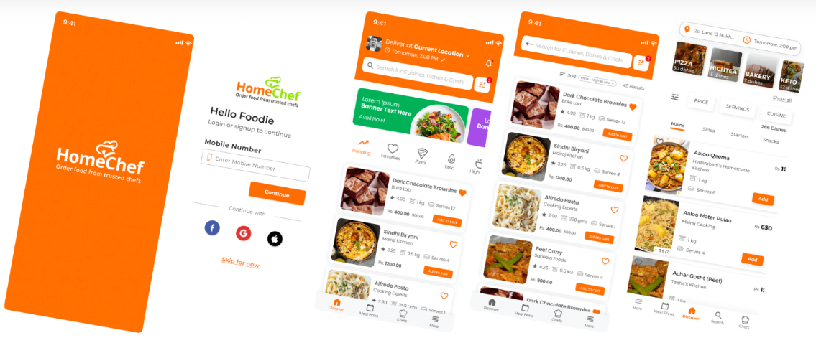

Notable Highlights
Reactree addressed the unstructured backend data of the previous app and optimized it for improved efficiency. The refined backend allowed for seamless data accessibility and analysis, enhancing the overall performance of the app.
Furthermore, Reactree’s in-house integration of an Alpha payment gateway provided HomeChef with a secure and reliable online payment processing system. This custom solution offers HomeChef full control over the payment process and enhances the user experience.

