MindTickle SEO Case Study

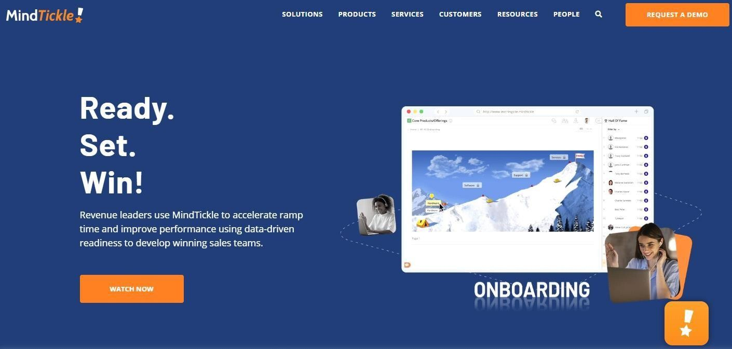

About MindTickle
MindTickle provides a comprehensive, data-driven solution for sales readiness and enablement that fuels revenue growth and brand affinity. Its purpose-built applications, proven methodologies, and best practices are designed to drive effective sales on boarding and ongoing readiness. With MindTickle, company leaders and sellers can continually assess, diagnose and develop the knowledge, skills, and behaviours required to effectively engage customers and drive growth. Companies across a wide range of industries use MindTickle's innovative capabilities for on-demand, online training, bite-sized mobile updates, gasification- based learning, coaching and role-play to ensure world-class sales performance.

Issues Faced by Client

Client was concerned about the less organic traffic on the website and search engine visibility.

Our Strategies
Klick Media Labs identified the client's requirement and conversion touch points, market segments, and audience personas. We did a competitive analysis to review the performance and engagement of the website, finding new on-page and off-page opportunities to implement.
- To do indept analysis of the website & current status
- Fix technical issue of the website
- We have improved the UI/UX of the website
- Improved the quality of the content on the website pages
- Published content on high authority Guest Blogging website
- We have developed the new pages belong to their industries
- Regularly fixing webmaster errors

Achievements

- Traffic Increased over the website up to 129.50%
- Improved competitive keyword ranking within 6 months
- Most of the keywords searches shows site on first page of Google
- Conversion rate increased up to 63.25%
- Increased organic new users on the site by 140%

Organic Traffic Graph

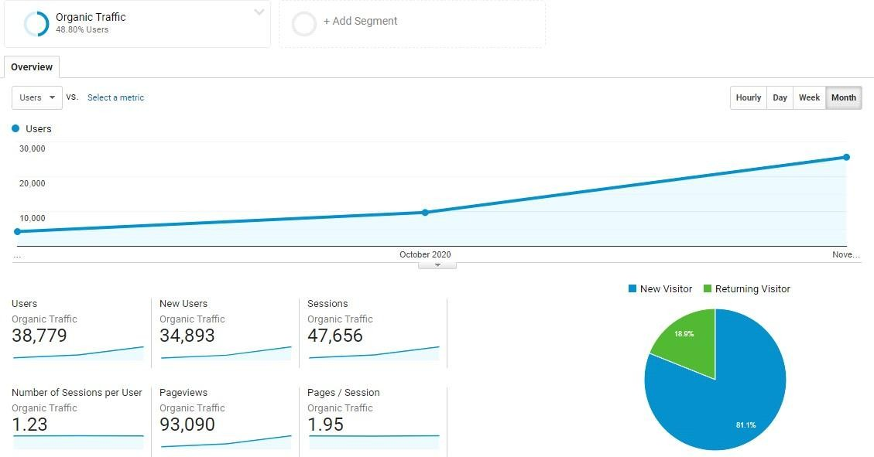

Goals

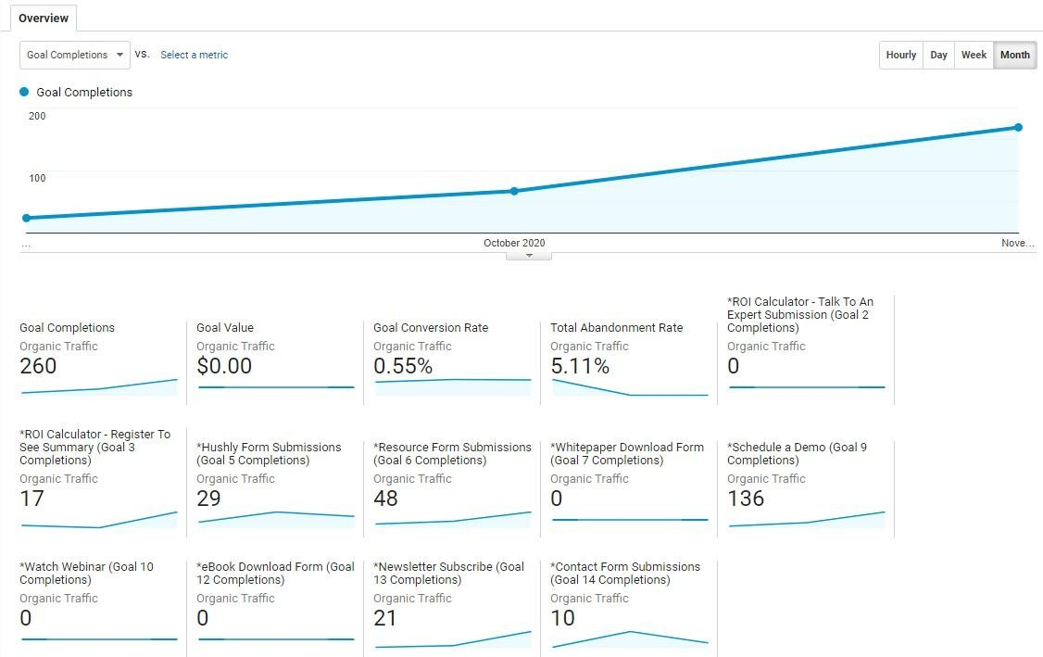

Keywords Improvement

Keyword | Avg. monthly searches | Base Ranking (March) | December
sales management coaching | 90 | 4 | 1
sales onboarding | 320 | not in 100 | 1
sales onboarding process | 50 | not in 100 | 1
sales onboarding program | 30 | 9 | 1
enablement training | 70 | 2 | 2
Sales LMS | 90 | not in 100 | 9
sales enablement companies | 90 | 40 | 10
sales productivity software | 40 | not in 100 | 10
sales enablement | 9900 | 30 | 10

*Notte: These arre just few keywords to highlight.

Scope For 2021

Next Year Plan - 2021 for MindTickle

Proposed Backlinks Plan for 2021

Activity | Quantification
Guest Posting | 30
Article Submission | 2
Blog Network | 2
Classified Ads | 10
Image Sharing | 10
Social Bookmarking | 20

On-Page Activity
- New solutions pages meta tags will be updated

- New industries wise pages meta tags will be updated
- 280 Pending official blogs will be optimized

- 94 Official blogs schema will be updated on website
- New case study meta tags will be updated
- 103 Resource pages will be updated on the website

- Approx 10 industries & solutions wise new pages will be developed
- Webmaster errors will be fixed quarterly

- Hot Jar suggestions quarterly

Additional Activities
- 20 AMP pages will be developed
- Chat bot will be implemented
- Additional FAQ’s page will be implemented
- FAQ schema will be implemented
- Indexing & Pagination issues checked & fixed
- Regular UI suggestions to increase conversion rate

Competitors Analysis
- Competitors links profile setup
- Competitors enhancement check & new pages suggestions
- Competitors blogs check & suggestions
- Competitors content audit & suggestions

SEO Parameters Will be Improved

S.No | Improvement Parameters | 2020 | 2021
1 | Improvement in DA (Domain Authority) | 45 | 50
2 | Improvement in DR (Domain Rating) | 67 | 75
3 | Improvement in PA (Page Authority) | 45 | 50
4 | Google Indexed Pages | 917 | 1000
5 | Ahrefs& Webmaster Backlinks | 15k | 16k

6 | Referring pages Increased | 6,440 | 7000
7 | Referring domains Increased | 1.12K | 1.5k

