PPC ADVERTISING FOR FURNITURE STORE IN EUROPE

SOLUTION
First of all our task was to get good stable ROAS and develop options for scaling. So we decided to divide it into 2 stages:
- Optimize ad campaigns to get good stable ROAS;
- Then scale successful campaigns;
To get a good return on investment we decided to use smart shopping campaigns on Google ads. It was a good step because this campaigns type can give us results much faster than any other. Our results for smart campaigns were next:
To optimize smart google campaigns we started testing different campaigns structures. We tested everything from audiences to product groups. In one of the tests with product groups which were divided by priority we received the next results:
So after this stage with testing, we decided to fix our results and use the structure “brand + effectiveness”. Then we started ad campaigns scaling. There are several options for scaling in smart shopping campaigns: increase the budget, decrease or remove ROAS goal in campaigns’ settings. The main thing to remember: everything should be done slowly and carefully. Our profit on campaigns decreased a bit, but we achieved our goal. Scaling results were next:
The next goal for us was to scale campaigns without a drop in profit.
To continue our scaling more effectively we used search campaigns and DSA with a structure that was similar to shopping campaigns. The dynamic was next:
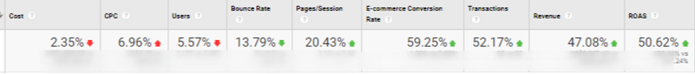
Similar campaigns were launched for all the countries where we were able to launch shopping ads in English.
To decide which country we should scale or not, we checked the performance data per country and compared it with our goals. Traffic increase by countries:
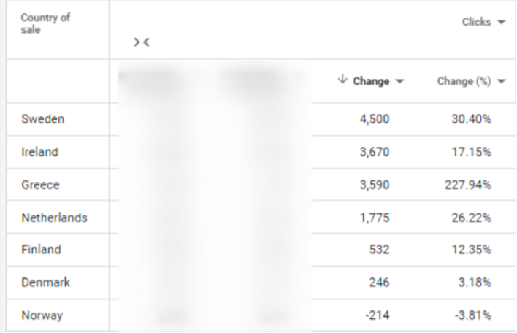
Also, we added promo campaigns in Merchant center to increase audience engagement and interest.
Then we, again and again, checked results, compared with goals, and optimized campaigns.
To have stable ROAS for all the campaigns and countries we tested strategies for “target ROAS” and “target CPA”. Sometimes we created our own strategies to get better results and optimize campaigns manually. After this stage of optimization, we achieved a good increase in conversions (conversion = transaction).
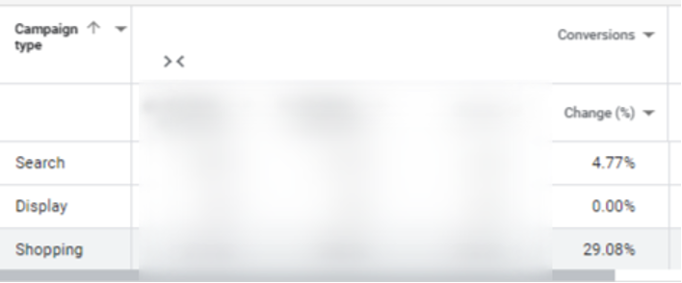
At this moment we are testing different combinations of smart + usual shopping campaigns and use custom strategies for bids.
Conclusion:
Using custom strategies and machine learning allows us to get better results much faster. If you work with a professional advertising agency you always can test new features and get better results. In our case, we had enough traffic for machine learning and it helps us to get results in a shorter time.
Even smart campaigns should be carefully optimized to save budgets and get good results.

