SEO Case Study: How I increased organic traffic to 13000% in Six Months

How to bring traffic to a website? What could be done to engage visitors on my website? These are very common questions asked by majority of website owners out there. I have seen people shutting down their business by running out of leads and paid campaigns.
But, what if I say there is a way where you can drive thousands of visitors to your website every month and never worry about conversions? Yes! That’s what I did to my website.

Here is my case study of how I single headedly increased my website’s traffic to 13000% in 6 months

After several weeks of niche research, I found a very competitive niche which I was sure would be a very good investment to make. But months after selecting the domain and setting up the website, I decided to stop procrastinating and start working on its SEO for a better traffic. That’s how it all started.
After months and month of no traffic and a lot of procrastination, I started exploiting my skills as an SEO Analyst to receive organic traffic from all over the world via major search engines like Google, Bing, Yahoo and more.
In December 2016, I made an inbound marketing strategy for the site and started working on it. Below is the analytics report for the month of December 2016.
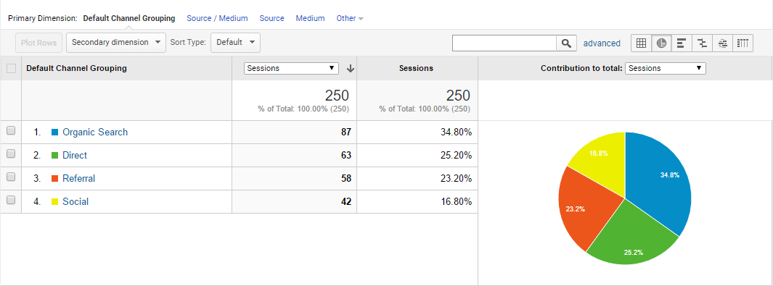
Figure 1 - December Traffic
By the time I started working on the SEO, there was little to no organic traffic on the website. After which, I started working on my self-made SEO Strategy which resulted in getting 87 organic visits for the entire December month and a few more from other channels like Social Media and Referrals.
But what happened in month of January 2017 was totally unexpected. The organic traffic jumped from 87 visitors in December to 417 organic Visitors that month (a 375% increase in SEO Traffic from previous month). Which pretty much made sure that my SEO Strategy is working just fine.
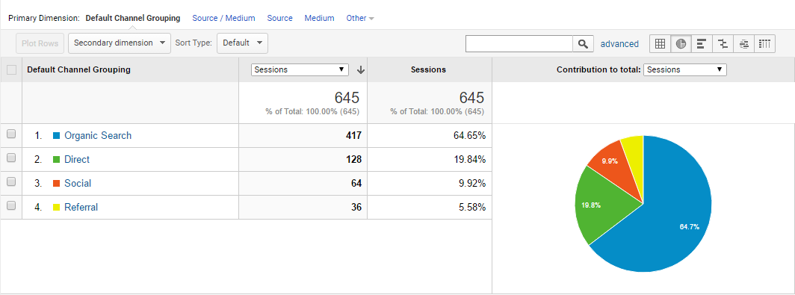
Figure 2 - January Traffic

However, I did some social sharing as well to keep the traffic coming with 64 visitors from Facebook, Twitter and other Social Media Platforms.
February 2017: Inspired and Motivated with the results of January Month, I optimized my site a bit more and made some high quality backlinks as per my strategy. That’s where the results kicked in and the Organic traffic increased to 639 Visitors that month.
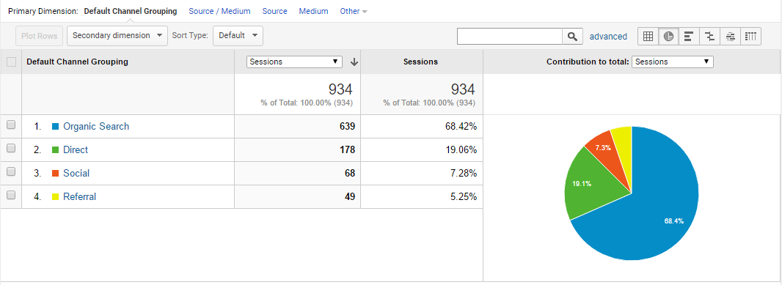
Figure 3 - February Traffic

Not to mention, I only gave 2 hours per day on the website’s SEO after my daily 9-5 Job.

And that’s when I thought it would be a good idea to monetize the site via Google AdSense. Nothing huge, but the site earned a small amount of $5 for the entire month based on the number of clicks and impressions.
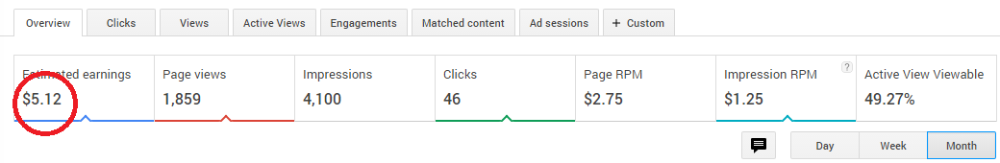
In February, 89% of the search traffic came from Google and the rest 11% from other Search Engines.
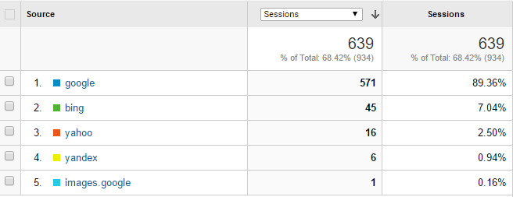

March 2017: The Traffic started falling in the first week of March, as I wasn’t able to give much time to the site due to my daily 9-5 Job. I decided to increase the work time from 2 hours to 4 hours a day, focusing more on Keyword Research and building High Quality Backlinks.
Skyrocketing the Rankings, the search traffic doubled up as compared to February and what I witnessed was a whopping 1200% increase in organic traffic as compared to the starting month i.e. December. Also, the AdSense earnings were 3 times to that of previous month.
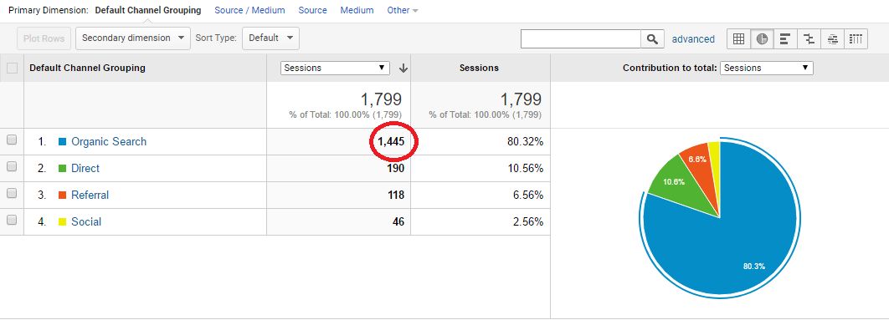
Figure 4 - March Traffic
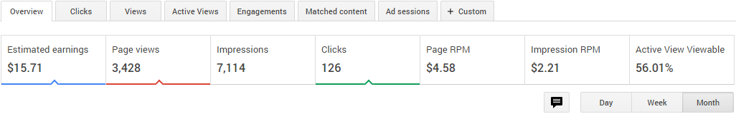

Common SEO Mistakes that I avoided

The results in these four months took a lot of hard work and practice, and of course the SEO Strategy, a successful strategy as it seemed. In order to maintain that success, there were a few mistakes I could have done that I avoided as learned in my past SEO Experiences. Some of them are mentioned below.
- Focusing on Keywords with little to no search traffic
- Building low-quality backlinks
- Focusing on a single keyword targeting a single page
- Expecting an overnight increase in rankings
- Excessive Link-Building
- Use of black hat tactics like keyword stuffing, hidden texts etc.
I played by the golden rules of SEO, which in terms are the White-Hat SEO Tactics as mentioned in Google Webmaster’s Guidelines. Which in fact, worked amazingly well as seen in the next month’s results.
April 2016: I quit my Job as a Digital Marketing Manager to start multiple Niche sites and become a Freelance Web Developer and SEO Consultant. The good thing that happened – now I was able to dedicate all of my time in building my website’s search traffic and most importantly – I work for myself.
April month’s analytics report showed more than 100% increase in Organic Traffic as compared to March’s traffic report.
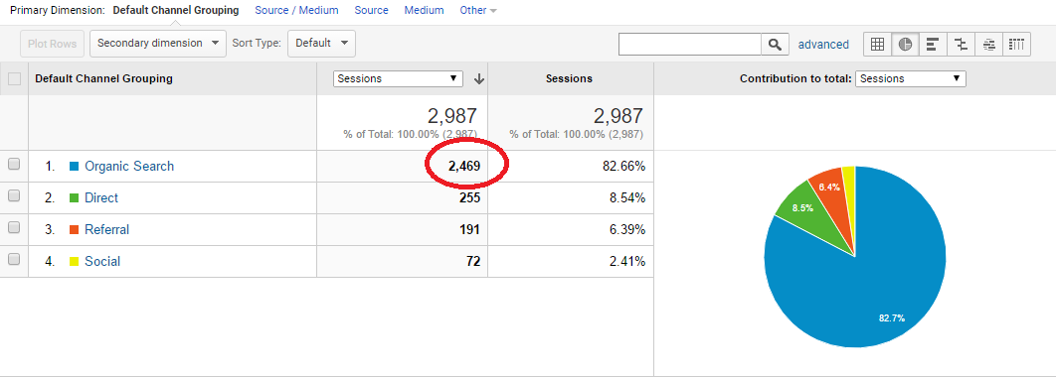
The visitors were again doubled the visitors of previous month and I witnessed a gradual increase in Social Media and Referral Traffic as well.

How Paid Campaign Would Have Cost Me a Fortune?
I am not really a fan of Paid Search when it comes to Search Engine Marketing, unless the business is product based or something to attract more leads. The primary goal of my Niche website was to attract a good amount of Organic Visitors without spending a single dime on Paid Campaigns.
And guess what? According to SEMRush, which a widely popular SEO Tool used for SEO Analysis, the overall worth of my ranking keywords was approx. $3.5K. Which means, most of the keywords I ranked on the Top 10 would have cost me a fortune, if I ran a paid campaign for those keywords.
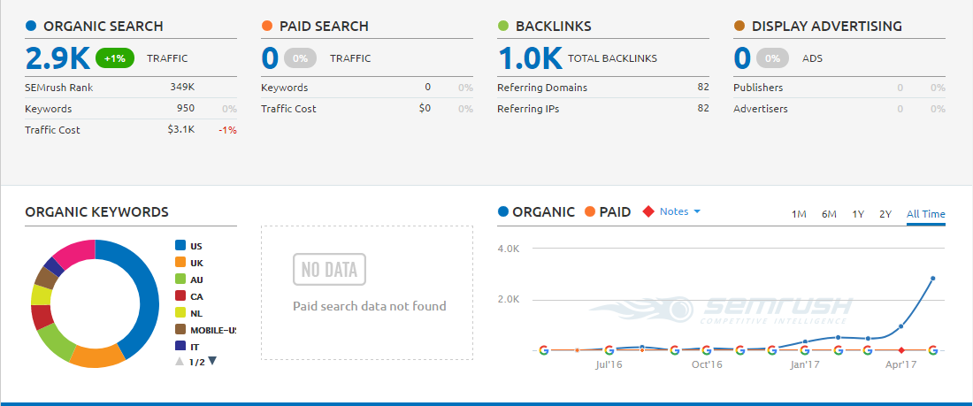

When Traffic increased by 13000% more than the starting month

May 2016: Quitting my Job and dedicating more than 4 hours a day resulted in something that I never even imagined would happen. With more than 90 keywords ranking on the first page and more than 900 Keywords ranking in Top 100’s of Google and other Search Engines, I started receiving traffic from all over the world, primarily the U.S.A.
To believe the analytics, the Organic Search of this month crossed 11,500 unique visitors, which was 4X times the Organic traffic of previous month and 132X times the Organic Traffic of December Month. When calculated, the percentage increase in the SEO traffic was 13000% more as compared to when it all started in the month of December.
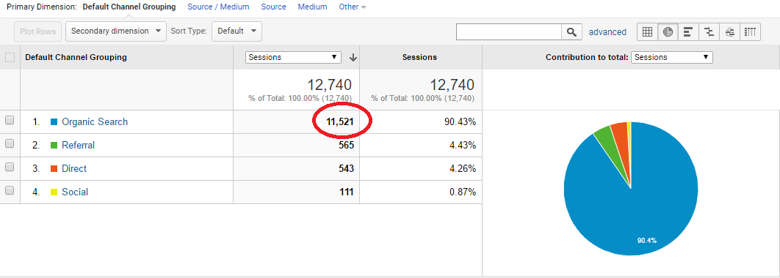
Undoubtedly, the SEO Strategies that I made started giving results like never before. And with the massive increase in traffic, the Google AdSense earnings for May 2017 also got increased to 4X times to that of past two months.
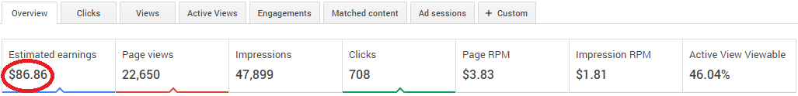

How I Earned my first $100 from this website?
Like I mentioned earlier, the primary goal of my website was to increase the Organic Traffic without paying a single dime. Everything was dependant on my strategies, the amount of time I gave to the website’s SEO and not to mention, the sleepless nights. When I started this website, I never thought it to be a source of passive income for me.
Adding up all the AdSense earnings from December to May, the total earnings were approx. $120, which in fact was a decent return on investment for me. And this was just AdSense. A website with 11500 visitors per month has great potential to earn 100 times this amount with Affiliate Marketing.
But unfortunately, the niche I selected didn’t had much scope in Affiliate Marketing and therefore I started working on other niches as well.

The overall Traffic Summary of these six months
When I first started working on the SEO for this website, there was nothing to brag about. Initially, the overall traffic of the website was 250 Visitors in the entire December month, which also included – Direct, Referral and Social Media Traffic apart from the organic visitors.
And this is how I raised the bar for every other month’s traffic and that too single headedly. Below are the stats for these 6 months (December 2016 – May 2017)
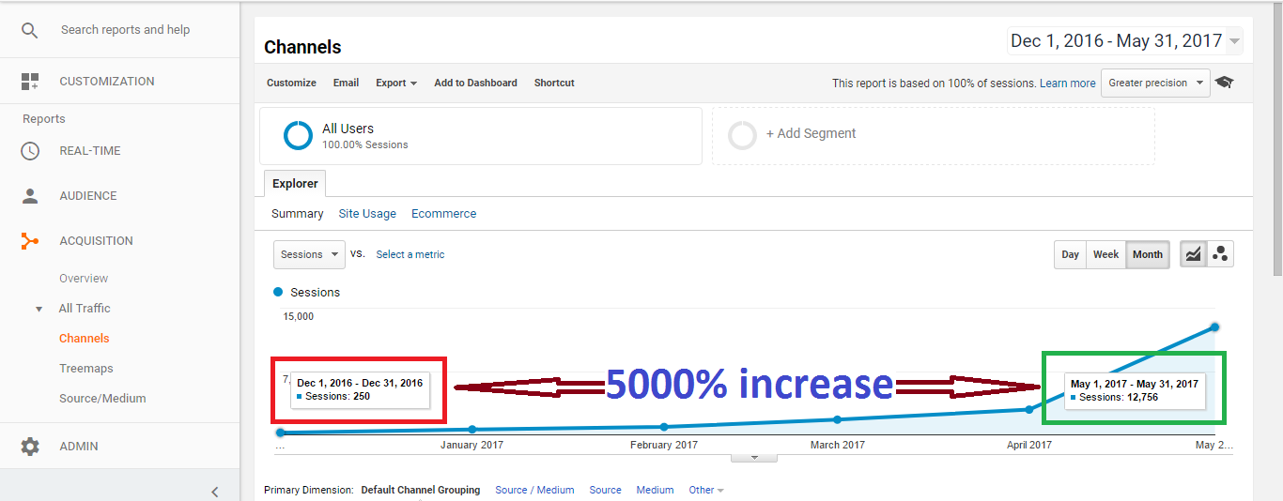
Talking about the overall traffic in these six months from all the sources, there was a 5000% increase in sessions from the December 2016 to May 2017.
The total number of Organic Searches were 16,593 Visitors in addition to the Direct, Referral and Social Visitors which increased the count to 19,371 Visitors within 6 months of inbound marketing.
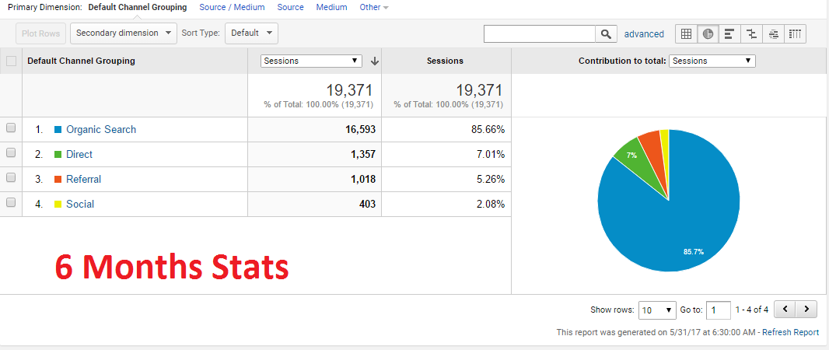

Talking about the Global Reach, there were visitors from 112 Countries in these 6 months, where 88% were from the U.S. and the remaining from other countries. Which made it clear that the keywords I targeted had majority of searches from the U.S.
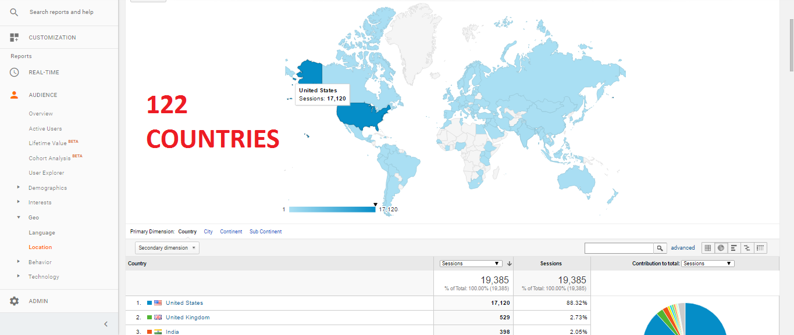
When I went a bit deep in the Demographics, I saw that the Traffic came from 2500 Cities from those 122 Countries, which made sure that this particular Niche is very popular among the people from all over the world.
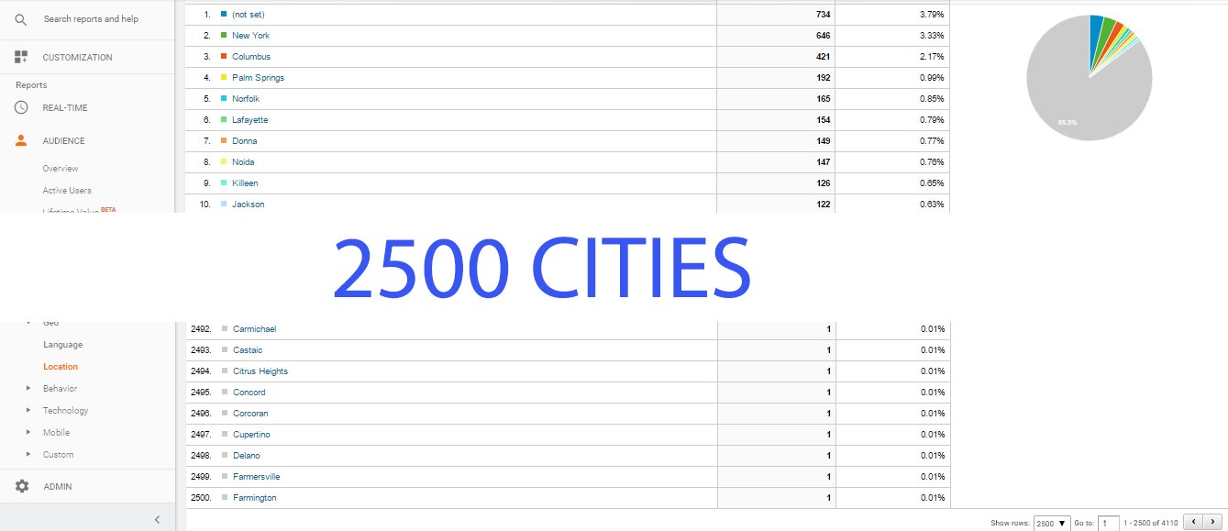

Major contributing Factors for increase in SEO Traffic
- Keyword Research: I knew that the keywords I selected are best for my niche site, making the Keyword Research one of the best contributing factor in getting visitors from all the popular search engines including Google, Yahoo, Bing and others.
Whilst, the majority of the search traffic was from Google (89.36%), the site received some visitors from other Search Engines as well.
- Backlinks: I focused more on the quality of backlinks instead of quantity, unlike what most of the SEO Companies do to increase rankings.
- Webmaster Guidelines: My way of doing SEO is very simple, never do what search engines don’t want you to and always follow white-hat practices. I went through every guideline that search engines provided and worked accordingly.
- Patience is Virtue: It was frustrating at times to see the rankings fall off or waiting for months to witness some increase in traffic, but as I mentioned earlier, it had its own benefits. What I would have paid $3K every month for is now permanent for years to come without spending a single dime.
- Regular On-Page Check-up: I audit my website every week for On-Page SEO Errors and fix what needs to be fixed. The most important factors being the website speed, relevancy of fresh content, keyword density and more.

Currently, I am working on a few more niche sites on which I will be making a case study soon. If you are interested in developing a new website or growing your website’s traffic just like mine (or even better), consult me by clicking right here.
If have any questions, feel free to ask.

