

8th January, 2025

To Whom It May Concern,

RE: Lot 411 – Hellbent / Flying Jess 2023 filly
Magic Millions
Gold Coast National Yearling Sale

I, Tom Dabernig, agree to train the Hellbent / Flying Jess 2023 filly for the syndication being formed by Joe O’Neill from Prime Thoroughbreds.

Dabernig Racing’s current daily training rate is $118.19 (plus GST).

Myself and our team are delighted to receive this horse to train.

Please contact me if you require any further information.

Kind Regards,
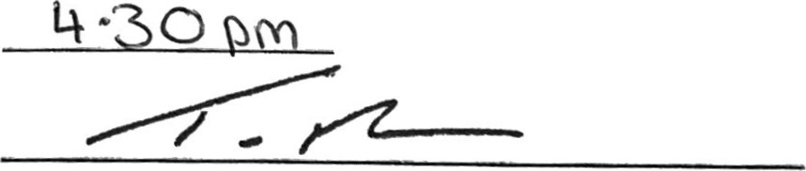

Tom Dabernig

