

9th February, 2025

To Whom It May Concern,

RE: Lot 116 – Capitalist / Chosen Heir 2023 filly
2025 Inglis Classic
Yearling Sale

I, Tom Dabernig, agree to train the Capitalist / Chosen Heir 2023 filly for the syndication being formed by Joe O’Neill from Prime Thoroughbreds.

Dabernig Racing’s current daily training rate is $118.19 (plus GST).

Myself and our team are delighted to receive this horse to train.

Please contact me if you require any further information.

Kind Regards,
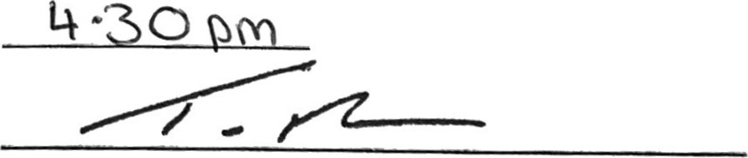

Tom Dabernig

