

Genes and Traits Assignment
Use your knowledge of genes and traits to answer the following questions.
- On the diagram below, label the cell, DNA, chromosome, nucleus, and gene in the blank boxes next to each part of the image.
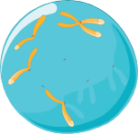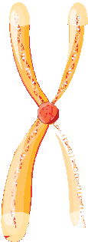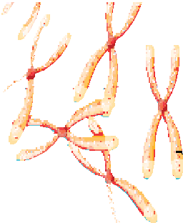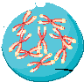

- Answer each of the following questions in a complete sentence.
  - How are proteins important for life?

  - How are genes and proteins related?

  - How are genes and DNA related?

  - From where did your genes originate?

  - How are genes “stored” inside the cell?

- Which traits did you inherit from each parent? For each trait below, decide if you inherited it from your mom, dad, or a combination of both. Then explain your answer. If you aren’t sure about traits from a parent, you may just include traits from one parent, or you can also interview a friend for this activity instead!

Trait | Mom, Dad, or Both? | Explanation
eye color

hair color

height
shape of nose

