

Mollusks Assignment
Use what you know of sponges, Cnidaria, worms, and mollusks to complete the questions below.
- Compare the body symmetries of sponges, Cnidaria, worms, and mollusks by drawing a simple sketch of the body shape of an example of each. Then identify each as radial, bilateral, or no symmetry.

Animal | Drawing | Body Symmetry
Sponges
Cnidaria
Worms
Mollusks

- Read each description of an animal. Then, identify it as a sponge, Cnidaria, worm, or mollusk by writing the answer in the blank provided.
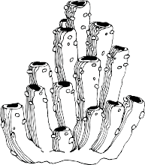
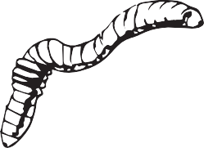
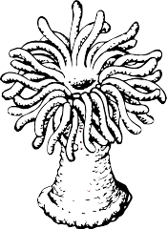
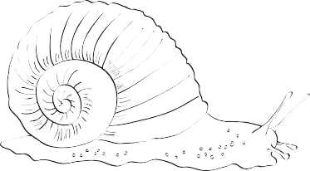

a. filter feeder that pulls water in through tiny pores in the body

b. has a long digestive tube that runs the length of the body from the mouth to the anus

c. soft-bodied with an outer shell; uses a radula for scraping food off rocks and other hard surfaces

d. small, soft organisms with tentacles and stinging cells for catching floating prey in the water

- How does the movement of Cnidaria, like jellyfish, compare to mollusks, like bivalves? What specific body parts, if any, are used to aid their movement? Write your answer in complete sentences.
