

Skeleton, Bones, and Joints Assignment

Use what you have learned about the skeletal system, bones, and joints to complete the following activities.
- Label the following bones on the skeletal system diagram below: skull, pelvis, mandible, scapula, tibia, ribs, humerus, sternum, clavicle, vertebral column, femur. Then shade in the bones that belong to the axial skeleton.

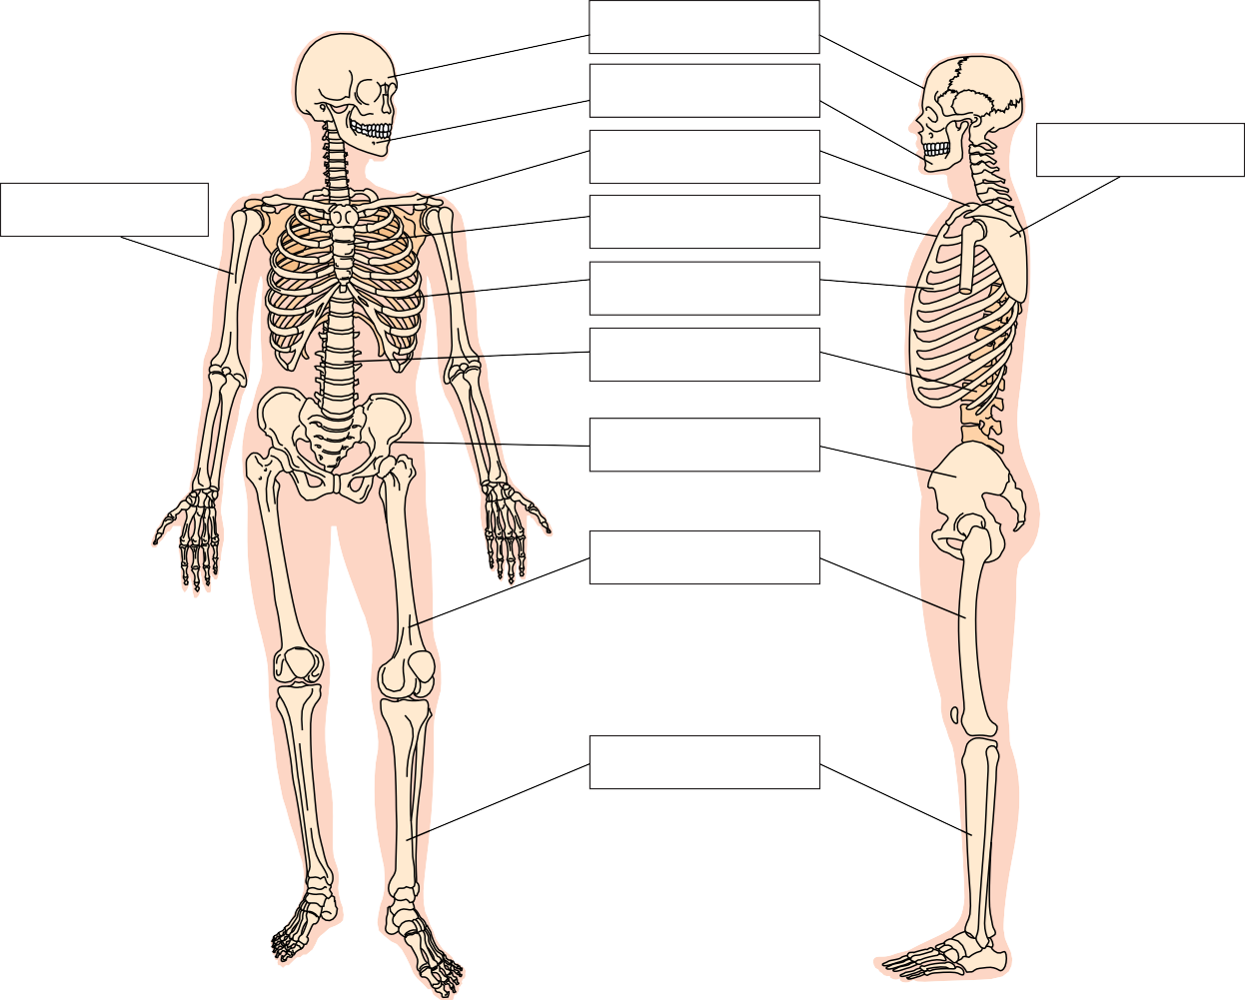

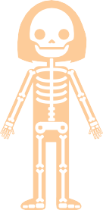
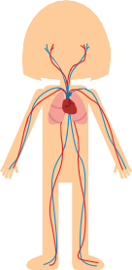
- Would your circulatory system function properly without the skeletal system? Why or why not?

- Imagine that some of the joints in your body were replaced with a different type. For each type of joint replacement, draw how the body movement would differ. Then write a brief description in the third column.

Joint Type Replacement | Drawing | Description
hinge joints in phalanges replaced with ball and socket joints
ball and socket joint between the scapula and humerus replaced with a hinge joint

