Name:

Assignment:
Position vs. Time

Part 1: Understanding Position vs. Time Graphs
- Describe the movement of the object that would produce the following graph. What is its velocity?
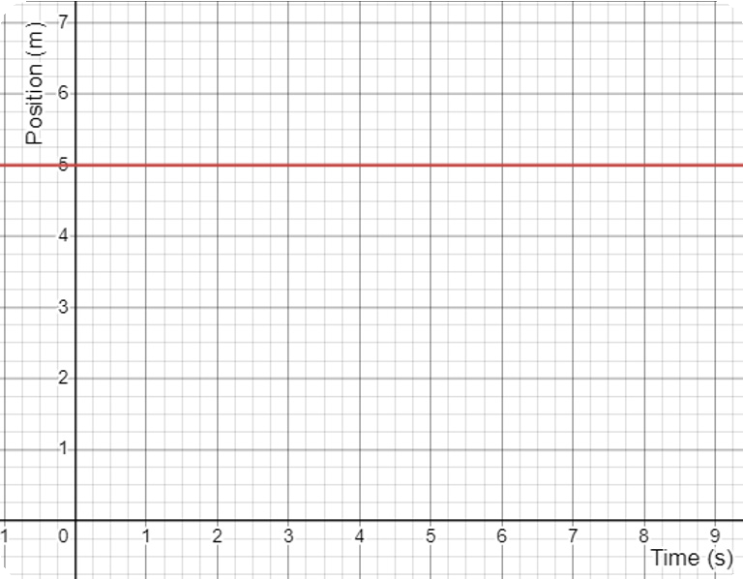

- Describe the movement of the object that would produce the following graph. What is its velocity?
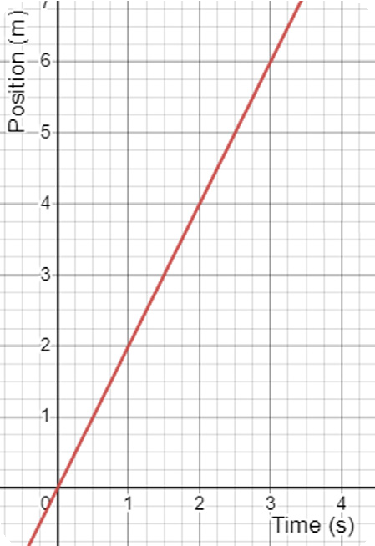

- How would this graph change if the velocity were less?

- 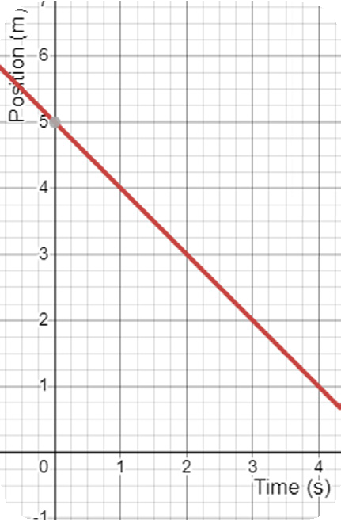Describe the movement of the object that would produce the following graph. What is its velocity?

- Predict how the graph would change if the velocity were – 3 m/s.

- When you look at two different position and time graphs, how can you tell which one has a higher velocity?

- How is the graph different when the velocity is negative?

Part 2: Interpreting Position vs. Time Graphs
- 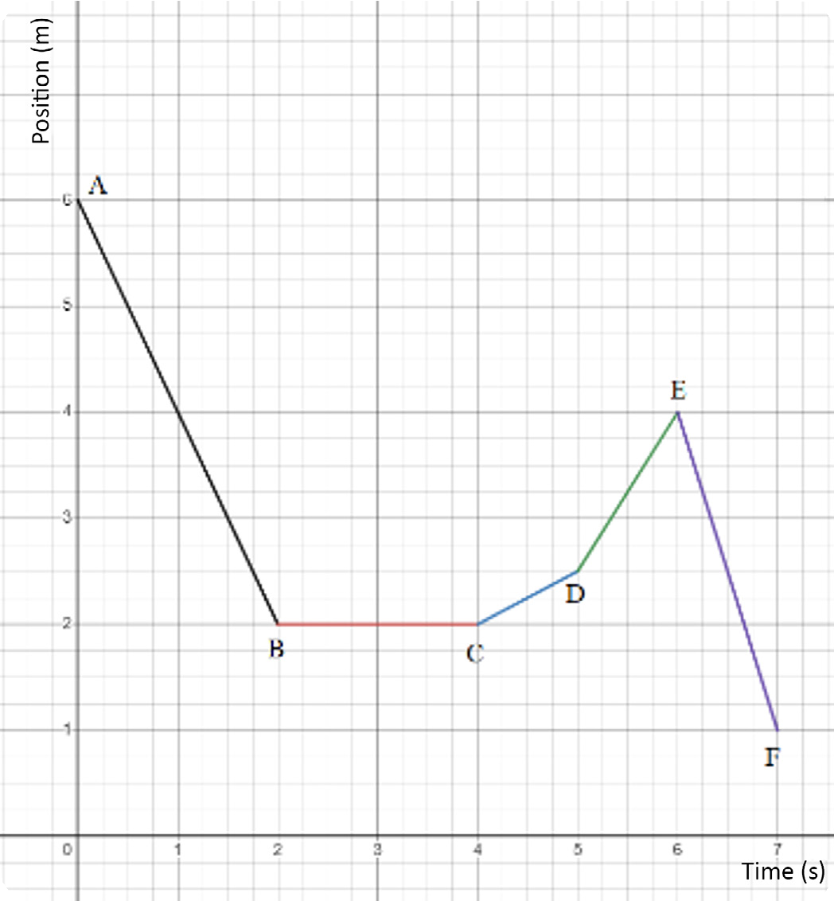Describe the motion that would be needed for an object to create the following position vs time graph.

- Give the velocity for each part of the graph in the problem above.

A – B
B – C
C – D
D – E
E – F

- The instantaneous velocity is the velocity that an object is going at a particular moment. When the line on the graph has a constant slope, the velocity is constant, so the instantaneous velocity is the same during the time. What is the instantaneous velocity of the object that produced the graph above at 3 seconds? What is the instantaneous velocity at 5.5 seconds?

