Types of Angles
Solve each problem. For some problems, you will be solving the actual angle measurement. For others, you will be solving for the value of the variable. Make sure to show all your work.
- Angle 1 and Angle 4 are vertical angles. If the measure of angle 1 equals $3x+14$ and the measure of angle 4 equals $5x-52,$ what is the measure of Angle 1?

- $∠A$ and $∠B$ are complementary angles. If the measure of $∠A$ equals $3x+40$ and the measure of $∠B$ equals $2x+35$, what is the value of $x$?

- Suppose that $m∠ABC=3x+8 and m∠XYZ= \frac{2}{3}x+62$. If $∠ABC$ and $∠XYZ$ are supplementary angles, what is the measure of $∠XYZ$?

- $∠X$ and $∠Y$ form a linear pair. If the measure of $∠X$ equals $5x+45$ and the measure of $∠Y$ equals $10x-15$, what is the measure of $∠X$?
- In the diagram below, the measure of angle CAD is equal to $3x + 17$ and the measure of angle DAB is equal to $2x + 12$. If the measure of angle CAB is $119°$, what is the value of $x$?
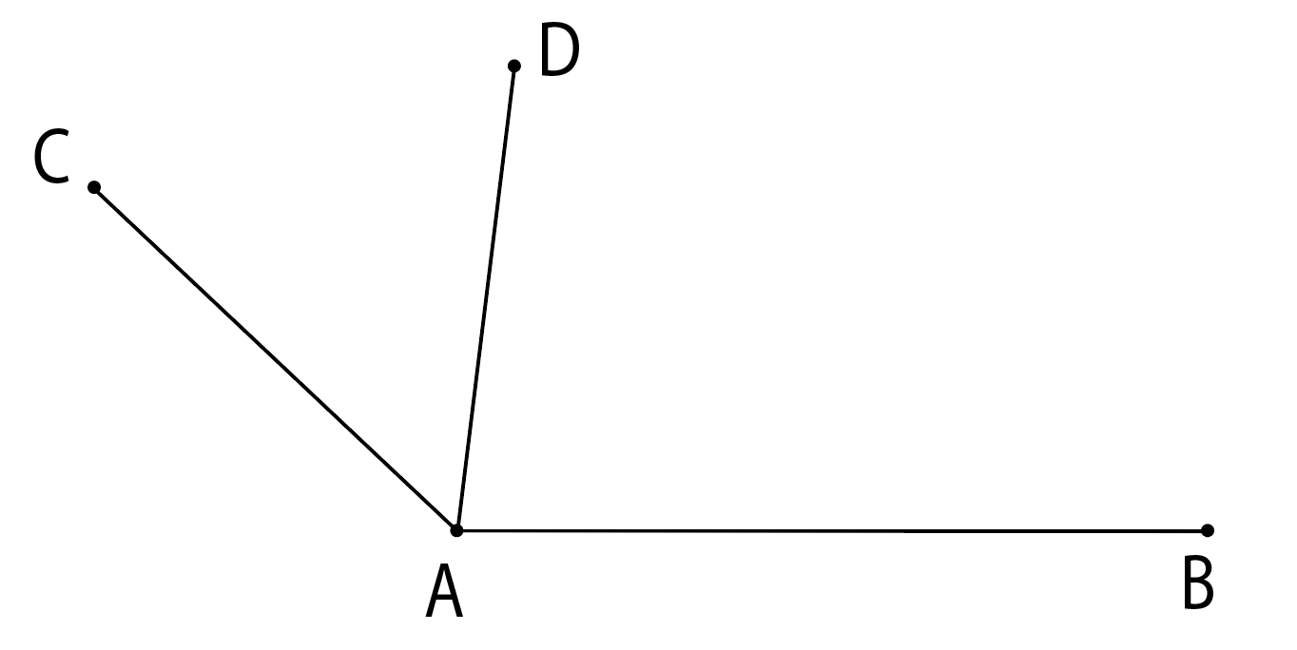

- Angle 2 and Angle 3 are vertical angles. If the measure of angle 2 equals $13x+27$ and the measure of angle 3 equals $9x+59,$ find the value of $x$.

- $∠A$ and $∠B$ are complementary angles. If the measure of $∠A$ equals $3x-22$ and the measure of $∠B$ equals $5x+40$, what is the measure of $∠B$?
- Suppose that $m∠ABC=163° and m∠XYZ=5x+2$. If $∠ABC$ and $∠XYZ$ are supplementary angles, determine the value of $x$.

- $∠X$ and $∠Y$ form a linear pair. If the measure of $∠X$ equals $24x-36°$ and the measure of $∠Y$ equals $12x$, how much is $x$?

- In the diagram below, the measure of angle CAB is equal to $5x-14$ and the measure of angle DAB is equal to $6x + 12$. If the measure of angle CAB is $130°$, what is the measure of angle DAB?

