The Slope of a Line
Find the slope of the line through each pair of points. Make sure to show all your work.
- $\left(6, -18\right) and (15, -18)$
- $\left(8, 12\right) and (0, 16)$
- $\left(-15, 37\right) and (-15, 2)$
- $\left(1 ,20\right) and (-5, 30)$

- $\left(4, -36\right) and (8, -12)$

- $\left(\frac{2}{3}, \frac{5}{9}\right) and (\frac{1}{3}, \frac{5}{9})$
- $\left(\frac{3}{8}, \frac{1}{5}\right) and (\frac{3}{8}, \frac{4}{15})$
- $\left(11, -23\right) and (7, -15)$
- $\left(-72, 54\right) and (-38, 100)$
- Use the graph below to answer the questions shown.
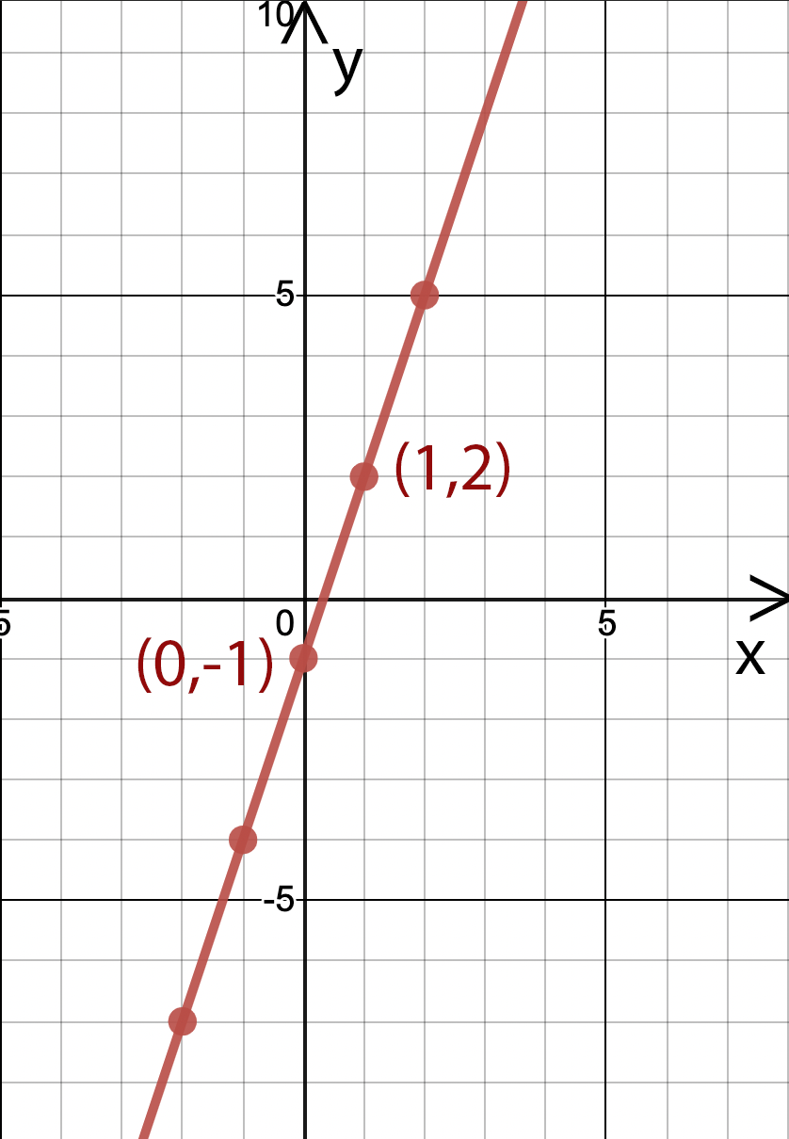

  - Does the graph shown have a positive or negative slope?
  - List at least one other ordered pair shown on the graph that is not yet labeled.
  - What is the slope of the line shown? Show all of your work

