Rotations
Complete this assignment, which covers rotations, translations, and reflections.
- In the four graphs below, determine what transformation was used to transform $∆ABC$ to $∆A'B'C'$. Then, for each one, write the correct description of the transformation along with the algebraic notation.
a. 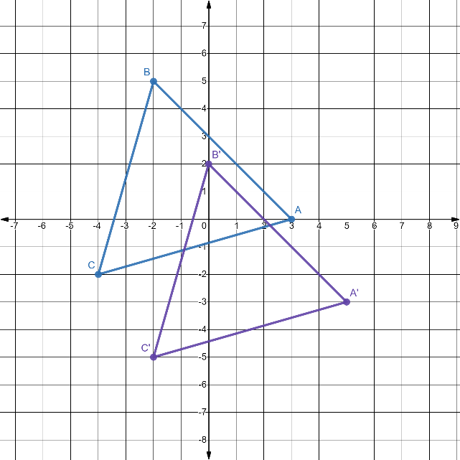 b. 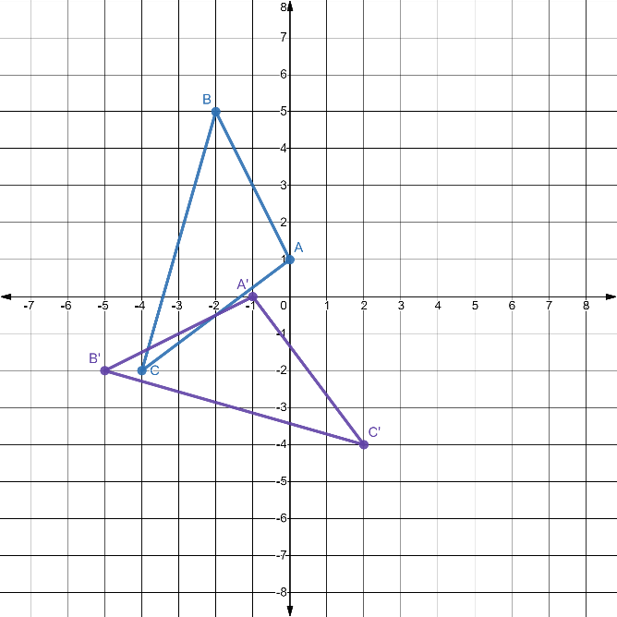
c. 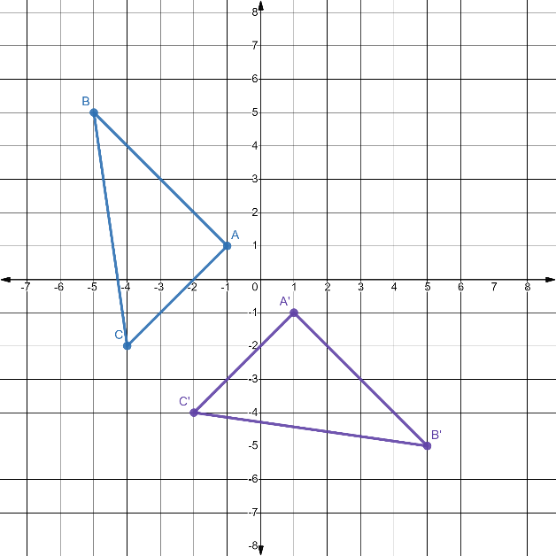 d. 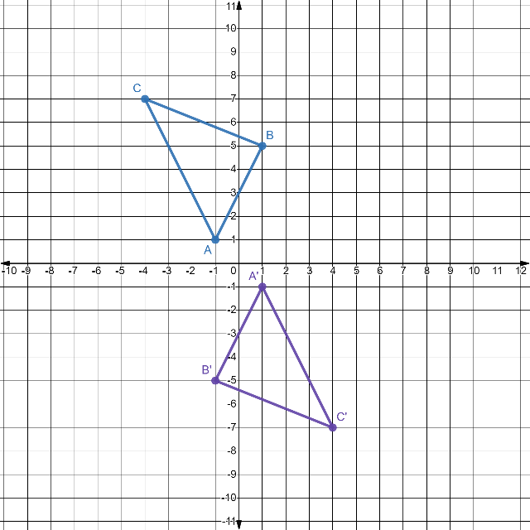

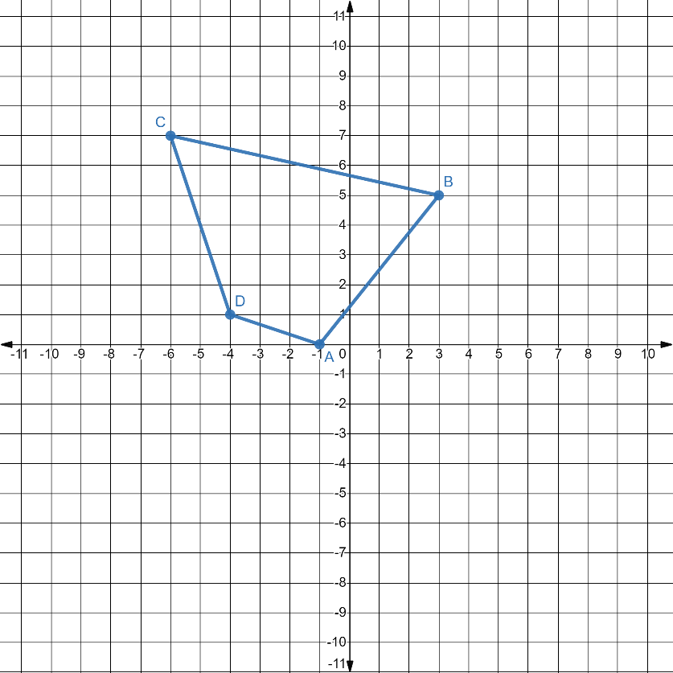
The graph above is of Quadrilateral ABCD.
- Where will vertex A be located after a rotation of -90°?

- Where will vertex B be located after a rotation of 90°?

- Where will vertex C be located after a -180° rotation?

- Where will vertex D be located after a 270° rotation?

- A rotation was performed on ∆GHI to transform it to ∆G’H’I’, shown below.

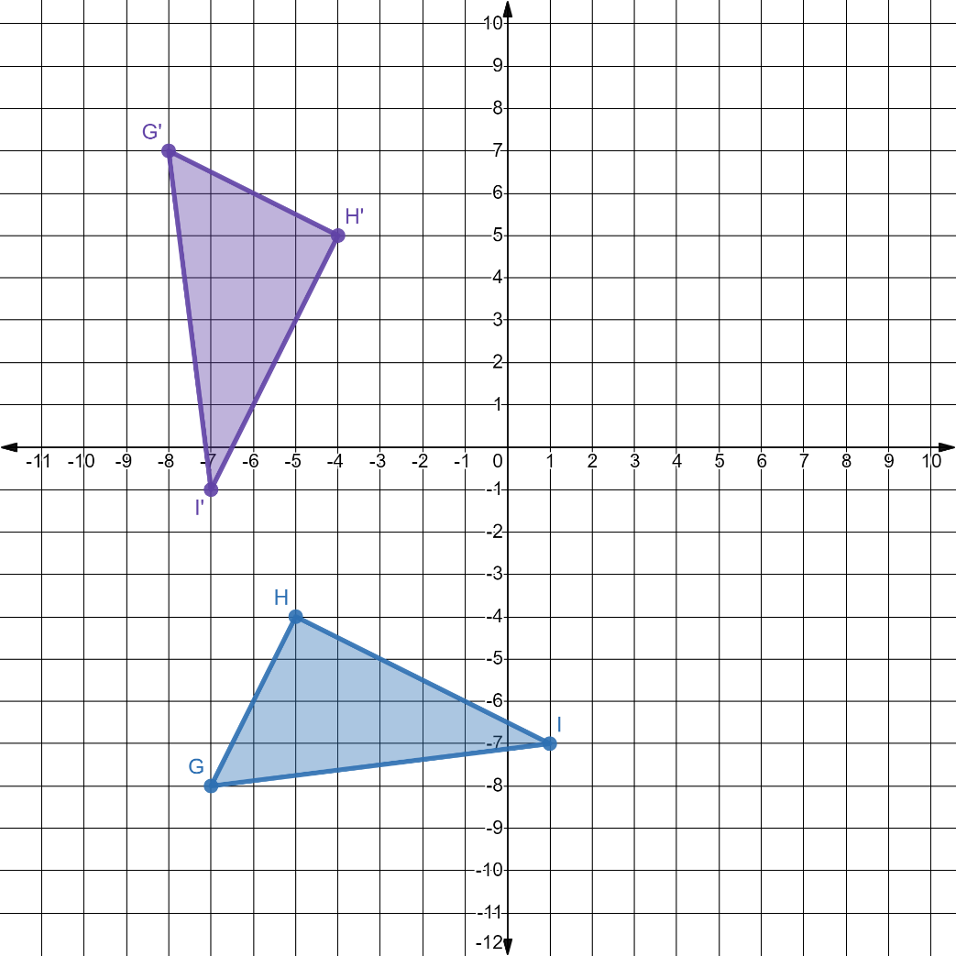

What rotation angle was used and how can you prove that the two triangles are congruent?

