Working with Non-Linear Data

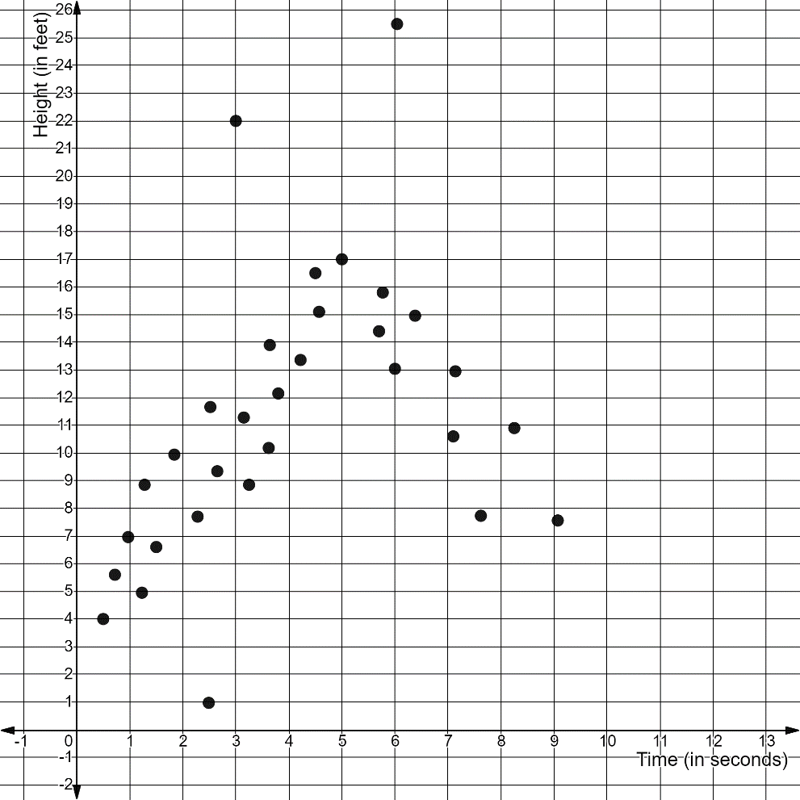
The scatterplot above shows the relationship between the height of blown bubbles in relation to the time that has elapsed.
- What is the trend of the data displayed in the scatterplot? What are the associations, if any?

- What domain can be used to create a linear model with the data? Explain what the domain and the linear association imply in this situation?

- Use the domain you obtained from part 1b to determine the equation for the line of best fit for the linear model.
(To calculate slope, use the points within the domain that are the farthest left and farthest right on the scatterplot)

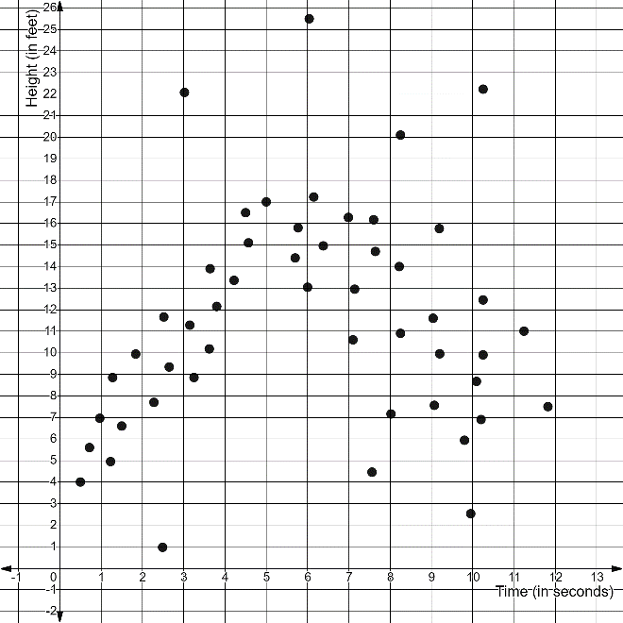
Suppose more data points were plotted on the scatterplot, shown above. Now with 50 data points, explain why there is now no way to create the same linear model and line of best fit as before? Are there any other linear associations on the scatterplot?

- The scatterplot below displays data for the number of bugs that appear during a rainfall (in the hundreds) in relation to the amount in rains (in inches).

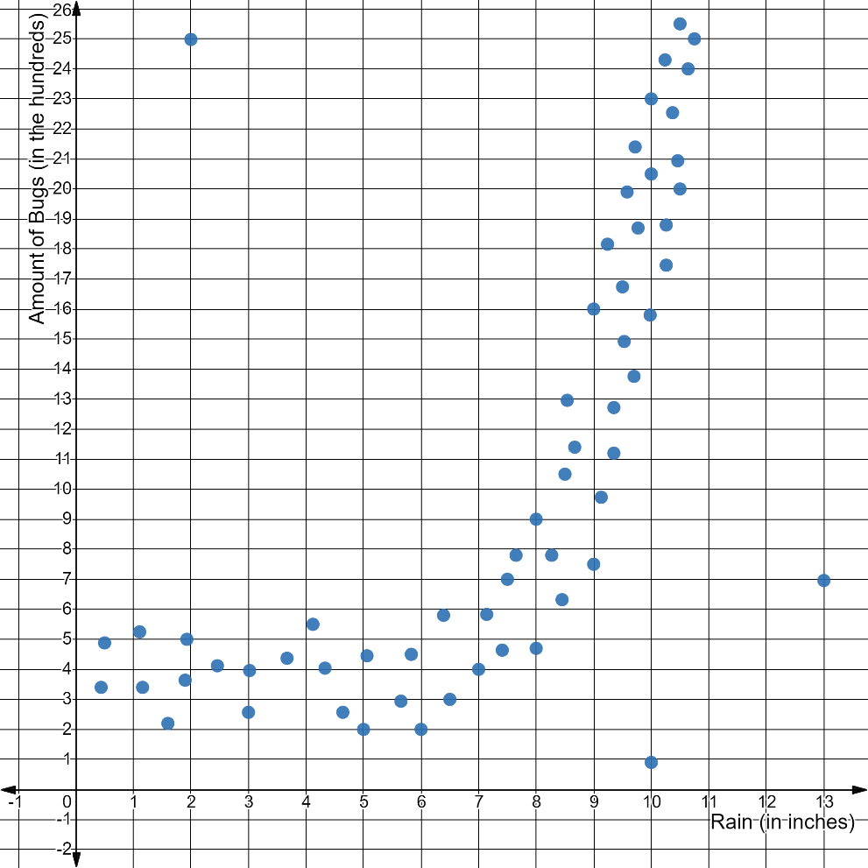

- Name the trend displayed in the scatterplot along with any associations there may be.

- Explain why the lowest possible domain value for a linear model of this data must begin at x = 6?

- Complete the rest of the domain for the linear model and explain what the domain represents. (Use whole numbers for your minimum and maximum domain values)

- What is the line of best fit to model the linear relationship in the scatterplot using the domain? Use reference points, where one point has the x-coordinate of 6 and the other has the x-coordinate of 11, when calculating for slope and y-intercept.

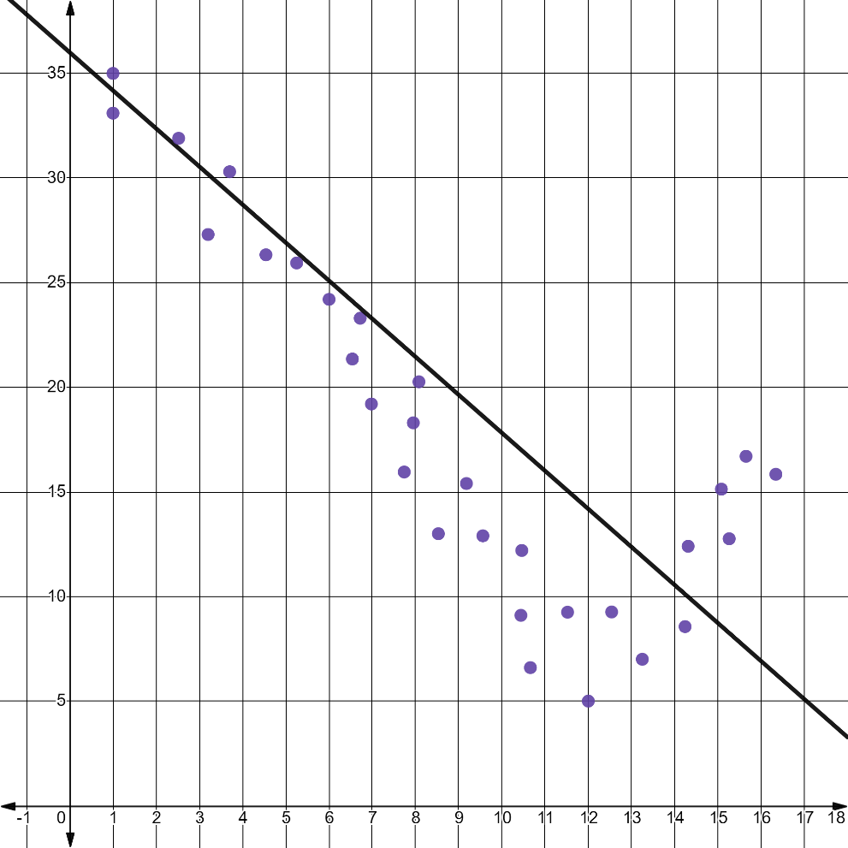
- Explain why the line of best fit in the graph above is not ideal for the linear model?

- Determine the domain of the attempted linear model and then explain its meaning.

- Explain how the line of best fit should be moved in order to better represent the data in the scatterplot.

- Determine a new domain for a linear model using the data in the scatterplot.

- Determine an equation for a line of best fit, that will better represent the data in the scatterplot.

