Systems of Linear Inequalities
- For each of the systems below, determine if they are a system of linear inequalities or not.
A.  $$\left\{\begin{aligned}x<y^{2}-3 \\ y^{2}≥\frac{x^{2}}{2}-12\end{aligned}\right.$$  Is this a system of linear inequalities? | B.  $$\left\{\begin{aligned}2x+7t<x+1 \\ 5t-9y≤8\end{aligned}\right.$$  Is this a system of linear inequalities?
C.  $$\left\{\begin{aligned}9y=3x+27 \\ 12y-5x<1\end{aligned}\right.$$  Is this a system of linear inequalities? | D.  $$\left\{\begin{aligned}y>-352 \\ 3≤2x-6y\end{aligned}\right.$$  Is this a system of linear inequalities?
E.  $$\left\{\begin{aligned}67x-93y≤39x+27 \\ 4y-17x>2y-6\end{aligned}\right.$$  Is this a system of linear inequalities? | F.  $$\left\{\begin{aligned}\frac{y}{3}>x+4 \\ \frac{4x}{35}≤\frac{2x}{5}-\frac{3y}{7}\end{aligned}\right.$$  Is this a system of linear inequalities?

- For each of the descriptions below, create a system of linear inequalities.
Part A: Suppose you are running in a marathon for charity, looking to raise at least $1500. People may sponsor you by donating either $15 or $25 for every mile you run. However, you cannot have more than 100 people sponsoring you for this marathon.
Now, create a system of inequalities using the above information (use x and y as the variables).

Part B: Your cell phone and tablet use the same account. The cell phone costs $0.10 for each minute of use and the tablet costs $0.15 for every minute of use. Each month, you want to only spend up to $450 and use less than 5,000 minutes on both of the devices.
Now, create a system of inequalities using the above information (use x and y as the variables).

- Write the system of inequalities that is represented in each of the graphs below.
A.  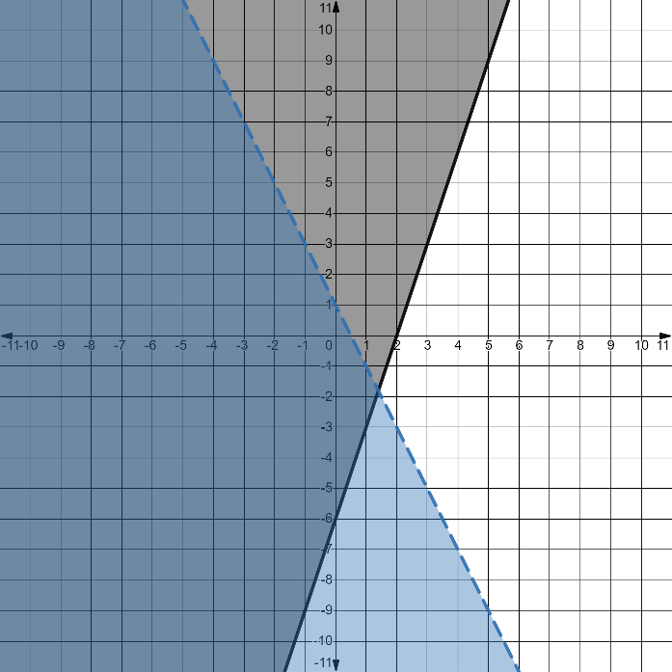  System of Inequalities: | B.  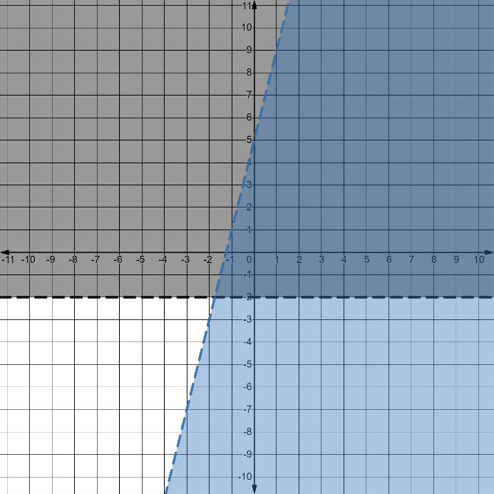  System of Inequalities:

C.  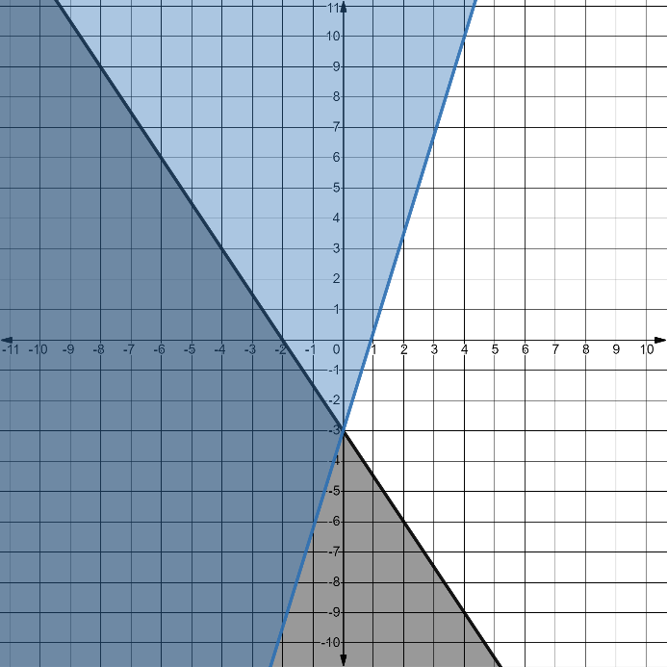  System of Inequalities: | D.  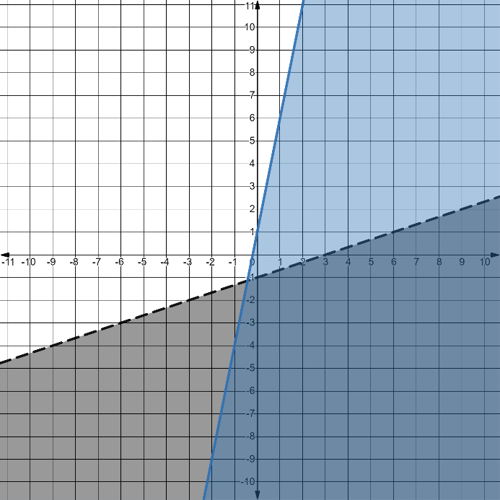  System of Inequalities:

