Video Study Guide:
Constructing a Linear Functions from a Graph

1. The graph below represents the distance a motorcycle travels as a function of time. Construct the linear function that is shown on the graph.
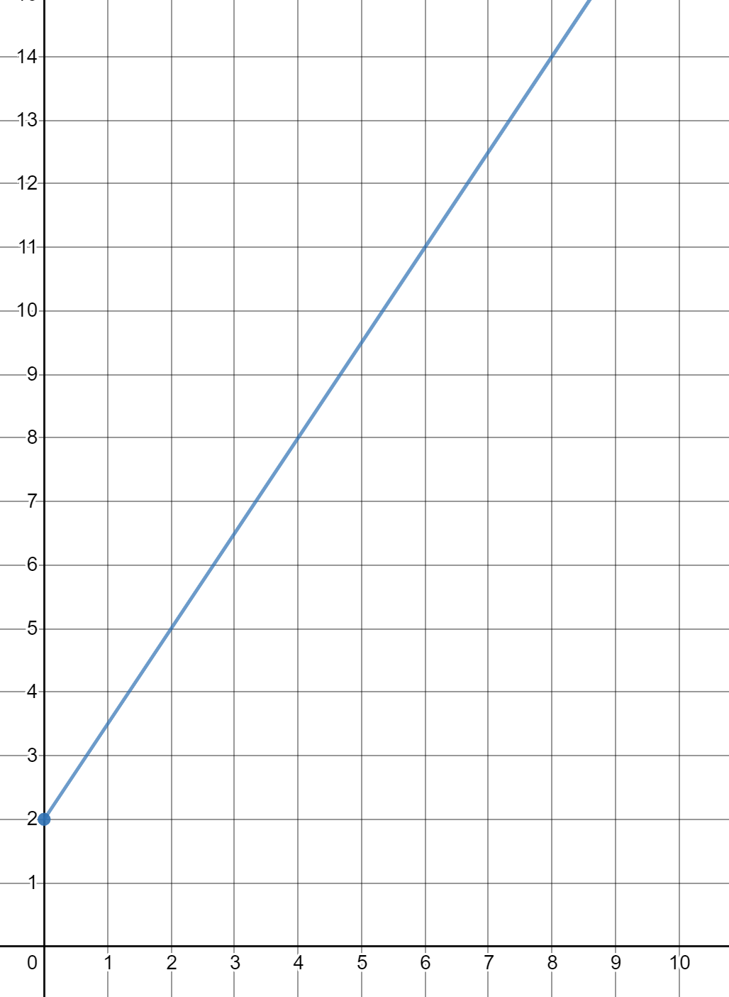
Time (minutes)

Distance (miles)

2. Construct the linear function that is represented in the graph.
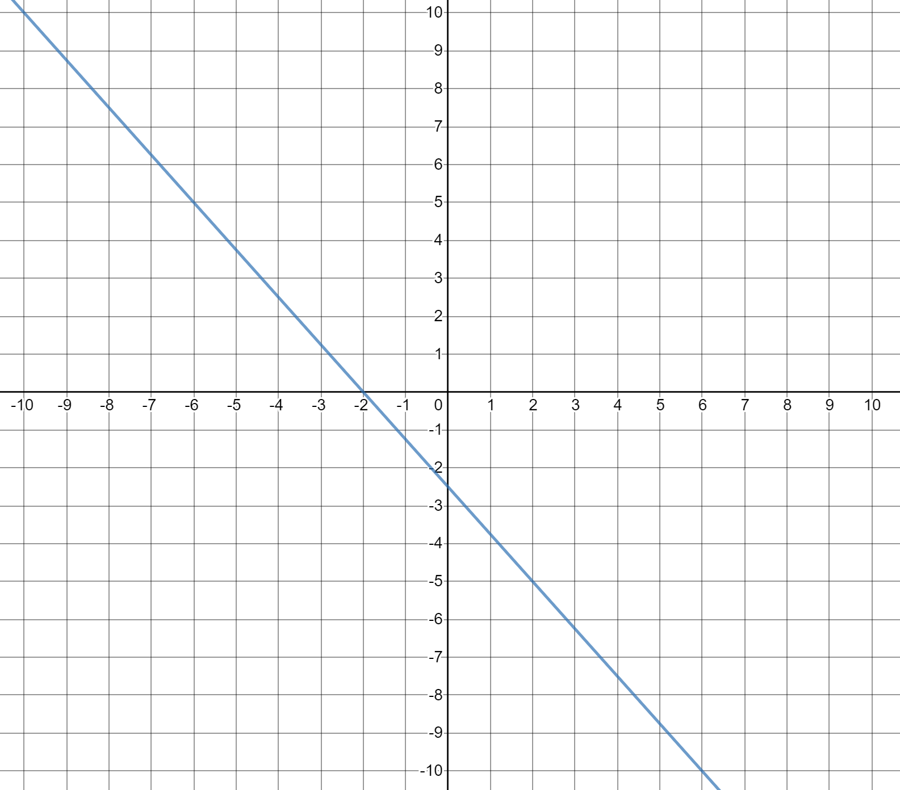

3. The graph below represents the relationship between the average rainfall that occurs in a jungle during the winter over a given number of days. Construct the linear function that is shown on the graph.

