Video Study Guide
Performing a Negative Rotation

1. Perform a rotation of $R_{-90°}$ on angle A. Use the origin as the center of rotation.
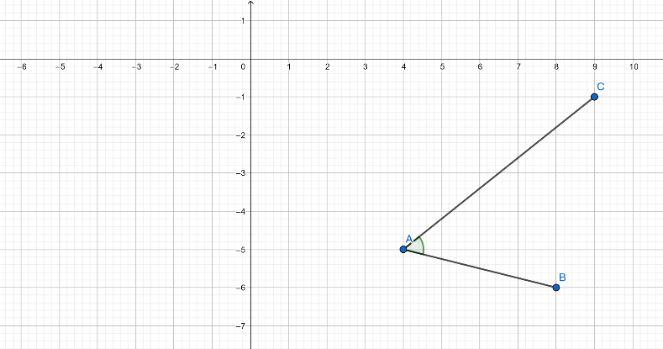

2. Rotate $∆JKL$ -180° around the origin.
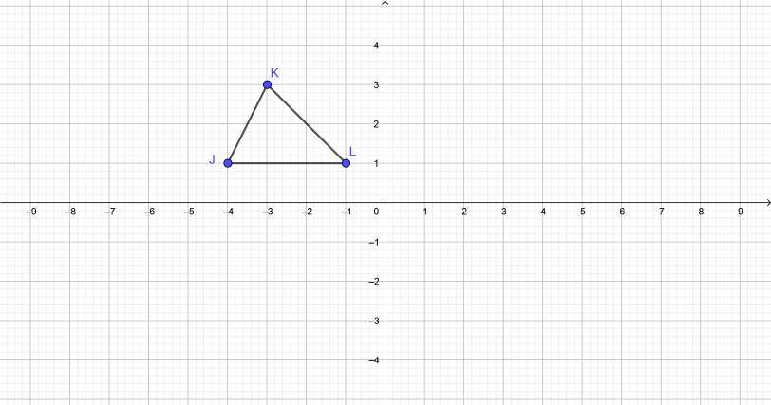

3. Perform a rotation of $R_{-270°}$ on $\overline{OP}$. Use the origin as the center of rotation.
