Video Study Guide
Solving for Unknowns in Angle Pairs
1. What is 𝑚∠𝐸𝐹𝐺 if 𝑚∠𝐸𝐹𝐻 = 73° and 𝑚∠𝐺𝐹𝐻 = 28°?
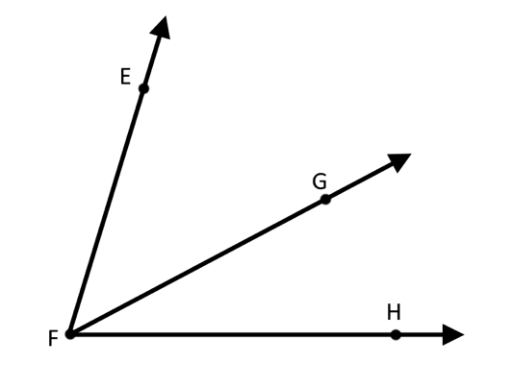

2. If the two angles below are complementary, what is the value of 𝑥?
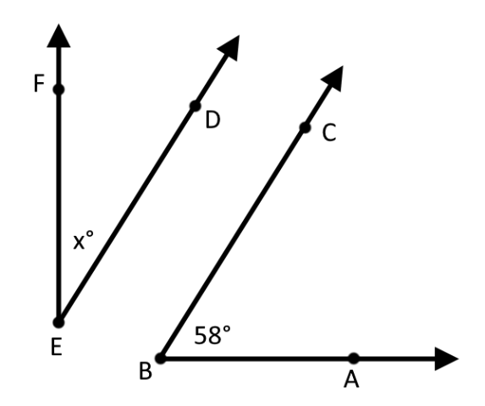

3. The two angles below are a linear pair. Find the value of 𝑞, 𝑚∠𝐿𝑀𝐾, and 𝑚∠𝐾𝑀𝐻.
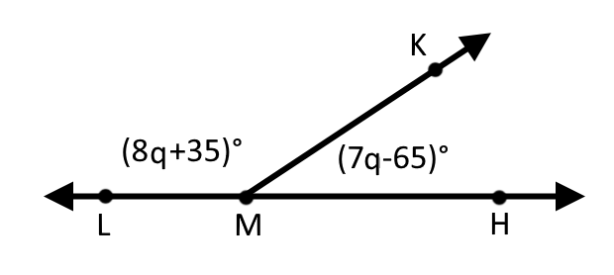

4. Find the value of 𝑥 in the following image.
