Video Study Guide:
Finding Interior Angles with Algebraic Expressions

1. Solve for $x$ and then determine the angle measurements for $∠A$, $∠B$, and $∠C$.

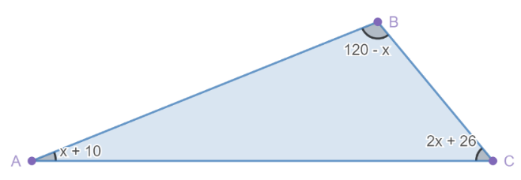

2. In a right triangle, two interior angle measurements are $(33 – x)°$ and $(5x – 3)°$, as shown below. Solve for $x$. What are the interior angle measurements of this triangle?

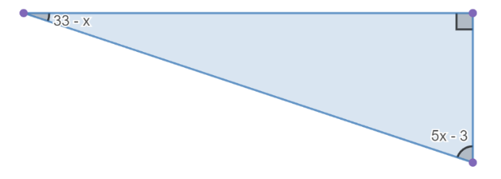

3. Solve for $x$. What are the interior angle measurements for this triangle?

