Video Study Guide:
Determining Slope from a Graph

1. Is the slope of the line shown in the graph positive, negative, 0, or undefined?
Calculate the slope value to show your answer is correct.
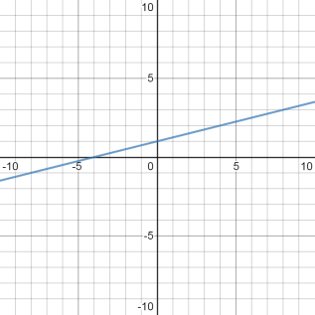

2. Is the slope of the line shown in the graph positive, negative, 0, or undefined?
Calculate the slope value to show your answer is correct.
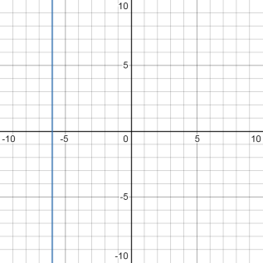

3. Is the slope of the line shown in the graph positive, negative, 0, or undefined?
Calculate the slope value to show your answer is correct.
