Video Study Guide
Using a Linear Model with Non-Linear Data

1. Identify the domain on the following scatterplot that can be analyzed using a linear model.
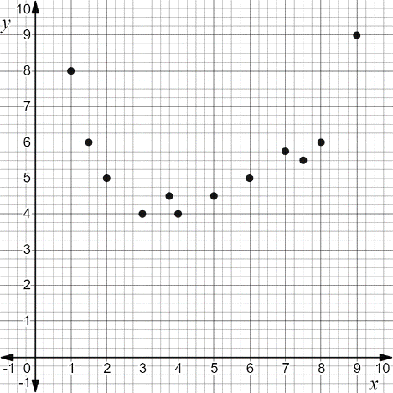

2. Identify the outliers that could be ignored on the following scatterplot to allow analysis with a linear model.
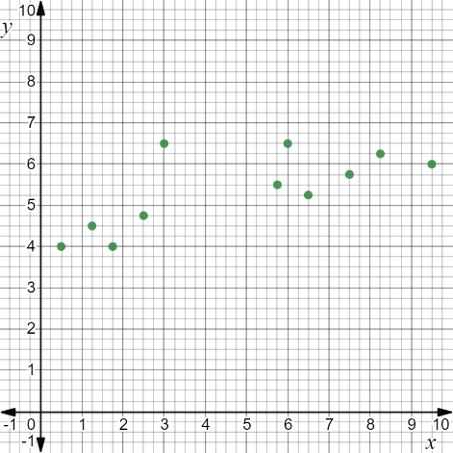

Speed (mph) | Gas Usage (mpg)
20 | 10
30 | 19
40 | 20
40 | 23
50 | 22
50 | 25
60 | 26
75 | 15
3. Cara is going on a road trip with her friends. She wants to make sure she saves as much money on gas as she can, so she wants to know how many miles per gallon she is getting when she drives her car at 55 miles per hour. Her data is shown in the table.
Create a scatterplot to visualize the data and determine if the association is linear or non-linear. Determine how to create a linear model for the data by stating a domain or identifying outliers to ignore.

